Electrocatalytic determination of captopril using a carbon paste electrode
modified with N-(ferrocenylmethylidene) fluorene-2-amine and graphene/ZnO nanocomposite

Abstract: A carbon paste electrode was modified with N-(ferrocenyl methylidene) fluorene-2-amine and graphene/ZnO nanocomposite. The electro oxidation of captopril (CAP) at the surface of the modified electrode was studied using electrochemical approaches. The electrochemical study of the modified electrode, as well as its efficiency for electrocatalytic oxidation of captopril, was described. The electrode was employed to study the electrocatalytic oxidation of captopril, using cyclic voltammetry (CV), chronoamperometry (CHA) and differential pulse voltammetry (DPV) as diagnostic techniques. It has been found that the oxidation of captopril at the surface of modified electrode occurs at a potential of about 340 mV less positive than that of an unmodified CPE. DPV of captopril at the electrochemical sensor exhibited two linear dynamic ranges (0.1–100.0 and 100.0–800.0 μM) with a detection limit (3σ) of 0.05 μM.

Keywords: captopril; carbon paste electrode; graphene/ZnO nanocomposite; N-(ferrocenyl methylidene) fluorene-2-amine.
INTRODUCTION
The electrochemical methods using chemically modified electrodes (CMEs) have been widely used as sensitive and selective analytical methods for the detection of the trace amounts of biologically important compounds. One of the most important properties of CMEs has been their ability to catalyze the electrode process via significant decreasing of over potential respect to unmodified electrode. With respect to relatively selective interaction of the electron mediator with the target analyte in a coordination fashion, these electrodes are capable to considerably enhance the selectivity in the electroanalytical methods.^{1–8}
Captopril (CAP) with the chemical name of (2S)-1-[(2S)-2- methyl-3- sulfanylpropanoyl] pyrrolidine-2-carboxylic acid is an ACE inhibitor widely used in the treatment of hypertension and some types of congestive heart failure.⁹⁻¹⁰ Captopril is a unique antihypertensive drug as it is the only one with a thoil-group in its structure. This gives it the ability to act as a scavenger of free radicals in living systems. A further advantage of the pharmaceutical is its antioxidant properties.¹¹
Captopril is used to treat high blood pressure and heart failure.¹² It decreases certain chemicals that tighten the blood vessels, so blood flows more smoothly and the heart can pump blood more efficiently. Serious toxicity has occurred primarily when captopril was given in high doses to patients with collagen vascular disease or renal insufficiency. Minor toxic effects which are seen include altered sense of taste, allergic skin rashes, and drug fever.^{13,14}
The determination of captopril is important both from a physiological point of view and for quality control purposes. Several methods have already been reported for the determination of captopril in pharmaceutical formulations and clinical samples, including high performance liquid chromatography, gas chromatography, spectrophotometry, fluorimetry, radiochemical, FT-Raman spectroscopy, capillary electrophoresis and chemiluminescence.¹⁵⁻¹⁹
Captopril with its thiol group can oxidize at the surface of various electrodes and different electrochemical methods have been used for its determination.²⁰⁻²⁵
Carbon-paste electrodes (CPEs) are widely utilized to perform the electrochemical determinations of a variety of biological and pharmaceutical species owing to their ow residual current and noise, ease of fabrication, wide anodic and cathodic potential ranges, rapid surface renewal, and low cost. Moreover, chemically modified electrodes (CMEs) can be easily prepared by adding different substances to the bulk of CPEs in order to increase sensitivity, selectivity, and rapidity of determinations.²⁶⁻³⁰ CPEs are widely applicable in both electrochemical studies and electroanalysis thank to their advantages such as very low background current (compared to solid graphite or noble metal electrodes), facility to prepare, low cost, large potential window, simple surface renewal process and easiness of miniaturization. Besides the advantageous properties and characteristics listed before, the feasibility of incorporation different substances during the paste preparation (which resulting in the so-called modified carbon paste electrode), allow the fabrication of electrodes with desired composition, and hence, with predetermined properties.³¹⁻³⁴
Therefore, in the present work, we describe the preparation of a new electrode modified with N-(ferrocenyl methylidene) fluorene-2-amine and graphene/ZnO nanocomposite and investigate its performance for the electrocatalytic determination of captopril in aqueous solutions.

EXPERIMENTAL
Apparatus and Chemicals

The electrochemical measurements were performed with an Autolab potentiostat/galvanostat (PGSTAT 302 N, Eco Chemie, the Netherlands). The experimental conditions were controlled with General Purpose Electrochemical System (GPES) software. A conventional three electrode cell was used at 25 ± 1⁰C. An Ag/AgCl/KCl (3.0 M) electrode, a platinum wire, and the graphene /Zno/FCPE were used as the reference, auxiliary and working electrodes, respectively. A Metrohm 710 pH meter was used for pH measurements. All solutions were freshly prepared with double distilled water. Captopril and all other reagents were of analytical grade from Merck (Darmstadt, Germany). The buffer solutions were prepared from orthophosphoric acid and its salts in the pH range of 2.0–9.0. Graphene/ZnO nanocomposite was synthesized in our laboratoty as reporthead line
Running title
ed previously.³⁵ Also, A typical SEM of the synthesized graphene/ZnO nanocomposite is shown in Fig. 1.

Preparation of the Electrode

The graphene/ZnO/FCPE were prepared by hand mixing 0.01 g of N-(ferrocenyl methylidene) fluorene-2-amine with 0.89 g graphite powder and 0.1 g graphene/ZnO nanocomposite with a mortar and pestle. Then, ̴ 0.7 mL of paraffin oil was added to the above mixture and mixed for 20 min until a uniformly wetted paste was obtained. The paste was then packed into the end of a glass tube (ca. 3.4 mm i.d. and 15 cm long). A copper wire inserted into the carbon paste provided the electrical contact. When necessary, a new surface was obtained by pushing an excess of the paste out of the tube and polishing with a weighing paper. For comparison, F modified carbon paste electrode (F-CPE) without graphene/ZnO, graphene/ZnO paste electrode (graphene/ZnO/CPE) without F, and unmodified carbon paste electrode (CPE) in the absence of both F and graphene/ZnO were also prepared in the same way.

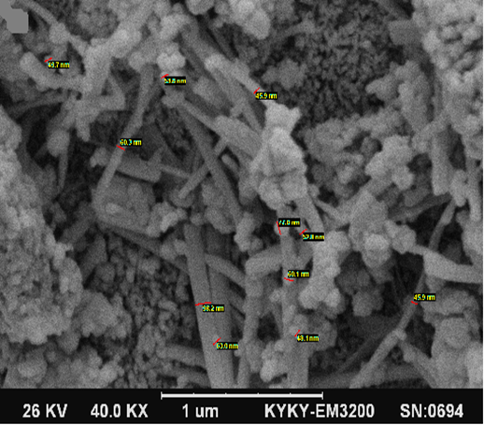
Fig. 1. SEM image of synthesized graphene/ZnO nanocomposite.

Preparation of N-(ferrocenylmethylidene) fluorene-2-amine

Ferrocenecarboxaldehyde (214 mg, 1 mmol) and9H-fluoren-2-amine(181 mg, 1 mmol) were mixed thoroughly using a pestle and mortar. After completion of the reaction as monitored by TLC (n-hexane:ethyl acetate 20:1), the solid products was recrystallized in CH₂Cl₂ and absolute ethanol (2:1)to give the pure imine product as brown solid in 90%.

RESULTS AND DISCUSSION

Electrochemical Behavior of Graphene /ZnO/FCPE

Graphene/ZnO/FCPE was prepared and its electrochemical behaviors were studied using cyclic voltammetry (CV) technique. A pair of reversible peaks were observed at E_{pa}= 0.64 V and E_{pc}= 0.54 V. The half-wave potential (E_{1/2}) and ΔEp were 0.59 and 0.10 V, respectively. The peak separa tion potential, (ΔEp=E_{pa}-E_{pc}), is greater than the (59/n) mV expected for a reversible system, which indicates a quasi reversible behavior for the mediator in an aqueous medium.³⁶ The electrode capability for the generation of a reproducible surface was examined by cyclic voltammetric data obtained in a 0.1 M phosphate buffer solution (PBS) (pH 7.0) from five separately prepared graphene/ZnO/FCPE. The calculated RSD for various parameters is accepted as the criteria for a satisfactory surface reproducibility (about 1– 4%), which is virtually the same as that expected for the renewed or ordinary carbon paste surface. However, we regenerated the surface of graphene/ZnO/FCPE before each experiment according to our previous results. In addition, the long-term stability of the graphene/ZnO/FCPE was tested over a three-week period. When CVs were recorded after the modified electrode was stored in atmosphere at room temperature, the peak potential for captopril oxidation was unchanged and the current signals showed less than 3.0% decrease relative to the initial response. The antifouling properties of the modified electrode toward captopril and its oxidation products were investigated by recording the CVs of the modified electrode before and after use in the presence of captopril. CVs were recorded in the presence of captopril after having cycled the potential 10 times at a scan rate of 10 mVs⁻¹. The peak potentials were unchanged and the currents decreased by less than 2.9%. Therefore, at the surface of graphene/ZnO/FCPE, not only the sensitivity increases, but the fouling effect of the analyte and its oxidation product also decreases.

Electrocatalytic Oxidation of captopril at a Graphene/ZnO/FCPE

Fig. 2 depicts the CV responses for the electrochemical oxidation of 60.0 µM captopril at unmodified CPE (curve b), Graphene/ZnO/CPE (curve d), FCPE (curve e) and graphene/ZnO/FCPE (curve f). As it is seen, while the anodic peak potential for captopril oxidation at the Graphene/ZnO/CPE, and unmodified CPE are 700 and 790 mV, respectively, the corresponding potentials at the surface of graphene/ZnO/FCPE and CPE are ~340 mV. However, graphene/ZnO/FCPE shows much higher anodic peak current for the oxidation of captopril compared to FCPE, indicating that the combination of graphene/ZnO nanocomposite and the mediator F has significantly improved the performance of the electrode toward captopril oxidation.
In fact, graphene/ZnO/FCPE in the absence of captopril exhibited a well behaved redox reaction (Fig. 2, curve c) in 0.1M PBS (pH 7.0). However, there was a drastic increase in the anodic peak current in the presence of 60.0 µM captopril (curve f), which can be related to the strong electrocatalytic effect of the graphene/ZnO/FCPE towards this compound.³⁶ Also, unmodified CPE (curve a) in 0.1 M PBS (pH 7.0) did not show any oxidation peak.
The effect of potential scan rate on the electrocatalytic oxidation of captopril at the graphene/ZnO/FCPE was investigated by CV (Fig. 3). As can be observed in Fig. 3, the oxidation peak potential shifted to more positive potentials with increasing scan rate, confirming the kinetic limitation in the electrochemical reaction. Also, a plot of peak height (I_{p}) vs. the square root of scan rate (v^{1/2}) was found to be linear in the range of 10–900 mVs⁻¹, suggesting that, at sufficient over potential, the process is diffusion rather than surface controlled (Fig. 3A). A plot of the scan rate-normalized current (Ip/v^{1/2}) vs. scan rate (Fig. 3B) exhibits the characteristic shape typical of an EC' process.³⁶

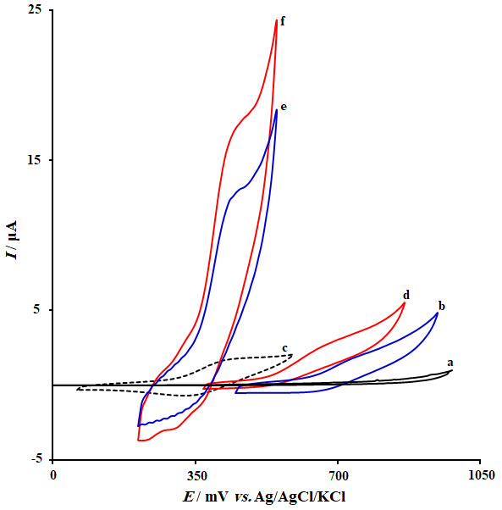
Fig. 2. CVs of (a) unmodified CPE in 0.1M PBS (pH 7.0); (b) unmodified CPE in 0.1M PBS (pH 7.0) containing 60.0 µM captopril; (c) graphene/ZnO /FCPE in 0.1M PBS (pH 7.0); (d) Graphene/ZnO CPE in 0.1M PBS (pH 7.0) containing 60.0 µM captopril; (e) FCPE in 0.1M PBS (pH 7.0) containing 60.0 µM captopril and (f) graphene/ZnO /FCPE in 0.1M PBS (pH 7.0) containing 60.0 µM captopril. In all cases the scan rate was 10 mVs⁻¹.

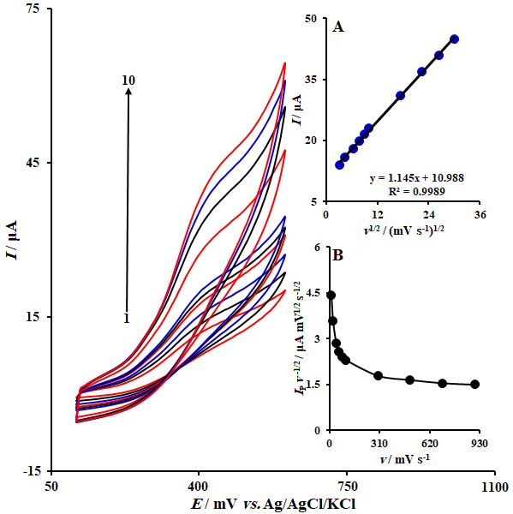
Fig. 3. CVs of graphene/ZnO /FCPE in 0.1M PBS (pH 7.0) containing 40.0 µM captopril at various scan rates; numbers 1–10 correspond to 10, 20, 40, 60, 80, 100, 300, 500, 700 and 900 mVs⁻¹, respectively. Insets: Variation of (A) anodic peak current vs. v^{1/2}; (B) normalized current (I_{p}/v^{1/2}) vs. v.

Chronoamperometric Measurements

Chronoamperometric measurements of captopril at graphene/ZnO/FCPE were carried out by setting the working electrode potential at 0.5 V vs. Ag/AgCl/KCl (3.0 M) for the various concentration of captopril in 0.1 M PBS (pH 7.0) (Fig. 4). For an electroactive material (captopril in this case) with a diffusion coefficient of D, the current observed for the electrochemical reaction at the mass transport limited condition is described by the Cottrell equation.³⁶

I =nFAD^{1/2}C_{b}π^{-1/2}t^{-1/2}

Where D and C_{b} are the diffusion coefficient (cm² s⁻¹) and the bulk concentration (molcm⁻³), respectively. Experimental plots of I vs. t^{-1/2} were employed, with the best fits for different concentrations of captopril (Fig. 4A). The slopes of the resulting straight lines were then plotted vs. captopril concentration (Fig. 4B). From the resulting slope and Cottrell equation the mean value of the D was found to be 1.2×10⁻⁶ cm²/s.

Calibration Plot and Limit of Detection

DPV method was used to determine the concentration of captopril (Fig. 5). The plot of peak current vs. captopril concentration consisted of two linear segments with slopes of 0.208 and 0.020 µA µM⁻¹ in the concentration ranges of 0.1-100.0 µM and 100.0-800.0 µM, respectively. The decrease in sensitivity (slope) of the second linear segment is likely due to kinetic limitation.⁷¹ The detection limit (3σ) of captopril was found to be 0.05 µM. This value is comparable with values reported by other research groups for electrocatalytic oxidation of captopril at the surface of chemically modified electrodes by other mediators (Table 1).

Interference Studies
The influence of various substances as compounds potentially interfering with the determination of captopril was studied under optimum conditions. The potentially interfering substances were chosen from the group of substances commonly found with captopril in pharmaceuticals and/or in biological fluids. The tolerance limit was defined as the maximum concentration of the interfering substance that caused an error of less than 5% in the determination of captopril. According to the results, L-lysine, glucose, NADH, acetaminophen, uric acid, ascorbic acid, dopamine, epinephrine, norepinephrine, L-asparagine, L-serine, L-threonine, L-proline, histidine, glycine, tryptophan, phenylalanine, lactose, saccarose, fructose, benzoic acid, methanol, ethanol, urea, Mg²⁺, Al³⁺, NH₄⁺, F⁻, SO₄²⁻ and S²⁻ did not show interference in the determination of captopril.

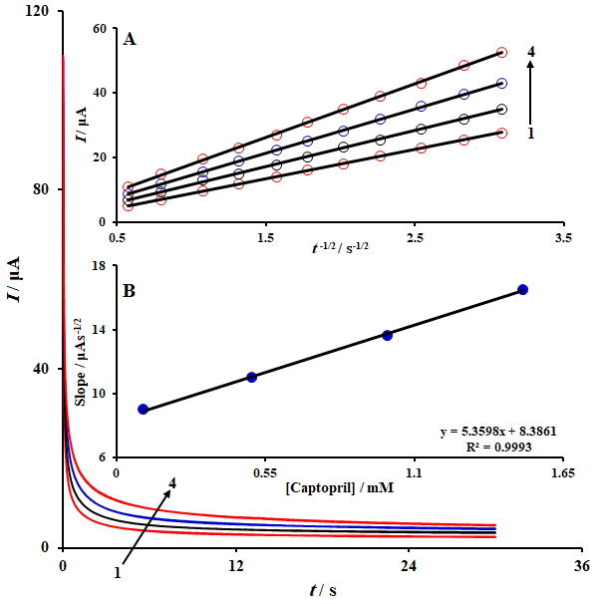
Fig. 4. Chronoamperograms obtained at graphene/ZnO/FCPE in 0.1 M PBS (pH 7.0) for different concentration of captopril. The numbers 1-4 correspond to 0.1, 0.5, 1.0, and 1.5 mM of captopril. Insets: (A) Plots of I vs. t^{-1/2} and (B) plot of the slope of the straight lines against captopril concentration.

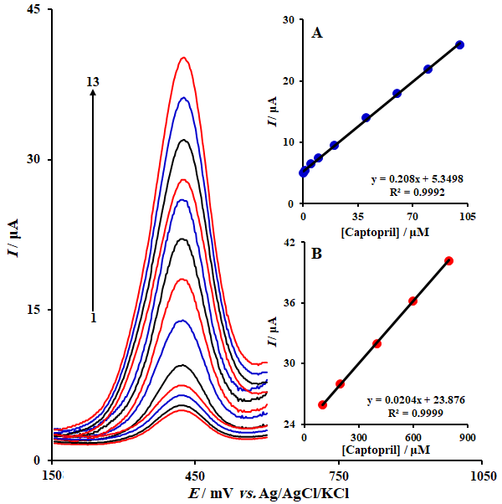
Fig. 5. DPVs of graphene/ZnO /FCPE in 0.1 M PBS (pH 7.0) containing different concentrations of captopril. From inner to outer correspond to 0.1, 1.0, 5.0, 10.0, 20.0, 40.0, 60.0, 80.0, 100.0, 200.0, 400.0, 600.0 and 800.0 µM of captopril. Inset: plots of the electrocatalytic peak current as a function of captopril concentration in the range of 0.1-100.0 µM (A) and 100.0-800.0 µM (B).

Real Sample Analysis

In order to evaluate the analytical applicability of the proposed method, also it was applied to the determination of captopril in captopril tablets and urine samples. Based on the repeated square wave voltammetric responses (n=5) of the samples that were spiked with specified concentration of captopril, measurements were made for determination of captopril concentrations in samples. The results are listed in Table 2.

Table 1. Comparison of the efficiency of some modified electrodes used in the electrocatalysis of captopril.
Ref. | LDR (μM) | LOD (μM) | Modifier | Electrode
9 | 7.0-2500.0 | 2.43 | Carbon nanotube | Carbon paste
37 | 1.0-430.0 | 0.87 | Graphene/ferrocene composite | Carbon paste
38 | 0.1-350.0 | 0.03 | Carbon nanotube | Carbon paste
39 | 0.3-90.0 | 0.10 | Multiwall Carbon Nanotubes | Carbon paste
This work | 0.1-800.0 | 0.05 | graphene/ZnO /F | Carbon paste

Table 2. The application of graphene/ZnO /FCPE for determination of captopril in captopril tablets and urine samples (n=5). All concentrations are in µM.
Sample | Spiked | Found | Recovery (%) | R.S.D. (%)
Captopril tablet | 0 | 9.5 | - | 3.4
Captopril tablet | 2.5 | 12.2 | 101.7 | 2.1
Captopril tablet | 7.5 | 16.9 | 99.4 | 1.8
Captopril tablet | 12.5 | 21.5 | 97.7 | 2.6
Urine | 0 | - | - | -
Urine | 5.0 | 5.1 | 102.0 | 1.9
Urine | 10.0 | 9.8 | 98.0 | 3.1
Urine | 15.0 | 15.1 | 100.7 | 2.3

CONCLUSIONS
This work describes the ability of a chemically modified carbon paste electrode by N-(Ferrocenyl methylidene) fluorene-2-amine and Graphene/ZnO nanocomposite. The electrochemical behavior of the captopril was studied by cyclic voltammetry. The results showed that the oxidation of captopril is catalyzed at pH 7.0, with the peak potential of captopril shifted by 340 mV to a less positive potential at the surface of the modified electrode. The modified electrode successfully resolves the overlapped voltammetric peaks of captopril. A low detection limit, together with the ease of preparation and regeneration of the electrode surface, as well as a long time of stability and reproducibility, makes the system discussed above useful in the construction of simple devices for the determination of captopril.

REFERENCES
1. J. Liu, S. Sun, C. Liu, S. Wei, Measurement 44 (2011) 1878. https://doi.org/ 10.1016/j.measurement.2011.09.001
2. H. Beitollahi, S. Tajik, H. Parvan, H. Soltani, A. Akbari, M.H. Asadi, Anal. Bioanal. Electrochem. 6 (2014) 54.
3. H. Sun, S. Zhao, F. Qu, Measurement 45 (2012) 1111. https://doi.org/10.1016/j.measurement.2012.01.029
4. H. Beitollahi, S. Ghofrani Ivari, M. Torkzadeh-Mahani, Biosens. Bioelectron. 110 (2018) 97. https://doi.org/10.1016/j.bios.2018.03.003
5. K.J. Huang, L. Wang, J. Li, T. Gan, Y.M. Liu, Measurement 46 (2013) 378. https://doi.org/10.1016/j.measurement.2012.07.012
6. M. Mazloum-Ardakani, H. Beitollahi, Z. Taleat, H. Naeimi, N. Taghavinia, J. Electroanal. Chem. 644 (2010) 1. https://doi.org/10.1016/j.jelechem.2010.02.034
7. R. Zhang, S. Liu, L. Wang, G. Yang, Measurement 46 (2013) 1089. https://doi.org/10.1016/j.measurement.2012.11.007
8. H. Beitollahi, H. Karimi-Maleh, H. Khabazzadeh, Anal. Chem. 80 (2008) 9848. https://doi.org/10.1021/ac801854j
9. H. Beitollahi, M.A. Taher, M. Ahmadipour, R. Hosseinzadeh, Measurement 47 (2014) 770. https://doi.org/10.1016/j.measurement.2013.10.001
10. D.T. Gimenes, M.C. Marra, J.M. de Freitas, R.A.A. Muñoz, E.M. Richter, Sens. Actuators B 212 (2015) 411. https://doi.org/10.1016/j.snb.2015.01.132
11. H. Beitollahi, S. Ghofrani Ivari, R. Alizadeh, R. Hosseinzadeh, Electroanalysis 27 (2015) 1742. https://doi.org/10.1002/elan.201500016
12. X. Ioannides, A. Economou, A. Voulgaropoulos, J. Pharm. Biomed. Anal. 33 (2003) 309. https://doi.org/10.1016/S0731-7085(03)00262-0
13. F. Tache, A. Farca, .Medvedovici, V. David, J. Pharm. Biomed. Anal. 28 (2002) 549. https://doi.org/10.1016/S0731-7085(01)00687-2
14. H. Krimi, M. Keyvanfard, K. Alizad, Iran. J. Pharm. Res. 15 (2016) 107.
15. K.R. Rezende, I.M. Mundim, L.S. Teixeira, W.C. Souza, J. Chromatogr. B 850 (2007) 59. https://doi.org/10.1016/j.jchromb.2006.11.007
16. A.M. El-Didamony, E.A.H. Erfan, Spectrochim. Acta, Part A 75 (2010) 1138. https://doi.org/10.1016/j.saa.2009.12.075
17. S. Mazurek, R. Szostak, J. Pharm. Biomed. Anal. 40 (2006) 1225. https://doi.org/10.1016/j.jpba.2005.03.047
18. T. Perez-Ruiz, C. Martinez-Lozano, R. Galera, Electrophoresis 27 (2006) 2310. https://doi.org/10.1002/elps.200500861
19. J.A.M. Pulgarin, L.F.G. Bermejo, P.F. Lopez, Anal. Chim. Acta 546 (2005) 60. https://doi.org/10.1016/j.aca.2005.05.014
20. B. Rezaei, S. Damiri, Sens. Actuators B 134 (2008) 324. https://doi.org/10.1016/j.snb.2008.05.004
21. X. Ioannides, A. Economou, A. Voulgaropoulos, J. Pharm. Biomed. Anal 33 (2003) 309. https://doi.org/10.1016/S0731-7085(03)00262-0
22. H. Parham, B. Zargar, Talanta 65 (2005) 776. https://doi.org/10.1016/j.talanta.2004.08.005
23. J.M.G. Fraga, A.I.J. Abizanda, F.J. Moreno, J.J.A. Leo´ n, Talanta 46 (1998) 75. https://doi.org/10.1016/S0039-9140(97)00254-3
24. W. Siangproh, P. Nagmukot, O. Chalapakul, Sens. Actuators B 91 (2003) 60. https://doi.org/10.1016/S0925-4005(03)00067-4
25. G.K. Ziyatdinova, G.K. Budnikov, V.I. Pogore ltsev, J. Anal. Chem. 61 (2006) 798. https://doi.org/10.1134/S1061934806080144
26. S. Tajik, M.A. Taher, Microchim. Acta 173 (2011) 249. https://doi.org/10.1007/s00604-011-0553-z
27. H. Beitollahi, S. Tajik, S.Z. Mohammadi, M. Baghayeri, Ionics 20 (2014) 571. https://doi.org/10.1007/s11581-013-1004-0
28. J.H. Luo, X.X. Jiao, N.B. Li, H.Q. Luo, J. Electroanal. Chem. 689 (2013) 130. https://doi.org/10.1016/j.jelechem.2012.10.013
29. H. Mahmoudi Moghaddam, H. Beitollahi, S. Tajik, H. Soltani, Electroanalysis 27 (2015) 2620. https://doi.org/10.1002/elan.201500166
30. Y. Wang, Y. Wu, J. Xie, X. Hu, Sens. Actuators B 177 (2013) 1161. https://doi.org/10.1016/j.snb.2012.12.048
31. H. Beitollahi, S. Tajik, Sh. Jahani, Electroanalysis 28 (2016) 1093. https://doi.org/10.1002/elan.201501020
32. E. Sabzi, R.E. Minaie, K. Farhadi, M.M. Golzan, Turk. J. Chem. 34 (2010) 901.
33. H. Beitollahi, J.B. Raoof, H. Karimi-Maleh, R. Hosseinzadeh, J. Solid State Electrochem. 16 (2012) 1701. https://doi.org/10.1007/s10008-011-1578-2
34. J. Huo, E. Shangguan, Q. Li, Electrochim. Acta 89 (2013) 600.
35. H. Beitollahi, F. Garkani Nejad, Electroanalysis 28 (2016) 2237. https://doi.org/10.1002/elan.201600143
36. A.J. Bard, L.R. Faulkner, Electrochemical Methods Fundamentals and Applications, 2nd ed., Wiley, New York, 2001.
37. V.K. Gupta, A. Nayak, S. Agarwal, B. Singhal, Comb.Chem. High Throughput Screen 14 (2011) 284. https://doi.org/10.2174/138620711795222437
38. M.B. Gholivand, M. Khodadadian, Electroanalysis 25 (2013) 1263. https://doi.org/10.1002/elan.201200665
39. M. Mazloum-Ardakani, F. Sabaghian, A. Khoshroo, M. Abolhasani, H. Naeimi, Ionics 21 (2015) 239. https://doi.org/10.1007/s11581-014-1159-3

