Supplementary Material

Evaluating the scientific performance of institutions within the university: an example from the University of Belgrade

IVAN PILČEVIĆ^{1*}, VELJKO JEREMIĆ¹ and DUŠAN VUJOŠEVIĆ²
¹Faculty of Organizational Sciences, University of Belgrade
²The Faculty of Computer Science, Union University
*Corresponding author: ivan.pilcevic@gmail.com

As we can see from TABLE Ia, the Institute Vinča leads the way with 2100 published papers. In addition, the quality of the journals in which those papers were published is quite high. The median value of indicator AVG_JIF_PERCENTILE is 66.309, meaning that half the Vinča papers came out in journals which are in top 33.691% in their respective JCR subject category.

TABLE Ia. Number of published papers, median and interquartile range for indicator Average Journal Impact Factor Percentile for five leading institutes
 |  | Inst  Vinca | Inst  ICTM | Inst  Biol Res | Inst  Phys | Inst  Mult Res
 | Number  of papers | 2100 | 1163 | 1109 | 954 | 531
AVG_JIF_PERCENTILE | Median | 66.309 | 63.057 | 55.195 | 74.423 | 65.382
 | IQR | 35.965 | 41.114 | 47.165 | 33.950 | 44.056

A remarkable result was achieved by the Institute of Physics. Fully half of its papers were published in journals which are placed in top 25.577% of the respective JCR subject category. On the other hand, the Institute for Biological Research “Siniša Stanković” has the lowest median value and highest interquartile range (IQR) among the top institutes (large variability of the observed indicator), meaning that its performance is weaker than the previously mentioned institutes.

TABLE Ib. Number of published papers, median and interquartile range for indicator Average Journal Impact Factor Percentile for Faculties of Medical Sciences
 |  | Fac  Med | Fac  Pharm | Fac  Vet Med | Fac  Dent
 | Number  of papers | 2456 | 780 | 287 | 312
AVG_JIF_PERCENTILE | Median | 40.256 | 51.611 | 33.784 | 32.916
 | IQR | 50.676 | 48.711 | 41.063 | 59.661
Our results show that the Faculty of Medicine has the largest number of published papers (2456), but that they are published in journals with lower ratings on the AVG_JIF_PERCENTILE indicator than those of the Institute Vinča and the Institute of Physics. A similar conclusion can be deduced for both the Faculty of Veterinary Medicine and the Faculty of Dental Medicine, while the Faculty of Pharmacy with a median value of 51.611 for indicator AVG_JIF_PERCENTILE has the best performance in the group of Faculties of Medical Sciences (TABLE Ib).

TABLE Ic. Number of published papers, median and interquartile range for indicator Average Journal Impact Factor Percentile for Faculties of Sciences and Mathematics
 |  | Fac  Biol | Fac  Chem | Fac  Phys Chem | Fac  Phys | Fac  Math
 | Number  of papers | 950 | 974 | 602 | 383 | 365
AVG_JIF_PERCENTILE | Median | 44.031 | 63.057 | 68.375 | 76.866 | 62.071
 | IQR | 44.709 | 40.626 | 38.579 | 24.451 | 44.967

In the group of Faculties of Sciences and Mathematics, the Faculty for Physical Chemistry and the Faculty of Physics stand out. Half of the papers from the Faculty for Physical Chemistry are published in the top 31.625% of journals, while half of the papers written by authors from the Faculty of Physics are in the top 23.134% of journals (TABLE Ic).

TABLE Id. Number of published papers, median and interquartile range for indicator Average Journal Impact Factor Percentile for Faculties of Technology and Engineering Sciences (top 5 in terms of number of published papers)
 |  | Fac  Techn Met | Fac  Elect Eng | Fac  Mech Eng | Fac  Agr | Fac  Min Geol
 | Number  of papers | 1343 | 697 | 692 | 619 | 378
AVG_JIF_PERCENTILE | Median | 63.333 | 60.294 | 55.455 | 47.283 | 49.156
 | IQR | 45.901 | 41.516 | 44.625 | 47.159 | 48.453

TABLE Ie. Number of published papers, median and interquartile range for indicator Average Journal Impact Factor Percentile for Faculties of Technology and Engineering Sciences (rest)
 |  | Fac  Org Sci | Fac  Tech Bor | Fac  Transport | Fac  Forestry | Fac  Civil Eng
 | Number  of papers | 333 | 264 | 224 | 205 | 182
AVG_JIF_PERCENTILE | Median | 39.091 | 46.019 | 55.532 | 28.313 | 44.815
 | IQR | 46.991 | 42.420 | 46.795 | 37.393 | 48.895

Among Faculties of Technology and Engineering Sciences, the Faculty of Technology and Metallurgy leads the way with more than 1300 published papers, half of those having appeared in the top 36.667% of journals (TABLE Id). Among Faculties of Technology and Engineering Sciences with fewer published papers (TABLE Ie), the Faculty of Transport and Traffic Engineering exhibits the best performance, with a median value for the indicator Average Journal Impact Factor Percentile of 55.532 (meaning that half of its papers were published in the top 44.468% of journals.

In addition to the indicator which represented the quality of the journals in which researchers from the University of Belgrade published their papers, we performed percentile-based analysis in terms of the quality of the published papers from 2009 to 2014. All of the JCR indexed journals are classified in one of the 22 research fields and for each field a baseline number for article citation score has been determined so the paper can be classified in a certain percentile group for the year in which it was published. According to Web of Science (Percentiles, 2017), 7 groups were determined: (I) Top 0.01%, (II) Top 0.01-0.1%, (III) Top 0.1-1%, (IV) Top 1-10%, (V) Top 10-20%, (VI) Top 20-50%, (VII) bottom-half. Our results showed that the University of Belgrade does not have any articles in the first percentile group, only four papers belong to group two, while 26 papers are in percentile group three. Consequently, we merged the first three groups and presented the results (FIGURES 1a-1e) as: (I) Top 1%, (II) Top 1-10%, (III) Top 10-20%, (IV) Top 20-50%, (V) bottom-half.

As we can see from Figure 1a, researchers from the Institute Vinča published a considerable number of cited papers. Namely, 0.2% of their papers are in the group of highly-cited papers (Top 1%), 5.1% papers are in the second group (papers which are in Top 1-10% by citations in research field), 7.82% of papers are in group of Top 10-20%, 29.93% of papers are in the category Top 20-50%, while 56.94% are, based on citation, in bottom-half. Among the leading institutes, the Institute for multidisciplinary studies performs quite well with only 49.47% of papers in bottom-half (the best result among the leading institutes). On the other hand, the Faculties of Medical Sciences are far below these results, as can be seen from FIGURE 1b.

FIGURE 1a. Percentage of papers belonging to certain percentile groups (five leading institutes)

FIGURE 1b. Percentage of papers belonging to certain percentile group (Faculties of Medical Sciences)

Although the Faculty of Biology has, besides the Faculty of Chemistry, the largest number of published papers among Faculties of Sciences and Mathematics, they are less cited than the other faculties from the group with 70.14% of papers origination from the Faculty of Biology appearing in bottom-half of the citation metrics (FIGURE 1c). On the other hand, the Faculty of Technology and Metallurgy (FIGURE 1d) is shown to have not only a large number of published papers but also a high citation score of those papers. In particular, 0.43% of papers are in the group of best papers (Top 1%), 7.04% of papers are in second group (papers rated as Top 1-10% by citation in a certain research field for a particular year), 9.61% of papers published by researchers from the Faculty of Technology and Metallurgy are in the Top 10-20%, 28.82% of papers are in Top 20-50%, while 54.11% of papers are placed in bottom-half. The results from the remaining Technology and Engineering Sciences Faculties are presented in FIGURE 1e.

FIGURE 1c. Percentage of papers belonging to certain percentile group (Faculties of Sciences and Mathematics)

FIGURE 1d. Percentage of papers belonging to certain percentile group (Faculties of Technology and Engineering Sciences - top 5)

FIGURE 1e. Percentage of papers belonging to certain percentile group (Faculties of Technology and Engineering Sciences - rest)

Particularly impressive is the performance of Faculty of Mathematics and Faculty of Mechanical Engineering which exceed in terms of Top 1% publications, with 2.38% and 2.49% respectively.

Researchers often emphasize the importance of presenting the results of collaboration patterns within a particular university^{1–3}. The institutions included in the analysis could be thought of as belonging to a network of collaboration⁴. It is possible to visualize this network through a network graph with the nodes’ sizes representing the average value of indicator Average Journal Impact Factor Percentile of papers produced by institutions and the edges’ widths representing the numbers of papers produced in collaboration (FIGURE 2).

The network graph of this study was made using Gephi, an open source software package for graph and network analysis^{5,6}. In addition to a visualisation, a network can be analysed in terms of its structure. The idea of analysing co-authorship through network graphs has already been used in the analysis of collaboration among particular researchers^{7,8}.

A co-authorship network is a type of a social network⁹, so analysis of its structure focuses on identifying the most influential members¹⁰. The different types of influence in a network are usually described with various centrality analyses, through: Degree Centrality, Eigenvector Centrality, Closeness Centrality and Betweenness Centrality. In our study, Degree Centrality¹¹ will identify the institutions with many collaborations. The results of this analysis, together with other measurements, are presented in table (TABLE II). Eigenvector Centrality¹² will be higher among influential institutions in the network¹¹. Closeness Centrality measures the average distance to all other nodes from each node¹³, looking for the node that is closest to all other nodes, indicating who is at the heart of a social network¹¹. For our network, the similarly defined Harmonic Closeness Centrality indicator produces different values, but exactly the same order. Betweenness Centrality measures the number of times that a particular node is the member of the shortest path between two other nodes¹³. In our study, Betweenness Centrality describes how much an institution connects to the circles of other institutions.

FIGURE 2: Network graph of the institutions’ scientific productivity and cooperation
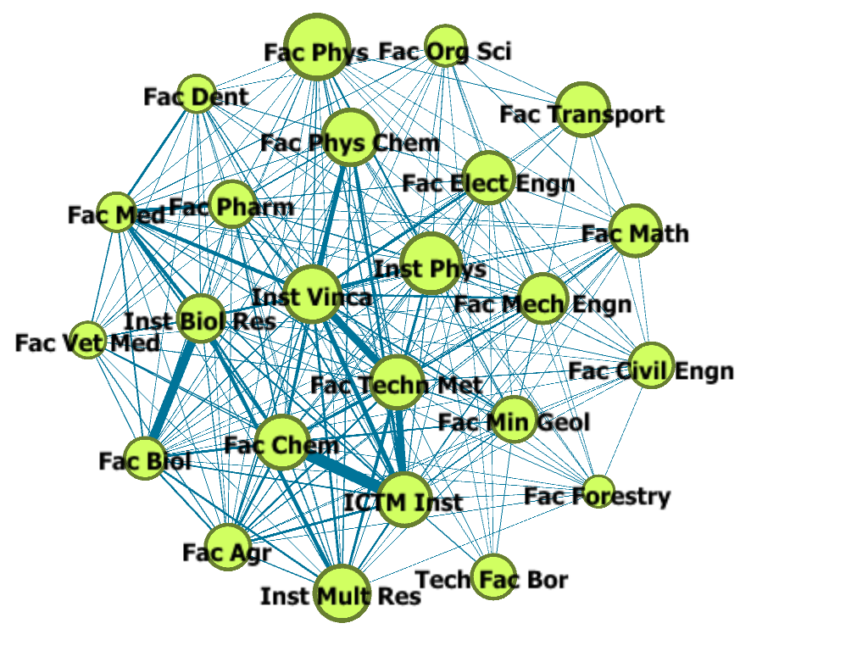

Inspired by web page-rank algorithms, the Hyperlink-Induced Topic Search (HITS) provides a measure of how valuable the information stored by a particular node is, and what the quality of the links to and from that particular node are¹². In our study, it will serve to pinpoint the institutions playing a hub role. Clustering Coefficients measure the level at which nodes are grouped together. Higher Clustering Coefficient scores reflect membership of tightly-knit social groups or clubs (cliques), while lower scores reflect the institutions out of cliques.

TABLE II: Centrality measures and other network description measures – Top five institutions
Degree Centrality | Eigenvector Centrality | Closeness Centrality | Betweenness Centrality | HITS | Clustering Coefficients | Triangles
Inst Vinca (23) | Inst Vinca (1) | Inst Vinca (1) | Inst Vinca (7.895) | Inst Vinca (0.244) | Fac Org Sci (0.747) | Inst Vinca (190)
Fac Techn Met (22), Inst Phys (22) | Fac Techn Met (0.981) | Fac Techn Met (0.958) | Inst Phys (6.570) | Fac Techn Met (0.240) | Inst Vinca (0.751) | Fac Techn Met (183)
 | Inst Phys (0.965) | Inst Phys (0.958) | Fac Techn Met (5.275) | Inst Phys (0.236) | Inst Phys (0.766) | Inst Phys (177), Fac Biol (177), Fac Agr (177)
Fac Biol (21), Fac Agr (21), ICTM Inst (21), Fac Mech Engn (21) | Fac Biol (0.964) | Fac Biol (0.92), ICTM Inst (0.92), Fac Agr (0.92), Fac Mech Engn (0.92) | Fac Elect Engn (5.250) | Fac Biol (0.235), Fac Agr (0.235) | Fac Elect Engn (0.779)
 | Fac Agr (0.964) |  | Fac Mech Engn (4.787) |  | Fac Mech Engn (0.790)

REFERENCES

1. H. G. Ceballos, S. E. Garza, F. J. Cantu, Scientometrics 114 (2018) 181–216 (http://dx.doi.org/10.1007/s11192-017-2561-1).
2. H. G. Ceballos, J. Fangmeyer, N. Galeano, E. Juarez, F. J. Cantu-Ortiz, Knowl. Manag. Res. Pract. 15 (2017) 346–355 (http://dx.doi.org/10.1057/s41275-017-0064-8).
3. M. Savić, M. Ivanović, B. Dimić Surla, Scientometrics 110 (2017) 195–216 (http://dx.doi.org/10.1007/s11192-016-2167-z).
4. C. S. Wagner, T. A. Whetsell, L. Leydesdorff, Scientometrics 110 (2017) 1633–1652 (http://dx.doi.org/10.1007/s11192-016-2230-9).
5. M. Bastian, S. Heymann, M. Jacomy, Gephi : An Open Source Software for Exploring and Manipulating Networks Visualization and Exploration of Large Graphs, in Int. AAAI Conf. Weblogs Soc. Media, 2009, pp. 361–362.
6. G. González-Alcaide, J. Park, C. Huamaní, J. M. Ramos, PLoS One 12 (2017) e0182513 (http://dx.doi.org/10.1371/journal.pone.0182513).
7. J. L. Ortega, I. F. Aguillo, J. Informetr. 7 (2013) 394–403 (http://dx.doi.org/10.1016/J.JOI.2012.12.007).
8. N. Aggrawal, A. Arora, Visualization, analysis and structural pattern infusion of DBLP co-authorship network using Gephi, in 2016 2nd Int. Conf. Next Gener. Comput. Technol., IEEE, 2016, pp. 494–500 (http://dx.doi.org/10.1109/NGCT.2016.7877466).
9. C. Kadushin, Understanding social networks : theories, concepts, and findings, Oxford University Press, 2012. https://global.oup.com/academic/product/understanding-social-networks-9780195379471?cc=us&lang=en&.
10. D. V Umadevi, Journal of Global Research in Computer Science, [s.n.], 2013. http://jgrcs.info/index.php/jgrcs/article/view/577.
11. J. Golbeck, Introduction to social media investigation : a hands-on approach, Syngress, 2015.
12. K. Cherven, Mastering Gephi network visualization : produce advanced network graphs in Gephi and gain valuable insights into your network datasets, 2015. https://www.packtpub.com/networking-and-servers/mastering-gephi-network-visualization.
13. R. Brath, D. Jonker, eds., Graph Analysis and Visualization, John Wiley & Sons, Inc., Hoboken, NJ, USA, 2015 (http://dx.doi.org/10.1002/9781119183662).

The Faculty of Architecture and Faculties of Social Sciences and Humanities group have not been presented due to the relatively small number of published papers

