Electronic Supplementary Information

Morphology dependent photocatalytic efficacy of Zinc Ferrite probed for Methyl Orange degradation
HUAN-YAN XU*, BO LI and PING LI
School of Materials Science and Engineering, Harbin University of Science and Technology, Harbin 150040, P. R. China

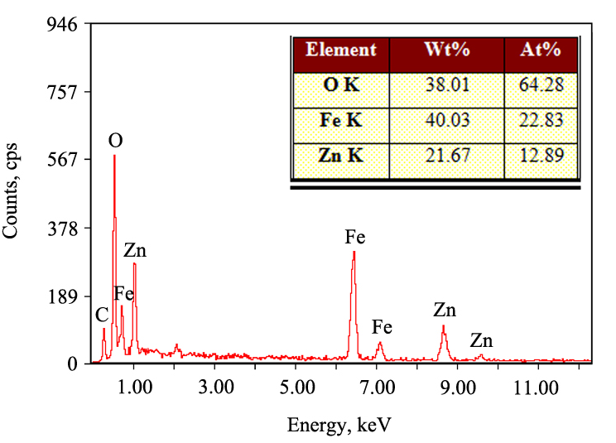
Fig. 1S. EDS pattern of NZFO sample.

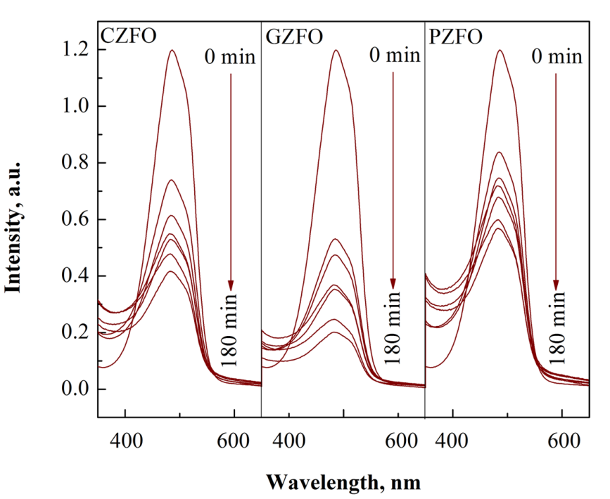
Fig. 2S. UV-Vis absorption spectra of MO solution after different reaction periods over different samples.

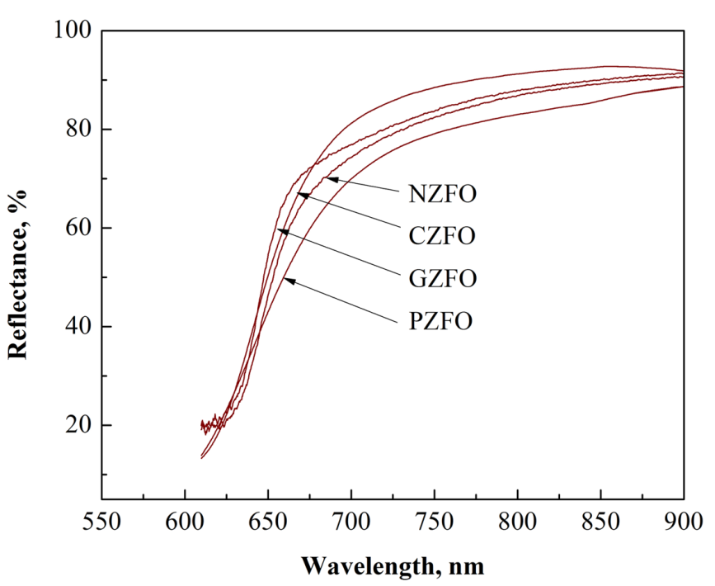
Fig. 3S. UV-vis DRS spectra of the obtained samples.
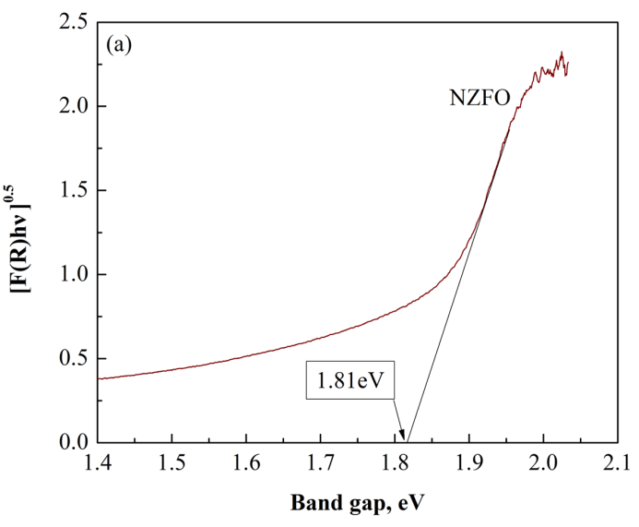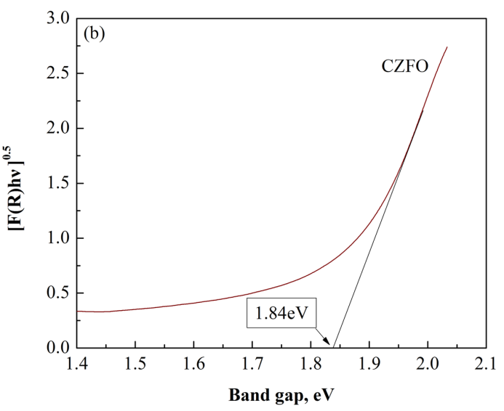
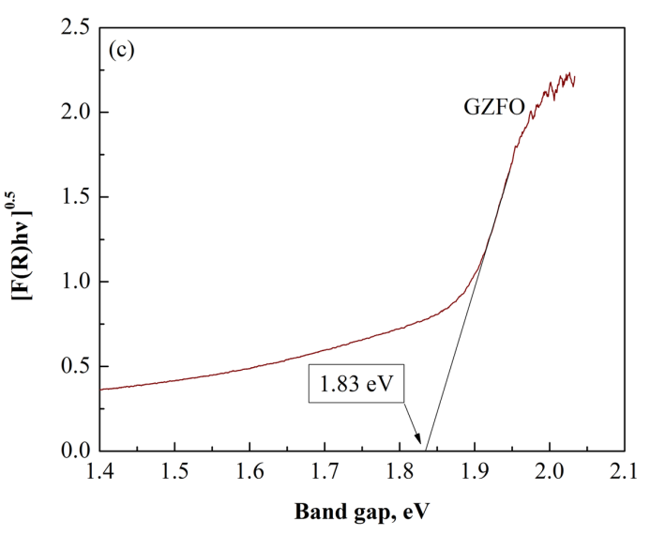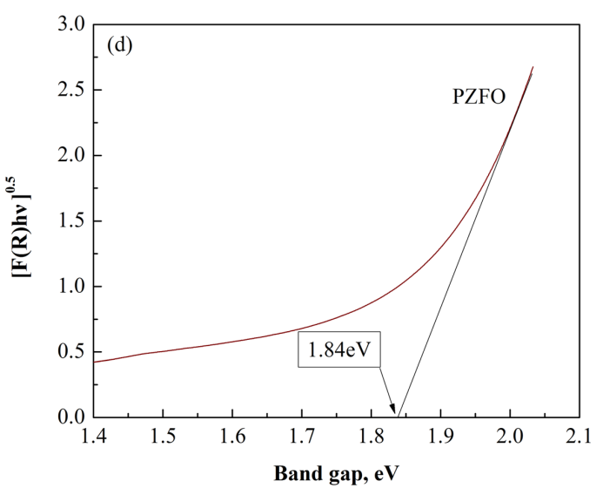
Fig. 4S. The relationships between [F(R)·hυ]^{0.5} and band gap of (a) NZFO, (b) CZFO, (c) GZFO and (d) PZFO.

Table 1S Particle sizes obtained using FESEM, average crystallite sizes calculated from XRD and specific surface area of NZFO, CZFO, GZFO and PZFO
Sample | Particle sizes measured using FESEM (nm) | average crystallite sizes calculated from XRD (nm) | specific surface area  (m² g⁻¹)
NZFO | 400-500 in length 30-40 in diameter | 41 | 26.27
CZFO | 100-700 | 125 | 5.38
GZFO | 200-300 | 96 | 9.04
PZFO | >2000 | 163 | 3.92

*Corresponding author. E-mail: xuhuanyan@hrbust.edu.cn

