Manuscript ID: 6824
Manuscript title: Morphology-dependent photocatalytic degradation of Methyl Orange over zinc ferrite
Authors: Huan-Yan Xu, Bo Li and Ping Li

Dear Editor:
The manuscript mentioned above has been carefully revised according to the reviewers’ comments item by item. And, English has been polished and improved. All the changes to this manuscript within the document have been marked by RED fonts.
All the revisions and explanations are addressed below in the section ‘Responses to the reviewers’ comments’. We would like to thank the reviewers for their valuable suggestions, which will be very helpful to improve our present study and guide our future study.
Furthermore, many thanks should be expressed to you for giving this manuscript one more chance for the possible publication in Journal of the Serbian Chemical Society.
Please do not hesitate to contact me, if any others are needed.
Best wishes,
Huan-Yan Xu

Response to reviewers’ comments

Reviewer A:
In the manuscript "The nature of morphology-dependent photocatalytic degradation of high-concentration Methyl Orange over zinc ferrite” by Huan-Yan Xu, Bo Li and Ping Li photocatallytic degradation of MO was studied using ZnFe2O4 prepared by different synthetic approaches and consequently having different morphologies. Prior to photocatalytic experiments, the synthetized samples were characterized using FESEM and XRD. However, I have doubts on the interpretation of the results, as outlined below. Based on these concerns I do not recommend the manuscript for publication in the Journal of the Serbian Chemical Society.
All the authors sincerely appreciate this reviewer for valuable suggestions. In the revised manuscript, the comments have been responded and English has been improved.
-Major points:
The authors correlated efficiency of the photocatalytic process to the specific surface area. However, the specific surface area was not experimentally determined by BET. The crystalline size of all samples, determined from the broadening of the XRD peaks, is in the range 41-163 nm, but, the size of particles is much larger, as noticed by the authors as well. Without BET, it is just speculation that specific surface area is reciprocal function of crystalline size. Anyway, how the values of the specific surface area were obtained?
Response:
In the original manuscript, we have stated that the surface area of these samples were measured by a Sibata SA-1100 surface area analyzer based on nitrogen adsorption-desorption data at liquid nitrogen temperature (please see the section ‘Characterization methods’ on page 4 ). The results were displayed in Figure 4 (on page 7). The specific surface area was reciprocal function of crystalline size. It was concluded from the experimental data, rather than a speculation.
Prior to photocatalytic experiments adsorption of MO onto ZnFe2O4 was performed in dark. Presented data (Figure 5a) are not convincing that equilibration process is completed, and it might proceed in parallel with photocatalytic process.
Response:
It has been well known that the adsorption plays an important role in the heterogeneous photocatalytic process and happens during the whole process. In this study, before irradiation by UV light, adsorption of MO onto ZnFe2O4 was performed in dark for 30 min to reach the adsorption-desorption equilibrium in order to evaluate the real photocatalytic ability of ZnFe2O4. This does not mean that the adsorption did not proceed in the following stage. The equilibrium of adsorption and desorption was dynamic during the whole process. In countless publications on photocatalysis, the experiments were operated as such, i.e., adsorption was firstly performed in dark to reach the adsorption-desorption equilibrium and then the photocatalytic reaction started.
-Minor points:
Light source is not described in Experimental.
Response:
The description on light source was supplemented in the section ‘Photocatalytic evaluation’.
A 15W ZSZ15-40 UV lamp with UV-light wavelength of 365 nm was located at 15cm above the beaker reactor. (Please see the resubmitted manuscript, Page 4)
Concentrations of photocatalysts (7 mg/mL) are very high. The most frequent concentration range is 0.5-2 mg/mL.
Response:
We are so sorry for this typing error. The photocatalyst dosage was 1 g L⁻¹ in this study. Sorry again for your confusion by this error. It has been revised in the resubmitted manuscript (page 7).
English should be significantly improved starting with title.
Response:
Yes, English has been polished and improved. Please see the resubmitted manuscript.

Reviewer B:
The manuscript describes study of photocatalytic degradation of Methyl Orange on synthesized Zinc ferrite (ZnFe2O4) photocatalysts with different morphologies (needle-, cube-, granule- and plate-like morphology).
All the authors sincerely express many thanks to the reviewer for his/her recognition to the scientific value of this manuscript. The academic suggestions are valuable. The comments are responded as follows:
The title should be changed, word “nature” has to be deleted, maybe phrase “high-concentrated” should be changed (depending on further corrections).
Response:
Thank you for your advice. The title has been changed in the resubmitted manuscript as follows:
Morphology-dependent photocatalytic degradation of Methyl Orange over zinc ferrite
The introduction is written in a formal way.
Response:
Thank you so much.
In the experimental part is missing detailed description of the synthesis ie. it is also desirable to write the quantities of substances (expressed in grams or mol) and not just their molar ratios. Also, in the photocatalytic process description is missing the data for the photocatalyst dosage, the type of lamp used for illumination and its distance from the samples, temperature of the systems and the characteristics of the filter. Considering the value of the band gap energy of the zinc ferrite (~1.9 eV), the question arises: why photocatalytic degradation was not made in the visible part of the spectrum? Characterization of the materials was carried out using FESEM, EDS and XRD methods and the description of the obtained results is correct. However, the EDS pattern is presented only for granule-like ZnFe2O4. Do you have the results of EDS analysis for other samples (maybe it should be in some Supplementary file)? UV/Vis characterization of photocatalysts (ZFO), reflection spectra, should be added, as well as full description of this technique (especially optical path-dimension of cuvette).
Response:
These questions are very valuable for the improvement of this study.
1. The specific quantity of each chemical reagent used in the preparation process was given in the resubmitted manuscript.
In the hydrothermal procedure, 1.72 g of ZnCl₂·2H₂O and 5.41 g of FeCl₃·6H₂O……
……the mixed solution of Zn(NO₃)₂·6H₂O (2.97 g) and Fe(NO₃)₃·9H₂O (8.08 g).
In the oxalate co-precipitation procedure, 2.97 g of Zn(NO₃)₂·6H₂O, 8.08 g of Fe(NO₃)₃·9H₂O and 6.3 g H₂C₂O₄·2H₂O were fully mixed and ground……
……immediately after 2.97 g of Zn(NO₃)₂·6H₂O and 8.08 g of Fe(NO₃)₃·9H₂O were dissolved……
2. The missing descriptions of photocatalytic process have been added in the resubmitted manuscript.
All the adsorption and photocatalysis experiments were performed at room temperature. A 15W ZSZ15-40 UV lamp with UV-light wavelength of 365 nm was located at 15cm above the beaker reactor. 0.1 g of ZnFe₂O₄ phtotocatalyst was weighed and placed into 100 mL MO solution with the concentration of 10 mg L⁻¹.
3. Although ZnFe₂O₄ has narrow band gap (∼1.9 eV) and can effectively absorb visible light, its photocatalytic activity under visible-light irradiation is very limited due to the rapid recombination of photoexcited charges and low absorption coeﬃcient of visible light (Applied Catalysis B: Environmental, 2018, 227, 330-339; ACS Applied Materials & Interfaces, 2017, 9, 41927-41936). So, in many reported studies on the photocatalysis of pure or decorated ZnFe₂O₄, the photocatalytic process was carried out under the irradiation of UV light (Journal of Environmental Management, 2017, 193, 146-153; Journal of Magnetism and Magnetic Materials, 2017, 441, 98-104; Journal of Materials Science-Materials in Electronics, 2016, 27, 5846-5850; Journal of Alloys and Compounds, 2015, 652, 132-138; Journal of the Ceramic Society of Japan, 2013, 121, 26-30).
4. EDS is just a semi-quantitative tool for the analysis of element composition, so it was not measured for all the samples. According to the reviewer’s advice, the EDS pattern of NZFO sample was added in the supplementary file.
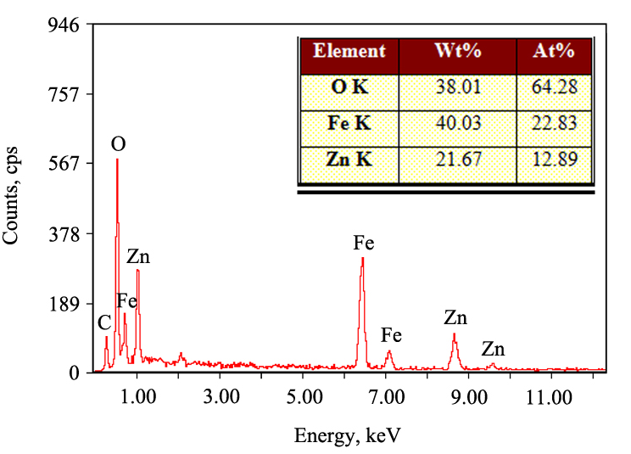
Fig 1S. EDS pattern of NZFO sample.
Likewise, there are no elemental impurities in NZFO sample, as shown in its EDS pattern (Figure 1S).
5. UV-vis DRS spectra of the obtained samples were added in the supplementary file. The full description of this technique was also added in the resubmitted manuscript.
UV-vis diffuse reflection spectroscopy (UV-vis DRS) was recorded to analyze the optical property of the obtained samples using an USB4000 UV-vis spectrometer (Ocean Optics) with an integral sphere. The reference sample (a standard template) was provided by South Africa Optics.
UV-vis DRS spectra (Figure 2S) indicate that NZFO, CZFO, GZFO and PZFO have similar optical absorption thresholds, suggesting no obvious difference in their optical structures.
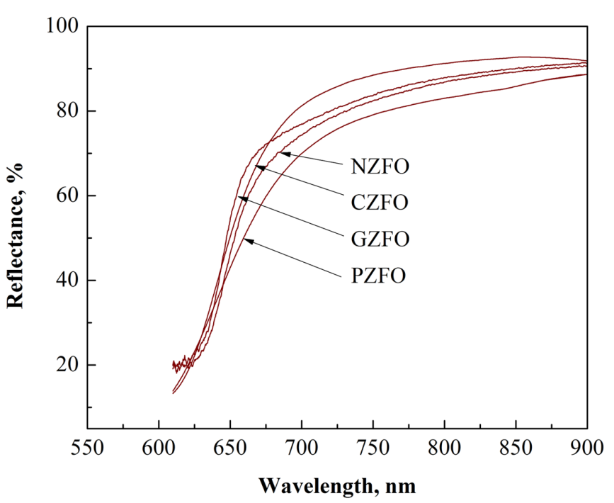
Fig. 2S. UV-vis DRS spectra of the obtained samples
In the part Characterization of ZnFe2O4 with different morphologies, when you are talking about particle size, you should explain why did you observed such differences in the morphologies of ZFO samples? Especially the method in which you used egg white. Did you choose already published synthesis procedures? If yes, give us some explanation regarding reaction mechanisms, from literature. If no, if you used original procedures, than you have to explain the findings somehow. These are the most interesting results in this publication. The other results, that photocatalytic activity depends on specific surface area, that is already known and published many times. Also, it would be nice to see reflectance spectra of ZFO samples (as I’ve already mentioned), just to check can they be used for photocatalysis, and how big are their band gaps.
Response:
1. The purpose of this study was to explore the effect of morphology on the photocatalytic performance of ZnFe2O4. So, many preparation routes were tried in our lab to prepare ZnFe2O4 with different morphologies. These four methods reported in this manuscript were eventually successful. Most of these methods were not directly extracted from related references. The existing reaction mechanisms cannot be gained. Now, it is a challenging task for us to give the reaction mechanisms of these four preparation procedures. It is an absolutely wonderful suggestion. I do think so. However, large amounts of work such as detailed characterizations of the intermediates in different reaction stages are required. If possible, we plan to prepare another manuscript to discuss this topic in future.
2. Yes, it has been already reported that the photocatalytic activity of a photocatalyst depends on its specific surface area. But, there are no related publications with ZnFe2O4. Furthermore, this study started from the morphology of ZnFe2O4.
3. Based on the reflectance spectra of ZnFe2O4 samples, their band gaps were obtained. And, the results were depicted in Figure 3S. The supplementary description was also added in the resubmitted manuscript.
Based on UV-vis DRS, the band gap (E_{g}) of these obtained samples can be determined by extrapolation of the linear portion of [F(R)·hυ]^{0.5} curve versus photon energy hυ to [F(R)·hυ]^{0.5} = 0.³⁰ As shown in Figure 3S, the E_{g} values of NZFO, CZFO, GZFO and PZFO are 1.81, 1.84, 1.83 and 1.84 eV, respectively. This also indicates they have similar band gaps.
- H. Y. Xu, L. C. Wu, L. G. Jin, K. J. Wu, J. Mater. Sci. Technol.33 (2017) 30
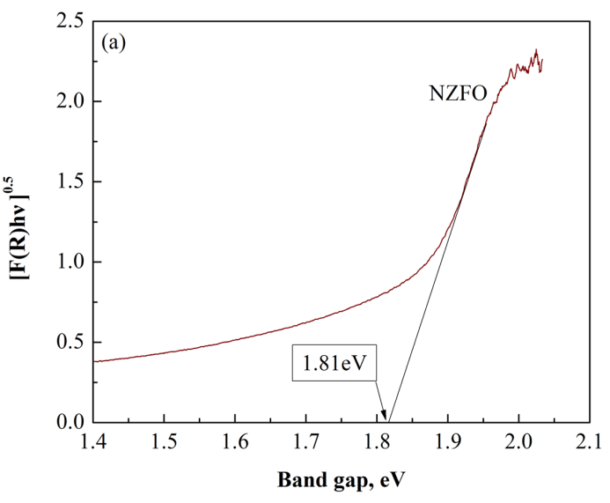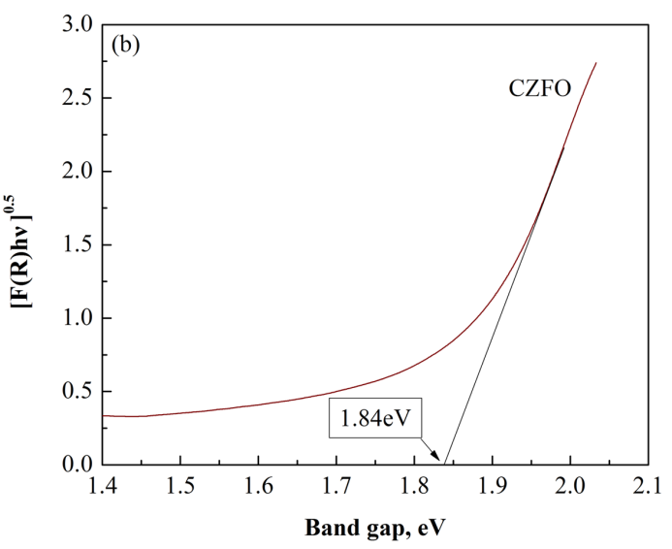
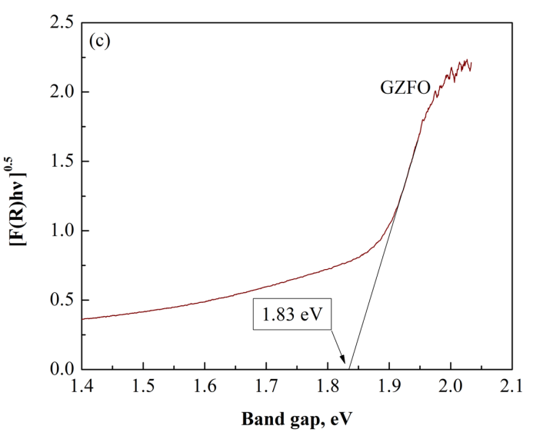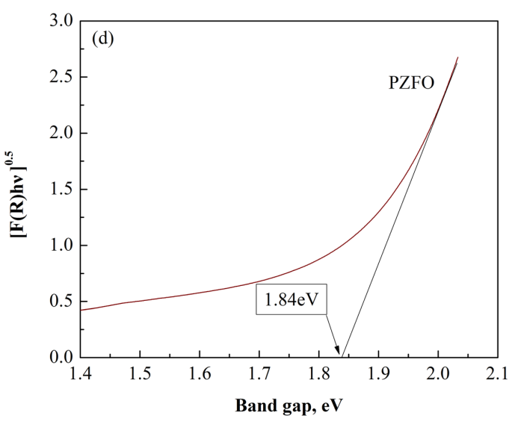
Fig. 3S. The relationships between [F(R)·hυ]^{0.5} and band gap of (a) NZFO, (b) CZFO, (c) GZFO and (d) PZFO.
Figure 5 (a): Control experiments? These are kinetic curves of adsorption and photodegradation of MO in the presence of ZFO samples. Lines should not be drawn using spline- they should simply connect the measured values.
Response:
Yes, Figure 5(a) has been revised as the suggested form. Moreover, ‘control experiments’ was revised as ‘comparative experiments’ in the resubmitted manuscript.
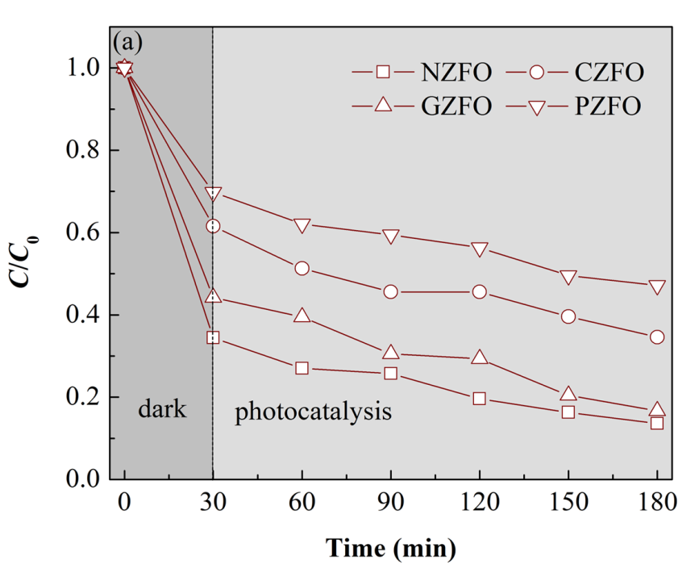
Fig. 5. (a) Comparative experiments and (b)……
Figure 7 and its description must be at the beginning of explanation of the photocatalytic degradation process. And also, UV-Vis spectra for degradation of MO on the other samples should be added in Supplementary file. Reading this paper I had a big doubt. Considering that I have experience working with the degradation of this dye, I first wondered how it was possible that you were able to record the absorption spectra at this concentration. On the basis of my experience, for all concentrations greater than 20 ppm comes to saturation and the spectrum is not possible to record, when standard quartz cuvette with 10 mm optical path is used. When I saw Figure 7, the first thing that came to my mind was that you worked at all times with a concentration of 10 ppm. Another solution for this problem can be filtration. Have you measured UV-Vis spectra of MO 100 ppm (without contact with the catalyst) before and after filtration? Maybe the part of the dye is retained on the filter so the intensity of recorded spectra is smaller than it is realistic.
It is necessary to determine where the mistake occurred? Whether the basic dye solution was 10 ppm (in this case, it is not possible to talk about high-concentrated MO), or there was a problem due to filtration of 100 ppm MO solutions or the optical path of cuvette (write the value)? Without these corrections, the manuscript can’t be published.
Response:
1. UV-Vis spectra for MO degradation over the other samples were added in the supplementary file.
The UV-Vis spectra for MO degradation over the other samples were illustrated in Figure 4S in the supplementary file. The intensities of UV-vis peaks were relatively stronger at 180 min reaction time, which indicates that MO molecules were not completely decomposed in these three systems.
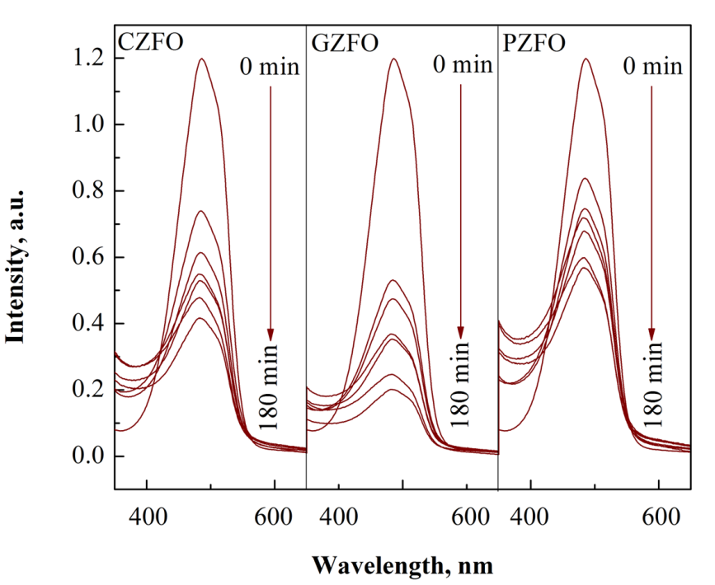
Fig. 4S. UV-Vis absorption spectra of MO solution after different reaction periods over different samples.
2. The concentration of basic MO solution used in this study was 10 mg L⁻¹. We are so sorry for this typing error and your confusion by this error. It has been revised in the resubmitted manuscript. And, the term ‘high-concentrated’ has been eliminated in the resubmitted manuscript.
Also, it would be desirable to compare the obtained results with degradation of MO on commercial Degussa P25.
Response:
This is a good idea. Undoubtedly, P25-TiO2 is a good criterion for the comparison of photocatalytic activity. However, in our present study, we focused on the effect of morphology on the photocatalytic performance of ZnFe2O4, so we think it is enough to compare the photocatalytic activity of ZnFe2O4 with different morphologies. Although P25-TiO2 is a good reference, it was not used in every published literature.
You can find a pdf file with small corrections enclosed.
Response:
Thank you so much for your detailed corrections. They have been revised in the resubmitted manuscript.

