Supplementary
Table Ⅰ CO₂ capacity of magnesite slag under different conditions ( 10% CO₂ )
Calcination temperature, ºC | Calcination time, h | Adsorption temperature, ºC | Flow rate, mL/min | Adsorption pressure, Mpa | CO₂ adsorption capacity, mmol/g
500 | 5 | 60 | 100 | 0.1 | 1.16
550 | 5 | 60 | 100 | 0.1 | 1.04
600 | 5 | 60 | 100 | 0.1 | 0.97
650 | 5 | 60 | 100 | 0.1 | 0.62
500 | 3 | 60 | 100 | 0.1 | 0.84
500 | 4 | 60 | 100 | 0.1 | 0.89
500 | 6 | 60 | 100 | 0.1 | 1.13
500 | 5 | 40 | 100 | 0.1 | 0.88
500 | 5 | 80 | 100 | 0.1 | 1.43
500 | 5 | 100 | 100 | 0.1 | 1.07
500 | 5 | 80 | 150 | 0.1 | 1.11
500 | 5 | 80 | 200 | 0.1 | 1.08
500 | 5 | 80 | 150 | 0.4 | 2.12
500 | 5 | 80 | 150 | 0.8 | 3.01

Table SⅠ Different MgO-based adsorbents performance
Adsorbents | Calcination tempterature, ºC | Calcination time, h | Regeneration temperature, ºC | Adsorption temperature, ºC | Adsorption  Capacity, mmol/g
MgO/Al₂O₃²⁷ | 600 | 5 | 120 | 25 | 0.73
MgO ( solvothermal) ²⁸ | 450 | 6.7 | - | - | -
MgO/OMC²⁹ | 900 | 6 | 200 | 25 | 2.04
MgO/ CMK-3³⁰ | 800 | 8.8 | 800 | 25 | 1.81
MgO(solvothermal) ³¹ | 550 | 22 | 160-840 | 90 | 0.36
Foam magnesia³² | 600 | 12 | 30-600 | 100 | 2.61
MgO/Al-SBA³³ | 450 | 7.8 | 100 | 25 | 1.36
MgO³⁴ | 400 | 8.6 | - | 50 | 0.81
MgO/k-SBA³⁵ | 540 | 17 | 300 | 20 | 0.91
MgO³⁶ | 400 | 5.3 | - | 50 | 1.59
MG-480-42-13.8³⁷ | 480 | 0.7 | - | 60 | 0.77
MgO/BM2.5h³⁸ | 323 | 0.5 | 850 | 25 | 1.61
MgO/Al₂O₃-0.2³⁹ | 400 | 1 | 450 | 60 | 2.1
Calcinated magnestie²² | 550 | 4 | 550 | 60 | 1.82
Calcinated magnesite slag (This work) | 500 | 5 | 550 | 80 | 3.01

Table SⅡ The XRF results of calcined magnesite slag at 500 ºC for 5 h
Element  Content/% | Mg | Si | Mn | Ca | Fe | Al
 | 32.18 | 11.09 | 3.18 | 1.51 | 1.19 | 3.82

Table Ⅱ Porous structure parameters achieved by N₂ adsorption-desorption isotherm
Sample | BET surface area, m²/g | Pore volume, cm³/g | Pore size, Å
calcined magnesite slag ( 500 ºC ) | 51.26 | 0.08 | 26.39
calcined magnesite slag ( 600 ºC ) | 28.03 | 0.04 | 27.30
After 4 cycles | 26.86 | 0.05 | 29.85
After 8 cycles | 29.43 | 0.04 | 27.42

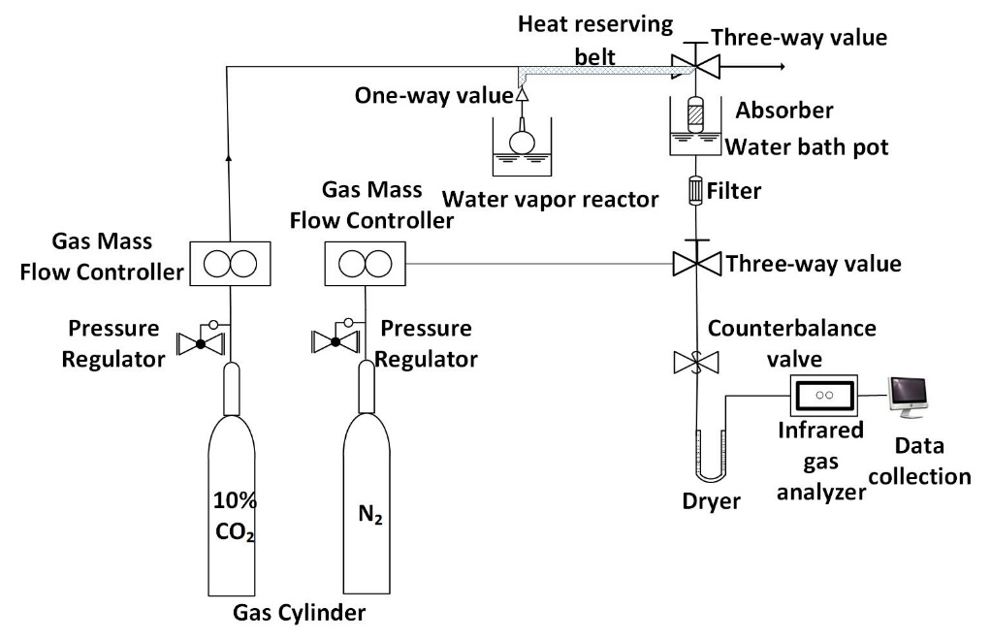
Figure 1 CO₂ adsorption experiment chart
Figure 2 TG-DSC curve of the magnesite slag

(a)
(b)
(c)
(d)
(e)
(f)
(g)
(h)
Figure S1 N₂ adsorption-desorption isotherms (a, c, e, g) and pore size distributions (b, d, f, h) of magnesite slag calcined at 500 ºC for 5 h, 600 ºC for 5 h, after 4 cycles and after 8 cycles (P / P₀: relative pressure; STP: standard temperature and pressure)

