Title :
Synthesized 1,3,5-triarylpyrazolines and 4-thiazolidinones bearing sulfonamide moiety as novel antimicrobial agents

Authors :
Thi-Dan Thach^{1,2}, T. Tuong-Vi Le², H. Thien-An Nguyen^{1,5}, Chi-Hien Dang^{1,5*}, Van-Su Dang³ and Thanh-Danh Nguyen^{4,5}*

¹Graduate University of Science and Technology, Vietnam Academy of Science and Technology, 18 Hoang Quoc Viet, Cau Giay, Hanoi, Vietnam.
²Tra Vinh University, Tra Vinh City, Tra Vinh Province, Vietnam.
³Department of Chemical Technology, Ho Chi Minh City University of Food Industry, Vietnam.
⁴Institute of Research and Development, Duy Tan University, Da Nang City, Vietnam.
⁵Institute of Chemical Technology, Vietnam Academy of Science and Technology, 1 Mac Dinh Chi Street, District 1, Ho Chi Minh City, Vietnam.

*Corresponding Authors: dangchihien@gmail.com (C. H. Dang); danh5463bd@yahoo.com (T. D. Nguyen)

^{Supplementary Data}

Contents
General procedure for synthesis of chalcones (1) 3
General procedure for synthesis of phenylhydrazones (3a-e) 5
Fig S1. ¹H NMR Spectrum of compound 2f 8
Fig S2. ¹³C NMR Spectrum of compound 2f 8
Fig S3. DEPT Spectra of compound 2f 9
Fig S4. MS Spectrum of compound 2f 9
Fig S5. ¹H Spectrum of compound 2h 10
Fig S6. ¹³C Spectrum of compound 2h 10
Fig S7. DEPT Spectra of compound 2h 11
Fig S8. MS spectrum of compound 2h 11
Fig S9. ¹H Spectrum of compound 4c 12
Fig S10. ¹³C Spectrum of compound 4c 12
Fig S11. DEPT Spectra of compound 4c 13
Fig S14. ¹³C Spectrum of compound 4d 14
Fig S15. DEPT Spectra of compound 4d 15

General procedure for synthesis of chalcones (1a-i)

To a stirred solution of acetophenones (0.215 mol) and aldehydes (0.215 mol) in methanol (60 mL) was slowly added 100 mL of aqueous sodium hydroxide solution (2.8 M) and mixed occasionally for 4h at room temperature, monitoring by TLC. After completion of the reaction, the mixture was cooled overnight at 0oC. The solid separated was filtered and washed water (10 mL) and cooled ethanol (10 mL). The solid was dried under the vacuum. It was purified by recrystallization in ethanol to afford the pure chalcones.
Benzalacetophenone (1a).
Yellow powder. Yield 80.8 %. ¹H NMR (500 MHz, acetone-d6, δ, ppm): 8.16-8.14 (m, 2H, -CH), 7.89 (d, 1H, J = 15.5, -CO-CH=CH), 7.86-7.83 (m, 2H, -CH), 7.81 (d, 1H, J = 15.5, -CO-CH=CH), 7.67-7.64 (m, 1H, -CH), 7.59-7.55 ( m, 2H, -CH), 7.49-7.45 ( m, 1H, CH).
(2E)-3-(2-hydroxyphenyl)-1-phenylprop-2-en-1-one (1b).
Orange powder. Yield 82.3 %. ¹H NMR (500 MHz, acetone-d6, δ, ppm): 8.23-8.19 (d, 1H, J 15.5 Hz, -CO-CH=CH), 8.17-8.14 (d,1H, J = 15.5, -CO-CH=CH), 8.09-8.06 (m, 2H, CH-), 7.57-7.54 (m, 1H, CH), 7.52-7.46 (m, 3H, -CH), 7.07-7.00 ( m, 2H, -CH), 6.48-6.45 ( m, 1H, CH).
(2E)-3-(4-methylphenyl)-1-phenylprop-2-en-1-one (1c).
Orange powder. Yield 81.0 %. ¹H NMR (500 MHz, CDCl₃, δ, ppm): 7.77 (d, 1H, J = 15.5, -CO-CH=CH), 8.01-7.97 (m, 2H, -CH), 7.86-7.57 (m, 2H, -CH), 7.52-7.50 (m, 1H, -CH), 7.48-7.44 ( m, 2H, -CH), 7.42 (d, 1H, J = 15.5, -CO-CH=CH), 7.16-7.12 ( m, 1H, CH), 2.34 (s, 3H, CH₃).
(2E)-3-(4-methoxyphenyl)-1-phenylprop-2-en-1-one (1d).
Orange powder. Yield 81.0 %. ¹H NMR (500 MHz, CDCl₃, δ, ppm): 8.00-7.98 (m, 2H, CH), 7.78 (d, 1H, J = 15.5, -CO-CH=CH), 7.88-7.55 (m, 2H, -CH), 7.54-7.52 (m, 1H, -CH), 7.48-7.45 ( m, 2H, -CH), 7.41 (d, 1H, J = 15.5, -CO-CH=CH), 6.92-6.89 ( m, 2H, -CH), 3.80 (s, 3H, OCH₃).
(2E)-1-(4-fluorophenyl)-3-(4-methylphenyl)prop-2-en-1-one (1e).
Pale yellow powder. Yield 76.0 %. ¹H NMR (500 MHz, CDCl₃, δ, ppm): 8.05-8.01 (m, 2H, CH), 7.79 (d, 1H, J =15.5, -CO-CH=CH), 7.53 (d, 2H, J = 8.0, -CH), 7.46 (d, 1H, J =15.5, -CO-CH=CH), 7.21-7.20 (m, 2H, -CH), 7.17-7.12 ( m, 2H, -CH), 2.37 (s, 3H, -CH₃).
(2E)-1-(4-fluorophenyl)-3-(4-methoxyphenyl)prop-2-en-1-one (1f).
Pale yellow powder. Yield 82.0 %. ¹H NMR (500 MHz, CDCl₃, δ, ppm): 8.03-8.00 (m, 2H, CH), 7.77 (d, 1H, J = 15.5, -CO-CH=CH), 7.57 (d, 2H, J = 8.5, -CH), 7.37 (d, 1H, J =15.5, -CO-CH=CH), 7.15-7.11 (m, 2H, -CH), 6.92-6.89 (m, 2H, -CH), 3.81 (s, 3H, OCH₃).
(2E)-1-(4-methoxyphenyl)-3-phenylprop-2-en-1-one (1g).
Pale yellow powder. Yield 78.0 %. ¹H NMR (500 MHz, DMSO-d6, δ, ppm): 8.15-8.13 (m, 2H, -CH), 7.84-7.82 (m, 2H, -CH), 7.80 (d, 1H, J = 15.5, -CO-CH=CH), 7.69 (d, 1H, J = 15.5, -CO-CH=CH), 7.08-7.06 (m, 2H, -CH), 7.02-7.00 ( m, 2H, -CH), 3.81 (s, 3H, OCH₃).
(2E)-1-(4-methoxyphenyl)-3-(4-methylphenyl)prop-2-en-1-one (1h).
Pale yellow powder. Yield 70.0 %. ¹H NMR (500 MHz, DMSO-d6, δ, ppm): 8.17-8.13 (m, 2H, -CH), 7.88 (d, 1H, J = 15.5, -CO-CH=CH), 7.77-7.75 (d, 2H, J = 8.0, -CH), 7.69 (d, 1H, J =15.5, -CO-CH=CH), 7.27 (d, 2H, J = 8.0, -CH), 7.09-7.06 ( m, 2H, -CH), 3.86 (s, 3H, OCH₃), 2.35 (s, 3H, -CH₃).
(2E)-1-(4-methoxyphenyl)-3-(4-methoxyphenyl)prop-2-en-1-one (1i).
Yellow powder. Yield 65.0 %. ¹H NMR (500 MHz, DMSO-d₆, δ, ppm): 8.15-8.13 (m, 2H, -CH), 7.84-7.82 (m, 2H, -CH), 7.80 (d, 1H, J = 15.5 Hz, -CO-CH=CH), 7.69 (d, 1H, J =15.5, -CO-CH=CH), 7.08-7.06 (m, 2H, -CH), 7.02-7.00 ( m, 2H, -CH), 3.86 (s, 3H, OCH₃), 3.81 (s, 3H, OCH₃).

General procedure for synthesis of phenylhydrazones (3a-e)

To a stirred solution of 4-hydrazinylbenzene sulfonamide hydrochloride (2.5 mmol) and benzaldehydes (2.5 mmol) in methanol (30 mL) was added one drop of acetic acid. The mixture was refluxed under stirring at for 4 h with a Dean-Stark equipment. The solvent was evaporated under vacuum and the residue was recrystallized in appropriate solvents to afford pure phenylhydrazones.
4-(2-Benzylidenehydrazinyl)benzene sulfonamide (3a).
Recrystallization in EtOAc. Pale yellow powder, m.p. 174-175 ºC. Yield 63.0 %. ¹H NMR (500 MHz, DMSO-d₆, δ, ppm): 10.77 (s, 1H, =N-NH-), 7.95 (s, 1H, -CH=N-), 7.70 (t, 4H, J = 9.0 Hz, -CH), 7.43 (t, 2H, J = 7.5 Hz, -CH), 7.35 ( t, 1H, J = 7.5 Hz, -CH), 7.16 ( d, 2H, J = 8.5 Hz, -CH), 7.06 (s, 2H, -SO₂NH₂).
4-(2-(4-Methylbenzylidene)hydrazinyl)benzene sulfonamide (3b).
Recrystallization in EtOH. Yellow powder, m.p. 213-214 ºC. Yield 67.0 %. ¹H NMR (500 MHz, DMSO-d₆, δ, ppm): 10.68 (s, 1H, =N-NH-), 7.91 (s, 1H, -CH=N-), 7.66 (d, 2H, J = 9.0, -CH), 7.59 (d, 2H, J = 8.0 Hz, -CH), 7.23 ( d, 2H, J = 8.0, -CH), 7.14 ( d, 2H, J = 9.0, CH), 7.04 ( s, 2H, -SO₂NH₂), 2.33 (s, 3H, CH₃).
4-(2-(4-Methoxybenzylidene)hydrazinyl)benzene sulfonamide (3c).
Recrystallization in EtOH. Yellow needle, m.p. 225-226 ºC. Yield 74.0 %. ¹H NMR (500 MHz, DMSO-d₆, δ, ppm): 10.59 (s, 1H, =N-NH-), 7.90 (s, 1H, -CH=N-), 7.65 (t, 4H, J = 8.5, -CH), 7.12 (d, 2H, J = 9.0, -CH), 7.03 (s, 2H, J = 8.0, SO₂NH₂), 6.99 (d, 2H, J = 9.0, CH), 3.79 (s, 3H, OCH₃).
4-(2-(2-Hydroxybenzylidene)hydrazinyl)benzene sulfonamide (3d).
Recrystallization in i-propanol. Yellow needle, m.p. 254-255 ºC. Yield 71.0 %. ¹H NMR (500 MHz, DMSO-d₆, δ, ppm): 10.78 (s, 1H, OH), 10.23 (s, 1H, =N-NH-), 8.24 (s, 1H, -CH=N-), 7.68-7.64 (m, 3H, -CH), 7.21-7.17 (m, 1H, -CH), 7.07-7.05 ( m, 4H, -CH and SO₂NH₂), 6.90-6.86 ( m, 2H, CH).
4-(2-(4-Chlorobenzylidene)hydrazinyl)benzene sulfonamide (3e).
Recrystallization in dichloromethane. Pale yellow needle, m.p. 210-211 ºC. Yield 66.0 %. ¹H NMR (500 MHz, DMSO-d₆, δ, ppm): 10.85 (s, 1H, =N-NH-), 7.93 (s, 1H, -CH=N-), 7.72 (d, 2H, J = 8.5, -CH), 7.67 (d, 2H, J = 8.5, -CH), 7.47 ( d, 2H, J = 9.0, -CH), 7.16 ( d, 2H, J = 8.5, -CH) 7.07 ( m, 2H, CH).

Fig S1. ¹H NMR Spectrum of compound 2f

Fig S2. ¹³C NMR Spectrum of compound 2f

Fig S3. DEPT Spectra of compound 2f

Fig S4. MS Spectrum of compound 2f

Fig S5. ¹H Spectrum of compound 2h

Fig S6. ¹³C Spectrum of compound 2h

Fig S7. DEPT Spectra of compound 2h

Fig S8. MS spectrum of compound 2h

Fig S9. ¹H Spectrum of compound 4c

Fig S10. ¹³C Spectrum of compound 4c

Fig S11. DEPT Spectra of compound 4c

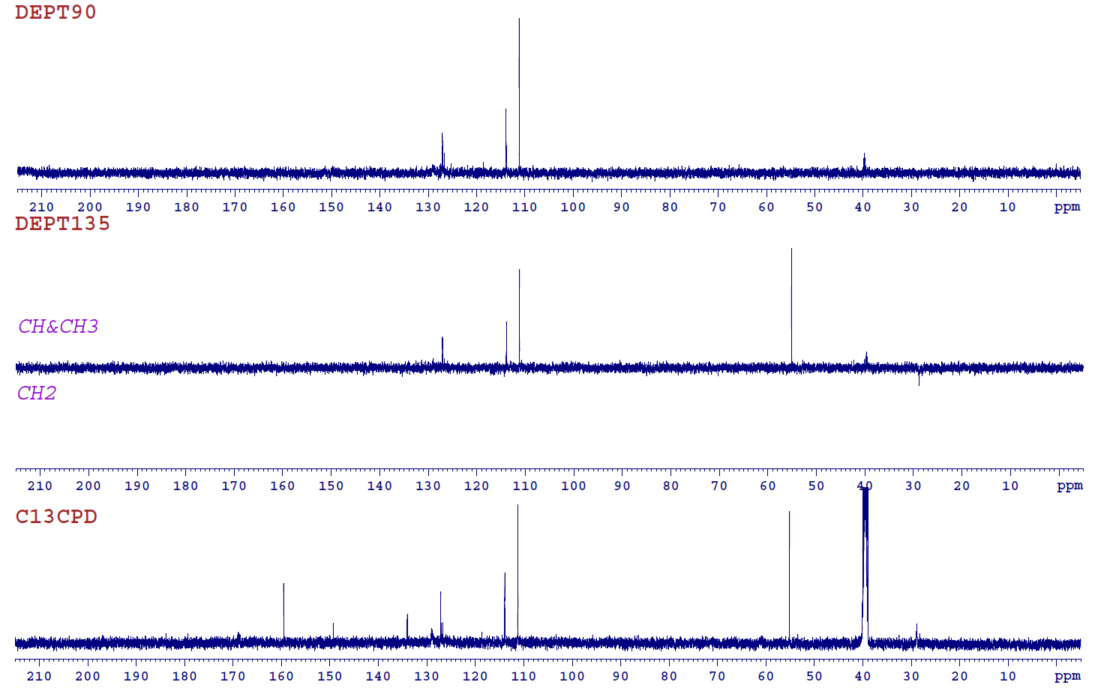

Fig S12. MS spectrum of compound 4c

Fig S13. ¹H Spectrum of compound 4d

Fig S14. ¹³C Spectrum of compound 4d

Fig S15. DEPT Spectra of compound 4d

Fig S16. MS spectrum of compound 4d

