Title :
Synthesis of sulfonamides bearing 1,3,5-triarylpyrazoline and 4-thiazolidinone moieties as novel antimicrobial agents

Authors :
Thi-Dan Thach^{1,2}, T. Tuong-Vi Le², H. Thien-An Nguyen^{1,5}, Chi-Hien Dang^{1,5*}, Van-Su Dang³ and Thanh-Danh Nguyen^{4,5}*

¹Graduate University of Science and Technology, Vietnam Academy of Science and Technology, 18 Hoang Quoc Viet, Cau Giay, Hanoi, Vietnam.
²Tra Vinh University, Tra Vinh City, Tra Vinh Province, Vietnam.
³Department of Chemical Technology, Ho Chi Minh City University of Food Industry, Vietnam.
⁴Institute of Research and Development, Duy Tan University, Da Nang City, Vietnam.
⁵Institute of Chemical Technology, Vietnam Academy of Science and Technology, 1 Mac Dinh Chi Street, District 1, Ho Chi Minh City, Vietnam.

*Corresponding Authors: dangchihien@gmail.com (C. H. Dang); danh5463bd@yahoo.com (T. D. Nguyen)

^{Supplementary Data}
Contents
General procedure for synthesis of chalcones (1a-i) 4
General procedure for synthesis of phenylhydrazones (3a-e) 6
Fig S1. ¹H NMR Spectrum of compound 2a (Acetone-d₆) 9
Fig S2. ¹³C NMR Spectrum of compound 2a (Acetone-d₆) 9
Fig S3. MS Spectrum of compound 2a 10
Fig S4. ¹H NMR Spectrum of compound 2b (Acetone-d₆) 10
Fig S5. ¹³C NMR Spectrum of compound 2b (Acetone-d₆) 11
Fig S6. MS Spectrum of compound 2b 11
Fig S7. ¹H NMR Spectrum of compound 2c (CDCl₃) 12
Fig S8. ¹³C NMR Spectrum of compound 2c (CDCl₃) 12
Fig S9. MS Spectrum of compound 2c 13
Fig S10. ¹H NMR Spectrum of compound 2d (CDCl₃) 13
Fig S11. ¹³C NMR Spectrum of compound 2d (CDCl₃) 14
Fig S12. MS Spectrum of compound 2d 14
Fig S13. ¹H NMR Spectrum of compound 2e (CDCl₃) 15
Fig S14. ¹³C NMR Spectrum of compound 2e (CDCl₃) 15
Fig S15. MS Spectrum of compound 2e 16
Fig S16. ¹H NMR Spectrum of compound 2f (CDCl₃) 16
Fig S17. ¹³C NMR Spectrum of compound 2f (CDCl₃) 17
Fig S18. DEPT Spectra of compound 2f (CDCl₃) 17
Fig S19. MS Spectrum of compound 2f 18
Fig S20. ¹H NMR Spectrum of compound 2g (DMSO) 18
Fig S21. ¹³C NMR Spectrum of compound 2g (DMSO) 19
Fig S22. MS Spectrum of compound 2g 19
Fig S23. ¹H Spectrum of compound 2h (DMSO) 20
Fig S24. ¹³C Spectrum of compound 2h (DMSO) 20
Fig S24. DEPT Spectra of compound 2h (DMSO) 21
Fig S25. MS spectrum of compound 2h 21
Fig S26. ¹H Spectrum of compound 2i (DMSO) 22
Fig S27. ¹³C Spectrum of compound 2i (DMSO) 22
Fig S28. MS spectrum of compound 2i 23
Fig S29. ¹H Spectrum of compound 4a (DMSO) 23
Fig S30. ¹³C Spectrum of compound 4a (DMSO) 24
Fig S31. HR-MS spectrum of compound 4a 24
Fig S32. ¹H Spectrum of compound 4b (DMSO) 25
Fig S33. ¹³C Spectrum of compound 4b (DMSO) 25
Fig S34. MS spectrum of compound 4b 26
Fig S35. ¹H Spectrum of compound 4c (DMSO) 26
Fig S36. ¹³C Spectrum of compound 4c (DMSO) 27
Fig S37. DEPT Spectra of compound 4c (DMSO) 27
Fig S38. MS spectrum of compound 4c 28
Fig S39. ¹H Spectrum of compound 4d (DMSO) 28
Fig S40. ¹³C Spectrum of compound 4d (DMSO) 29
Fig S41. DEPT Spectra of compound 4d (DMSO) 29
Fig S42. MS spectrum of compound 4d 30
Fig S43. ¹H Spectrum of compound 4e (DMSO) 30
Fig S44. ¹³C Spectrum of compound 4e (DMSO) 30
Fig S45. MS spectrum of compound 4e (DMSO) 31

General procedure for synthesis of chalcones (1a-i)

To a stirred solution of acetophenones (0.215 mol) and aldehydes (0.215 mol) in methanol (60 mL) was slowly added 100 mL of aqueous sodium hydroxide solution (2.8 M) and mixed occasionally for 4h at room temperature, monitoring by TLC. After completion of the reaction, the mixture was cooled overnight at 0oC. The solid separated was filtered and washed water (10 mL) and cooled ethanol (10 mL). The solid was dried under the vacuum. It was purified by recrystallization in ethanol to afford the pure chalcones.
Benzalacetophenone (1a).
Yellow powder. Yield 80.8 %. ¹H NMR (500 MHz, acetone-d6, δ, ppm): 8.16-8.14 (m, 2H, -CH), 7.89 (d, 1H, J = 15.5, -CO-CH=CH), 7.86-7.83 (m, 2H, -CH), 7.81 (d, 1H, J = 15.5, -CO-CH=CH), 7.67-7.64 (m, 1H, -CH), 7.59-7.55 ( m, 2H, -CH), 7.49-7.45 ( m, 1H, CH).
(2E)-3-(2-hydroxyphenyl)-1-phenylprop-2-en-1-one (1b).
Orange powder. Yield 82.3 %. ¹H NMR (500 MHz, acetone-d6, δ, ppm): 8.23-8.19 (d, 1H, J 15.5 Hz, -CO-CH=CH), 8.17-8.14 (d,1H, J = 15.5, -CO-CH=CH), 8.09-8.06 (m, 2H, CH-), 7.57-7.54 (m, 1H, CH), 7.52-7.46 (m, 3H, -CH), 7.07-7.00 ( m, 2H, -CH), 6.48-6.45 ( m, 1H, CH).
(2E)-3-(4-methylphenyl)-1-phenylprop-2-en-1-one (1c).
Orange powder. Yield 81.0 %. ¹H NMR (500 MHz, CDCl₃, δ, ppm): 7.77 (d, 1H, J = 15.5, -CO-CH=CH), 8.01-7.97 (m, 2H, -CH), 7.86-7.57 (m, 2H, -CH), 7.52-7.50 (m, 1H, -CH), 7.48-7.44 ( m, 2H, -CH), 7.42 (d, 1H, J = 15.5, -CO-CH=CH), 7.16-7.12 ( m, 1H, CH), 2.34 (s, 3H, CH₃).
(2E)-3-(4-methoxyphenyl)-1-phenylprop-2-en-1-one (1d).
Orange powder. Yield 81.0 %. ¹H NMR (500 MHz, CDCl₃, δ, ppm): 8.00-7.98 (m, 2H, CH), 7.78 (d, 1H, J = 15.5, -CO-CH=CH), 7.88-7.55 (m, 2H, -CH), 7.54-7.52 (m, 1H, -CH), 7.48-7.45 ( m, 2H, -CH), 7.41 (d, 1H, J = 15.5, -CO-CH=CH), 6.92-6.89 ( m, 2H, -CH), 3.80 (s, 3H, OCH₃).
(2E)-1-(4-fluorophenyl)-3-(4-methylphenyl)prop-2-en-1-one (1e).
Pale yellow powder. Yield 76.0 %. ¹H NMR (500 MHz, CDCl₃, δ, ppm): 8.05-8.01 (m, 2H, CH), 7.79 (d, 1H, J =15.5, -CO-CH=CH), 7.53 (d, 2H, J = 8.0, -CH), 7.46 (d, 1H, J =15.5, -CO-CH=CH), 7.21-7.20 (m, 2H, -CH), 7.17-7.12 ( m, 2H, -CH), 2.37 (s, 3H, -CH₃).
(2E)-1-(4-fluorophenyl)-3-(4-methoxyphenyl)prop-2-en-1-one (1f).
Pale yellow powder. Yield 82.0 %. ¹H NMR (500 MHz, CDCl₃, δ, ppm): 8.03-8.00 (m, 2H, CH), 7.77 (d, 1H, J = 15.5, -CO-CH=CH), 7.57 (d, 2H, J = 8.5, -CH), 7.37 (d, 1H, J =15.5, -CO-CH=CH), 7.15-7.11 (m, 2H, -CH), 6.92-6.89 (m, 2H, -CH), 3.81 (s, 3H, OCH₃).
(2E)-1-(4-methoxyphenyl)-3-phenylprop-2-en-1-one (1g).
Pale yellow powder. Yield 78.0 %. ¹H NMR (500 MHz, DMSO-d6, δ, ppm): 8.15-8.13 (m, 2H, -CH), 7.84-7.82 (m, 2H, -CH), 7.80 (d, 1H, J = 15.5, -CO-CH=CH), 7.69 (d, 1H, J = 15.5, -CO-CH=CH), 7.08-7.06 (m, 2H, -CH), 7.02-7.00 ( m, 2H, -CH), 3.81 (s, 3H, OCH₃).
(2E)-1-(4-methoxyphenyl)-3-(4-methylphenyl)prop-2-en-1-one (1h).
Pale yellow powder. Yield 70.0 %. ¹H NMR (500 MHz, DMSO-d6, δ, ppm): 8.17-8.13 (m, 2H, -CH), 7.88 (d, 1H, J = 15.5, -CO-CH=CH), 7.77-7.75 (d, 2H, J = 8.0, -CH), 7.69 (d, 1H, J =15.5, -CO-CH=CH), 7.27 (d, 2H, J = 8.0, -CH), 7.09-7.06 ( m, 2H, -CH), 3.86 (s, 3H, OCH₃), 2.35 (s, 3H, -CH₃).
(2E)-1-(4-methoxyphenyl)-3-(4-methoxyphenyl)prop-2-en-1-one (1i).
Yellow powder. Yield 65.0 %. ¹H NMR (500 MHz, DMSO-d₆, δ, ppm): 8.15-8.13 (m, 2H, -CH), 7.84-7.82 (m, 2H, -CH), 7.80 (d, 1H, J = 15.5 Hz, -CO-CH=CH), 7.69 (d, 1H, J =15.5, -CO-CH=CH), 7.08-7.06 (m, 2H, -CH), 7.02-7.00 ( m, 2H, -CH), 3.86 (s, 3H, OCH₃), 3.81 (s, 3H, OCH₃).

General procedure for synthesis of phenylhydrazones (3a-e)

To a stirred solution of 4-hydrazinylbenzene sulfonamide hydrochloride (2.5 mmol) and benzaldehydes (2.5 mmol) in methanol (30 mL) was added one drop of acetic acid. The mixture was refluxed under stirring at for 4 h with a Dean-Stark equipment. The solvent was evaporated under vacuum and the residue was recrystallized in appropriate solvents to afford pure phenylhydrazones.
4-(2-Benzylidenehydrazinyl)benzene sulfonamide (3a).
Recrystallization in EtOAc. Pale yellow powder, m.p. 174-175 ºC. Yield 63.0 %. ¹H NMR (500 MHz, DMSO-d₆, δ, ppm): 10.77 (s, 1H, =N-NH-), 7.95 (s, 1H, -CH=N-), 7.70 (t, 4H, J = 9.0 Hz, -CH), 7.43 (t, 2H, J = 7.5 Hz, -CH), 7.35 ( t, 1H, J = 7.5 Hz, -CH), 7.16 ( d, 2H, J = 8.5 Hz, -CH), 7.06 (s, 2H, -SO₂NH₂).
4-(2-(4-Methylbenzylidene)hydrazinyl)benzene sulfonamide (3b).
Recrystallization in EtOH. Yellow powder, m.p. 213-214 ºC. Yield 67.0 %. ¹H NMR (500 MHz, DMSO-d₆, δ, ppm): 10.68 (s, 1H, =N-NH-), 7.91 (s, 1H, -CH=N-), 7.66 (d, 2H, J = 9.0, -CH), 7.59 (d, 2H, J = 8.0 Hz, -CH), 7.23 ( d, 2H, J = 8.0, -CH), 7.14 ( d, 2H, J = 9.0, CH), 7.04 ( s, 2H, -SO₂NH₂), 2.33 (s, 3H, CH₃).
4-(2-(4-Methoxybenzylidene)hydrazinyl)benzene sulfonamide (3c).
Recrystallization in EtOH. Yellow needle, m.p. 225-226 ºC. Yield 74.0 %. ¹H NMR (500 MHz, DMSO-d₆, δ, ppm): 10.59 (s, 1H, =N-NH-), 7.90 (s, 1H, -CH=N-), 7.65 (t, 4H, J = 8.5, -CH), 7.12 (d, 2H, J = 9.0, -CH), 7.03 (s, 2H, J = 8.0, SO₂NH₂), 6.99 (d, 2H, J = 9.0, CH), 3.79 (s, 3H, OCH₃).
4-(2-(2-Hydroxybenzylidene)hydrazinyl)benzene sulfonamide (3d).
Recrystallization in i-propanol. Yellow needle, m.p. 254-255 ºC. Yield 71.0 %. ¹H NMR (500 MHz, DMSO-d₆, δ, ppm): 10.78 (s, 1H, OH), 10.23 (s, 1H, =N-NH-), 8.24 (s, 1H, -CH=N-), 7.68-7.64 (m, 3H, -CH), 7.21-7.17 (m, 1H, -CH), 7.07-7.05 ( m, 4H, -CH and SO₂NH₂), 6.90-6.86 ( m, 2H, CH).
4-(2-(4-Chlorobenzylidene)hydrazinyl)benzene sulfonamide (3e).
Recrystallization in dichloromethane. Pale yellow needle, m.p. 210-211 ºC. Yield 66.0 %. ¹H NMR (500 MHz, DMSO-d₆, δ, ppm): 10.85 (s, 1H, =N-NH-), 7.93 (s, 1H, -CH=N-), 7.72 (d, 2H, J = 8.5, -CH), 7.67 (d, 2H, J = 8.5, -CH), 7.47 ( d, 2H, J = 9.0, -CH), 7.16 ( d, 2H, J = 8.5, -CH) 7.07 ( m, 2H, CH).

Fig S1. ¹H NMR Spectrum of compound 2a (Acetone-d₆)

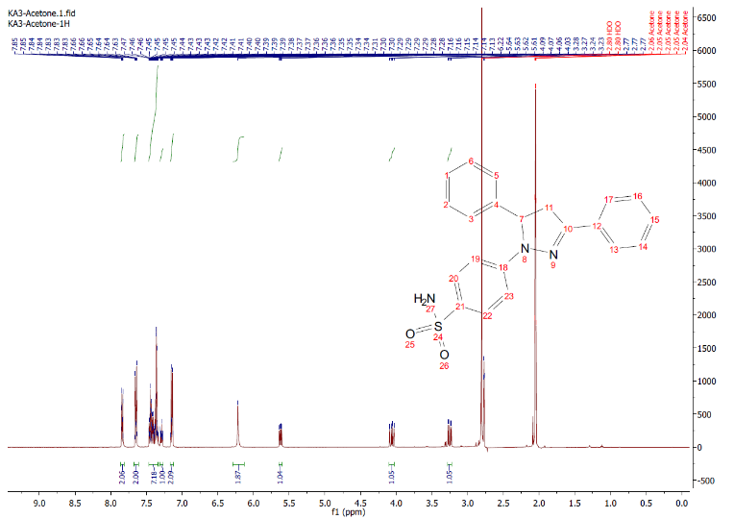

Fig S2. ¹³C NMR Spectrum of compound 2a (Acetone-d₆)

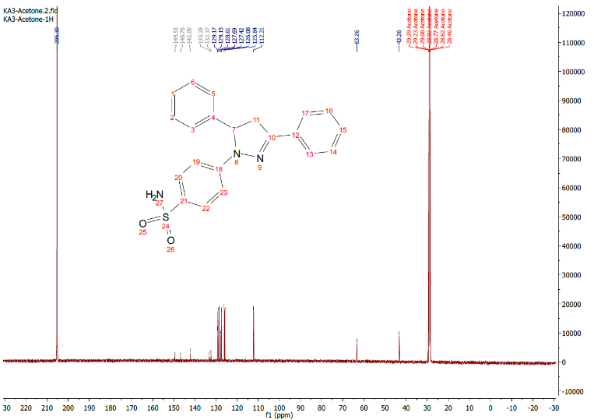

Fig S3. HR-MS Spectrum of compound 2a

Fig S4. ¹H NMR Spectrum of compound 2b (Acetone-d₆)
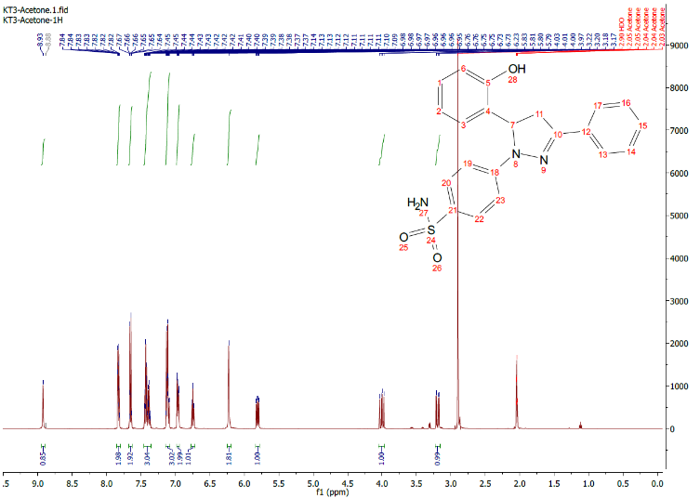

Fig S5. ¹³C NMR Spectrum of compound 2b (Acetone-d₆)

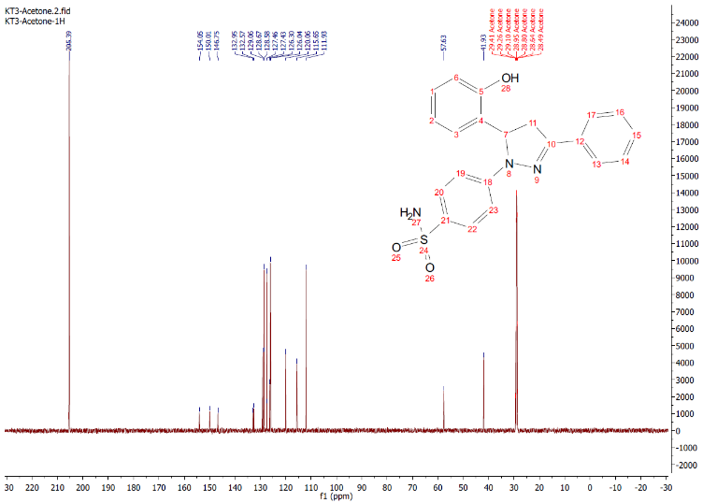

Fig S6. HR-MS Spectrum of compound 2b

Fig S7. ¹H NMR Spectrum of compound 2c (CDCl₃)

Fig S8. ¹³C NMR Spectrum of compound 2c (CDCl₃)

Fig S9. HR-MS Spectrum of compound 2c

Fig S10. ¹H NMR Spectrum of compound 2d (CDCl₃)

Fig S11. ¹³C NMR Spectrum of compound 2d (CDCl₃)

Fig S12. HR-MS Spectrum of compound 2d

Fig S13. ¹H NMR Spectrum of compound 2e (CDCl₃)

Fig S14. ¹³C NMR Spectrum of compound 2e (CDCl₃)

Fig S15. HR-MS Spectrum of compound 2e

Fig S16. ¹H NMR Spectrum of compound 2f (CDCl₃)

Fig S17. ¹³C NMR Spectrum of compound 2f (CDCl₃)

Fig S18. DEPT Spectra of compound 2f (CDCl₃)

Fig S19. HR-MS Spectrum of compound 2f

Fig S20. ¹H NMR Spectrum of compound 2g (DMSO)

Fig S21. ¹³C NMR Spectrum of compound 2g (DMSO)

Fig S22. HR-MS Spectrum of compound 2g

Fig S23. ¹H Spectrum of compound 2h (DMSO)

Fig S24. ¹³C Spectrum of compound 2h (DMSO)

Fig S24. DEPT Spectra of compound 2h (DMSO)

Fig S25. HR-MS spectrum of compound 2h

Fig S26. ¹H Spectrum of compound 2i (DMSO)

Fig S27. ¹³C Spectrum of compound 2i (DMSO)

Fig S28. HR-MS spectrum of compound 2i

Fig S29. ¹H Spectrum of compound 4a (DMSO)

Fig S30. ¹³C Spectrum of compound 4a (DMSO)

Fig S31. HR-MS spectrum of compound 4a

Fig S32. ¹H Spectrum of compound 4b (DMSO)

Fig S33. ¹³C Spectrum of compound 4b (DMSO)

Fig S34. HR-MS spectrum of compound 4b

Fig S35. ¹H Spectrum of compound 4c (DMSO)

Fig S36. ¹³C Spectrum of compound 4c (DMSO)

Fig S37. DEPT Spectra of compound 4c (DMSO)

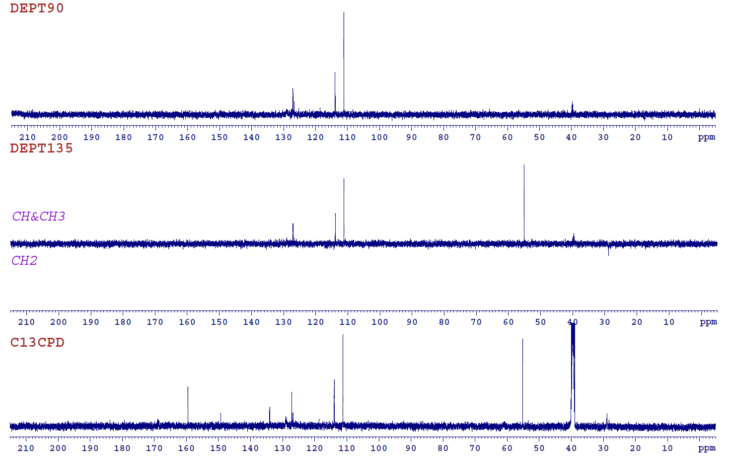

Fig S38. HR-MS spectrum of compound 4c

Fig S39. ¹H Spectrum of compound 4d (DMSO)

Fig S40. ¹³C Spectrum of compound 4d (DMSO)

Fig S41. DEPT Spectra of compound 4d (DMSO)

Fig S42. HR-MS spectrum of compound 4d

Fig S43. ¹H Spectrum of compound 4e (DMSO)

Fig S44. ¹³C Spectrum of compound 4e (DMSO)

Fig S45. HR-MS spectrum of compound 4e (DMSO)

