Supplementary File

THEORETICAL DETERMINATION OF THE ELECTRODE POTENTIAL OF CYANIDIN

1. Experimental
The cyclic voltammogram was recorded on a Voltalab 80 PGZ 402 apparatus, equipped with VoltaMaster 4 software (version 7.0). The following operating conditions have been chosen:
- working electrode: glassy carbon electrode;
- reference electrode: Ag/AgCl/satd. KCl
- supporting electrolyte: MeOH 0.1M NaClO₄ (pH=2.35)
- scan rate: 500 mV/s

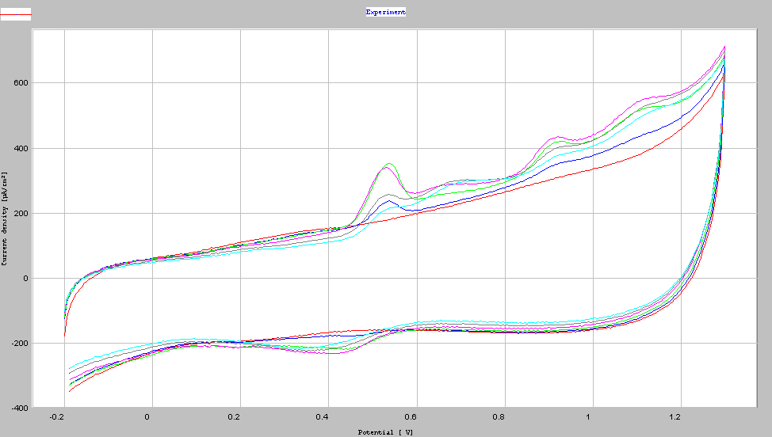
Figure 1. Cyclic voltammogram obtained for the methanolic solution of cyanidin

2. Computational part
The intermediate values that have been used for the calculation of ΔG_{T} (see Eqs. (1)-(4) in Methodology) are given below:

Table 1s. Values of Gibbs free energies (including thermal corrections and ZPEs (Zero Point Energies)
Compound | Gas-phase energies / a.u. |  | Solvent energies / a.u.
Cy_red 1 |  | -1023.118992 | -1023.196070
Cy_red 2 |  | -1023.119832 | -1023.195989
Cy_red 3 |  | -1023.110404 | -1023.189853
Cy_red 4 |  | -1023.109500 | -1023.189476
Cy_red 5 |  | -1023.111252 | -1023.191810
Cy_red 6 |  | -1023.112248 | -1023.191946
Cy_ox 1 |  | -1021.952232 | -1022.045650
Cy_ox 2 |  | -1021.953428 | -1022.046253
Cy_ox 3 |  | -1021.943508 | -1022.037914
Cy_ox 4 |  | -1021.953429 | -1022. 046253
Cy_ox 5 |  | -1021.952232 | -1022. 045650
Cy_ox 6 |  | -1021.953428 | -1022. 046253
1,2-benzoquinone (Q) |  | -379.149551 | -379.162770
1,2-dihydroxybenzene  (QH₂) |  | -380.290650 | -380.300895
*1 a.u. = 627.5 kcal mol⁻¹; solvent = methanol

Table 2s. Solvation energies (ΔG_{sol})
Compound | ΔG_{sol} / kcal mol⁻¹
Cy_red 1 |  | -48.37
Cy_red 2 |  | -47.79
Cy_red 3 |  | -49.85
Cy_red 4 |  | -50.18
Cy_red 5 |  | -50.55
Cy_red 6 |  | -50.10
Cy_ox 1 |  | -58.62
Cy_ox 2 |  | -58.25
Cy_ox 3 |  | -59.24
Cy_ox 4 |  | -58.25
Cy_ox 5 |  | -58.62
Cy_ox 6 |  | -58.25
1,2-benzoquinone (Q) |  | -8.30
1,2-dihydroxybenzene  (QH₂) |  | -6.43

