SUPPORTING INFORMATION TO

Glutamic acid as a green and bio-based α-amino acid catalyst promoted one-pot access to polyfunctionalized dihydro-2-oxypyrroles via imin-based four condensation domino reaction of amines, dialkyl acetylenedicarboxylaes and formaldehyde at room temperature

FARZANEH MOHAMADPOUR ^{a,*}
ª Young Researchers and Elite Club, Shiraz Branch, Islamic Azad University, Shiraz, Iran
* Corresponding author. mohamadpour.f.7@gmail.com

Methyl4-(4-ethylphenylamino)-1-(4-ethylphenyl)-2,5-dihydro-5-oxo-1H-pyrrole-3-carboxylate (5f) (Table II, entry 6)
Yield: 86%; M.p. 125-127 °C; ¹H NMR (400 MHz, CDCl₃): 1.26 (6H, t, J=2.4 Hz, 2CH₂CH₃), 2.67 (4H, q, J=7.2 Hz, 2CH₂CH₃), 3.76 (3H, s, 2OCH₃), 4.53 (2H, s, CH₂-N),7.09 (2H, d, J=8.4 Hz, ArH), 7.17 (2H, d, J=8.4 Hz, ArH), 7.24 (2H, d, J=8.8 Hz, ArH),7.70 (2H, d, J=8.8 Hz, ArH), 8.05( 1H, s, NH) ppm.

Ethyl4-(4-ethylphenylamino)-1-(4-ethylphenyl)-2,5-dihydro-5-oxo-1H-pyrrole-3-carboxylate (5g) (Table II, entry 7)
Yield: 87%; M.p. 102-104 °C; ¹H NMR (400 MHz, CDCl₃): 1.24 (9H, m, 3 CH₂CH₃), 2.67 (4H, q, J=7.2 Hz, 2CH₂CH₃), 4.22 (2H, q, J=7.2 Hz, CH₂CH₃), 4.54 (2H, s, CH₂-N), 7.09 (2H, d, J=8.4 Hz, ArH), 7.16 (2H, d, J=8.4 Hz, ArH), 7.24 (2H, d, J=8.4 Hz, ArH), 7.71 (2H, d, J=8.8 Hz, ArH), 8.01 (1H, s, NH) ppm.

Ethyl 1-(4-bromophenyl)-3-(butylamino)-2,5-dihydro-2-oxo-1H-pyrrole-4-carboxylate (5k) (Table II, entry 11)

Yield: 85%; M.p. 96-98 °C; ¹H NMR (400 MHz, CDCl₃): 0.97 (3H, t, J = 7.2 Hz, CH₃), 1.35 (3H, t, J = 7.2 Hz, OCH₂CH₃), 1.43 (2H, sextet, J = 7.6 Hz, CH₂), 1.61 (2H, quintet, J = 7.6 Hz, CH₂), 3.87 (2H, t, J = 7.2 Hz, CH₂-NH), 4.28 (2H, q, J = 7.2 Hz, OCH₂CH₃), 4.40 (2H, s, CH₂-N), 6.72 (1H, br s, NH), 7.52 (2H, d, J = 8.8 Hz, ArH), 7.70 (2H, d, J = 8.8 Hz, ArH).

Methyl4-(4-fluoroyphenylamino)-1-(4-fluorophenyl)-2,5-dihydro-5-oxo-1H-pyrrole-3-carboxylate (5l) (Table II, entry 12)
Yield: 94%; M.p. 161-163 °C; ¹H NMR (400 MHz, CDCl₃): 3.79 (3H, s, OCH₃), 4.52 (2H, s, CH₂-N), 7.04 (2H, t, J=8.4 Hz, ArH), 7.08-7.16 (4H, m, ArH), 7.73-7.76 (2H, m, ArH), 8.05 (1H, s, NH).

Methyl4-(4-methoxyphenylamino)-1-(4-methoxyphenyl)-2,5-dihydro-5-oxo-1H-pyrrole-3-carboxylate (5o) (Table II, entry 15)

Yield: 87%; M.p. 171-173 °C; ¹H NMR (400 MHz, CDCl₃): 3.77 (3H, s, CH₃), 3.83 (6H, s, 2OCH₃), 4.50 (2H, s, CH₂-N), 6.89 (4H, d, J=17.6 Hz, ArH), 7.13 (1H, s, ArH) ,7.68 (1H, s, ArH), 8.03 (1H, s, NH).

Ethyl4-(4-methoxyphenylamino)-1-(4-methoxyphenyl)-2,5-dihydro-5-oxo-1H-pyrrole-3-carboxylate (5p) (Table II, entry 16)
Yield: 86%; M.p. 153-155 °C; ¹H NMR (400 MHz, CDCl₃): 1.26 (3H, t, J=7.2Hz, CH₂CH₃), 3.83 (6H, s, 2OCH₃), 4.23 (2H, q, J=7.2 Hz, CH₂CH₃), 4.50 (2H, s, CH₂-N), 6.87 (2H, d, J=8.8 Hz, ArH), 6.93 (2H, d, J=8.8 Hz, ArH), 7.12 (2H, d, J=8.8 Hz, ArH), 7.69 (2H, d, J=8.8 Hz, ArH), 8.02 (1H, s, NH).

Methyl4-(4-methylphenylamino)-1-(4-methylphenyl)-2,5-dihydro-5-oxo-1H-pyrrole-3-carboxylate (5r) (Table II, entry 18)
Yield: 90%; M.p. 175-176 °C; ¹H NMR (400 MHz, CDCl₃): 2.36 (6H, s, 2CH₃), 3.77 (3H, s, OCH₃), 4.52( 2H, s, CH₂-N), 7.06 (2H, d, J=8.4 Hz, ArH), 7.14 (2H, d, J=8.4 Hz, ArH), 7.21(2H, d, J=8.4 Hz, ArH), 7.68 (2H, d, J=8.8 Hz, ArH), 8.03 (1H, s, NH).

Ethyl4-(4-methylphenylamino)-1-(4-methylphenyl)-2,5-dihydro-5-oxo-1H-pyrrole-3-carboxylate (5s) (Table II, entry 19)
Yield: 88%; M.p. 131-133 °C; ¹H NMR (400 MHz, CDCl₃): 1.25 (3H, t, J=7.2 Hz, CH₂CH₃), 2.37 (6H, s, 2CH₃), 4.23 (2H, q, J=7.2 Hz, 2CH₂CH₃), 4.53 (2H, s, CH₂-N),7.06 (2H, d, J=8.4 Hz, ArH), 7.14 (2H, d, J=8.4 Hz, ArH), 7.21 (2H, d, J=8.4 Hz, ArH), 7.68 (2H, d, J=8.4 Hz, ArH), 8.01 (1H, s, NH).

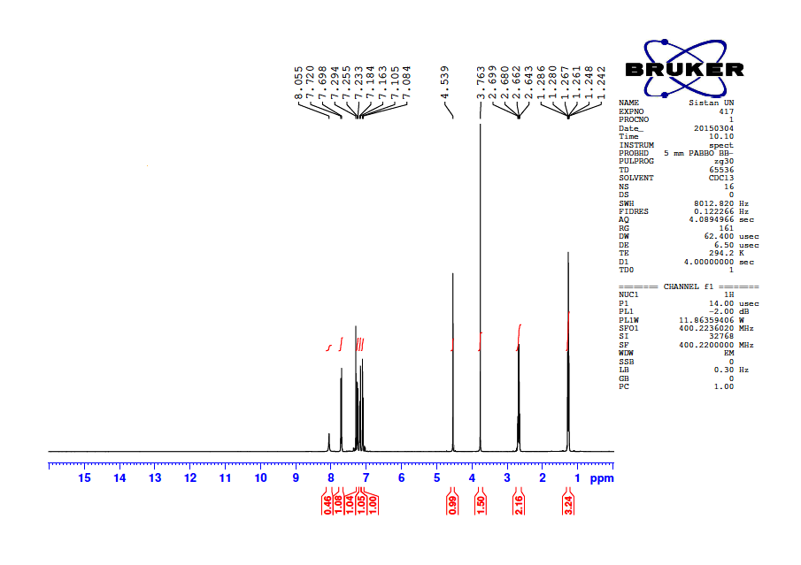
Fig. S-1.¹H NMR Spectrum of compound (400 MHz, CDCl₃) of 5f

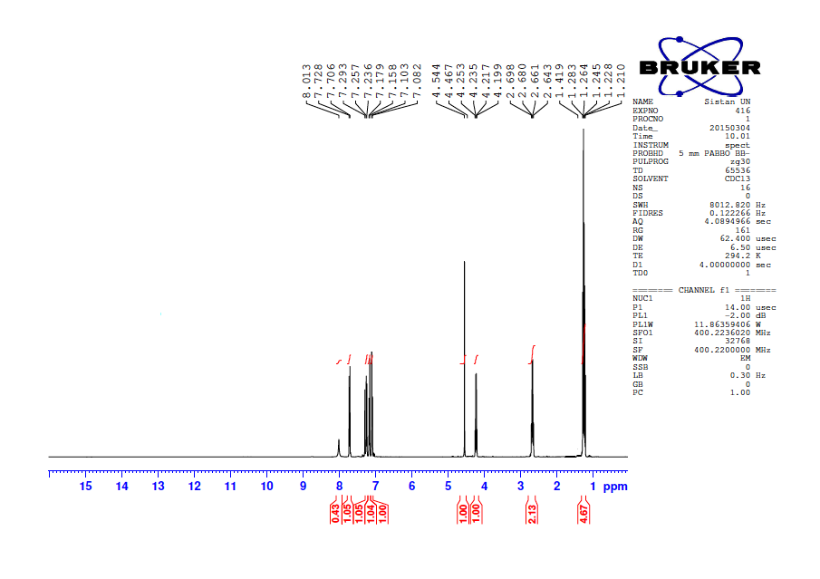
Fig. S-2.¹H NMR Spectrum of compound (400 MHz, CDCl₃) of 5g

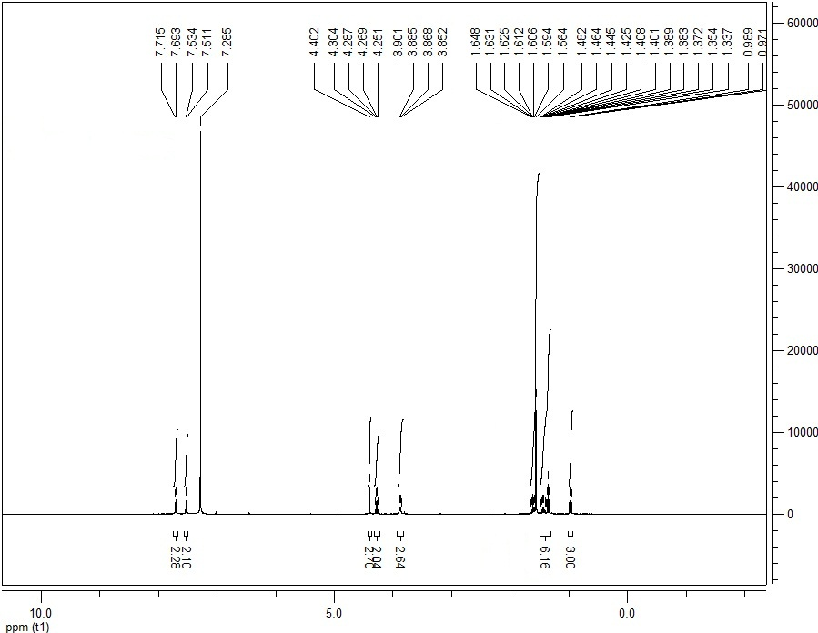

Fig. S-3.¹H NMR Spectrum of compound (400 MHz, CDCl₃) of 5k

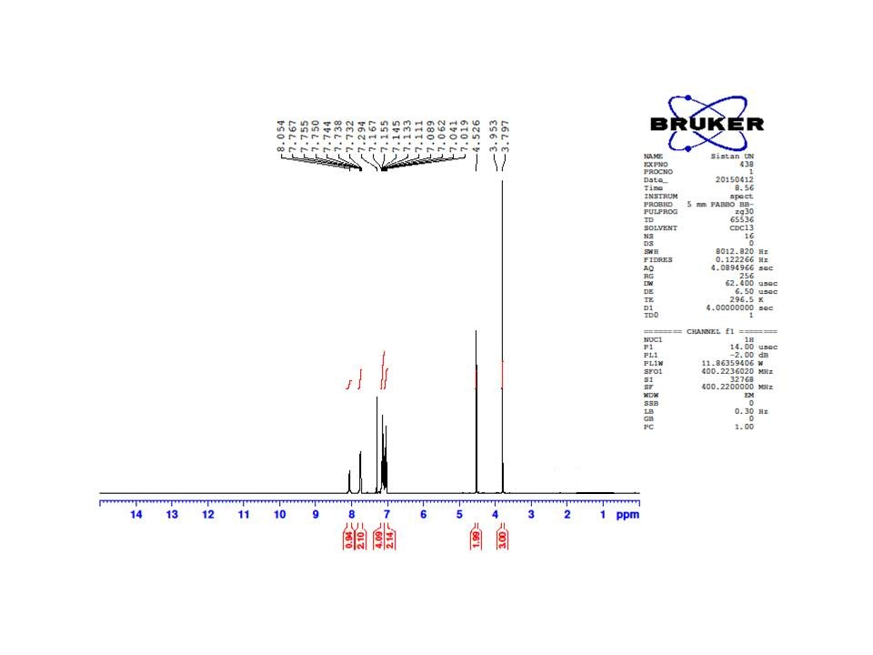
Fig. S-4.¹H NMR Spectrum of compound (400 MHz, CDCl₃) of 5l

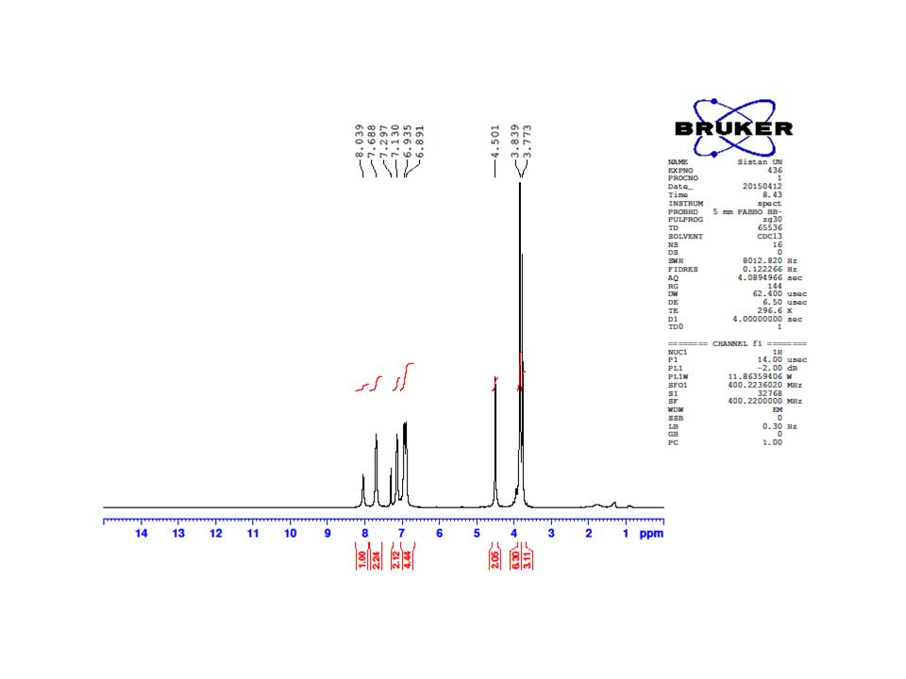
Fig. S-5.¹H NMR Spectrum of compound (400 MHz, CDCl₃) of 5o

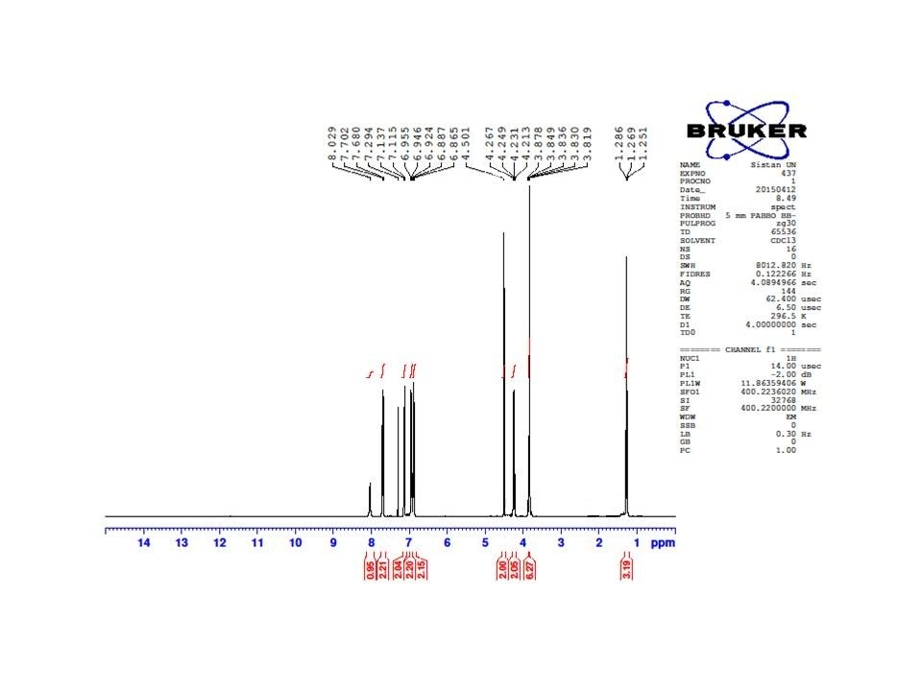
Fig. S-6.¹H NMR Spectrum of compound (400 MHz, CDCl₃) of 5p

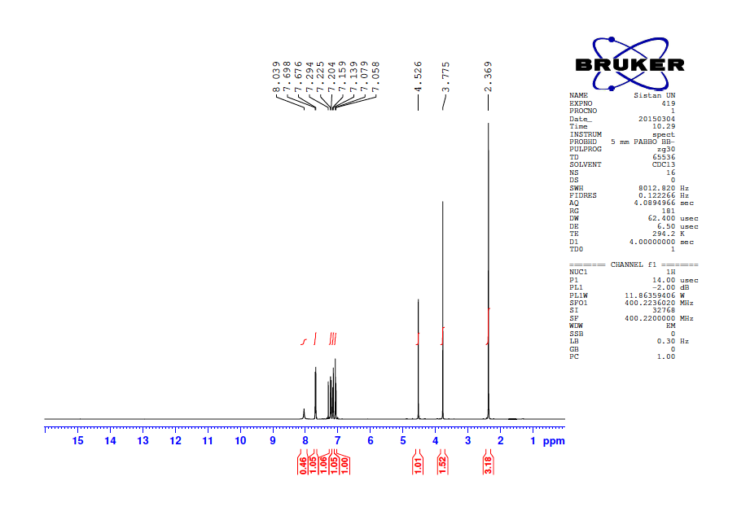
Fig. S-7.¹H NMR Spectrum of compound (400 MHz, CDCl₃) of 5r

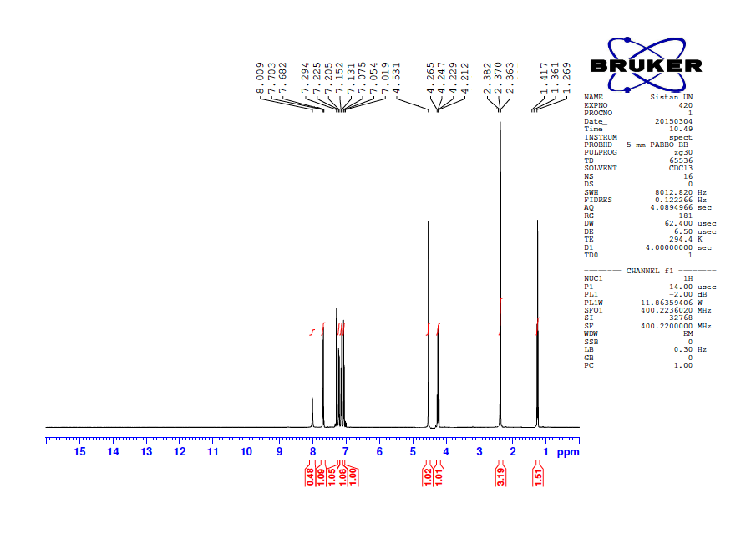
Fig. S-8.¹H NMR Spectrum of compound (400 MHz, CDCl₃) of 5s

