SUPLAMENTARY MATERIAL TO

**Chemical and Photoinduced Nuclease Activity of A Novel Minor Groove DNA Binder CuII Complex**

UFUK YILDIZ1[1]* and BURAK ÇOBAN1

*Department of Chemistry, Faculty of Arts and Sciences, Bulent Ecevit University, Zonguldak 67100, Turkey*

**Fig. S1.** GC-MS spectrum for dtb.

**Fig. S2.** 1H-NMR spectrum for dtb.

**Fig. S3.** 13C-NMR spectrum for dtb.

**Fig. S4.** FT-IR spectrum for dtb.

**Fig. S5.** ESI-MS spectrum for [Cu(dtb)(phen)]2+.

**Fig. S6.** FT-IR spectrum for [Cu(dtb)(phen)]2+.

D:\Post-doc\nuclease\Fig.S1.tif

Fig. S1. GC-MS spectrum for dtb.

D:\Post-doc\nuclease\Fig.S2.tif

Fig. S2. 1H-NMR spectrum for dtb.

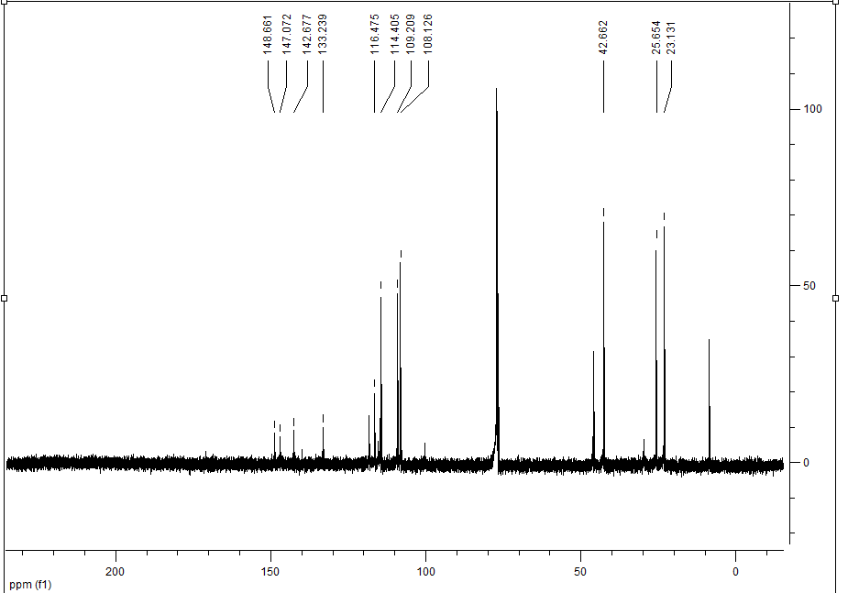

Fig. S3. 13C-NMR spectrum for dtb.



Fig. S4. FT-IR spectrum for dtb.

D:\Post-doc\nuclease\Fig.s4.tif

Fig. S5. ESI-MS spectrum for [Cu(dtb)(phen)]2+

.



Fig. S6. FT-IR spectrum for [Cu(dtb)(phen)]2+.

1. *Corresponding author. E-mail: ufyildiz@gmail.com