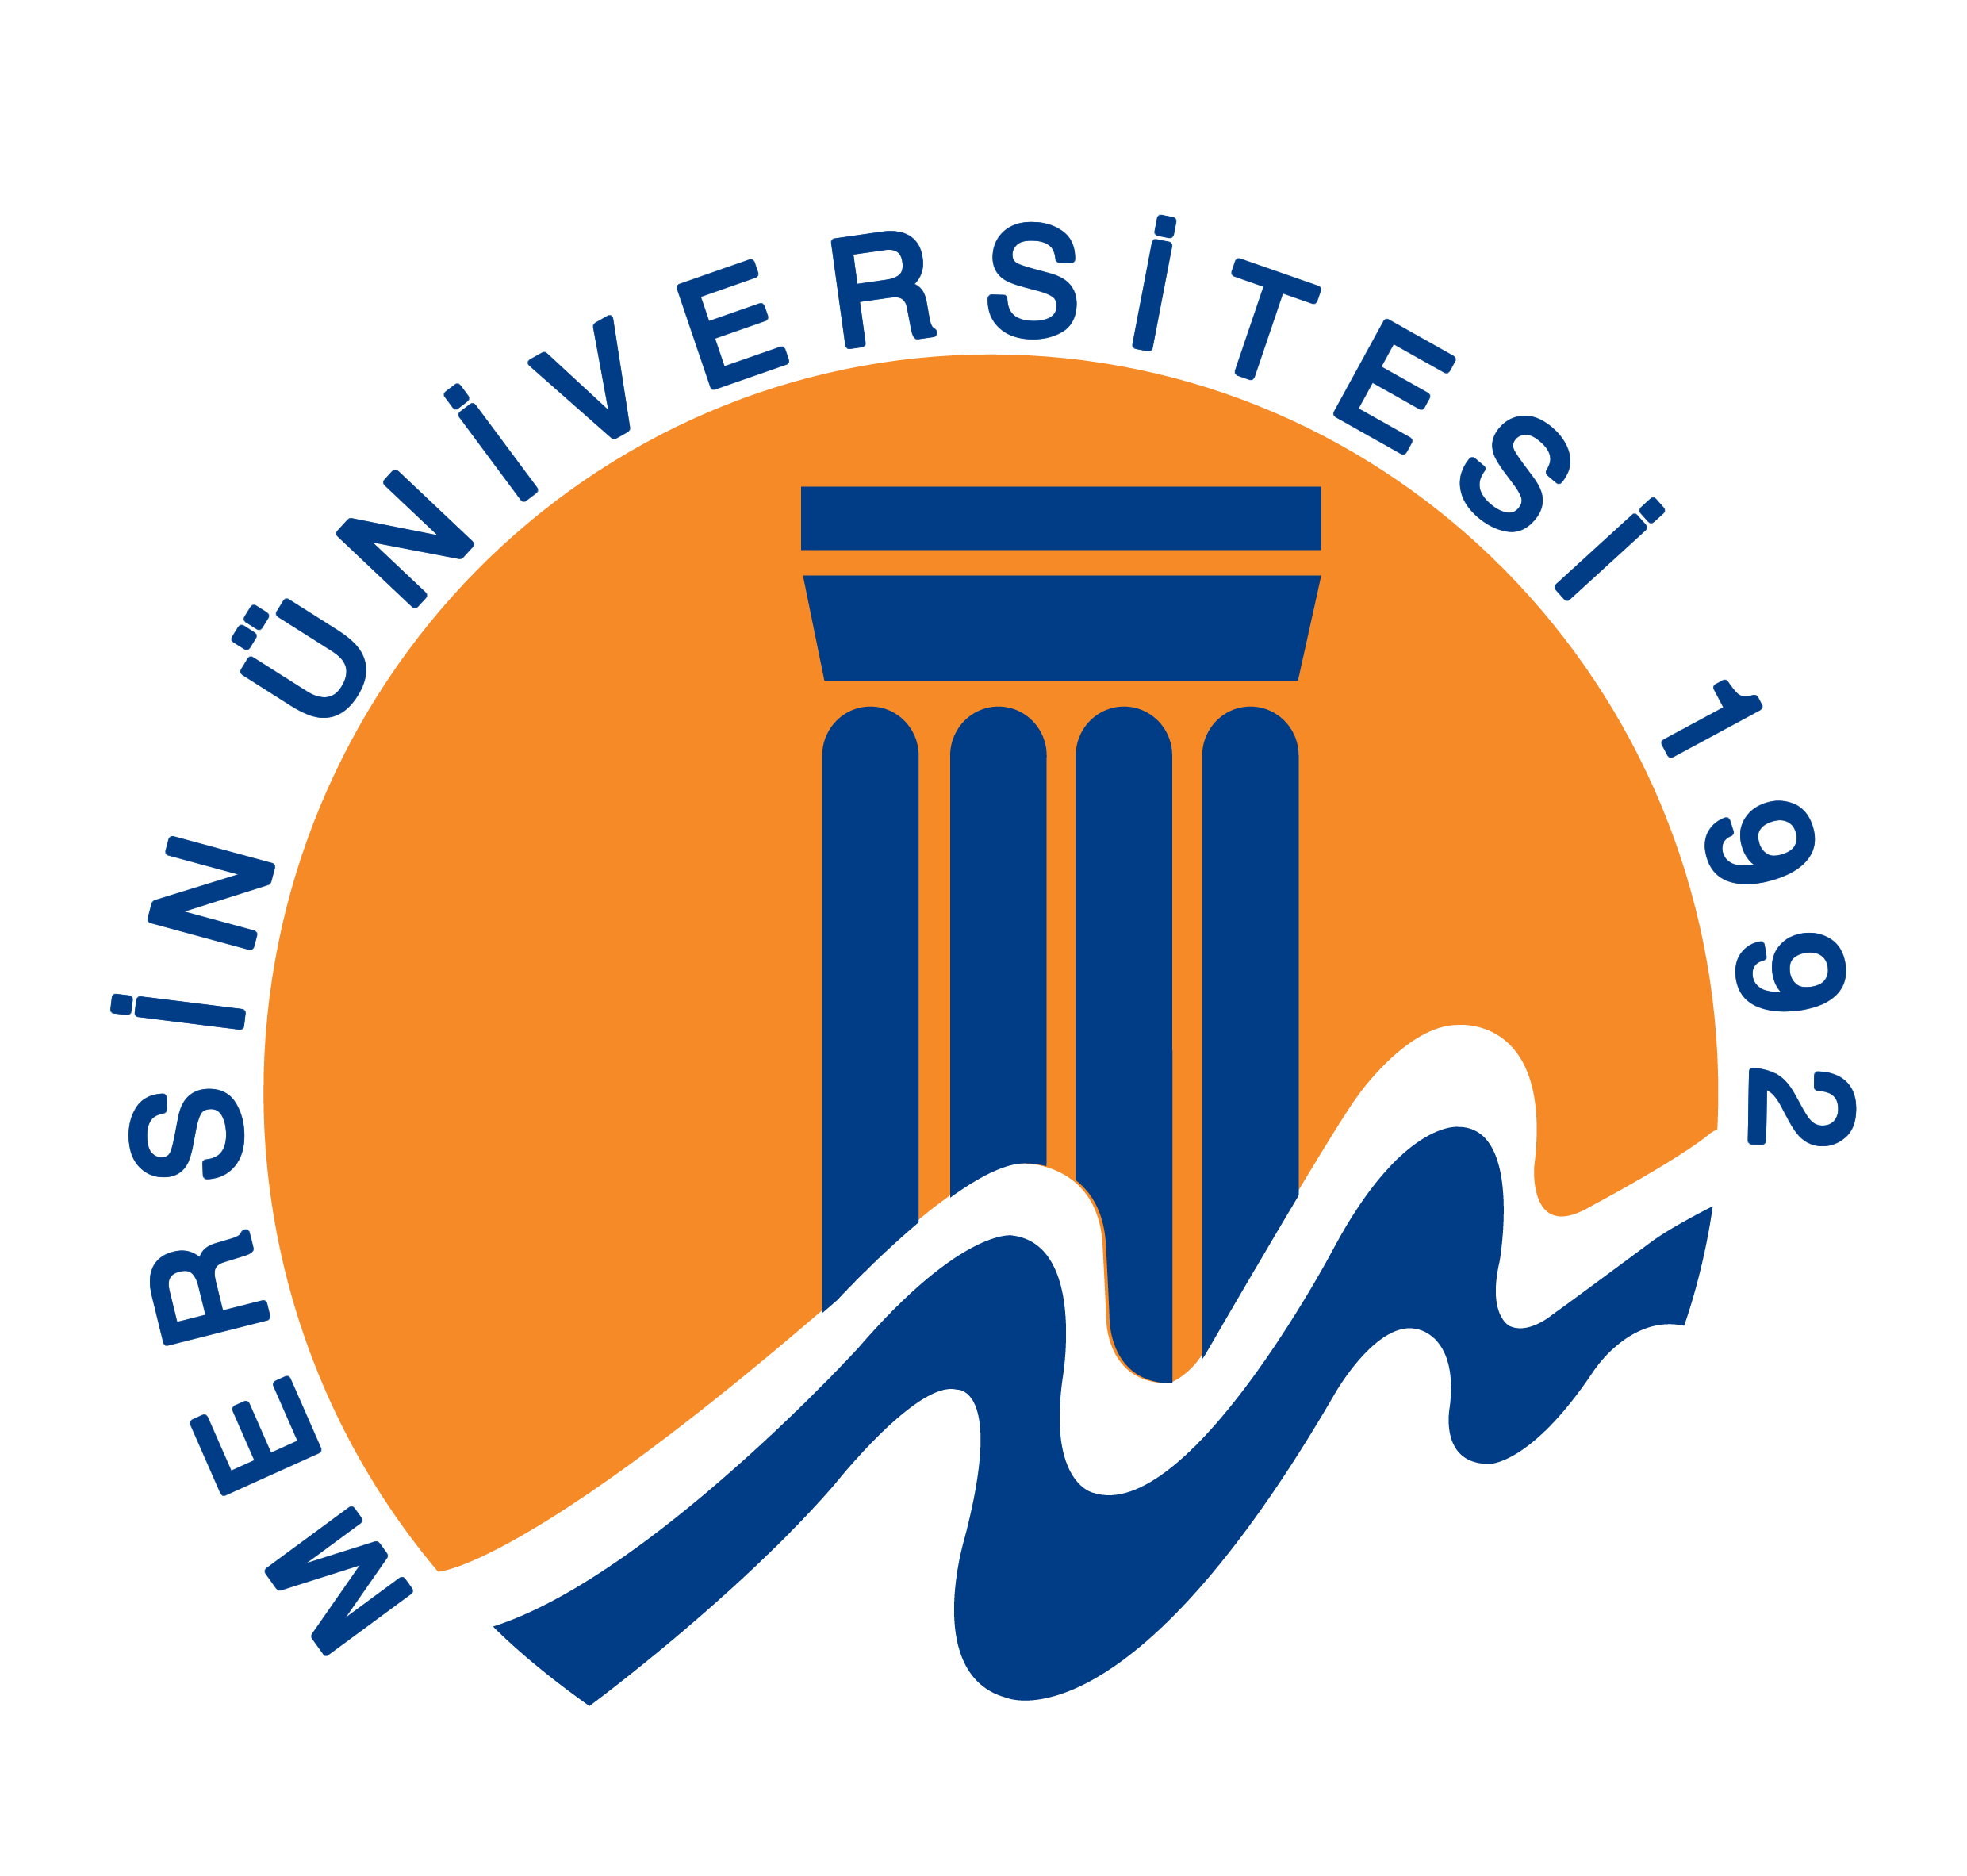 MERSIN UNIVERSITY
[Dept. of Chem.·Fac. of Art & Scien.·Mersin·TURKEY-Tel:+90-324-3610001/4827·Fax:+90-324-3610047·e-mail: yabalakerdal@gmail.com]

08/12/2018

Dear Dr. Bojan Radak
Vinča Institute of Nuclear Sciences, Belgrade

I would like to contribute to Journal of the Serbian Chemical Society with our revised research paper dealing with “Application of the eco-friendly subcritical water oxidation method in the degradation of epichlorohydrin”. This manuscript has not been published already, nor under consideration for publication or in press elsewhere.

This is an original and scientifically favourable work that should benefit the readers. Water sources that contaminated with epichlorohydrin can be effectively cleaned and potential risks can be eliminated by performing this work. Significant TOC removal rates were obtained for epichlorohydrin through synergistic effect of subcritical water medium, and H₂O₂. Also, applied method is environmentally friendly. Response surface methodology was utilized in this work and obtained results were statistically evaluated in a wide range. So, this manuscript should be published in a such qualified journal.

Would you please take our manuscript into consideration to be examined for publication in the journal?
I am looking forward to hearing from you soon.

Yours faithfully
Corresponding Author:
Dr. Erdal YABALAK
Mersin University, Faculty of Arts and Science, Department of Chemistry, 33343-Mersin, TURKEY
Tel : +90-544-546 31 72
Fax : +90-324-361 00 47
E-mail : yabalakerdal@gmail.com ; erdalyabalak@mersin.edu.tr

A list of suggested reviewers was given below.

Assoc. Prof. Dr. Mustafa Kemal Sangün
Department of Chemistry, Faculty of Arts and Science, Mustafa Kemal University, Antakya Hatay - 31024, Turkey
e-mail: ksangun@gmail.com

Assoc. Prof. Dr. İbrahim TEĞİN
Department of Chemistry, Faculty of Arts and Science, Siirt University
e-mail: ibrahim.tegin@gmail.com

Prof. Dr. Adnan ÖZCAN
Department of Chemistry, Faculty of Science, Anadolu University,
Eskişehir, 26470, Turkey
e-mail: aozcan@anadolu.edu.tr

Prof. Dr. Yu Yang
Department of chemistry, East Carolina University
e-mail: yangy@ecu.edu

Dr. Mustafa Zafer Özel
Department of Chemistry,
The University of York, UK
Email: mustafa.ozel@york.ac.uk

