Supplementary Information (SI)
SPECTROSCOPIC (FTIR, UV-VIS AND NMR), THEORETICAL INVESTIGATION AND MOLECULAR DOCKING OF SOME SUBSTITUTED 1,8-DIOXODECAHYDROACRIDINE DERIVATIVES
KRISHNA KANT YADAV¹, ABHISHEK KUMAR¹, SANCHARI BEGAM², KHONDEKAR NURJAMAL², AMARENDRA KUMAR^{1*}, GOUTAM BRAHMACHARI² AND NEERAJ MISRA¹
¹Department of Physics, University of Lucknow, Lucknow-226007
²Laboratory of Natural Products & Organic Synthesis, Department of Chemistry, Visva-Bharati
(a Central University), Santiniketan-731 235, West Bengal, India

Keywords: 1, 8-dioxodecahydroacridine derivatives; FT-IR; UV-Vis; NMR; Global Reactivity Descriptors; Molecular docking

RUNNING TITLE: SPECTROSCOPIC AND THEORETICAL INVESTIGATION OF SUBSTITUTED 1,8-DIOXODECAHYDROACRIDINE DERIVATIVES

----------------------------------
*Corresponding Author
Email: akgkp25@yahoo.co.in

Fig.S1: Experimental NMR plot of MTDOSA
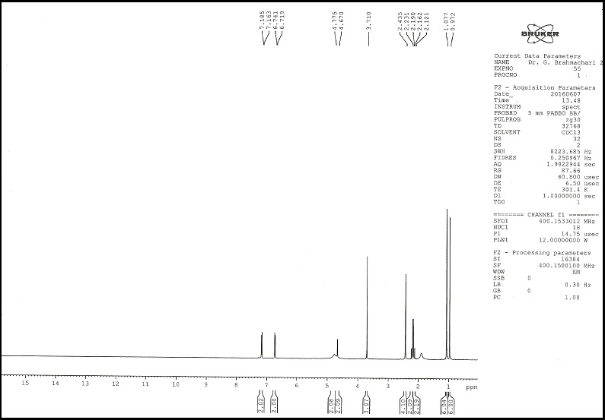

Fig.S1(a)
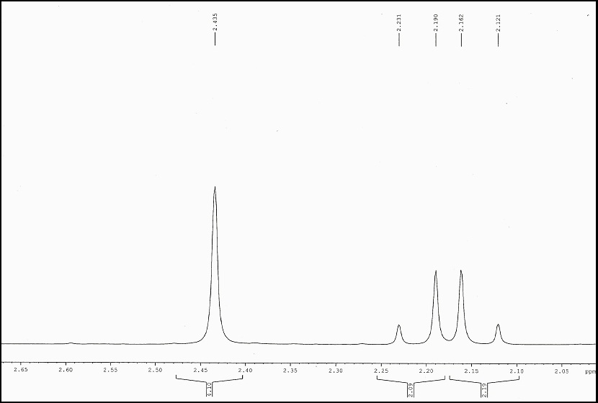

Fig. S1(b) (extended scale-I)

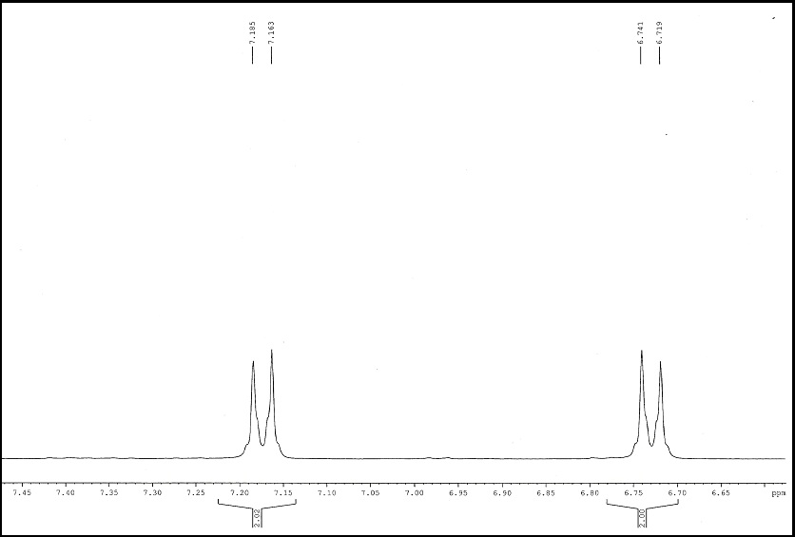
Fig. S1(c) (extended scale-II)

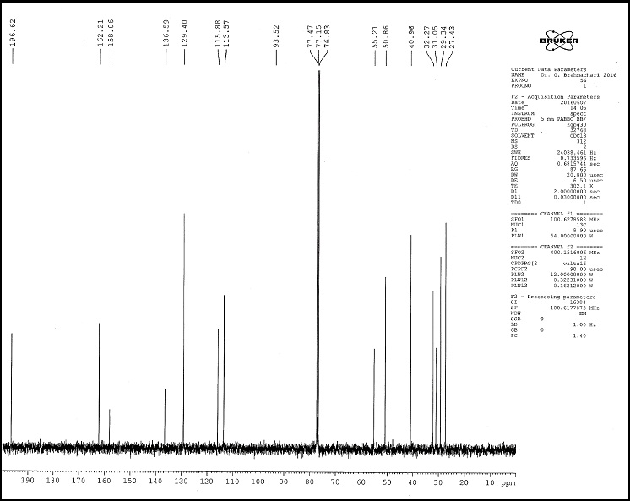
Fig. S1 (d) ¹³C NMR MTDOSA

Fig.S2: Experimental NMR plot of NTDOSA
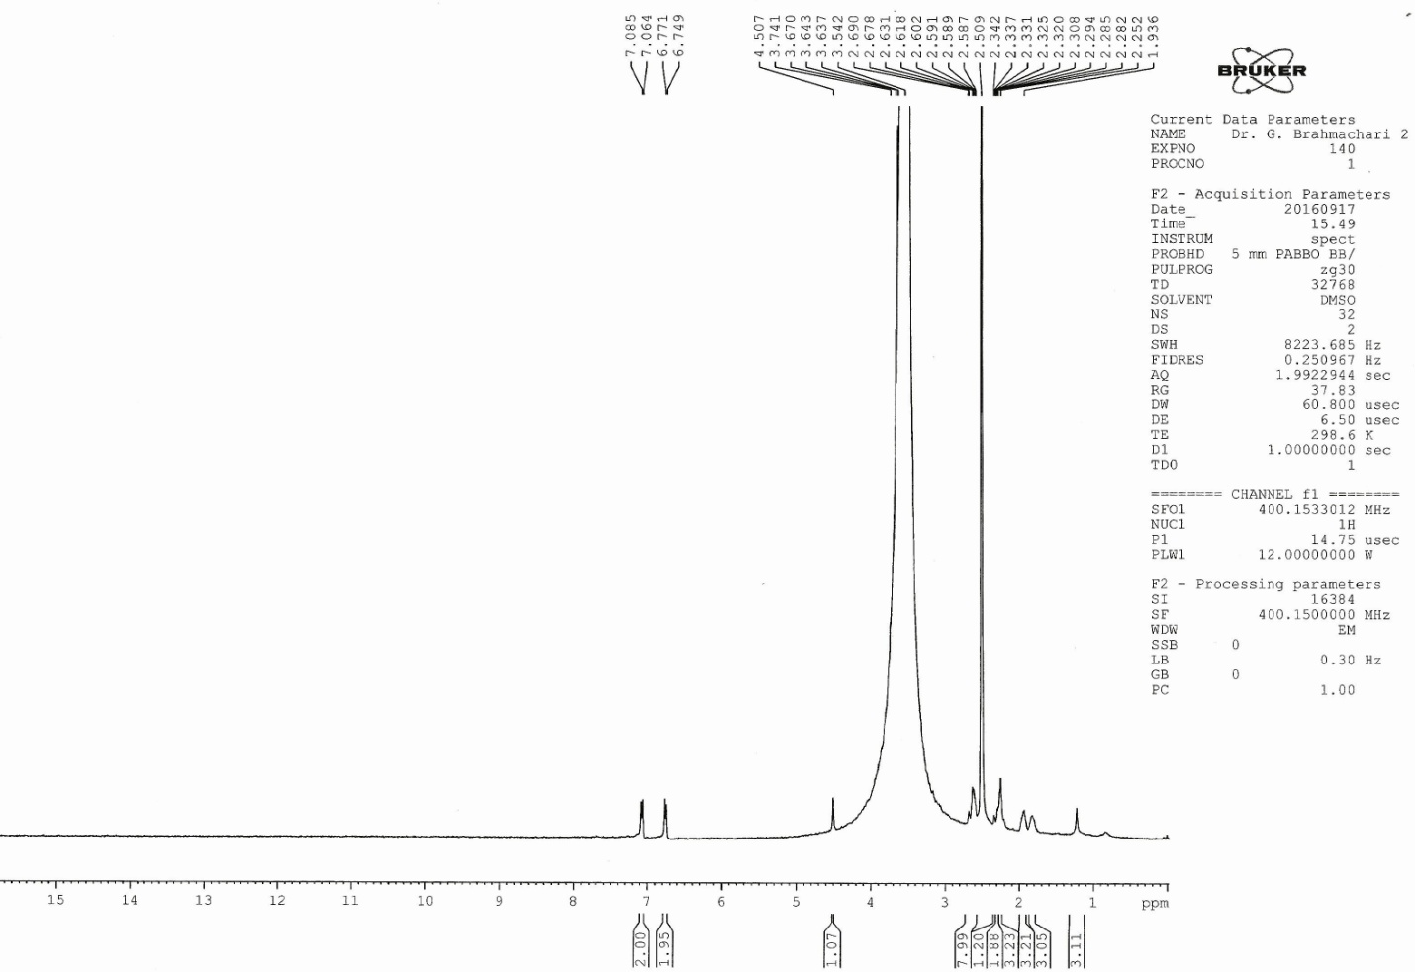

Fig. S2(a)

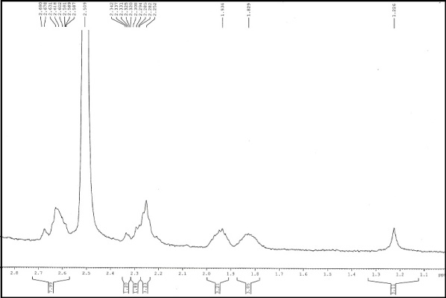
Fig. S2(b) (extended scale-I)

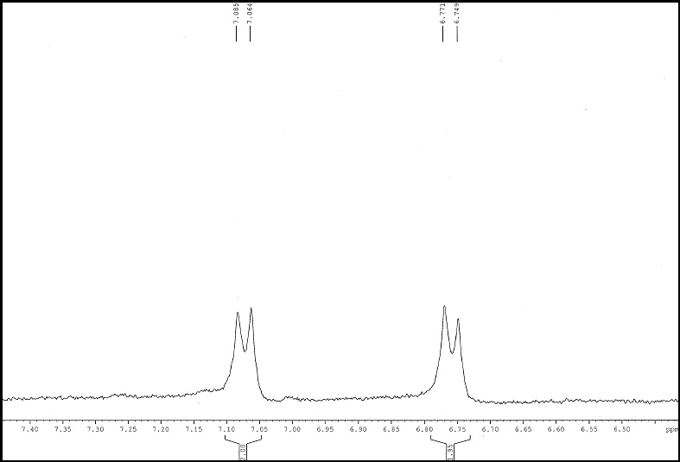

Fig. S2(c) (extended scale-II)

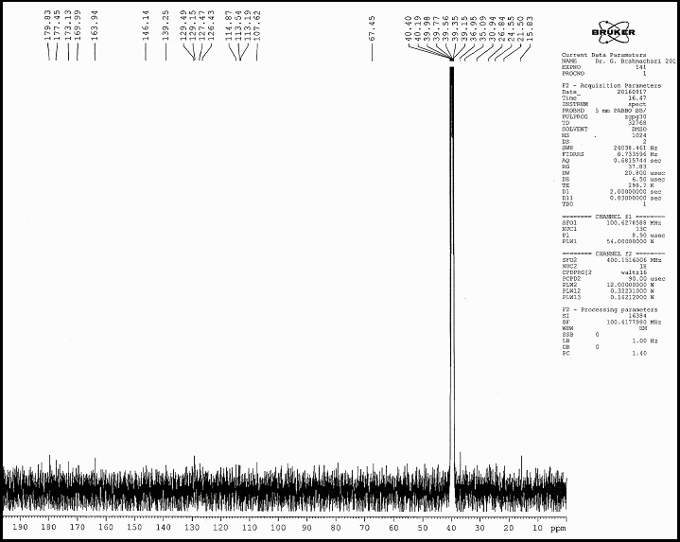

Fig. S2(d) ¹³C NMR NTDOSA

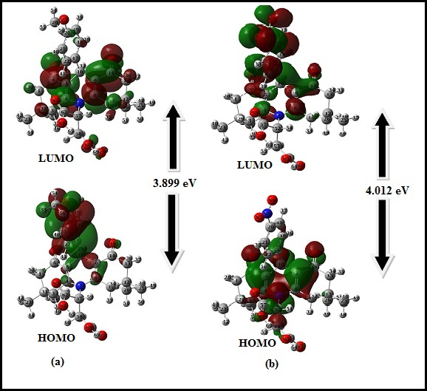
Fig.S3: HOMO, LUMO plots of (a) MTDOSA (b) NTDOSA molecules

Table S-I: Optimized geometric parameter for MTDOSA.
Parameter | DFT/B3LYP6311++G(d,p) | Parameter | DFT/B3LYP6311++G(d,p)
Bond length, Å |  | C58-C66-O68 | 111.28
C1-C2 | 1.537 | O67-C66-O68 | 121.96
C1-C6 | 1.518 | C66-O68-H69 | 109.02
C1-H29 | 1.093 | Dihedral Angle (in degree)
C1-H30 | 1.098 | C6-C1-C2-C3 | 53.25
C2-C3 | 1.546 | C6-C1-C2-C23 | 171.72
C2-H23 | 1.538 | C6-C1-C2-C24 | -67.97
C2-H24 | 1.541 | H29-C1-C2-C3 | 175.71
C3-C4 | 1.515 | H29-C1-C2-C23 | -65.82
C3-H31 | 1.096 | H29-C1-C2-C24 | 54.49
C3-H32 | 1.090 | H30-C1-C2-C3 | -65.83
C4-C5 | 1.355 | H30-C1-C2-C23 | 52.64
C4-N7 | 1.416 | H30-C1-C2-C24 | 172.94
C5-C6 | 1.476 | C2-C1-C6-C5 | -33.75
C5-C10 | 1.511 | C2-C1-C6-O15 | 147.79
C6-O15 | 1.220 | H29-C1-C6-C5 | -158.30
N7-C8 | 1.415 | H29-C1-C6-O15 | 23.24
N7-C57 | 1.461 | H30-C1-C6-C5 | 86.87
C8-C9 | 1.354 | H30-C1-C6-O15 | -91.58
C8-C11 | 1.516 | C1-C2-C3-C4 | -59.60
C9-C10 | 1.515 | C1-C2-C3-H31 | 71.40
C9-C14 | 1.475 | C1-C2-C3-H32 | -173.19
C10-C17 | 1.534 | C23-C2-C3-C4 | -168.84
C10-H33 | 1.093 | C23-C2-C3-H31 | -47.84
C11-C12 | 1.547 | C23-C2-C3-H32 | 67.57
C11-H34 | 1.099 | C24-C2-C3-C4 | 71.36
C11-H35 | 1.093 | C24-C2-C3-H31 | -167.63
C12-C13 | 1.536 | C24-C2-C3-H32 | -52.22
C12-C25 | 1.537 | C1-C2-C23-H42 | -58.56
C12-C26 | 1.541 | C1-C2-C23-H43 | 61.42
C13-C14 | 1.519 | C1-C2-C23-H44 | -179.06
C13-H36 | 1.098 | C3-C2-C23-H42 | 59.32
C13-H37 | 1.092 | C3-C2-C23-H43 | 179.31
C14-O16 | 1.221 | C3-C2-C23-H44 | -61.17
C17-C18 | 1.402 | C24-C2-C23-H42 | -179.73
C17-C22 | 1.393 | C24-C2-C23-H43 | -59.74
C18-C19 | 1.386 | C24-C2-C23-H44 | 59.77
C18-H38 | 1.083 | C1-C2-C24-H45 | 59.66
C19-C20 | 1.399 | C1-C2-C24-H46 | -179.43
C19-H39 | 1.084 | C1-C2-C24-H47 | -60.34
C20-C21 | 1.395 | C3-C2-C24-H45 | -59.76
C20-O27 | 1.369 | C3-C2-C24-H46 | 61.14
C21-C22 | 1.398 | C3-C2-C24-H47 | -179.77
C21-H40 | 1.082 | C23-C2-C24-H45 | -179.43
C22-H41 | 1.083 | C23-C2-C24-H46 | -58.53
C23-H42 | 1.093 | C23-C2-C24-H47 | 60.56
C23-H43 | 1.094 | C2-C3-C4-C5 | 26.53
C23-H44 | 1.095 | C2-C3-C4-N7 | -151.00
C24-H45 | 1.092 | H31-C3-C4-C5 | -94.64
C24-H46 | 1.095 | H31-C3-C4-N7 | 87.82
C24-H47 | 1.094 | H32-C3-C4-C5 | 148.43
C25-H48 | 1.094 | H32-C3-C4-N7 | -29.09
C25-H49 | 1.094 | C3-C4-C5-C6 | -3.83
C25-H50 | 1.094 | C3-C4-C5-C10 | 176.63
C26-H51 | 1.094 | N7-C4-C5-C6 | 173.66
C26-H52 | 1.092 | N7-C4-C5-C10 | -5.87
C26-H53 | 1.093 | C3-C4-CN7-C8 | 159.64
O27-C28 | 1.418 | C3-C4-N7-C57 | -23.90
C28-H54 | 1.089 | C5-C4-N7-C8 | -17.94
C28-H55 | 1.095 | C3-C4-N7-C57 | 158.50
C28-H56 | 1.096 | C4-C5-C6-C1 | 7.42
C57-C58 | 1.576 | C4-C5-C6-O15 | -174.13
C57-H59 | 1.089 | C10-C5-C6-C1 | -173.01
C57-C62 | 1.551 | C10-C5-C6-O15 | 4.43
C58-H60 | 1.093 | C4-C5-C10-C9 | 26.43
C58-H61 | 1.087 | C4-C5-C10-C17 | -99.03
C58-C66 | 1.511 | C4-C5-C10-H33 | 143.46
C62-O63 | 1.197 | C6-C5-C10-C9 | -153.12
C62-O64 | 1.346 | C6-C5-C10-C17 | 81.41
O64-H65 | 0.973 | C6-C5-C10-H33 | -36.08
C66-O67 | 1.198 | C4-N7-C8-C9 | 17.88
C66-O68 | 1.372 | C4-N7-C8-C11 | -159.18
O68-H69 | 0.97 | C57-N7-C8-C9 | -158.71
Bond Angle (in degree) |  | C57-N7-C8-C11 | 24.21
C2-C1-C6 | 113.48 | C4-N7-C57-C58 | 79.23
C2-C1-H29 | 111.82 | C4-N7-C57-H59 | -163.69
C2-C1-H30 | 109.44 | C4-N7-C57-C62 | -52.58
C6-C1-H29 | 107.99 | C8-N7-C57-C58 | -104.31
C6-C1-H30 | 106.73 | C8-N7-C57-H59 | 12.76
H29-C1-H30 | 107.06 | C8-N7-C57-C62 | 123.87
C1-C2-C3 | 107.84 | N7-C8-C9-C10 | 6.00
C1-C2-C23 | 109.97 | N7-C8-C9-C14 | -173.13
C1-C2-C24 | 110.42 | C11-C8-C9-C10 | -177.07
C3-C2-C23 | 108.77 | C11-C8-C9-C14 | 3.79
C3-C2-C24 | 110.83 | N7-C8-C11-C12 | 151.92
C23-C2-C24 | 108.98 | N7-C8-C11-H34 | -86.85
C2-C3-C4 | 114.11 | N7-C8-C11-H35 | 20.39
C2-C3-H31 | 108.66 | C9-C8-C11-C12 | -25.08
C2-C3-H32 | 107.77 | C9-C8-C11-H34 | 96.13
C4-C3-H31 | 108.34 | C9-C8-C11-H35 | -146.62
C4-C3-H32 | 110.87 | C8-C9-C10-C5 | -26.41
H31-C3-H32 | 106.83 | C8-C9-C10-C17 | 99.90
C3-C4-C5 | 121.87 | C8-C9-C10-H33 | -143.40
C3-C4-N7 | 118.33 | C14-C9-C10-C5 | 152.75
C5-C4-N7 | 119.74 | C14-C9-C10-C17 | -80.94
C4-C5-C6 | 120.89 | C14-C9-C10-H33 | 35.75
C4-C5-C10 | 122.20 | C8-C9-C14-C13 | -8.69
C6-C5-C10 | 116.90 | C8-C9-C14-O16 | 172.84
C1-C6-C5 | 117.96 | C10-C9-C14-C13 | 172.14
C1-C6-O15 | 120.76 | C10-C9-C14-O16 | -6.32
C5-C6-O15 | 121.27 | C5-C10-C17-C18 | -149.36
C4-N7-C8 | 118.69 | C5-C10-C17-C22 | 41.44
C4-N7-C57 | 122.68 | C9-C10-C17-C18 | 96.70
C8-N7-C57 | 118.52 | C9-C10-C17-C22 | -82.49
N7-C8-C9 | 120.31 | H33-C10-C17-C18 | -20.96
N7-C8-C11 | 117.41 | H33-C10-C17-C22 | 159.84
C9-C8-C11 | 122.22 | C8-C11-C12-C13 | 48.17
C8-C9-C10 | 121.61 | C8-C11-C12-C25 | 167.80
C8-C9-C14 | 120.79 | C8-C11-C12-C26 | -72.65
C10-C9-C14 | 117.58 | H34-C11-C12-C13 | -73.62
C5-C10-C9 | 109.09 | H34-C11-C12-C25 | 45.99
C5-C10-C17 | 113.38 | H34-C11-C12-C26 | 165.54
C5-C10-H33 | 107.89 | H35-C11-C12-C13 | 171.34
C9-C10-C17 | 111.93 | H35-C11-C12-C25 | -69.03
C9-C10-H33 | 107.96 | H35-C11-C12-C26 | 50.52
C17-C10-H33 | 106.34 | C11-C12-C13-C14 | -53.15
C8-C11-C12 | 114.22 | C11-C12-C13-H36 | 66.10
C8-C11-H34 | 109.20 | C11-C12-C13-H37 | -175.49
C8-C11-H35 | 110.59 | C25-C12-C13-C14 | -172.02
C12-C11-H34 | 108.14 | C25-C12-C13-H36 | -52.76
C12-C11-H35 | 107.58 | C25-C12-C13-H37 | 65.45
H34-C11-H35 | 106.80 | C26-C12-C13-C14 | 67.63
C11-C12-C13 | 108.10 | C26-C12-C13-H36 | -173.11
C11-C12-C25 | 108.90 | C26-C12-C13-H37 | -54.70
C11-C12-C26 | 110.34 | C11-C12-C25-H48 | -60.27
C13-C12-C25 | 110.11 | C11-C12-C25-H49 | 179.88
C13-C12-C26 | 110.41 | C11-C12-C25-H50 | 60.38
C25-C12-C26 | 108.96 | C13-C12-C25-H48 | 57.10
C12-C13-C14 | 113.47 | C13-C12-C25-H49 | -61.75
C12-C13-H36 | 109.58 | C13-C12-C25-H50 | 178.75
C12-C13-H37 | 111.68 | C26-C12-C25-H48 | 179.32
C14-C13-H36 | 106.80 | C26-C12-C25-H49 | 59.47
C14-C13-H37 | 107.98 | C26-C12-C25-H50 | -60.02
H36-C13-H37 | 107.02 | C11-C12-C26-H51 | -61.40
C9-C14-C13 | 117.88 | C11-C12-C26-H52 | 59.50
C9-C14-O16 | 121.44 | C11-C12-C26-H53 | 179.41
C13-C14-O16 | 120.66 | C13-C12-C26-H51 | 179.15
C10-C17-C18 | 119.85 | C13-C12-C26-H52 | -69.50
C10-C17-C22 | 122.16 | C13-C12-C26-H53 | 59.89
C18-C17-C22 | 117.98 | C25-C12-C26-H51 | 58.11
C17-C18-C19 | 121.23 | C25-C12-C26-H52 | 179.02
C17-C18-H38 | 119.21 | C25-C12-C26-H53 | -61.04
C19-C18-H38 | 119.55 | C12-C13-C14-C9 | 34.93
C18-C19-C20 | 120.17 | C12-C13-C14-O16 | -146.59
C18-C19-H39 | 121.12 | H36-C13-C14-C9 | -85.90
C20-C19-H39 | 118.70 | H36-C13-C14-O16 | 92.56
C19-C20-C21 | 119.46 | H37-C13-C14-C9 | 158.29
C19-C20-O27 | 115.94 | H37-C13-C14-O16 | -22.23
C21-C20-O27 | 124.61 | C10-C17-C18-C19 | -179.00
C20-C21-C22 | 119.67 | C10-C17-C18-H38 | 0.66
C20-C21-H40 | 121.28 | C22-C17-C18-C19 | -0.21
C22-C21-H40 | 119.05 | C22-C17-C18-H38 | 179.88
C17-C22-C21 | 121.49 | C10-C17-C22-C21 | 179.05
C17-C22-H41 | 120.36 | C10-C17-C22-H41 | -1.88
C21-C22-H41 | 118.14 | C18-C17-C22-C21 | -0.15
C2-C23-H42 | 111.35 | C18-C17-C22-H41 | 178.91
C2-C23-H43 | 110.68 | C17-C18-C19-C20 | -0.14
C2-C23-H44 | 111.17 | C17-C18-C19-H39 | -179.66
H42-C23-H43 | 107.88 | H38-C18-C19-C20 | -179.81
H42-C23-H44 | 108.02 | H38-C18-C19-H39 | 0.67
H43-C23-H44 | 107.59 | C18-C19-C20-C21 | 0.01
C2-C24-H45 | 112.19 | C18-C19-C20-O27 | -179.77
C2-C24-H46 | 110.79 | H39-C19-C20-C21 | 179.52
C2-C24-H47 | 110.41 | H39-C19-C20-O27 | -0.24
H45-C24-H46 | 108.08 | C19-C20-C21-C22 | 0.07
H45-C24-H47 | 107.59 | C19-C20-C21-H40 | -179.44
H46-C24-H47 | 107.59 | O27-C20-C21-C22 | 179.81
C12-C25-H48 | 111.39 | O27-C20-C21-H40 | 0.30
C12-C25-H49 | 110.59 | C19-C20-O27-C28 | 178.73
C12-C25-H50 | 111.16 | C21-C20-O27-C28 | -1.02
H48-C25-H49 | 107.79 | C20-C21-C22-C17 | 0.02
H48-C25-H50 | 108.12 | C20-C21-C22-H41 | -179.07
H49-C25-H50 | 107.63 | H40-C21-C22-C17 | 179.54
C12-C26-H51 | 110.76 | H40-C21-C22-H41 | 0.45
C12-C26-H52 | 112.20 | C20-O27-C28-H54 | -179.53
C12-C26-H53 | 110.27 | C20-O27-C28-H55 | -60.75
H51-C26-H52 | 108.11 | C20-O27-C28-H56 | 61.70
H51-C26-H53 | 107.73 | N7-C57-C58-H60 | -109.09
H52-C26-H53 | 107.60 | N7-C57-C58-H61 | 9.67
C20-O27-C28 | 118.42 | N7-C57-C58-C66 | 129.19
O27-C28-H54 | 105.93 | H59-C57-C58-H60 | 134.60
O27-C28-H55 | 111.50 | H59-C57-C58-H61 | -106.63
O27-C28-H56 | 111.56 | H59-C57-C58-C66 | 12.89
H54-C28-H55 | 109.28 | C62-C57-C58-H60 | 22.28
H54-C28-H56 | 109.24 | C62-C57-C58-H61 | 141.04
H55-C28-H56 | 108.24 | C62-C57-C58-C66 | -99.43
N7-C57-C58 | 114.08 | N7-C57-C62-O63 | -1.65
N7-C57-H59 | 105.57 | N7-C57-C62-O64 | -179.67
N7-C57-H62 | 112.82 | C58-C57-C62-O63 | -133.63
C58-C57-H59 | 106.90 | C58-C57-C62-O64 | 48.34
C58-C57-C62 | 113.74 | H59-C57-C62-O63 | 111.37
H59-C57-C62 | 102.45 | H59-C57-C62-O64 | -66.64
C57-C58-H60 | 111.06 | C57-C58-C66-O67 | -124.96
C57-C58-H61 | 109.01 | C57-C58-C66-O68 | 55.32
C57-C58-C66 | 114.52 | H60-C58-C66-O67 | 111.28
H60-C58-H61 | 107.90 | H60-C58-C66-O68 | -68.43
H60-C58-C66 | 107.28 | H61-C58-C66-O67 | 4.19
H61-C58-C66 | 106.77 | H61-C58-C66-O68 | 176.08
C57-C62-O63 | 124.04 | C57-C62-O64-H65 | 5.02
C57-C62-O64 | 115.14 | O63-C62-O64-H65 | -173.07
O63-C62-O64 | 120.79 | C58-C66-O68-H69 | -179.57
C62-O64-H65 | 112.85 | O67-C66-O68-H69 | -0.16
C58-C66-O67 | 126.75

Table S-II: Optimized geometric parameters for NTDOSA.
Parameter | DFT/B3LYP6311++G(d,p) | Parameter | DFT/B3LYP6311++G(d,p)
Bond length, Å |  | O66-C65-O67 | 124.27
C1-C2 | 1.538 | Dihedral Angle (in degree)
C1-C6 | 1.517 | C6-C1-C2-C3 | 52.83
C1-H27 | 1.092 | C6-C1-C2-C23 | 171.23
C1-H28 | 1.092 | C6-C1-C2-C24 | -68.48
C2-C3 | 1.548 | H27-C1-C2-C3 | 175.40
C2-C23 | 1.538 | H27-C1-C2-C23 | -66.19
C2-C24 | 1.541 | H27-C1-C2-C24 | 54.09
C3-C4 | 1.514 | H28-C1-C2-C3 | -66.22
C3-H29 | 1.096 | H28-C1-C2-C23 | 52.093
C3-H30 | 1.090 | H28-C1-C2-C24 | 172.48
C4-C5 | 1.355 | C2-C1-C6-C5 | -32.48
C4-N7 | 1.415 | C2-C1-C6-O15 | 159.65
C5-C6 | 1.476 | H27-C1-C6-C5 | -157.13
C5-C10 | 1.510 | H27-C1-C6-O15 | 24.73
C6-O15 | 1.221 | H28-C1-C6-C5 | 88.20
N7-C8 | 1.4132 | H28-C1-C6-O15 | -89.93
N7-C52 | 1.4637 | C1-C2-C3-C4 | -49.73
C8-C9 | 1.355 | C1-C2-C3-H29 | 71.34
C8-C11 | 1.516 | C1-C2-C3-H30 | -173.20
C9-C10 | 1.515 | C23-C2-C3-C4 | -169.93
C9-C14 | 1.475 | C23-C2-C3-H29 | -47.85
C10-C17 | 1.534 | C23-C2-C3-H30 | 66.59
C10-H31 | 1.091 | C24-C2-C3-C4 | 71.35
C11-C12 | 1.547 | C24-C2-C3-H29 | -167.56
C11-H32 | 1.099 | C24-C2-C3-H30 | -52.12
C11-H33 | 1.094 | C1-C2-C23-H40 | -58.56
C12-C13 | 1.573 | C1-C2-C23-H41 | 61.44
C12-C25 | 1.537 | C1-C2-C23-H42 | -179.09
C12-C26 | 1.542 | C3-C2-C23-H40 | 59.39
C13-C14 | 1.517 | C3-C2-C23-H41 | 179.40
C13-H34 | 1.098 | C3-C2-C23-H42 | -61.13
C13-H35 | 1.092 | C24-C2-C23-H40 | -179.40
C14-O16 | 1.221 | C24-C2-C23-H41 | -59.73
C17-C18 | 1.400 | C24-C2-C23-H42 | 59.72
C17-C22 | 1.400 | C1-C2-C24-H43 | 59.75
C18-C19 | 1.389 | C1-C2-C24-H44 | -179.33
C18-H36 | 1.082 | C1-C2-C24-H45 | -60.28
C19-C20 | 1.391 | C3-C2-C24-H43 | -59.85
C19-H37 | 1.081 | C3-C2-C24-H44 | 61.05
C20-C21 | 1.391 | C3-C2-C24-H45 | -179.88
C20-N65 | 1.475 | C23-C2-C24-H43 | -179.38
C21-C22 | 1.390 | C23-C2-C24-H44 | -58.47
C21-H38 | 1.081 | C23-C2-C24-H45 | 60.57
C22-H39 | 1.083 | C2-C3-C4-C5 | 26.26
C23-H40 | 1.093 | C2-C3-C4-N7 | -151.12
C23-H41 | 1.093 | H29-C3-C4-C5 | -94.96
C23-H42 | 1.095 | H29-C3-C4-N7 | 87.64
C24-H43 | 1.092 | H30-C3-C4-C5 | 148.09
C24-H44 | 1.094 | H30-C3-C4-N7 | -29.29
C24-H45 | 1.094 | C3-C4-C5-C6 | -2.74
C25-H46 | 1.094 | C3-C4-C5-C10 | 177.47
C25-H47 | 1.094 | N7-C4-C5-C6 | 174.61
C25-H48 | 1.095 | N7-C4-C5-C10 | -5.16
C26-H49 | 1.094 | C3-C4-N7-C8 | 159.78
C26-H50 | 1.093 | C3-C4-N7-C52 | -24.86
C26-H51 | 1.093 | C5-C4-N7-C8 | -17.68
C52-C53 | 1.574 | C5-C4-N7-C52 | 157.69
C52-H54 | 1.092 | C4-C5-C6-C1 | 5.82
C52-C57 | 1.552 | C4-C5-C6-O15 | -176.03
C53-H55 | 1.094 | C10-C5-C6-C1 | -174.38
C53-H56 | 1.087 | C10-C5-C6-O15 | 3.75
C53-C61 | 1.511 | C4-C5-C10-C9 | 24.95
C57-O58 | 1.198 | C4-C5-C10-C17 | -100.29
C57-O59 | 1.344 | C4-C5-C10-H31 | 142.27
O59-H60 | 0.974 | C6-C5-C10-C9 | -154.83
C61-O62 | 1.198 | C6-C5-C10-C17 | 79.91
C61-O63 | 1.371 | C6-C5-C10-H31 | -37.51
O63-H64 | 0.970 | C4-N7-C8-C9 | 17.54
N65-O66 | 1.226 | C4-N7-C8-C11 | -159.31
N65-O67 | 1.227 | C52-N7-C8-C9 | -157.99
Bond Angle (in degree) |  | C52-N7-C8-C11 | 25.14
C2-C1-C6 | 113.55 | C4-N7-C52-C53 | 79.63
C2-C1-H27 | 111.84 | C4-N7-C52-H54 | -163.25
C2-C1-H28 | 109.48 | C4-N7-C52-C57 | -52.35
C6-C1-H27 | 108.02 | C8-N7-C52-C53 | -105.01
C6-C1-H28 | 106.68 | C8-N7-C52-H54 | 12.10
H27-C1-H28 | 106.95 | C8-N7-C52-C57 | 123.01
C1-C2-C3 | 107.96 | N7-C8-C9-C10 | 5.38
C1-C2-C23 | 109.92 | N7-C8-C9-C14 | -173.33
C1-C2-C24 | 110.48 | C11-C8-C9-C10 | -177.89
C3-C2-C23 | 108.67 | C11-C8-C9-C14 | 3.38
C3-C2-C24 | 110.45 | N7-C8-C11-C12 | 151.56
C23-C2-C24 | 108.97 | N7-C8-C11-H32 | -87.17
C2-C3-C4 | 113.11 | N7-C8-C11-H33 | 29.99
C2-C3-H29 | 108.67 | C9-C8-C11-C12 | -25.25
C2-C3-H30 | 107.76 | C9-C8-C11-H32 | 96.01
C4-C3-H29 | 108.39 | C9-C8-C11-H33 | -146.81
C4-C3-H30 | 110.77 | C8-C9-C10-C5 | -24.99
H29-C3-H30 | 106.85 | C8-C9-C10-C17 | 101.23
C3-C4-C5 | 121.67 | C8-C9-C10-H31 | -142.35
C3-C4-N7 | 118.40 | C14-C9-C10-C5 | 153.77
C5-C4-N7 | 119.87 | C14-C9-C10-C17 | -79.99
C4-C5-C6 | 121.13 | C14-C9-C10-H31 | 36.42
C4-C5-C10 | 122.31 | C8-C9-C14-C13 | -7.80
C6-C5-C10 | 116.55 | C8-C9-C14-C16 | 173.90
C1-C6-C5 | 118.04 | C10-C9-C14-C13 | 173.41
C1-C6-O15 | 121.98 | C10-C9-C14-O16 | -4.87
C5-C6-O15 | 120.94 | C5-C10-C17-C18 | -138.92
C4-N7-C8 | 118.74 | C5-C10-C17-C22 | 41.97
C4-N7-C52 | 122.51 | C9-C10-C17-C18 | 97.10
C8-N7-C52 | 118.58 | C9-C10-C17-C22 | -81.99
N7-C8-C9 | 120.46 | H31-C10-C17-C18 | -22.39
N7-C8-C11 | 117.42 | H31-C10-C17-C22 | 160.49
C9-C8-C11 | 122.02 | C8-C11-C12-C13 | 48.43
C8-C9-C10 | 121.68 | C8-C11-C12-C25 | 168.02
C8-C9-C14 | 120.94 | C8-C11-C12-C26 | -72.36
C10-C9-C14 | 117.35 | H32-C11-C12-C13 | -73.34
C5-C10-C9 | 109.29 | H32-C11-C12-C25 | 46.24
C5-C10-C17 | 113.35 | H32-C11-C12-C26 | 165.85
C5-C10-H31 | 108.07 | H33-C11-C12-C13 | 171.53
C9-C10-C17 | 111.66 | H33-C11-C12-C25 | -68.87
C9-C10-H31 | 108.01 | H33-C11-C12-C26 | 50.72
C17-C10-H31 | 106.20 | C11-C12-C13-C14 | -52.92
C8-C11-C12 | 114.23 | C11-C12-C13-H34 | 66.35
C8-C11-H32 | 109.14 | C11-C12-C13-H35 | -175.29
C8-C11-H33 | 110.47 | C25-C12-C13-C14 | -171.74
C12-C11-H32 | 108.20 | C25-C12-C13-H34 | -52.46
C12-C11-H33 | 107.67 | C25-C12-C13-H35 | 65.88
H32-C11-H33 | 106.82 | C26-C12-C13-C14 | 67.84
C11-C12-C13 | 108.11 | C26-C12-C13-H34 | -172.87
C11-C12-C25 | 108.88 | C26-C12-C13-H35 | -54.51
C11-C12-C26 | 110.34 | C11-C12-C25-H46 | -60.29
C13-C12-C25 | 110.08 | C11-C12-C25-H47 | 179.87
C13-C12-C26 | 110.38 | C11-C12-C25-H48 | 60.38
C25-C12-C26 | 109.02 | C13-C12-C25-H46 | 58.05
C12-C13-C14 | 113.53 | C13-C12-C25-H47 | -61.77
C12-C13-H34 | 109.60 | C13-C12-C25-H48 | 178.73
C12-C13-H35 | 111.73 | C26-C12-C25-H46 | 179.27
C14-C13-H34 | 106.76 | C26-C12-C25-H47 | 59.45
C14-C13-H35 | 107.93 | C26-C12-C25-H48 | -60.03
H34-C13-H35 | 106.93 | C11-C12-C26-H49 | -61.32
C9-C14-C13 | 117.95 | C11-C12-C26-H50 | 59.61
C9-C14-O16 | 121.18 | C11-C12-C26-H51 | 179.54
C13-C14-O16 | 120.83 | C13-C12-C26-H49 | 179.23
C10-C17-C18 | 119.58 | C13-C12-C26-H50 | -59.81
C10-C17-C22 | 121.48 | C13-C12-C26-H51 | 60.10
C18-C17-C22 | 118.92 | C25-C12-C26-H49 | 58.19
C17-C18-C19 | 120.94 | C25-C12-C26-H50 | 179.14
C17-C18-H36 | 119.29 | C25-C12-C26-H51 | -60.93
C19-C18-H36 | 119.75 | C12-C13-C14-C9 | 34.15
C18-C19-C20 | 118.77 | C12-C13-C14-O16 | -147.55
C18-C19-H37 | 121.48 | H34-C13-C14-C9 | -86.73
C20-C19-H37 | 119.74 | H34-C13-C14-O16 | 91.55
C19-C20-C21 | 121.68 | H35-C13-C14-C9 | 158.59
C19-C20-N65 | 119.20 | H35-C13-C14-O16 | -23.11
C21-C20-N65 | 119.11 | C10-C17-C18-C19 | -178.81
C20-C21-C22 | 118.81 | C10-C17-C18-H36 | 0.73
C20-C21-H38 | 119.79 | C22-C17-C18-C19 | 0.31
C22-C21-H38 | 121.38 | C22-C17-C18-H36 | 179.86
C17-C22-C21 | 120.86 | C10-C17-C22-C21 | 178.78
C17-C22-H39 | 120.39 | C10-C17-C22-H39 | -1.99
C21-C22-H39 | 118.73 | C18-C17-C22-C21 | -0.32
C2-C23-H40 | 111.37 | C18-C17-C22-H39 | 178.89
C2-C23-H41 | 110.67 | C17-C18-C19-C20 | 0.012
C2-C23-H42 | 111.15 | C17-C18-C19-H37 | -179.79
H40-C23-H41 | 107.88 | H36-C18-C19-C20 | -179.56
H40-C23-H42 | 108.03 | H36-C18-C19-H37 | 0.65
H41-C23-H42 | 107.55 | C18-C19-C20-C21 | -0.29
C2-C24-H43 | 112.27 | C18-C19-C20-N65 | 179.90
C2-C24-H44 | 110.78 | H37-C19-C20-C21 | 179.49
C2-C24-H45 | 110.36 | H37-C19-C20-N65 | -0.31
H43-C24-H44 | 108.05 | C19-C20-C21-C22 | 0.28
H43-C24-H45 | 107.58 | C19-C20-C21-H38 | -179.47
H44-C24-H45 | 107.57 | N65-C20-C21-C22 | -179.91
C12-C25-H46 | 111.39 | N65-C20-C21-H38 | 0.33
C12-C25-H47 | 110.56 | C19-C20-N65-O66 | 0.01
C12-C25-H48 | 111.15 | C19-C20-N65-O67 | -179.85
H46-C25-H47 | 107.78 | C21-C20-N65-O66 | -179.80
H46-C25-H48 | 108.14 | C21-C20-N65-O67 | 0.33
H47-C25-H48 | 107.68 | C20-C21-C22-C17 | -0.02
C12-C26-H49 | 110.78 | C20-C21-C22-H39 | -179.19
C12-C26-H50 | 112.23 | H38-C21-C22-C17 | 179.78
C12-C26-H51 | 110.25 | H38-C21-C22-H39 | 0.55
H49-C26-H50 | 108.10 | N7-C52-C53-H55 | -107.87
H49-C26-H51 | 107.70 | N7-C52-C53-H56 | 10.99
H50-C26-H51 | 107.58 | N7-C52-C53-C61 | 130.24
N7-C52-C53 | 114.06 | H54-C52-C53-H55 | 135.81
N7-C52-H54 | 105.56 | H54-C52-C53-H56 | -105.31
N7-C52-C57 | 112.32 | H54-C52-C53-C61 | 13.93
C53-C52-H54 | 106.94 | C57-C52-C53-H55 | 23.19
C53-C52-C57 | 114.21 | C57-C52-C53-H56 | 142.06
H54-C52-C57 | 102.47 | C57-C52-C53-C61 | -98.68
C52-C53-H55 | 111.13 | N7-C52-C57-O58 | -3.19
C52-C53-H56 | 108.95 | N7-C52-C57-O59 | 178.86
C52-C53-C61 | 114.29 | C53-C52-C57-O58 | -135.10
H55-C53-H56 | 107.98 | C53-C52-C57-O59 | 46.95
H55-C53-C61 | 107.49 | H54-C52-C57-O58 | 109.63
H56-C53-C61 | 106.71 | H54-C52-C57-O59 | -68.31
C52-C57-O58 | 125.45 | C52-C53-C61-O62 | -122.93
C52-C57-O59 | 115.45 | C52-C53-C61-O63 | 57.14
O58-C57-O59 | 120.92 | H55-C53-C61-O62 | 113.21
C57-O59-H60 | 113.01 | H55-C53-C61-O63 | -66.70
C53-C61-O62 | 126.68 | H56-C53-C61-O62 | 2.42
C53-C61-O63 | 111.22 | H56-C53-C61-O63 | -177.65
O62-C61-O63 | 122.09 | C52-C57-O59-H60 | 5.16
C61-O63-H64 | 109.16 | O58-C57-O59-H60 | -172.84
C20-N65-O66 | 117.88 | C53-C61-O63-H64 | 179.76
C20-N65-O67 | 117.85 | O62-C61-O63-H64 | -0.15

Table. S-III: Vibrational analysis of prominent modes of MTDOSA at the B3LYP/6-311++G (d,p) level.
Cal. Frequency,  cm⁻¹ | Scaled Frequency, cm⁻¹ | Exp. FTIR Frequency,  cm⁻¹ | Assignment
3753 | 3630 | 3630 | ν_{as}[O-H)(99)]
3644 | 3523 | 3312 | ν_{s}[O-H)(99)]
3203 | 3097 | 3069 | ν_{as} [C-H)R1(94)]
3195 | 3090 |  | ν_{as} [C-H)R1(98)]
3188 | 3083 |  | ν_{s} [C-H)R1(89)]
3180 | 3075 |  | ν_{as} [C-H)R1(98)]
3148 | 3045 |  | ν_{as} [C-H) CH₂ (98)]
3127 | 3024 |  | ν_{as} [C-H) CH₃-O (91)]
3104 | 3002 | 3002 | ν_{as} [C-H)R2 (91)]
3099 | 2997 |  | ν_{as} [C-H)CH₃-R4 (76)]
3098 | 2996 |  | ν_{as} [C-H)CH₃-R2(64)]
3097 | 2995 |  | ν[C57-H59 (94)]
3090 | 2988 |  | ν_{s} [C-H)CH₃-R4 (54)]
3089 | 2987 |  | ν_{as} [C-H)CH₃-R2(83)]
3085 | 2983 |  | ν_{as} [C-H)CH₃-R4(68)]
3083 | 2981 |  | ν [C-H)R2 (54)]
3083 | 2981 |  | ν_{as} [C-H){R2(44)+CH₃-R2(26)}]
3081 | 2979 |  | ν_{as} [(C-H){R2+R3+CH₃-R2}(70)]
3080 | 2979 |  | ν_{as} [(C-H){R2+R3+CH₃-R2}(70)]
3077 | 2976 |  | ν_{as} [C-H)CH₃-R4(89)]
3075 | 2974 |  | ν_{as} [C-H)CH₃-R2(84)]
3061 | 2960 | 2959 | ν_{as} [C-H)R4 (69)]
3058 | 2957 |  | ν_{s} [C-H)CH₂ (87)]
3055 | 2954 |  | ν_{as} [C-H)CH₃-O-R1(100)]
3043 | 2943 |  | ν_{s} [C-H)R2 (79)]
3026 | 2926 |  | ν_{s} [C-H)CH₃-R4 (87)]
3023 | 2923 |  | ν_{s} [C-H)CH₃-R2 (31)]
3016 | 2916 |  | ν_{s} [C-H)CH₃-R4 (71)]
3015 | 2915 |  | ν_{as} [C-H)CH₃-R2(78)]
3007 | 2908 |  | ν_{s} [C-H)R2 (73)]
3004 | 2905 |  | ν_{s} [C-H)R24(76)]
2999 | 2900 |  | ν_{s} [C-H)CH₃-O-R1(91)]
2985 | 2886 | 2877 | ν_{s} [C-H)R4 (72)]
1846 | 1785 | 1808 | ν_{s} [(O=C)COOH(74)]
1836 | 1776 | 1731 | ν_{s} [(O=C)COOH(82)]
1722 | 1665 | 1668 | ν_{s} [(O=C)R2+R4(89)]
1716 | 1660 |  | ν [(O=C)R4(64)]
1678 | 1622 | 1618 | ν_{s} [(C=C)R3(68)]
1648 | 1593 | 1600 | ν_{as} [C-C)R1(62)]+ β [(H-C-C)R1(19)]
1627 | 1573 | 1575 | ν_{as} [(C=C)R3(71)]
1616 | 1563 | 1556 | ν_{as} [C-C)R1(43)]
1540 | 1489 | 1510 | β [(H-C-C)R1(48)]
1514 | 1464 |  | β_{O} [(H-C-H)CH₃-R2(48)]
1513 | 1463 | 1461 | β_{O} [(H-C-H)CH₃-R4(59)]
1507 | 1457 |  | β_{O} [(H-C-H)CH₃-R4(55)]
1506 | 1456 |  | β_{O} [(H-C-H)CH₃-R2(51)]
1505 | 1456 |  | β_{O} [(H-C-H)CH₃-0-R1(72)]
1500 | 1450 |  | β_{O} [(H-C-H)CH₃-R2+R2(39)]
1498 | 1449 |  | β_{O} [(H-C-H)CH₃-R4+R4(52)]
1491 | 1442 |  | β_{O} [(H-C-H)CH₃-O-R1(73)]
1490 | 1441 |  | β_{O} [(H-C-H)CH₃-R2+R2(54)]
1489 | 1440 | 1440 | β_{O} [(H-C-H)CH₃-R4(34)]
1483 | 1434 | 1434 | β_{O} [(H-C-H)CH₃-R2+R2(56)]
1481 | 1433 |  | β_{O} [(H-C-H)R4+CH₂(43)]
1475 | 1427 |  | β_{O} [(H-C-H)R4+CH₂(64)]
1474 | 1426 |  | β_{O} [(H-C-H)CH₃-O-R1(84)]
1463 | 1415 |  | β_{O} [(H-C-H)CH₃-R4+R4(73)]
1461 | 1413 |  | β_{O} [(H-C-H)CH₃-R2+R2(61)]
1455 | 1407 |  | β [(H-C-C)R1(30)]
1439 | 1391 |  | τ_{i}[{(H-C-C-N)(R3+R4)+(H-C-C-O)(COOH)}(22)]
1424 | 1377 |  | β_{O} [(H-C-H)CH₃-R4(42)]
1423 | 1376 |  | β_{O} [(H-C-H)CH₃-R1+R1(74)]
1403 | 1356 | 1360 | β_{O} [(H-C-H)CH₃-R4(79)]
1402 | 1357 |  | β_{O} [(H-C-H)CH₃-R1(22)]
1385 | 1339 | 1328 | τ_{i}[{(H-C-C-N)(R3+R4)+(H-C-C-O)(COOH)}(18)]
1361 | 1316 |  | β [(H-O-C)COOH(63)]
1352 | 1308 |  | ν_{s} [C6-C5+C14-C9) (20)]
1346 | 1301 | 1301 | β_{O} [(H-C-H)CH₂-R4(23)]
1340 | 1295 |  | ν_{s} [(C-C)R1 (20)]+ β [(H-C-C)R1(57)]
1318 | 1275 | 1260 | β [(H-O-C)COOH(19)]
1268 | 1226 | 1233 | ν [O27-C20) (34)]
1264 | 1222 |  | ν_{as} [(N-C)R3 (17)]
1249 | 1208 |  | ν [N7-C57) (20)]
1235 | 1195 | 1194 | β_{O} [(H-C-C)CH₂(34)]
1204 | 1164 | 1163 | β [(H-C-C)R1(58)]
1201 | 1161 |  | τ_{i}[(H-C-O-C)CH3-O-R1(48)]
1183 | 1143 |  | ν [(O-C) COOH(17)]
1168 | 1130 | 1137 | β_{O} [(H-C-H)CH₃-O-R1(19)]+ τ_{i}[(H-C-O-C)CH3-O-R1(54)]
1146 | 1108 | 1106 | ν [(O-C) COOH(26)]+ β [(H-O-C)COOH(19)]
1142 | 1104 |  | β_{O} [(H-C-C)R2(21)]
1139 | 1101 |  | β_{O} [(H-C-C)R1(25)]
1136 | 1099 |  | β [(H-C-C)R1(34)]
1123 | 1086 |  | ν [(C-C) R1+R2(20)]
1063 | 1028 | 1031 | ν [O27-C28) (72)]
1036 | 1002 |  | τ_{i}[(H-C-C-C)CH3-R4+R4(21)]
1034 | 999 | 998 | τ_{i}[(H-C-C-C)CH3-R2(21)]
1027 | 993 |  | β [(H-C-C)R1(19)]+ β [(C-C-C)R1(60)]
985 | 953 |  | τ_{i}[(H-C-C-C)R1(86)]
968 | 936 | 934 | τ_{i}[(H-C-C-C)R1(51)]
948 | 917 |  | τ_{i}[(H-C-C-C)CH₃-R1(20)]
944 | 913 | 910 | β [(C-C-N)R1+R2+R3(20)]
905 | 875 | 882 | τ_{i}[(H-C-C-C)R2(26)]
864 | 836 | 845 | τ_{i}[(H-C-C-C)R1(24)]
826 | 799 | 806 | τ_{i}[(H-C-C-C)R1(66)]
784 | 758 | 776 | ν [O27-C20) (18)]
760 | 735 | 722 | τ_{o} [(O-C-O-C)COOH(41)]
688 | 665 | 685 | τ_{i}[(H-O-C-C)COOH(20)]
666 | 644 | 651 | τ_{i}[(H-O-C-C)COOH(38)]
644 | 623 | 637 | τ_{o} [{(O15-C1-C5-C6)(R2+(O-C-O-C)(COOH)}(18)]
642 | 621 | 606 | β [(O-C-O)COOH(20)]
597 | 577 | 567 | τ_{i}[(H-O-C-C)COOH(24)]
541 | 523 | 532 | τ_{i}[(H-O-C-C)COOH(27)]
426 | 412 | 422 | τ_{i}[(C-C-C-C)R1+R3(75)]
399 | 386 | 415 | β [(C58-C57-N7)(19)]
392 | 379 |  | β [(O-C-C)COOH(42)]
385 | 373 |  | τ_{o}[(H-C-C-C)R2(23)]
285 | 275 |  | β [(C-O-C)CH₃-O-R1(22)]
237 | 229 |  | τ_{i}[(H-C-O-C)CH₃-O-R1(46)]
228 | 220 |  | τ_{i}[(H-C-C-C)CH₃-R2(22)]
222 | 215 |  | τ_{i}[(H-C-C-C)CH₃-R4+R4(19)]
152 | 147 |  | τ_{i}[(H-C-C-C)CH₃-R4+R4(18)]
141 | 136 |  | β [(C-C-C)R2+R4(20)]
106 | 102 |  | τ_{i}[(C-C-C-C)R2(24)]
84 | 81 |  | τ_{i}[(C-C-C-C)CH₃-O-R1(24)]
79 | 76 |  | τ_{i}[(C-C-C-C)CH₃-O-R1(20)]
63 | 61 |  | τ_{i}[(O-C-C-C)COOH(35)]
61 | 59 |  | τ_{i}[(C-C-C-C)R1+R2+R3+R4(26)]
43 | 42 |  | τ_{i}[(C57-C4-C8-N7)(27)]
ν: stretching; ν_{s}: symmetric stretching; ν_{as}: anti-symmetric stretching; β: bending in-plane; β_{O}: bending out-of-plane; τ_{i}: torsion in plane; τ_{o} : torsion out-of-plane

Table S-IV: Vibrational analysis of prominent modes of NTDOSA at the B3LYP/6-311++G (d, p) level
Calculated Freq., cm⁻¹ | Scaled Freq., cm⁻¹ | Exp. Freq., cm⁻¹ | Assignment
3751 | 3627 | 3631 | ν_{as}[(O-H)COOH(100)]
3637 | 3517 | 3312 | ν_{s}[(O-H)COOH(99)]
3221 | 3115 |  | ν_{s} [C-H)R1(91)]
3220 | 3114 |  | ν_{as} [C-H)R1(92)]
3200 | 3094 |  | ν_{s} [C-H)R1(82)]
3199 | 3093 | 3069 | ν_{as} [C-H)R1(82)]
3148 | 3045 |  | ν_{as} [C-H) CH₂ (90)]
3104 | 3002 | 3002 | ν_{as} [C-H)R2(82)]
3099 | 2997 |  | ν_{as} [C-H) CH₃-R4 (79)]
3096 | 2993 |  | ν [C52-H54)(95)]
3091 | 2989 |  | ν_{as} [C-H) CH₃-R4 (46)]
3090 | 2988 |  | ν_{as} [C-H) CH₃-R2 (82)]
3087 | 2985 |  | ν_{as} [C-H) CH₃-R4 (69)]
3086 | 2983 |  | ν_{as} [C-H) CH₃-R2+R2 (77)]
3085 | 2983 |  | ν_{as} [C-H) R4 (62)]
3082 | 2981 |  | ν_{as} [C-H) CH₃-R2+R2 (26)]
3080 | 2979 |  | ν [C-H)R3(90)]
3080 | 2978 |  | ν_{as} [C-H) CH₃-R4 (87)]
3077 | 2975 |  | ν_{as} [C-H) CH₃-R2 (83)]
3063 | 2962 |  | ν [C-H)R4(71)]
3060 | 2959 | 2959 | ν [C53-H56)(87)]
3041 | 2941 |  | ν_{as} [C-H) R2 (78)]
3027 | 2927 |  | ν_{s} [C-H) CH₃-R4 (79)]
3024 | 2924 |  | ν_{s} [C-H) CH₃-R2 (29)]
3017 | 2918 |  | ν_{s} [C-H) CH₃-R4 (70)]
3016 | 2916 |  | ν_{s} [C-H) CH₃-R4 (70)]
3009 | 2909 |  | ν_{s} [C-H) R2 (74)]
3006 | 2907 |  | ν_{s} [C-H) R4 (74)]
2988 | 2889 | 2877 | ν_{s} [C-H) R4 (73)]
1845 | 1784 | 1808 | ν_{s} [O=C) COOH (84)]
1835 | 1775 | 1731 | ν_{s} [O=C) COOH (82)]
1721 | 1665 | 1668 | ν_{s} [O=C) R2+R4 (90)]
1716 | 1659 |  | ν [O=C) R2 (68)]
1678 | 1623 | 1618 | ν_{s} [C=C) R3 (67)]
1642 | 1588 | 1586 | ν_{as} [C-C) R1(36)]
1633 | 1579 | 1576 | ν_{as} [C-C) R1(28)]+ β [(H-C-C)R1(18)]
1624 | 1571 | 1556 | ν_{as} [C=C) R3 (73)]
1569 | 1517 | 1510 | ν_{as} [(O-N) NO₂ (77)]
1523 | 1472 |  | β [(H-C-C)R1(63)]
1514 | 1464 |  | β_{O} [(H-C-H)CH₃-R2(40)]
1513 | 1463 | 1461 | β_{O} [(H-C-H)CH₃-R4(61)]
1508 | 1458 |  | β_{O} [(H-C-H)CH₃-R4(57)]
1506 | 1457 |  | β_{O} [(H-C-H)CH₃-R2(56)]
1499 | 1449 |  | β_{O} [(H-C-H)CH₃-R4+R4(57)]
1498 | 1448 |  | β_{O} [(H-C-H)CH₃-R2+R2(66)]
1490 | 1441 | 1440 | β_{O} [(H-C-H)CH₃-R2+R2(51)]
1489 | 1440 |  | β_{O} [(H-C-H)CH₃-R4(42)]
1482 | 1433 | 1434 | β_{O} [(H-C-H)R4+CH₂(54)]
1481 | 1432 |  | β_{O} [(H-C-H)CH₃-R2+R2(55)]
1477 | 1428 |  | β_{O} [(H-C-H)R4+CH₂(66)]
1463 | 1414 |  | β_{O} [(H-C-H)CH₃-R4+R4(71)]
1461 | 1413 |  | β_{O} [(H-C-H)CH₃-R2+R2(61)]
1454 | 1406 |  | ν_{as} [C-C) R1(19)]+ β [(H-C-C)R1(25)]
1436 | 1389 |  | τ_{i}[{(H-C-C-N)(R3+R4)+(H-C-C-O)(COOH)}(21)]
1427 | 1380 |  | β_{O} [(H-C-H)CH₃-R4(60)]
1423 | 1376 |  | β_{O} [(H-C-H)CH₃-R2+R2(90)]
1405 | 1359 | 1360 | β_{O} [(H-C-H)CH₃-R4(87)]
1402 | 1356 |  | β_{O} [(H-C-H)CH₃-R2(42)]
1384 | 1338 | 1328 | τ_{i}[{(H-C-C-N)(R3+R4)+(H-C-C-O)(COOH)}(16)]
1366 | 1321 |  | ν_{s} [C-H) NO₂-R1 (66)]
1361 | 1316 |  | β [(H-O-C)COOH(54)]
1355 | 1310 |  | ν_{s} [C-C) R2+R4(16)]
1346 | 1302 | 1301 | β [(H-C-C)R1(28)]+ β_{O} [(H-C-C)R2+CH₂(17)]
1343 | 1299 |  | β [(H-C-C)R1(28)]
1319 | 1276 |  | β [(H-O-C)COOH(16)]
1296 | 1253 |  | β [(H-O-C)COOH(19)]
1265 | 1223 |  | ν_{as} [(N-C) R3(19)]
1248 | 1207 |  | ν_{as} [(N-C) R3(34)]
1233 | 1192 |  | β_{O} [(H-C-C)COOH(34)]
1211 | 1171 |  | β [(H-C-C)R1(51)]
1209 | 1169 |  | β [(H-C-C)R1(16)]
1187 | 1148 | 1137 | ν_{as} [O-C) COOH(19)]
1145 | 1107 | 1108 | ν_{as} [O-C) COOH(24)]+ β [(H-O-C)COOH(17)]
1143 | 1105 |  | β_{O} [(H-C-H)R2(23)]
1140 | 1102 |  | β_{O} [(H-C-H)R4(23)]
1135 | 1097 |  | β [(H-C-C)R1(46)]
1122 | 1085 |  | ν_{as} [C-C) R2+R3(18)]
1118 | 1081 | 1031 | ν [N-C) NO₂+R1(21)]
1036 | 1002 |  | τ_{i}[{(H-C-C-C)(CH3-R2+R2)(16)]
1034 | 1000 |  | τ_{i}[{(H-C-C-C)(CH3-R2)(21)]
1033 | 998 | 998 | β [(C-C-C)R1(69)]
1014 | 981 |  | β [(H-C-C)R1(65)]
997 | 964 | 934 | τ_{i}[{(H-C-C-C)(R1)(57)]
952 | 921 |  | ν_{as} [C-C) CH₃-R4+R4(24)]+ τ_{i}[{(H-C-C-C)(CH₃-R4)(17)]
950 | 919 |  | τ_{i}[{(H-C-C-C)(CH₃-R4)(18)]
944 | 913 | 910 | β [(H-C-C)R1+R2+R3(18)]
904 | 875 | 882 | τ_{i}[{(H-C-C-C)(R2)(27)]
892 | 863 |  | τ_{i}[{(H-C-C-C)(R1)(43)]
877 | 848 | 845 | τ_{i}[{(H-C-C-C)(R1)(95)]
871 | 842 |  | ν_{as} [(O-C) COOH(17)]
859 | 830 |  | τ_{i}[{(H-C-C-C)(R1)(93)]
837 | 810 | 811 | β [(O-N-C)NO₂(17)]
788 | 762 | 776 | ν_{as} [(C-C) CH3-R2+R2(16)]
761 | 736 |  | τ_{o}[{(O-C-C-C)(R1)+(O-C-O-C)COOH}(40)]
743 | 719 | 722 | τ_{o}[(O-C-O-N)(NO₂-R1)(40)]
712 | 689 |  | τ_{o}[(O-C-O-N)(NO₂-R1)(19)]
708 | 684 | 685 | τ_{o}[(O-C-O-N)(NO₂-R1)(21)]
690 | 667 | 667 | τ_{i}[(H-O-C-C)(COOH)(21)]
666 | 644 |  | τ_{i}[(H-O-C-C)(COOH)(35)]
642 | 621 |  | β [(O-N-O)COOH(17)]
640 | 618 |  | β [(C-C-C)R1+R3(41)]
621 | 600 |  | β [(O-N-O)COOH(18)]
594 | 574 |  | β [(O-N-O)COOH(18)]+ τ_{i}[(H-O-C-C)(COOH)(20)]
576 | 557 |  | β [(O-C-C)R2+R4(25)]
543 | 525 | 5532 | τ_{i}[(H-O-C-C)(COOH)(30)]
539 | 521 |  | β [(O-N-C)NO₂-R1(26)]
534 | 516 |  | β [(O-N-C)NO₂-R1(19)]
517 | 500 | 459 | β [(O-N-C)NO₂-R1(19)]
419 | 405 | 415 | τ_{i}[(C-C-C-C)(R1)(53)]
398 | 385 |  | β [(O-C-C)COOH(16)+(C53-C52-N7)(19)]
390 | 377 |  | τ_{o}[(C-C-C-C)(CH₃-R4+R4)(40)]
389 | 377 |  | τ_{o}[(C-C-C-C)(CH₃-R2+R2)(40)]
375 | 363 |  | τ_{o}[(C-C-C-C)(CH₃-R2+R2)(30)]
272 | 263 |  | τ_{o}[(N-C-C-C)(NO₂-R1+R1)(27)]
241 | 233 |  | τ_{i}[(H-C-C-C)(CH3-R2+R2)(20)]+ τ_{i}[(H-C-C-C)(CH3-R4+R4)(16)]
230 | 222 |  | τ_{i}[(H-C-C-C)(CH3-R2+R2)(23)]
224 | 216 |  | τ_{i}[(H-C-C-C)(CH3-R4+R4)(43)]
175 | 169 |  | β [(N-C-C)NO₂-R1(22)+(C-C-C)COOH+R1(18)]
106 | 103 |  | τ_{i}[{(C-C-C-C)(R2)+(C53-C52-N7-C4)}(22)]
79 | 77 |  | τ_{i}[{(C-C-C-C)(R2)+(C53-C52-N7-C4)}(19)]
65 | 63 |  | τ_{i}[(O-N-C-C)(NO₂-R1)(30)]+ τ_{i}[(C-C-C-C)(R1+R2+R3-R4)(18)]
62 | 60 |  | τ_{i}[(O-C-C-C)(COOH)(35)]
58 | 56 |  | τ_{i}[(C-C-C-C)(R1+R2+R3-R4)(20)]
43 | 41 |  | τ_{o}[(C52-C4-C8-N7)(34)]
41 | 40 |  | τ_{i}[(C-C-C-C)(R1+R2+R3-R4)(19)]
32 | 33 |  | τ_{i}[(O-N-C-C)(NO₂-R1)(29)]
31 | 30 |  | τ_{i}[(O-C-C-C)(COOH)(24)]
25 | 25 |  | τ_{i}[(O-C-C-C)(COOH)(18)]
ν: stretching; ν_{s}: symmetric stretching; ν_{as}: anti-symmetric stretching; β: bending in-plane; β_{O}: bending out-of-plane; τ_{i}: torsion in plane; τ_{o} : torsion out-of-plane

Tab. S-V: Experimental and calculated absorption wavelengths, nm, excitation energies, eV, absorbance values and oscillator strengths of MTDOSA
Excitation energy, eV | Wavelength, nm |  | Oscillator strength | Orbital transition
 | TD-DFT/B3LYP/6-311++G(d,p) | Experimental
5.5109 | 224.98 | 225.6 | 0.1984 | HOMO-4→LUMO+4(5%)
 |  |  |  | HOMO→LUMO+6(18%)
 |  |  |  | HOMO→LUMO+7(50%)
 |  |  |  | HOMO→LUMO+8(6%)
5.4198 | 228.76 |  | 0.0100 | HOMO→LUMO+5(36%)
 |  |  |  | HOMO→LUMO+6(29%)
 |  |  |  | HOMO→LUMO+7(39%)
5.3300 | 232.61 |  | 0.0002 | HOMO-4→LUMO+1(68%)
 |  |  |  | HOMO-4→LUMO+2(13%)
 |  |  |  | HOMO-2→LUMO+1(12%)
4.3627 | 284.19 | 288.2 | 0.0187 | HOMO-1→LUMO+1(11%)
 |  |  |  | HOMO →LUMO+1(70%)
 |  |  |  | HOMO→LUMO+2(09%)
3.5586 eV | 348.41 |  | 0.1312 | HOMO-1 →LUMO(77%)
 |  |  |  | HOMO →LUMO(20%)

Tab. S-VI: Experimental and calculated absorption wavelengths, nm, excitation energies, eV, absorbance values and oscillator strengths of NTDOSA
Excitation energy, eV | Wavelength, nm |  | Oscillator strength | Orbital transition
 | TD-DFT/B3LYP/6-311++G(d,p) | Experimental
4.0163 | 308.70 | 269.4 | 0.1391 | HOMO-4→LUMO(70%)
 |  |  |  | HOMO-3→LUMO(25%)
4.3298 | 286.35 |  | 0.1751 | HOMO-5→LUMO(88%)
 |  |  |  | HOMO→LUMO+2(7%)
4.4276 | 280.02 |  | 0.0109 | HOMO-11→LUMO(34%)
 |  |  |  | HOMO-10→LUMO(38%)
 |  |  |  | HOMO-3→LUMO+1(15%)
 |  |  |  | HOMO →LUMO+2(15%)
4.4376 | 279.39 |  | 0.0502 | HOMO-11→LUMO(08%)
 |  |  |  | HOMO-10 →LUMO(9%)
 |  |  |  | HOMO-5→LUMO(7%)
 |  |  |  | HOMO -3→LUMO+1(12%)
 |  |  |  | HOMO →LUMO+2(57%)
4.6466 | 266.83 |  | 0.0110 | HOMO-3 →LUMO+1(14%)
 |  |  |  | HOMO→LUMO+3(67%)
 |  |  |  | HOMO→LUMO+4(5%)
 |  |  |  | HOMO→LUMO+5(09%)
4.6933 | 264.17 |  | 0.0067 | HOMO→LUMO+3(8%)
 |  |  |  | HOMO →LUMO+4(89%)
5.0769 | 244.21 |  | 0.0521 | HOMO -4→LUMO+1(26%)
 |  |  |  | HOMO-3 →LUMO+1(06%)
 |  |  |  | HOMO -2→LUMO+2(46%)
 |  |  |  | HOMO-2 →LUMO+3(06%)
 |  |  |  | HOMO-1 →LUMO+1(5%)
5.2619 | 236.25 |  | 0.0717 | HOMO-5→LUMO+1(25%)
 |  |  |  | HOMO→LUMO+6(26%)
 |  |  |  | HOMO→LUMO+7(35%)
5.2780 | 234.91 | 233.2 | 0.1370 | HOMO-5→LUMO+1(32%)
 |  |  |  | HOMO→LUMO+7(48%)

Table S-VII: Experimental and theoretical, ¹H and ¹³C NMR isotropic chemical shifts (δ, in ppm) (with respect to TMS) MTDOSA with DFT (B3LYP/6-311++G(d,p)) method in DMSO.
Atom | δcal. | δexp. | Assignment
C1 | 56.5682 | 40.96 | [ C(R2)]
C2 | 42.6899 | 31.05 | [ C(R2)]
C3 | 45.5566 | 32.27 | [ C(R2)]
C4 | 167.2499 | 115.88 | [ C(R2,R3)]
C5 | 126.1185 | 113.57 | [ C(R2,R3)]
C6 | 205.9577 | 196.62 | [ C(R2)]
C8 | 162.6507 | 115.88 | [ C(R3,4)]
C9 | 127.596 | 113.57 | [ C(R3,4)]
C10 | 37.2998 | 50.86 | [ C(R3)]
C11 | 46.3124 | 32.27 | [ C(R4)]
C12 | 42.923 | 31.05 | [ C(R4)]
C13 | 56.0562 | 40.96 | [ C(R4)]
C14 | 205.9336 | 196.62 | [ C(R4)]
C17 | 146.5313 | 129.40 | [ C(R1)]
C18 | 138.1241 | 136.59 | [ C(R1)]
C19 | 123.7251 | 129.40 | [ C(R1)]
C20 | 167.5973 | 158.06 | [ C(R1)]
C21 | 114.6153 | 129.40 | [ C(R1)]
C22 | 136.3578 | 136.59 | [ C(R1)]
C23 | 33.6405 | 27.43 | [ C(CH₃-R2)]
C24 | 26.7414 | 27.43 | [ C(CH₃-R2)]
C25 | 33.8613 | 29.34 | [ C(CH₃-R4)]
C26 | 26.8242 | 29.34 | [ C(CH₃-R4)]
C28 | 57.4729 | 55.21 | [ C(CH₃-O-R1)]
C57 | 61.5561 | 93.52 | [ C(NR3)]
C58 | 48.0001 | 50.86 | [ C(CH₂)]
C62 | 177.5777 | 162.21 | [ C(COOH)]
C66 | 176.9226 | 162.21 | [ C(COOH)]
Chemical shift for Hydrogen
Atom | δcal. | δexp. | Assignment
H29 | 2.1596 | 2.44(2H, s) | [s, H(R2)]
H30 | 2.4513 | 2.44(2H, s) | [s, H(R2)]
H31 | 2.9517 | 2.16-2.12(2H, m) | [m, H(R2)]
H32 | 2.1395 | 2.16-2.12(2H, m) | [m, H(R2)]
H33 | 5.3505 | 4.78(br s) | [s, H(C-R1,R3)]
H34 | 2.6412 | 2.23-2.19(2H, m) | [m, H(R4)]
H35 | 1.8643 | 2.23-2.19(2H, m) | [m, H(R4)]
H36 | 2.1917 | 2.44(2H, s) | [s, H(R4)]
H37 | 2.0298 | 2.44(2H, s) | [s, H(R4)]
H38 | 7.8589 | 7.17(1H, d, J = 8.8 Hz) | [d, H(R1)]
H39 | 6.9039 | 6.73(1H, d, J = 8.4 Hz) | [d, H(R1)]
H40 | 6.8884 | 6.73 (1H, d, J = 8.4 Hz) | [d, H(R1)]
H41 | 8.1223 | 7.17 (1H, d, J = 8.8 Hz) | [d, H(R1)]
H42 | 1.1034 | 0.97 (3H, s) | [s, H(CH₃-R2)]
H43 | 1.1004 | 0.97 (3H, s) | [s, H(CH₃-R2)]
H44 | 1.1731 | 0.97 (3H, s) | [s, H(CH₃-R2)]
H45 | 1.3565 | 0.97 (3H, s) | [s, H(CH₃-R2)]
H46 | 0.8171 | 0.97 (3H, s) | [s, H(CH₃-R2)]
H47 | 0.8885 | 0.97 (3H, s) | [s, H(CH₃-R2)]
H48 | 0.9945 | 1.08 (3H, s) | [s, H(CH₃-R4)]
H49 | 1.0912 | 1.08 (3H, s) | [s, H(CH₃-R4)]
H50 | 1.1789 | 1.08 (3H, s) | [s, H(CH₃-R4)]
H51 | 0.8115 | 1.08 (3H, s) | [s, H(CH₃-R4)]
H52 | 1.3637 | 1.08 (3H, s) | [s, H(CH₃-R4)]
H53 | 0.8535 | 1.08 (3H, s) | [s, H(CH₃-R4)]
H54 | 4.1108 | 3.71 (3H, s) | [s, H(CH₃-O-R1)]
H55 | 3.7625 | 3.71 (3H, s) | [s, H(CH₃-O-R1)]
H56 | 3.7903 | 3.71 (3H, s) | [s, H(CH₃-O-R1)]
H59 | 4.7417 | 4.78 | [ H(C-R3)]
H60 | 3.752 | 4.67 | [ H(CH₂)]
H61 | 2.8325 | 4.67 | [ H(CH₂)]
H65 | 9.7824 |  | [ H(COOH)]
H69 | 6.9706 |  | [ H(COOH)]

Table S-VIII: Experimental and theoretical, ¹H and ¹³C NMR isotropic chemical shifts (δ, in ppm) (with respect to TMS) of NTDOSA with DFT (B3LYP/6-311++G(d,p)) method in DMSO
Atom | δcal. | δexp. | Assignment
Corbon
C1 | 55.8721 | 35.09 | [ C(R2)]
C2 | 42.4765 | 24.55 | [ C(R2)]
C3 | 45.4334 | 26.84 | [ C(R2)]
C4 | 168.7219 | 114.87 | [ C(R2,R3)]
C5 | 125.0398 | 113.54 | [ C(R2,R3)]
C6 | 205.9295 | 177.45 | [ C(R2)]
C8 | 164.4064 | 126.43 | [ C(R3,R4)]
C9 | 125.6429 | 107.62 | [ C(R3,R4)]
C10 | 39.3279 | 36.95 | [ C(R3)]
C11 | 46.4148 | 26.84 | [ C(R4)]
C12 | 42.9173 | 24.55 | [ C(R4)]
C13 | 55.6659 | 35.09 | [ C(R4)]
C14 | 206.2335 | 179.83 | [ C(R4)]
C17 | 164.7724 | 127.47 | [ C(R1)]
C18 | 138.2502 | 129.49 | [ C(R1)]
C19 | 130.0735 | 146.14 | [ C(R1)]
C20 | 156.7579 | 163.94 | [ C(R1)]
C21 | 131.4079 | 139.25 | [ C(R1)]
C22 | 136.0572 | 129.15 | [ C(R1)]
C23 | 33.4636 | 15.83 | [C(CH₃-R2)]
C24 | 26.7644 | 15.83 | [ C(CH₃-R2)]
C25 | 33.1922 | 21.50 | [C(CH₃-R4)]
C26 | 26.7744 | 21.50 | [C(CH₃-R4)]
C52 | 61.8097 | 67.45 | [ C(NR3)]
C53 | 47.6303 | 30.94 | [ C(CH₂)]
C57 | 177.6375 | 173.11 | [ C(COOH)]
C61 | 176.4971 | 169.99 | [ C(COOH)]
Hydrogen
H27 | 2.2047 | 2.69-2.59 (2H, m) | [m, H(R2)]
H28 | 2.419 | 2.69-2.59 (2H, m) | [m, H(R2)]
H29 | 2.9088 | 2.69-2.59 (2H, m) | [m, H(R2)]
H30 | 2.1713 | 2.69-2.59 (2H, m) | [m, H(R2)]
H31 | 5.5051 | 4.51 (s) | [s, H(R3)]
H32 | 2.6342 | 2.69-2.59 (2H, m) | [m, H(R4)]
H33 | 1.9143 | 2.69-2.59 (2H, m) | [m, H(R4)]
H34 | 2.2446 | 2.69-2.59 (2H, m) | [m, H(R4)]
H35 | 2.1475 | 2.69-2.59 (2H, m) | [m, H(R4)]
H36 | 8.0988 | 6.76 (1H, d, J = 8.8 Hz) | [d, H(R1)]
H37 | 8.1757 | 7.07 (1H, d, J = 8.4 Hz) | [d, H(R1)]
H38 | 8.4868 | 7.07 (1H, d, J = 8.4 Hz) | [d, H(R1)]
H39 | 8.4312 | 6.76 (1H, d, J = 8.8 Hz) | [d, H(R1)]
H40 | 1.1063 | 1.83 (3H, s) | [s, H(CH₃-R2)]
H41 | 1.119 | 1.83 (3H, s) | [s, H(CH₃-R2)]
H42 | 1.2112 | 1.83 (3H, s) | [s, H(CH₃-R2)]
H43 | 1.3445 | 1.23 (3H, s) | [s, H(CH₃-R2)]
H44 | 0.8175 | 1.23 (3H, s) | [s, H(CH₃-R2)]
H45 | 0.895 | 1.23 (3H, s) | [s, H(CH₃-R2)]
H46 | 0.9771 | 2.25 (3H, s) | [s, H(CH₃-R4)]
H47 | 1.071 | 2.25 (3H, s) | [s, H(CH₃-R4)]
H48 | 1.1639 | 2.25 (3H, s) | [s, H(CH₃-R4)]
H49 | 0.8346 | 1.94 (3H, s) | [s, H(CH₃-R4)]
H50 | 1.3659 | 1.94 (3H, s) | [s, H(CH₃-R4)]
H51 | 0.8936 | 1.94 (3H, s) | [s, H(CH₃-R4)]
H54 | 4.7507 | 2.34-2.33 (1H, m) | [s, H(C-R3)]
H55 | 3.801 | 2.33-2.28 (2H, m) | [m, H(CH₂)]
H56 | 2.8027 | 2.33-2.28 (2H, m) | [m, H(CH₂)]
H60 | 9.8863 |  | [ H(COOH)]
H64 | 6.9745 |  | [ H(COOH)]

