Supplementary Information (SI)
SPECTROSCOPIC (FTIR, UV-VIS AND NMR), THEORETICAL INVESTIGATION AND MOLECULAR DOCKING OF SOME SUBSTITUTED 1,8-DIOXODECAHYDROACRIDINE DERIVATIVES
KRISHNA KANT YADAV¹, ABHISHEK KUMAR¹, SANCHARI BEGAM², KHONDEKAR NURJAMAL², AMARENDRA KUMAR^{1*}, GOUTAM BRAHMACHARI² AND NEERAJ MISRA¹
¹Department of Physics, University of Lucknow, Lucknow-226007
²Laboratory of Natural Products & Organic Synthesis, Department of Chemistry, Visva-Bharati
(a Central University), Santiniketan-731 235, West Bengal, India

Keywords: 1, 8-dioxodecahydroacridine derivatives; FT-IR; UV-Vis; NMR; Global Reactivity Descriptors; Molecular docking

RUNNING TITLE: SPECTROSCOPIC AND THEORETICAL INVESTIGATION OF SUBSTITUTED 1,8-DIOXODECAHYDROACRIDINE DERIVATIVES

----------------------------------
*Corresponding Author
Email: akgkp25@yahoo.co.in

Fig.S1: Experimental NMR plot of MTDOSA
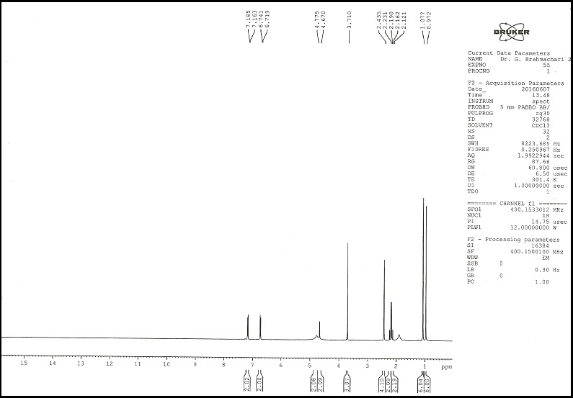

Fig.S1(a)
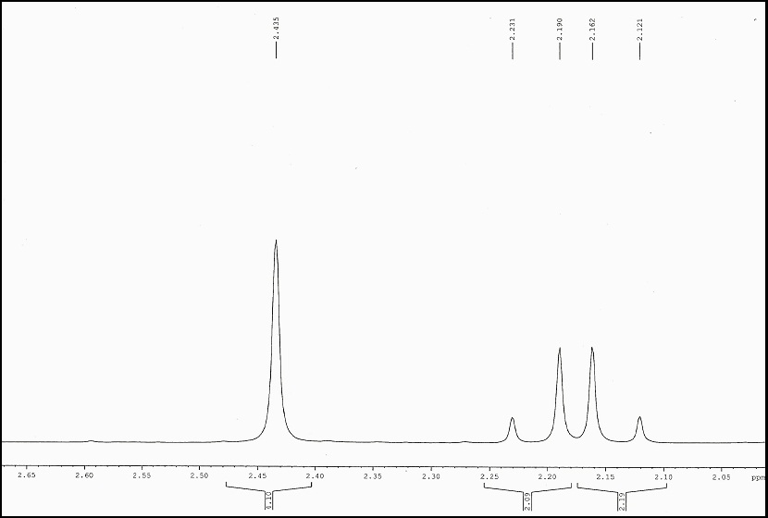

Fig. S1(b) (extended scale-I)

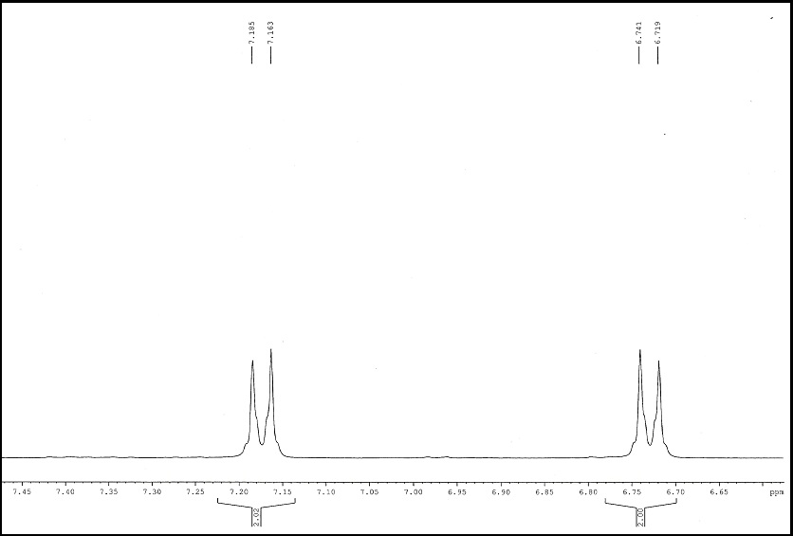
Fig. S1(c) (extended scale-II)

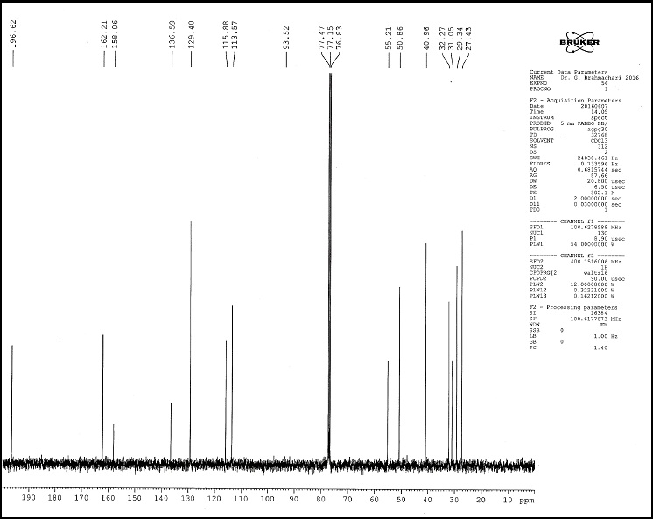
Fig. S1 (d) ¹³C NMR MTDOSA

Fig.S2: Experimental NMR plot of NTDOSA
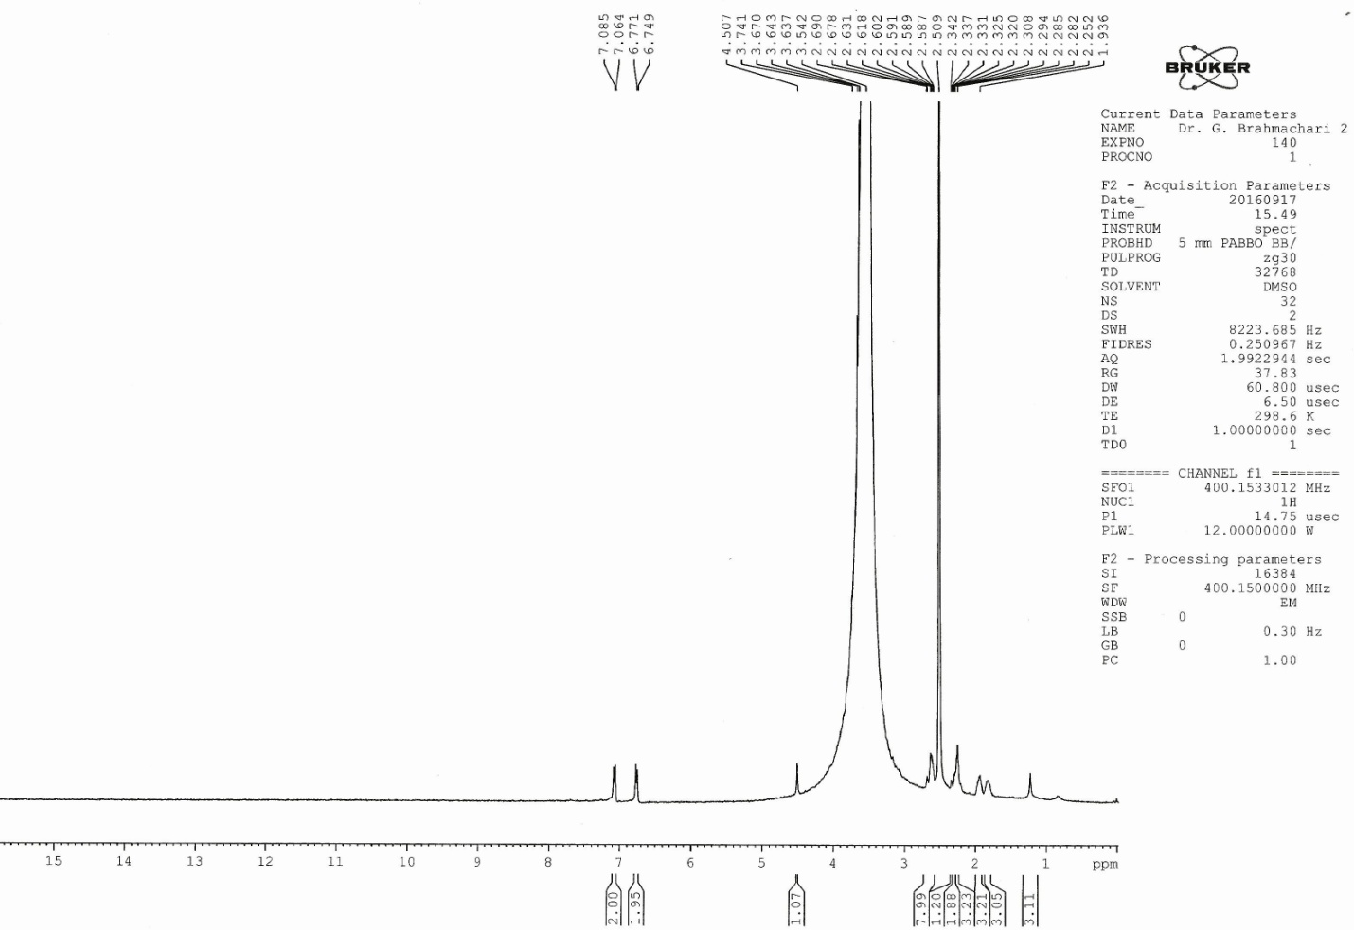

Fig. S2(a)

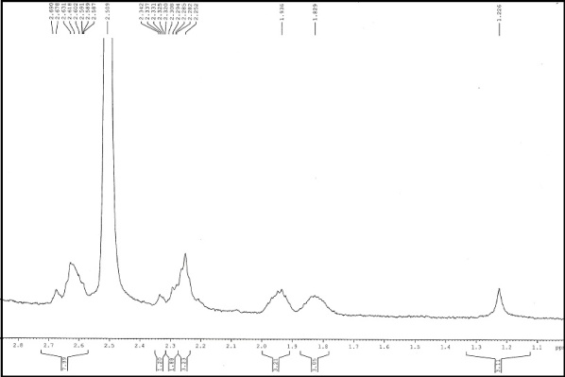
Fig. S2(b) (extended scale-I)

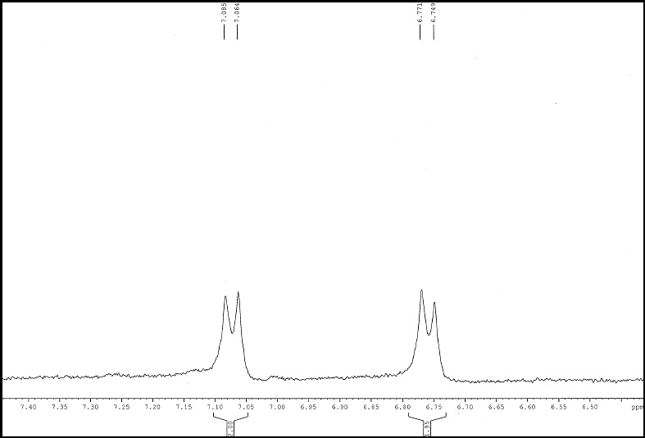

Fig. S2(c) (extended scale-II)

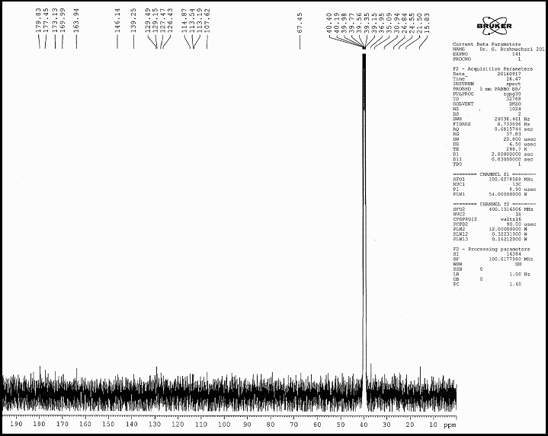

Fig. S2(d) ¹³C NMR NTDOSA

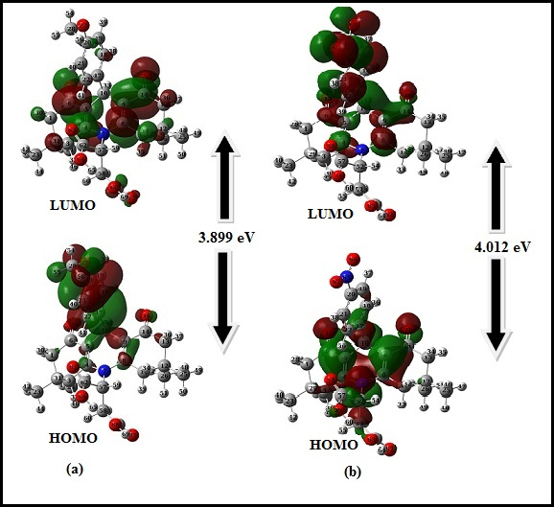
Fig.S3: HOMO, LUMO plots of (a) MTDOSA (b) NTDOSA molecules

Table S-I: Optimized geometric parameter for MTDOSA.
Parameter | DFT/B3LYP6311++G(d,p) |  | Parameter |  | DFT/B3LYP6311++G(d,p)
Bond length, Å |  |  | C20-O27-C28 118.42
C1-C2 | 1.537 |  | N7-C57-C58 |  | 114.08
C1-C6 | 1.518 |  | C58-C57-C62 |  | 113.74
C2-C3 | 1.546 |  | C57-C58-C66 | 114.52
C3-C4 | 1.515 |  | C57-C62-O63 |  | 124.04
C4-C5 | 1.355 |  | C57-C62-O64 |  | 115.14
C4-N7 | 1.416 |  | O63-C62-O64 |  | 120.79
C5-C6 | 1.476 |  | C58-C66-O67 |  | 126.75
C5-C10 | 1.511 |  | C58-C66-O68 |  | 111.28
C6-O15 | 1.220 |  | O67-C66-O68 |  | 121.96
N7-C8 | 1.415 |  | Dihedral Angle (in degree)
N7-C57 | 1.461 |  | C6-C1-C2-C3 |  | 53.25
C8-C9 | 1.354 |  | C6-C1-C2-C23 |  | 171.72
C8-C11 | 1.516 |  | C6-C1-C2-C24 |  | -67.97
C9-C10 | 1.515 |  | C2-C1-C6-C5 |  | -33.75
C9-C14 | 1.475 |  | C2-C1-C6-O15 |  | 147.79
C10-C17 | 1.534 |  | C1-C2-C3-C4 |  | -59.60
C11-C12 | 1.547 |  | C23-C2-C3-C4 |  | -168.84
C12-C13 | 1.536 |  | C24-C2-C3-C4 |  | 71.36
C12-C25 | 1.537 |  | C2-C3-C4-C5 |  | 26.53
C12-C26 | 1.541 |  | C2-C3-C4-N7 |  | -151.00
C13-C14 | 1.519 |  | C3-C4-C5-C6 |  | -3.83
C14-O16 | 1.221 |  | C3-C4-C5-C10 |  | 176.63
C17-C18 | 1.402 |  | N7-C4-C5-C6 |  | 173.66
C17-C22 | 1.393 |  | N7-C4-C5-C10 |  | -5.87
C18-C19 | 1.386 |  | C3-C4-CN7-C8 |  | 159.64
C19-C20 | 1.399 |  | C3-C4-N7-C57 |  | -23.90
C20-C21 | 1.395 |  | C5-C4-N7-C8 |  | -17.94
C20-O27 | 1.369 |  | C3-C4-N7-C57 |  | 158.50
C21-C22 | 1.398 |  | C4-C5-C6-C1 |  | 7.42
O27-C28 | 1.418 |  | C4-C5-C6-O15 |  | -174.13
C57-C58 | 1.576 |  | C10-C5-C6-C1 |  | -173.01
C57-C62 | 1.551 |  | C10-C5-C6-O15 |  | 4.43
C58-C66 | 1.511 |  | C4-C5-C10-C9 |  | 26.43
C62-O63 | 1.197 |  | C4-C5-C10-C17 |  | -99.03
C62-O64 | 1.346 |  | C6-C5-C10-C9 |  | -153.12
O64-H65 | 0.973 |  | C6-C5-C10-C17 |  | 81.41
C66-O67 | 1.198 |  | C4-N7-C8-C9 |  | 17.88
C66-O68 | 1.372 |  | C4-N7-C8-C11 |  | -159.18
O68-H69 | 0.97 |  | C57-N7-C8-C9 |  | -158.71
Bond Angle (in degree) |  |  | C57-N7-C8-C11 |  | 24.21
C2-C1-C6 | 113.48 |  | C4-N7-C57-C58 |  | 79.23
C1-C2-C3 | 107.84 |  | C4-N7-C57-C62 |  | -52.58
C1-C2-C23 | 109.97 |  | C8-N7-C57-C58 |  | -104.31
C1-C2-C24 | 110.42 |  | C8-N7-C57-C62 |  | 123.87
C3-C2-C23 | 108.77 |  | N7-C8-C9-C10 |  | 6.00
C3-C2-C24 | 110.83 |  | N7-C8-C9-C14 |  | -173.13
C23-C2-C24 | 108.98 |  | C11-C8-C9-C10 |  | -177.07
C2-C3-C4 | 114.11 |  | C11-C8-C9-C14 |  | 3.79
C3-C4-C5 | 121.87 |  | N7-C8-C11-C12 |  | 151.92
C3-C4-N7 | 118.33 |  | C9-C8-C11-C12 |  | -25.08
C5-C4-N7 | 119.74 |  | C8-C9-C10-C5 |  | -26.41
C4-C5-C6 | 120.89 |  | C8-C9-C10-C17 |  | 99.90
C4-C5-C10 | 122.20 |  | C14-C9-C10-C5 |  | 152.75
C6-C5-C10 | 116.90 |  | C14-C9-C10-C17 |  | -80.94
C1-C6-C5 | 117.96 |  | C8-C9-C14-C13 |  | -8.69
C1-C6-O15 | 120.76 |  | C8-C9-C14-O16 |  | 172.84
C5-C6-O15 | 121.27 |  | C10-C9-C14-C13 |  | 172.14
C4-N7-C8 | 118.69 |  | C10-C9-C14-O16 |  | -6.32
C4-N7-C57 | 122.68 |  | C5-C10-C17-C18 |  | -149.36
C8-N7-C57 | 118.52 |  | C5-C10-C17-C22 |  | 41.44
N7-C8-C9 | 120.31 |  | C9-C10-C17-C18 |  | 96.70
N7-C8-C11 | 117.41 |  | C9-C10-C17-C22 |  | -82.49
C9-C8-C11 | 122.22 |  | C8-C11-C12-C13 |  | 48.17
C8-C9-C10 | 121.61 |  | C8-C11-C12-C25 |  | 167.80
C8-C9-C14 | 120.79 |  | C8-C11-C12-C26 |  | -72.65
C10-C9-C14 | 117.58 |  | C11-C12-C13-C14 |  | -53.15
C5-C10-C9 | 109.09 |  | C25-C12-C13-C14 |  | -172.02
C5-C10-C17 | 113.38 |  | C26-C12-C13-C14 |  | 67.63
C9-C10-C17 | 111.93 |  | C12-C13-C14-C9 |  | 34.93
C8-C11-C12 | 114.22 |  | C12-C13-C14-O16 |  | -146.59
C11-C12-C13 | 108.10 |  | C10-C17-C18-C19 |  | -179.00
C11-C12-C25 | 108.90 |  | C22-C17-C18-C19 |  | -0.21
C11-C12-C26 |  | 110.34 | C10-C17-C22-C21 |  | 179.05
C13-C12-C25 | 110.11 |  | C18-C17-C22-C21 |  | -0.15
C13-C12-C26 | 110.41 |  | C17-C18-C19-C20 |  | -0.14
C25-C12-C26 | 108.96 |  | C18-C19-C20-C21 |  | 0.01
C12-C13-C14 | 113.47 |  | C18-C19-C20-O27 |  | -179.77
C9-C14-C13 | 117.88 |  | C19-C20-C21-C22 |  | 0.07
C9-C14-O16 | 121.44 |  | O27-C20-C21-C22 |  | 179.81
C13-C14-O16 | 120.66 |  | C19-C20-O27-C28 |  | 178.73
C10-C17-C18 | 119.85 |  | C21-C20-O27-C28 |  | -1.02
C10-C17-C22 | 122.16 |  | C20-C21-C22-C17 |  | 0.02
C18-C17-C22 | 117.98 |  | N7-C57-C58-C66 |  | 129.19
C17-C18-C19 | 121.23 |  | C62-C57-C58-C66 |  | -99.43
C18-C19-C20 | 120.17 |  | N7-C57-C62-O63 |  | -1.65
C19-C20-C21 | 119.46 |  | N7-C57-C62-O64 |  | -179.67
C19-C20-O27 | 115.94 |  | C58-C57-C62-O63 |  | -133.63
C21-C20-O27 | 124.61 |  | C58-C57-C62-O64 |  | 48.34
C20-C21-C22 | 119.67 |  | C57-C58-C66-O67 |  | -124.96
C17-C22-C21 | 121.49 |  | C57-C58-C66-O68 |  | 55.32

Table S-II: Optimized geometric parameters for NTDOSA.
Parameter | DFT/B3LYP6311++G(d,p) |  | Parameter | DFT/B3LYP6311++G(d,p)
Bond length, Å |  |  | H54-C52-C57 | 102.47
C1-C2 | 1.538 |  | C52-C53-C61 |  | 114.29
C1-C6 | 1.517 |  | C52-C57-O58 | 125.45
C2-C3 | 1.548 |  | C52-C57-O59 | 115.45
C2-C23 | 1.538 |  | O58-C57-O59 | 120.92
C2-C24 | 1.541 |  | C57-O59-H60 | 113.01
C3-C4 | 1.514 |  | C53-C61-O62 | 126.68
C4-C5 | 1.355 |  | C53-C61-O63 | 111.22
C4-N7 | 1.415 |  | O62-C61-O63 | 122.09
C5-C6 | 1.476 |  | C61-O63-H64 | 109.16
C5-C10 | 1.510 |  | C20-N65-O66 | 117.88
C6-O15 | 1.221 |  | C20-N65-O67 | 117.85
N7-C8 | 1.4132 |  | O66-C65-O67 | 124.27
N7-C52 | 1.4637 |  | Dihedral Angle (in degree)
C8-C9 | 1.355 |  | C6-C1-C2-C3 | 52.83
C8-C11 | 1.516 |  | C6-C1-C2-C23 | 171.23
C9-C10 | 1.515 |  | C6-C1-C2-C24 | -68.48
C9-C14 | 1.475 |  | C2-C1-C6-C5 | -32.48
C10-C17 | 1.534 |  | C2-C1-C6-O15 | 159.65
C11-C12 | 1.547 |  | C1-C2-C3-C4 | -49.73
C12-C13 | 1.573 |  | C23-C2-C3-C4 | -169.93
C12-C25 | 1.537 |  | C24-C2-C3-C4 | 71.35
C12-C26 | 1.542 |  | C2-C3-C4-C5 | 26.26
C13-C14 | 1.517 |  | C2-C3-C4-N7 | -151.12
C14-O16 | 1.221 |  | C3-C4-C5-C6 | -2.74
C17-C18 | 1.400 |  | C3-C4-C5-C10 | 177.47
C17-C22 | 1.400 |  | N7-C4-C5-C6 | 174.61
C18-C19 | 1.389 |  | N7-C4-C5-C10 | -5.16
C19-C20 | 1.391 |  | C3-C4-N7-C8 | 159.78
C20-C21 | 1.391 |  | C3-C4-N7-C52 | -24.86
C20-N65 | 1.475 |  | C5-C4-N7-C8 | -17.68
C21-C22 | 1.390 |  | C5-C4-N7-C52 | 157.69
C52-C53 | 1.574 |  | C4-C5-C6-C1 | 5.82
C52-C57 | 1.552 |  | C4-C5-C6-O15 | -176.03
C53-C61 | 1.511 |  | C10-C5-C6-C1 | -174.38
C57-O58 | 1.198 |  | C10-C5-C6-O15 | 3.75
C57-O59 | 1.344 |  | C4-C5-C10-C9 | 24.95
C61-O62 | 1.198 |  | C4-C5-C10-C17 | -100.29
C61-O63 | 1.371 |  | C6-C5-C10-C9 | -154.83
N65-O66 | 1.226 |  | C6-C5-C10-C17 | 79.91
N65-O67 | 1.227 |  | C4-N7-C8-C9 | 17.54
Bond Angle (in degree) |  |  | C4-N7-C8-C11 | -159.31
C2-C1-C6 | 113.55 |  | C52-N7-C8-C9 | -157.99
C1-C2-C3 | 107.96 |  | C52-N7-C8-C11 | 25.14
C1-C2-C23 | 109.92 |  | C4-N7-C52-C53 | 79.63
C1-C2-C24 | 110.48 |  | C4-N7-C52-C57 | -52.35
C3-C2-C23 | 108.67 |  | C8-N7-C52-C53 | -105.01
C3-C2-C24 | 110.45 |  | C8-N7-C52-C57 | 123.01
C23-C2-C24 | 108.97 |  | N7-C8-C9-C10 | 5.38
C2-C3-C4 | 113.11 |  | N7-C8-C9-C14 | -173.33
C3-C4-C5 | 121.67 |  | C11-C8-C9-C10 | -177.89
C3-C4-N7 | 118.40 |  | C11-C8-C9-C14 | 3.38
C5-C4-N7 | 119.87 |  | N7-C8-C11-C12 | 151.56
C4-C5-C6 | 121.13 |  | C9-C8-C11-C12 | -25.25
C4-C5-C10 | 122.31 |  | C8-C9-C10-C5 | -24.99
C6-C5-C10 | 116.55 |  | C8-C9-C10-C17 | 101.23
C1-C6-C5 | 118.04 |  | C14-C9-C10-C5 | 153.77
C1-C6-O15 | 121.98 |  | C14-C9-C10-C17 | -79.99
C5-C6-O15 | 120.94 |  | C8-C9-C14-C13 | -7.80
C4-N7-C8 | 118.74 |  | C8-C9-C14-C16 | 173.90
C4-N7-C52 | 122.51 |  | C10-C9-C14-C13 | 173.41
C8-N7-C52 | 118.58 |  | C10-C9-C14-O16 | -4.87
N7-C8-C9 | 120.46 |  | C5-C10-C17-C18 | -138.92
N7-C8-C11 | 117.42 |  | C5-C10-C17-C22 | 41.97
C9-C8-C11 | 122.02 |  | C9-C10-C17-C18 | 97.10
C8-C9-C10 | 121.68 |  | C9-C10-C17-C22 | -81.99
C8-C9-C14 | 120.94 |  | C8-C11-C12-C13 | 48.43
C10-C9-C14 | 117.35 |  | C8-C11-C12-C25 | 168.02
C5-C10-C9 | 109.29 |  | C8-C11-C12-C26 | -72.36
C5-C10-C17 | 113.35 |  | C11-C12-C13-C14 | -52.92
C9-C10-C17 | 111.66 |  | C25-C12-C13-C14 | -171.74
C8-C11-C12 |  | 114.23 | C26-C12-C13-C14 | 67.84
C11-C12-C13 | 108.11 |  | C12-C13-C14-C9 | 34.15
C11-C12-C25 | 108.88 |  | C12-C13-C14-O16 | -147.55
C11-C12-C26 | 110.34 |  | C10-C17-C18-C19 | -178.81
C13-C12-C25 | 110.08 |  | C10-C17-C22-C21 | 178.78
C13-C12-C26 | 110.38 |  | C18-C17-C22-C21 | -0.32
C25-C12-C26 | 109.02 |  | C17-C18-C19-C20 | 0.012
C12-C13-C14 | 113.53 |  | C18-C19-C20-C21 | -0.29
C9-C14-C13 | 117.95 |  | C18-C19-C20-N65 | 179.90
C9-C14-O16 | 121.18 |  | C19-C20-C21-C22 | 0.28
C13-C14-O16 | 120.83 |  | N65-C20-C21-C22 | -179.91
C10-C17-C18 | 119.58 |  | C19-C20-N65-O66 | 0.01
C10-C17-C22 | 121.48 |  | C19-C20-N65-O67 | -179.85
C18-C17-C22 | 118.92 |  | C21-C20-N65-O66 | -179.80
C17-C18-C19 | 120.94 |  | C21-C20-N65-O67 | 0.33
C18-C19-C20 | 118.77 |  | C20-C21-C22-C17 | -0.02
C19-C20-C21 | 121.68 |  | N7-C52-C53-C61 | 130.24
C19-C20-N65 | 119.20 |  | C57-C52-C53-C61 | -98.68
C21-C20-N65 | 119.11 |  | N7-C52-C57-O58 | -3.19
C20-C21-C22 | 118.81 |  | N7-C52-C57-O59 | 178.86
C17-C22-C21 | 120.86 |  | C53-C52-C57-O58 | -135.10
N7-C52-C53 | 114.06 |  | C53-C52-C57-O59 | 46.95
N7-C52-C57 | 112.32 |  | C52-C53-C61-O62 | -122.93
C53-C52-C57 | 114.21 |  | C52-C53-C61-O63 | 57.14

Table. S-III: Vibrational analysis of prominent modes of MTDOSA at the B3LYP/6-311++G (d,p) level.
Cal. Frequency,  cm⁻¹ | Scaled Frequency, cm⁻¹ | Exp. FTIR Frequency,  cm⁻¹ | Assignment
3753 | 3630 | 3630 | ν_{as}[O-H)(99)]
3644 | 3523 | 3312 | ν_{s}[O-H)(99)]
3203 | 3097 | 3069 | ν_{as} [C-H)R1(94)]
3195 | 3090 |  | ν_{as} [C-H)R1(98)]
3188 | 3083 |  | ν_{s} [C-H)R1(89)]
3180 | 3075 |  | ν_{as} [C-H)R1(98)]
3148 | 3045 |  | ν_{as} [C-H) CH₂ (98)]
3127 | 3024 |  | ν_{as} [C-H) CH₃-O (91)]
3104 | 3002 | 3002 | ν_{as} [C-H)R2 (91)]
3099 | 2997 |  | ν_{as} [C-H)CH₃-R4 (76)]
3098 | 2996 |  | ν_{as} [C-H)CH₃-R2(64)]
3097 | 2995 |  | ν[C57-H59 (94)]
3090 | 2988 |  | ν_{s} [C-H)CH₃-R4 (54)]
3089 | 2987 |  | ν_{as} [C-H)CH₃-R2(83)]
3085 | 2983 |  | ν_{as} [C-H)CH₃-R4(68)]
3083 | 2981 |  | ν [C-H)R2 (54)]
3083 | 2981 |  | ν_{as} [C-H){R2(44)+CH₃-R2(26)}]
3081 | 2979 |  | ν_{as} [(C-H){R2+R3+CH₃-R2}(70)]
3080 | 2979 |  | ν_{as} [(C-H){R2+R3+CH₃-R2}(70)]
3077 | 2976 |  | ν_{as} [C-H)CH₃-R4(89)]
3075 | 2974 |  | ν_{as} [C-H)CH₃-R2(84)]
3061 | 2960 | 2959 | ν_{as} [C-H)R4 (69)]
3058 | 2957 |  | ν_{s} [C-H)CH₂ (87)]
3055 | 2954 |  | ν_{as} [C-H)CH₃-O-R1(100)]
3043 | 2943 |  | ν_{s} [C-H)R2 (79)]
3026 | 2926 |  | ν_{s} [C-H)CH₃-R4 (87)]
3023 | 2923 |  | ν_{s} [C-H)CH₃-R2 (31)]
3016 | 2916 |  | ν_{s} [C-H)CH₃-R4 (71)]
3015 | 2915 |  | ν_{as} [C-H)CH₃-R2(78)]
3007 | 2908 |  | ν_{s} [C-H)R2 (73)]
3004 | 2905 |  | ν_{s} [C-H)R24(76)]
2999 | 2900 |  | ν_{s} [C-H)CH₃-O-R1(91)]
2985 | 2886 | 2877 | ν_{s} [C-H)R4 (72)]
1846 | 1785 | 1808 | ν_{s} [(O=C)COOH(74)]
1836 | 1776 | 1731 | ν_{s} [(O=C)COOH(82)]
1722 | 1665 | 1668 | ν_{s} [(O=C)R2+R4(89)]
1716 | 1660 |  | ν [(O=C)R4(64)]
1678 | 1622 | 1618 | ν_{s} [(C=C)R3(68)]
1648 | 1593 | 1600 | ν_{as} [C-C)R1(62)]+ β [(H-C-C)R1(19)]
1627 | 1573 | 1575 | ν_{as} [(C=C)R3(71)]
1616 | 1563 | 1556 | ν_{as} [C-C)R1(43)]
1540 | 1489 | 1510 | β [(H-C-C)R1(48)]
1514 | 1464 |  | β_{O} [(H-C-H)CH₃-R2(48)]
1513 | 1463 | 1461 | β_{O} [(H-C-H)CH₃-R4(59)]
1507 | 1457 |  | β_{O} [(H-C-H)CH₃-R4(55)]
1506 | 1456 |  | β_{O} [(H-C-H)CH₃-R2(51)]
1505 | 1456 |  | β_{O} [(H-C-H)CH₃-0-R1(72)]
1500 | 1450 |  | β_{O} [(H-C-H)CH₃-R2+R2(39)]
1498 | 1449 |  | β_{O} [(H-C-H)CH₃-R4+R4(52)]
1491 | 1442 |  | β_{O} [(H-C-H)CH₃-O-R1(73)]
1490 | 1441 |  | β_{O} [(H-C-H)CH₃-R2+R2(54)]
1489 | 1440 | 1440 | β_{O} [(H-C-H)CH₃-R4(34)]
1483 | 1434 | 1434 | β_{O} [(H-C-H)CH₃-R2+R2(56)]
1481 | 1433 |  | β_{O} [(H-C-H)R4+CH₂(43)]
1475 | 1427 |  | β_{O} [(H-C-H)R4+CH₂(64)]
1474 | 1426 |  | β_{O} [(H-C-H)CH₃-O-R1(84)]
1463 | 1415 |  | β_{O} [(H-C-H)CH₃-R4+R4(73)]
1461 | 1413 |  | β_{O} [(H-C-H)CH₃-R2+R2(61)]
1455 | 1407 |  | β [(H-C-C)R1(30)]
1439 | 1391 |  | τ_{i}[{(H-C-C-N)(R3+R4)+(H-C-C-O)(COOH)}(22)]
1424 | 1377 |  | β_{O} [(H-C-H)CH₃-R4(42)]
1423 | 1376 |  | β_{O} [(H-C-H)CH₃-R1+R1(74)]
1403 | 1356 | 1360 | β_{O} [(H-C-H)CH₃-R4(79)]
1402 | 1357 |  | β_{O} [(H-C-H)CH₃-R1(22)]
1385 | 1339 | 1328 | τ_{i}[{(H-C-C-N)(R3+R4)+(H-C-C-O)(COOH)}(18)]
1361 | 1316 |  | β [(H-O-C)COOH(63)]
1352 | 1308 |  | ν_{s} [C6-C5+C14-C9) (20)]
1346 | 1301 | 1301 | β_{O} [(H-C-H)CH₂-R4(23)]
1340 | 1295 |  | ν_{s} [(C-C)R1 (20)]+ β [(H-C-C)R1(57)]
1318 | 1275 | 1260 | β [(H-O-C)COOH(19)]
1268 | 1226 | 1233 | ν [O27-C20) (34)]
1264 | 1222 |  | ν_{as} [(N-C)R3 (17)]
1249 | 1208 |  | ν [N7-C57) (20)]
1235 | 1195 | 1194 | β_{O} [(H-C-C)CH₂(34)]
1204 | 1164 | 1163 | β [(H-C-C)R1(58)]
1201 | 1161 |  | τ_{i}[(H-C-O-C)CH3-O-R1(48)]
1183 | 1143 |  | ν [(O-C) COOH(17)]
1168 | 1130 | 1137 | β_{O} [(H-C-H)CH₃-O-R1(19)]+ τ_{i}[(H-C-O-C)CH3-O-R1(54)]
1146 | 1108 | 1106 | ν [(O-C) COOH(26)]+ β [(H-O-C)COOH(19)]
1142 | 1104 |  | β_{O} [(H-C-C)R2(21)]
1139 | 1101 |  | β_{O} [(H-C-C)R1(25)]
1136 | 1099 |  | β [(H-C-C)R1(34)]
1123 | 1086 |  | ν [(C-C) R1+R2(20)]
1063 | 1028 | 1031 | ν [O27-C28) (72)]
1036 | 1002 |  | τ_{i}[(H-C-C-C)CH3-R4+R4(21)]
1034 | 999 | 998 | τ_{i}[(H-C-C-C)CH3-R2(21)]
1027 | 993 |  | β [(H-C-C)R1(19)]+ β [(C-C-C)R1(60)]
985 | 953 |  | τ_{i}[(H-C-C-C)R1(86)]
968 | 936 | 934 | τ_{i}[(H-C-C-C)R1(51)]
948 | 917 |  | τ_{i}[(H-C-C-C)CH₃-R1(20)]
944 | 913 | 910 | β [(C-C-N)R1+R2+R3(20)]
905 | 875 | 882 | τ_{i}[(H-C-C-C)R2(26)]
864 | 836 | 845 | τ_{i}[(H-C-C-C)R1(24)]
826 | 799 | 806 | τ_{i}[(H-C-C-C)R1(66)]
784 | 758 | 776 | ν [O27-C20) (18)]
760 | 735 | 722 | τ_{o} [(O-C-O-C)COOH(41)]
688 | 665 | 685 | τ_{i}[(H-O-C-C)COOH(20)]
666 | 644 | 651 | τ_{i}[(H-O-C-C)COOH(38)]
644 | 623 | 637 | τ_{o} [{(O15-C1-C5-C6)(R2+(O-C-O-C)(COOH)}(18)]
642 | 621 | 606 | β [(O-C-O)COOH(20)]
597 | 577 | 567 | τ_{i}[(H-O-C-C)COOH(24)]
541 | 523 | 532 | τ_{i}[(H-O-C-C)COOH(27)]
426 | 412 | 422 | τ_{i}[(C-C-C-C)R1+R3(75)]
399 | 386 | 415 | β [(C58-C57-N7)(19)]
392 | 379 |  | β [(O-C-C)COOH(42)]
385 | 373 |  | τ_{o}[(H-C-C-C)R2(23)]
285 | 275 |  | β [(C-O-C)CH₃-O-R1(22)]
237 | 229 |  | τ_{i}[(H-C-O-C)CH₃-O-R1(46)]
228 | 220 |  | τ_{i}[(H-C-C-C)CH₃-R2(22)]
222 | 215 |  | τ_{i}[(H-C-C-C)CH₃-R4+R4(19)]
152 | 147 |  | τ_{i}[(H-C-C-C)CH₃-R4+R4(18)]
141 | 136 |  | β [(C-C-C)R2+R4(20)]
106 | 102 |  | τ_{i}[(C-C-C-C)R2(24)]
84 | 81 |  | τ_{i}[(C-C-C-C)CH₃-O-R1(24)]
79 | 76 |  | τ_{i}[(C-C-C-C)CH₃-O-R1(20)]
63 | 61 |  | τ_{i}[(O-C-C-C)COOH(35)]
61 | 59 |  | τ_{i}[(C-C-C-C)R1+R2+R3+R4(26)]
43 | 42 |  | τ_{i}[(C57-C4-C8-N7)(27)]
ν: stretching; ν_{s}: symmetric stretching; ν_{as}: anti-symmetric stretching; β: bending in-plane; β_{O}: bending out-of-plane; τ_{i}: torsion in plane; τ_{o} : torsion out-of-plane

Table S-IV: Vibrational analysis of prominent modes of NTDOSA at the B3LYP/6-311++G (d, p) level
Calculated Freq., cm⁻¹ | Scaled Freq., cm⁻¹ | Exp. Freq., cm⁻¹ | Assignment
3751 | 3627 | 3631 | ν_{as}[(O-H)COOH(100)]
3637 | 3517 | 3312 | ν_{s}[(O-H)COOH(99)]
3221 | 3115 |  | ν_{s} [C-H)R1(91)]
3220 | 3114 |  | ν_{as} [C-H)R1(92)]
3200 | 3094 |  | ν_{s} [C-H)R1(82)]
3199 | 3093 | 3069 | ν_{as} [C-H)R1(82)]
3148 | 3045 |  | ν_{as} [C-H) CH₂ (90)]
3104 | 3002 | 3002 | ν_{as} [C-H)R2(82)]
3099 | 2997 |  | ν_{as} [C-H) CH₃-R4 (79)]
3096 | 2993 |  | ν [C52-H54)(95)]
3091 | 2989 |  | ν_{as} [C-H) CH₃-R4 (46)]
3090 | 2988 |  | ν_{as} [C-H) CH₃-R2 (82)]
3087 | 2985 |  | ν_{as} [C-H) CH₃-R4 (69)]
3086 | 2983 |  | ν_{as} [C-H) CH₃-R2+R2 (77)]
3085 | 2983 |  | ν_{as} [C-H) R4 (62)]
3082 | 2981 |  | ν_{as} [C-H) CH₃-R2+R2 (26)]
3080 | 2979 |  | ν [C-H)R3(90)]
3080 | 2978 |  | ν_{as} [C-H) CH₃-R4 (87)]
3077 | 2975 |  | ν_{as} [C-H) CH₃-R2 (83)]
3063 | 2962 |  | ν [C-H)R4(71)]
3060 | 2959 | 2959 | ν [C53-H56)(87)]
3041 | 2941 |  | ν_{as} [C-H) R2 (78)]
3027 | 2927 |  | ν_{s} [C-H) CH₃-R4 (79)]
3024 | 2924 |  | ν_{s} [C-H) CH₃-R2 (29)]
3017 | 2918 |  | ν_{s} [C-H) CH₃-R4 (70)]
3016 | 2916 |  | ν_{s} [C-H) CH₃-R4 (70)]
3009 | 2909 |  | ν_{s} [C-H) R2 (74)]
3006 | 2907 |  | ν_{s} [C-H) R4 (74)]
2988 | 2889 | 2877 | ν_{s} [C-H) R4 (73)]
1845 | 1784 | 1808 | ν_{s} [O=C) COOH (84)]
1835 | 1775 | 1731 | ν_{s} [O=C) COOH (82)]
1721 | 1665 | 1668 | ν_{s} [O=C) R2+R4 (90)]
1716 | 1659 |  | ν [O=C) R2 (68)]
1678 | 1623 | 1618 | ν_{s} [C=C) R3 (67)]
1642 | 1588 | 1586 | ν_{as} [C-C) R1(36)]
1633 | 1579 | 1576 | ν_{as} [C-C) R1(28)]+ β [(H-C-C)R1(18)]
1624 | 1571 | 1556 | ν_{as} [C=C) R3 (73)]
1569 | 1517 | 1510 | ν_{as} [(O-N) NO₂ (77)]
1523 | 1472 |  | β [(H-C-C)R1(63)]
1514 | 1464 |  | β_{O} [(H-C-H)CH₃-R2(40)]
1513 | 1463 | 1461 | β_{O} [(H-C-H)CH₃-R4(61)]
1508 | 1458 |  | β_{O} [(H-C-H)CH₃-R4(57)]
1506 | 1457 |  | β_{O} [(H-C-H)CH₃-R2(56)]
1499 | 1449 |  | β_{O} [(H-C-H)CH₃-R4+R4(57)]
1498 | 1448 |  | β_{O} [(H-C-H)CH₃-R2+R2(66)]
1490 | 1441 | 1440 | β_{O} [(H-C-H)CH₃-R2+R2(51)]
1489 | 1440 |  | β_{O} [(H-C-H)CH₃-R4(42)]
1482 | 1433 | 1434 | β_{O} [(H-C-H)R4+CH₂(54)]
1481 | 1432 |  | β_{O} [(H-C-H)CH₃-R2+R2(55)]
1477 | 1428 |  | β_{O} [(H-C-H)R4+CH₂(66)]
1463 | 1414 |  | β_{O} [(H-C-H)CH₃-R4+R4(71)]
1461 | 1413 |  | β_{O} [(H-C-H)CH₃-R2+R2(61)]
1454 | 1406 |  | ν_{as} [C-C) R1(19)]+ β [(H-C-C)R1(25)]
1436 | 1389 |  | τ_{i}[{(H-C-C-N)(R3+R4)+(H-C-C-O)(COOH)}(21)]
1427 | 1380 |  | β_{O} [(H-C-H)CH₃-R4(60)]
1423 | 1376 |  | β_{O} [(H-C-H)CH₃-R2+R2(90)]
1405 | 1359 | 1360 | β_{O} [(H-C-H)CH₃-R4(87)]
1402 | 1356 |  | β_{O} [(H-C-H)CH₃-R2(42)]
1384 | 1338 | 1328 | τ_{i}[{(H-C-C-N)(R3+R4)+(H-C-C-O)(COOH)}(16)]
1366 | 1321 |  | ν_{s} [C-H) NO₂-R1 (66)]
1361 | 1316 |  | β [(H-O-C)COOH(54)]
1355 | 1310 |  | ν_{s} [C-C) R2+R4(16)]
1346 | 1302 | 1301 | β [(H-C-C)R1(28)]+ β_{O} [(H-C-C)R2+CH₂(17)]
1343 | 1299 |  | β [(H-C-C)R1(28)]
1319 | 1276 |  | β [(H-O-C)COOH(16)]
1296 | 1253 |  | β [(H-O-C)COOH(19)]
1265 | 1223 |  | ν_{as} [(N-C) R3(19)]
1248 | 1207 |  | ν_{as} [(N-C) R3(34)]
1233 | 1192 |  | β_{O} [(H-C-C)COOH(34)]
1211 | 1171 |  | β [(H-C-C)R1(51)]
1209 | 1169 |  | β [(H-C-C)R1(16)]
1187 | 1148 | 1137 | ν_{as} [O-C) COOH(19)]
1145 | 1107 | 1108 | ν_{as} [O-C) COOH(24)]+ β [(H-O-C)COOH(17)]
1143 | 1105 |  | β_{O} [(H-C-H)R2(23)]
1140 | 1102 |  | β_{O} [(H-C-H)R4(23)]
1135 | 1097 |  | β [(H-C-C)R1(46)]
1122 | 1085 |  | ν_{as} [C-C) R2+R3(18)]
1118 | 1081 | 1031 | ν [N-C) NO₂+R1(21)]
1036 | 1002 |  | τ_{i}[{(H-C-C-C)(CH3-R2+R2)(16)]
1034 | 1000 |  | τ_{i}[{(H-C-C-C)(CH3-R2)(21)]
1033 | 998 | 998 | β [(C-C-C)R1(69)]
1014 | 981 |  | β [(H-C-C)R1(65)]
997 | 964 | 934 | τ_{i}[{(H-C-C-C)(R1)(57)]
952 | 921 |  | ν_{as} [C-C) CH₃-R4+R4(24)]+ τ_{i}[{(H-C-C-C)(CH₃-R4)(17)]
950 | 919 |  | τ_{i}[{(H-C-C-C)(CH₃-R4)(18)]
944 | 913 | 910 | β [(H-C-C)R1+R2+R3(18)]
904 | 875 | 882 | τ_{i}[{(H-C-C-C)(R2)(27)]
892 | 863 |  | τ_{i}[{(H-C-C-C)(R1)(43)]
877 | 848 | 845 | τ_{i}[{(H-C-C-C)(R1)(95)]
871 | 842 |  | ν_{as} [(O-C) COOH(17)]
859 | 830 |  | τ_{i}[{(H-C-C-C)(R1)(93)]
837 | 810 | 811 | β [(O-N-C)NO₂(17)]
788 | 762 | 776 | ν_{as} [(C-C) CH3-R2+R2(16)]
761 | 736 |  | τ_{o}[{(O-C-C-C)(R1)+(O-C-O-C)COOH}(40)]
743 | 719 | 722 | τ_{o}[(O-C-O-N)(NO₂-R1)(40)]
712 | 689 |  | τ_{o}[(O-C-O-N)(NO₂-R1)(19)]
708 | 684 | 685 | τ_{o}[(O-C-O-N)(NO₂-R1)(21)]
690 | 667 | 667 | τ_{i}[(H-O-C-C)(COOH)(21)]
666 | 644 |  | τ_{i}[(H-O-C-C)(COOH)(35)]
642 | 621 |  | β [(O-N-O)COOH(17)]
640 | 618 |  | β [(C-C-C)R1+R3(41)]
621 | 600 |  | β [(O-N-O)COOH(18)]
594 | 574 |  | β [(O-N-O)COOH(18)]+ τ_{i}[(H-O-C-C)(COOH)(20)]
576 | 557 |  | β [(O-C-C)R2+R4(25)]
543 | 525 | 5532 | τ_{i}[(H-O-C-C)(COOH)(30)]
539 | 521 |  | β [(O-N-C)NO₂-R1(26)]
534 | 516 |  | β [(O-N-C)NO₂-R1(19)]
517 | 500 | 459 | β [(O-N-C)NO₂-R1(19)]
419 | 405 | 415 | τ_{i}[(C-C-C-C)(R1)(53)]
398 | 385 |  | β [(O-C-C)COOH(16)+(C53-C52-N7)(19)]
390 | 377 |  | τ_{o}[(C-C-C-C)(CH₃-R4+R4)(40)]
389 | 377 |  | τ_{o}[(C-C-C-C)(CH₃-R2+R2)(40)]
375 | 363 |  | τ_{o}[(C-C-C-C)(CH₃-R2+R2)(30)]
272 | 263 |  | τ_{o}[(N-C-C-C)(NO₂-R1+R1)(27)]
241 | 233 |  | τ_{i}[(H-C-C-C)(CH3-R2+R2)(20)]+ τ_{i}[(H-C-C-C)(CH3-R4+R4)(16)]
230 | 222 |  | τ_{i}[(H-C-C-C)(CH3-R2+R2)(23)]
224 | 216 |  | τ_{i}[(H-C-C-C)(CH3-R4+R4)(43)]
175 | 169 |  | β [(N-C-C)NO₂-R1(22)+(C-C-C)COOH+R1(18)]
106 | 103 |  | τ_{i}[{(C-C-C-C)(R2)+(C53-C52-N7-C4)}(22)]
79 | 77 |  | τ_{i}[{(C-C-C-C)(R2)+(C53-C52-N7-C4)}(19)]
65 | 63 |  | τ_{i}[(O-N-C-C)(NO₂-R1)(30)]+ τ_{i}[(C-C-C-C)(R1+R2+R3-R4)(18)]
62 | 60 |  | τ_{i}[(O-C-C-C)(COOH)(35)]
58 | 56 |  | τ_{i}[(C-C-C-C)(R1+R2+R3-R4)(20)]
43 | 41 |  | τ_{o}[(C52-C4-C8-N7)(34)]
41 | 40 |  | τ_{i}[(C-C-C-C)(R1+R2+R3-R4)(19)]
32 | 33 |  | τ_{i}[(O-N-C-C)(NO₂-R1)(29)]
31 | 30 |  | τ_{i}[(O-C-C-C)(COOH)(24)]
25 | 25 |  | τ_{i}[(O-C-C-C)(COOH)(18)]
ν: stretching; ν_{s}: symmetric stretching; ν_{as}: anti-symmetric stretching; β: bending in-plane; β_{O}: bending out-of-plane; τ_{i}: torsion in plane; τ_{o} : torsion out-of-plane

Tab. S-V: Experimental and calculated absorption wavelengths, nm, excitation energies, eV, absorbance values and oscillator strengths of MTDOSA
Excitation energy, eV | Wavelength, nm |  | Oscillator strength | Orbital transition
 | TD-DFT/B3LYP/6-311++G(d,p) | Experimental
5.5109 | 224.98 | 225.6 | 0.1984 | HOMO-4→LUMO+4(5%)
 |  |  |  | HOMO→LUMO+6(18%)
 |  |  |  | HOMO→LUMO+7(50%)
 |  |  |  | HOMO→LUMO+8(6%)
5.4198 | 228.76 |  | 0.0100 | HOMO→LUMO+5(36%)
 |  |  |  | HOMO→LUMO+6(29%)
 |  |  |  | HOMO→LUMO+7(39%)
5.3300 | 232.61 |  | 0.0002 | HOMO-4→LUMO+1(68%)
 |  |  |  | HOMO-4→LUMO+2(13%)
 |  |  |  | HOMO-2→LUMO+1(12%)
4.3627 | 284.19 | 288.2 | 0.0187 | HOMO-1→LUMO+1(11%)
 |  |  |  | HOMO →LUMO+1(70%)
 |  |  |  | HOMO→LUMO+2(09%)
3.5586 eV | 348.41 |  | 0.1312 | HOMO-1 →LUMO(77%)
 |  |  |  | HOMO →LUMO(20%)

Tab. S-VI: Experimental and calculated absorption wavelengths, nm, excitation energies, eV, absorbance values and oscillator strengths of NTDOSA
Excitation energy, eV | Wavelength, nm |  | Oscillator strength | Orbital transition
 | TD-DFT/B3LYP/6-311++G(d,p) | Experimental
4.0163 | 308.70 | 269.4 | 0.1391 | HOMO-4→LUMO(70%)
 |  |  |  | HOMO-3→LUMO(25%)
4.3298 | 286.35 |  | 0.1751 | HOMO-5→LUMO(88%)
 |  |  |  | HOMO→LUMO+2(7%)
4.4276 | 280.02 |  | 0.0109 | HOMO-11→LUMO(34%)
 |  |  |  | HOMO-10→LUMO(38%)
 |  |  |  | HOMO-3→LUMO+1(15%)
 |  |  |  | HOMO →LUMO+2(15%)
4.4376 | 279.39 |  | 0.0502 | HOMO-11→LUMO(08%)
 |  |  |  | HOMO-10 →LUMO(9%)
 |  |  |  | HOMO-5→LUMO(7%)
 |  |  |  | HOMO -3→LUMO+1(12%)
 |  |  |  | HOMO →LUMO+2(57%)
4.6466 | 266.83 |  | 0.0110 | HOMO-3 →LUMO+1(14%)
 |  |  |  | HOMO→LUMO+3(67%)
 |  |  |  | HOMO→LUMO+4(5%)
 |  |  |  | HOMO→LUMO+5(09%)
4.6933 | 264.17 |  | 0.0067 | HOMO→LUMO+3(8%)
 |  |  |  | HOMO →LUMO+4(89%)
5.0769 | 244.21 |  | 0.0521 | HOMO -4→LUMO+1(26%)
 |  |  |  | HOMO-3 →LUMO+1(06%)
 |  |  |  | HOMO -2→LUMO+2(46%)
 |  |  |  | HOMO-2 →LUMO+3(06%)
 |  |  |  | HOMO-1 →LUMO+1(5%)
5.2619 | 236.25 |  | 0.0717 | HOMO-5→LUMO+1(25%)
 |  |  |  | HOMO→LUMO+6(26%)
 |  |  |  | HOMO→LUMO+7(35%)
5.2780 | 234.91 | 233.2 | 0.1370 | HOMO-5→LUMO+1(32%)
 |  |  |  | HOMO→LUMO+7(48%)

Table S-VII: Experimental and theoretical, ¹H and ¹³C NMR isotropic chemical shifts (δ, in ppm) (with respect to TMS) MTDOSA with DFT (B3LYP/6-311++G(d,p)) method in DMSO.
Atom | δcal. | δexp. | Assignment
C1 | 56.5682 | 40.96 | [ C(R2)]
C2 | 42.6899 | 31.05 | [ C(R2)]
C3 | 45.5566 | 32.27 | [ C(R2)]
C4 | 167.2499 | 115.88 | [ C(R2,R3)]
C5 | 126.1185 | 113.57 | [ C(R2,R3)]
C6 | 205.9577 | 196.62 | [ C(R2)]
C8 | 162.6507 | 115.88 | [ C(R3,4)]
C9 | 127.596 | 113.57 | [ C(R3,4)]
C10 | 37.2998 | 50.86 | [ C(R3)]
C11 | 46.3124 | 32.27 | [ C(R4)]
C12 | 42.923 | 31.05 | [ C(R4)]
C13 | 56.0562 | 40.96 | [ C(R4)]
C14 | 205.9336 | 196.62 | [ C(R4)]
C17 | 146.5313 | 129.40 | [ C(R1)]
C18 | 138.1241 | 136.59 | [ C(R1)]
C19 | 123.7251 | 129.40 | [ C(R1)]
C20 | 167.5973 | 158.06 | [ C(R1)]
C21 | 114.6153 | 129.40 | [ C(R1)]
C22 | 136.3578 | 136.59 | [ C(R1)]
C23 | 33.6405 | 27.43 | [ C(CH₃-R2)]
C24 | 26.7414 | 27.43 | [ C(CH₃-R2)]
C25 | 33.8613 | 29.34 | [ C(CH₃-R4)]
C26 | 26.8242 | 29.34 | [ C(CH₃-R4)]
C28 | 57.4729 | 55.21 | [ C(CH₃-O-R1)]
C57 | 61.5561 | 93.52 | [ C(NR3)]
C58 | 48.0001 | 50.86 | [ C(CH₂)]
C62 | 177.5777 | 162.21 | [ C(COOH)]
C66 | 176.9226 | 162.21 | [ C(COOH)]
Chemical shift for Hydrogen
Atom | δcal. | δexp. | Assignment
H29 | 2.1596 | 2.44(2H, s) | [s, H(R2)]
H30 | 2.4513 | 2.44(2H, s) | [s, H(R2)]
H31 | 2.9517 | 2.16-2.12(2H, m) | [m, H(R2)]
H32 | 2.1395 | 2.16-2.12(2H, m) | [m, H(R2)]
H33 | 5.3505 | 4.78(br s) | [s, H(C-R1,R3)]
H34 | 2.6412 | 2.23-2.19(2H, m) | [m, H(R4)]
H35 | 1.8643 | 2.23-2.19(2H, m) | [m, H(R4)]
H36 | 2.1917 | 2.44(2H, s) | [s, H(R4)]
H37 | 2.0298 | 2.44(2H, s) | [s, H(R4)]
H38 | 7.8589 | 7.17(1H, d, J = 8.8 Hz) | [d, H(R1)]
H39 | 6.9039 | 6.73(1H, d, J = 8.4 Hz) | [d, H(R1)]
H40 | 6.8884 | 6.73 (1H, d, J = 8.4 Hz) | [d, H(R1)]
H41 | 8.1223 | 7.17 (1H, d, J = 8.8 Hz) | [d, H(R1)]
H42 | 1.1034 | 0.97 (3H, s) | [s, H(CH₃-R2)]
H43 | 1.1004 | 0.97 (3H, s) | [s, H(CH₃-R2)]
H44 | 1.1731 | 0.97 (3H, s) | [s, H(CH₃-R2)]
H45 | 1.3565 | 0.97 (3H, s) | [s, H(CH₃-R2)]
H46 | 0.8171 | 0.97 (3H, s) | [s, H(CH₃-R2)]
H47 | 0.8885 | 0.97 (3H, s) | [s, H(CH₃-R2)]
H48 | 0.9945 | 1.08 (3H, s) | [s, H(CH₃-R4)]
H49 | 1.0912 | 1.08 (3H, s) | [s, H(CH₃-R4)]
H50 | 1.1789 | 1.08 (3H, s) | [s, H(CH₃-R4)]
H51 | 0.8115 | 1.08 (3H, s) | [s, H(CH₃-R4)]
H52 | 1.3637 | 1.08 (3H, s) | [s, H(CH₃-R4)]
H53 | 0.8535 | 1.08 (3H, s) | [s, H(CH₃-R4)]
H54 | 4.1108 | 3.71 (3H, s) | [s, H(CH₃-O-R1)]
H55 | 3.7625 | 3.71 (3H, s) | [s, H(CH₃-O-R1)]
H56 | 3.7903 | 3.71 (3H, s) | [s, H(CH₃-O-R1)]
H59 | 4.7417 | 4.78 | [ H(C-R3)]
H60 | 3.752 | 4.67 | [ H(CH₂)]
H61 | 2.8325 | 4.67 | [ H(CH₂)]
H65 | 9.7824 |  | [ H(COOH)]
H69 | 6.9706 |  | [ H(COOH)]

Table S-VIII: Experimental and theoretical, ¹H and ¹³C NMR isotropic chemical shifts (δ, in ppm) (with respect to TMS) of NTDOSA with DFT (B3LYP/6-311++G(d,p)) method in DMSO
Atom | δcal. | δexp. | Assignment
Corbon
C1 | 55.8721 | 35.09 | [ C(R2)]
C2 | 42.4765 | 24.55 | [ C(R2)]
C3 | 45.4334 | 26.84 | [ C(R2)]
C4 | 168.7219 | 114.87 | [ C(R2,R3)]
C5 | 125.0398 | 113.54 | [ C(R2,R3)]
C6 | 205.9295 | 177.45 | [ C(R2)]
C8 | 164.4064 | 126.43 | [ C(R3,R4)]
C9 | 125.6429 | 107.62 | [ C(R3,R4)]
C10 | 39.3279 | 36.95 | [ C(R3)]
C11 | 46.4148 | 26.84 | [ C(R4)]
C12 | 42.9173 | 24.55 | [ C(R4)]
C13 | 55.6659 | 35.09 | [ C(R4)]
C14 | 206.2335 | 179.83 | [ C(R4)]
C17 | 164.7724 | 127.47 | [ C(R1)]
C18 | 138.2502 | 129.49 | [ C(R1)]
C19 | 130.0735 | 146.14 | [ C(R1)]
C20 | 156.7579 | 163.94 | [ C(R1)]
C21 | 131.4079 | 139.25 | [ C(R1)]
C22 | 136.0572 | 129.15 | [ C(R1)]
C23 | 33.4636 | 15.83 | [C(CH₃-R2)]
C24 | 26.7644 | 15.83 | [ C(CH₃-R2)]
C25 | 33.1922 | 21.50 | [C(CH₃-R4)]
C26 | 26.7744 | 21.50 | [C(CH₃-R4)]
C52 | 61.8097 | 67.45 | [ C(NR3)]
C53 | 47.6303 | 30.94 | [ C(CH₂)]
C57 | 177.6375 | 173.11 | [ C(COOH)]
C61 | 176.4971 | 169.99 | [ C(COOH)]
Hydrogen
H27 | 2.2047 | 2.69-2.59 (2H, m) | [m, H(R2)]
H28 | 2.419 | 2.69-2.59 (2H, m) | [m, H(R2)]
H29 | 2.9088 | 2.69-2.59 (2H, m) | [m, H(R2)]
H30 | 2.1713 | 2.69-2.59 (2H, m) | [m, H(R2)]
H31 | 5.5051 | 4.51 (s) | [s, H(R3)]
H32 | 2.6342 | 2.69-2.59 (2H, m) | [m, H(R4)]
H33 | 1.9143 | 2.69-2.59 (2H, m) | [m, H(R4)]
H34 | 2.2446 | 2.69-2.59 (2H, m) | [m, H(R4)]
H35 | 2.1475 | 2.69-2.59 (2H, m) | [m, H(R4)]
H36 | 8.0988 | 6.76 (1H, d, J = 8.8 Hz) | [d, H(R1)]
H37 | 8.1757 | 7.07 (1H, d, J = 8.4 Hz) | [d, H(R1)]
H38 | 8.4868 | 7.07 (1H, d, J = 8.4 Hz) | [d, H(R1)]
H39 | 8.4312 | 6.76 (1H, d, J = 8.8 Hz) | [d, H(R1)]
H40 | 1.1063 | 1.83 (3H, s) | [s, H(CH₃-R2)]
H41 | 1.119 | 1.83 (3H, s) | [s, H(CH₃-R2)]
H42 | 1.2112 | 1.83 (3H, s) | [s, H(CH₃-R2)]
H43 | 1.3445 | 1.23 (3H, s) | [s, H(CH₃-R2)]
H44 | 0.8175 | 1.23 (3H, s) | [s, H(CH₃-R2)]
H45 | 0.895 | 1.23 (3H, s) | [s, H(CH₃-R2)]
H46 | 0.9771 | 2.25 (3H, s) | [s, H(CH₃-R4)]
H47 | 1.071 | 2.25 (3H, s) | [s, H(CH₃-R4)]
H48 | 1.1639 | 2.25 (3H, s) | [s, H(CH₃-R4)]
H49 | 0.8346 | 1.94 (3H, s) | [s, H(CH₃-R4)]
H50 | 1.3659 | 1.94 (3H, s) | [s, H(CH₃-R4)]
H51 | 0.8936 | 1.94 (3H, s) | [s, H(CH₃-R4)]
H54 | 4.7507 | 2.34-2.33 (1H, m) | [s, H(C-R3)]
H55 | 3.801 | 2.33-2.28 (2H, m) | [m, H(CH₂)]
H56 | 2.8027 | 2.33-2.28 (2H, m) | [m, H(CH₂)]
H60 | 9.8863 |  | [ H(COOH)]
H64 | 6.9745 |  | [ H(COOH)]

