Reviewer A:
The revised version of the manuscript “Hysteresis and memory effects of a micellar surfactant solution” could be accepted for publication in Journal of the Serbian Chemical Society after following corrections:

1. Page 6, Figure 2 should be modified. The experiment represents non-equilibrium process, so with heating rate increase the curve conductivity vs. temperature should be shifted towards higher temperature. Therefore, in Figure 2 open cycle symbol should be for heating rate 4 °C/min, not for heating rate 2 °C/min.
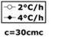
I accept suggestion.
Due to that, I have removed legends from this figure

2. Page 6, the text “Fig 2. The onset of micelle formation appears at 27°C for a lower heating rate and at 21°C for a higher heating rate” should be modified to “Fig 2. Conductivity vs. temperature curves of aqueous CTAB solution obtained at different heating rate”.
I have changed the capture of Fig 2 , with addition explanation about the heating rate in measurements, due to change I have made in 1.
Fig 2. Conductivity vs. temperature curves of aqueous CTAB solution obtained at different heating rate. The onset of micelle formation appears at 27°C for a higher heating rate (open circle), and at 21°C for a lower heating rate (solid rhombus); concentration of CTAB is 30cmc

3. Page 6, the text “The structural transformation (i.e. rise in conductivity) seems to occur at 27°C for the lower rate and at 21°C for the higher rate.” should be changed to “The structural transformation (i.e. rise in conductivity) seems to occur at 27°C for the higher rate and at 21°C for the lower rate.”, as it was in the previous version of manuscript. The reason is given in the first comment.
I accept suggestion.
The structural transformation (i.e. rise in conductivity) seems to occur at 27°C for the higher rate (4°C/h) and at 21°C for the lower rate (2°C/h).

4. Page 6, the text “Fig 3. The “equilibration curve” at 20°C” should be modified to “Fig 3. The “equilibration curve” at 20°C for aqueous CTAB solution with nominal concentrations of 30cmc”.
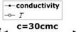I have deleted legends from figure 3

The right axis I kept, because for this measurement it is necessary to have all data in one graph, in order to follow changes in conductivity and temperature, as a function of time. Additional to that, I changed figure capture into:
Fig 3. Dependence of both, conductivity (solid circle) of 30cmc CTAB and temperature (open square) on the required equilibration time; the “conductivity equilibration curve” obtained at 20°C
5. Page 8, the text “Fig 5. Normalized conductivity for different nominal concentrations. Two groups of curves are observed, which indicates the presence of at least two different structural regimes below 90cmc and above 135cmc. This structural transition and the concentration at which it occurs was not further investigated in this work” should be changed to “Fig 5. Normalized conductivity vs. temperature curves for different nominal concentrations of aqueous CTAB solution”.
I accept suggestion.
Fig 5. Normalized conductivity vs. temperature curves for different nominal concentrations of aqueous CTAB solution
6. Pages 8-9, at the end of the text “One viewpoint proposes the existence of two characteristic points on the conductivity curve, the Krafft point and the Krafft temperature.” following references should be added: J. Phys. Chem. B 2003, 107, 5398-5403 and J. Phys. Chem. B 2002, 106, 9033-9035
Due to limitation in the number of references (for this journal), I could not add any additional. I used my publication as the reference where I already used suggested papers.
One viewpoint proposes the existence of two characteristic points on the conductivity curve, the Krafft point and the Krafft temperature [34].
7. Page 9, the text “The evolution of the conductivity towards equilibrium at this particular temperature of 23°C is shown in Fig 6. Here, the conductivity revealed a more complex, irregular behaviour than at the other temperatures, presumably due to the very significant slope of the conductivity-temperature curve at this temperature (c.f. Fig 5).” should be changed to “The evolution of the conductivity towards equilibrium at this particular temperature of 23°C for aqueous CTAB solution with nominal concentrations of 30cmc is shown in Fig 6. Here, the conductivity revealed a more complex, irregular behaviour, with longer equilibration and relaxation times than at the other temperatures, presumably due to the very significant slope of the conductivity-temperature curve at this temperature (c.f. Fig 5).”.
I accepted the suggestion.
The evolution of the conductivity towards equilibrium at this particular temperature of 23°C for aqueous CTAB solution with nominal concentrations of 30cmc is shown in Fig 6. Here, the conductivity revealed a more complex, irregular behaviour, with longer equilibration and relaxation times than at the other temperatures, presumably due to the very significant slope of the conductivity-temperature curve at this temperature (c.f. Fig 5).
8. Page 10, the text “Fig 6. The “equilibration curve” for 30cmc at 23°C, which exhibited an unusually complex behavior and the longest equilibration and relaxation times” should be changed to “Fig 6. The “equilibration curve” at 23°C for aqueous CTAB solution with nominal concentrations of 30cmc”.
I accepted the suggestion.
Fig 6. The conductivity “equilibration curve” at 23°C for aqueous CTAB solution with nominal concentrations of 30cmc

9. Page 10, the text “For the sake of simplicity, we have reduced this discussion to the cooling part of the problem, as shown for the typical down-equilibration in Fig 5.” should be changed to “For the sake of simplicity, we have reduced this discussion to the cooling part of the problem, as shown for the typical down-equilibration in Fig 3.”.
I accepted the suggestion.
For the sake of simplicity, we have reduced this discussion to the cooling part of the problem, as shown for the typical down-equilibration in Fig 3.
10. Page 10, the text “The dependence on this time to equilibration on temperature is depicted in Fig 7.” should be changed to “The linear dependence of the time needed to reach an equilibration vs. equilibration temperature is depicted in Fig 7. The extrapolation of obtained dependence to low temperatures can be used to predict how rapidly one can “erase“ the structural memory.”.
I accepted the suggestion.
The linear dependence of the time needed to reach an equilibration vs. equilibration
temperature is depicted in Fig 7. The extrapolation of obtained dependence to low temperatures can be used to predict how rapidly one can “erase“ the structural memory.

11. Page 10, the text “Fig 7. The time to equilibration as a function of the equilibration temperature. The extrapolation to low temperatures can be used to predict how rapidly one can “erase“ the structural memory” should be changed to “Fig 7. The dependence of the time to equilibration on the equilibration temperature”.
I accepted the suggestion.
Fig 7. The dependence of the time to equilibration on the equilibration temperature

12. Page 10, the sentence “It also shows the existence of a structural memory effect, which can be "erased" within reasonably short times at temperatures below ≈ 10°C.” should be changed to “It also shows the existence of a structural memory effect, which can be "erased" within reasonably short times at temperatures below 15°C.”.
I accepted the suggestion.
It also shows the existence of a structural memory effect, which can be "erased" within reasonably short times at temperatures below 15°C.

13. Page 11, the text “Above the critical micelle concentration and at the Krafft temperature, monomers aggregate and micelles started to form in a solution. At this point, a significant increase of conductivity has been detected, what indicates the micelles formation in the solution.
From the conductivity results we can signify that two additional observations, such as time-effects and the thermal history of CTAB solution, are very important for the appropriate preparation and utilization of these surfactant solutions. When the micellar solution is cooled below the Krafft temperature, crystals will precipitate and the solution becomes visibly turbid, as demonstrated by the experiments. A reproducible conductivity hysteresis is detected in heating-cooling cycles.” should be changed to “During the heating, at temperatures in vicinity of the Krafft temperature conductivity of CTAB solution increases sharply with temperature increase due to enhanced solubility of CTAB. Above the Krafft temperature, the slope of conductivity vs. temperature curve decreases indicating monomers aggregation and micelles formation. When the micellar solution is cooled below the Krafft temperature, crystals will precipitate and the solution becomes visibly turbid. A reproducible conductivity hysteresis is detected in heating-cooling cycles. From the conductivity results we can signify that two additional observations, such as time-effects and the thermal history of CTAB solution, are very important for the appropriate preparation and utilization of these surfactant solutions.”.
I accepted the suggestion.
During the heating at temperatures in vicinity of the Krafft temperature, conductivity of CTAB solution increases sharply with temperature increase due to enhanced solubility of CTAB. Above the Krafft temperature, the slope of conductivity vs. temperature curve decreases indicating monomers aggregation and micelles formation. When the micellar solution is cooled below the Krafft temperature, crystals will precipitate and the solution becomes visibly turbid. A reproducible conductivity hysteresis is detected in heating-cooling cycles. From the conductivity results we can signify that two additional observations, such as time-effects and the thermal history of CTAB solution, are very important for the appropriate preparation and utilization of these surfactant solutions.
14. Check all the references, because the reference [34] appears in the text before the references [32] and [33].
I accepted the suggestion. The main results are described in the reference [17] , not in [34].
Previous work [17] (page 4)

Reviewer B:
This version of the manuscript is better than the previous one. But, the main criticism is related to unclear figures (for example, legends of figures are unnecessary) as well as to inadequate figures captions. For instance:
- Page 5, line 6. Instead: ....for concentration above the cmc [34]
there should be: for CTAB concentration above the cmc [34]
I accepted the suggestion.
for CTAB concentration above the cmc [34].
- Page 5, line 10. instead: .... between 10°C and 70°C.
there should be:
….between 10°C and 70°C (Figure 1).
I accepted the suggestion.
between 10°C and 70°C (Fig 1).
- Page 5, line 13 (i.e. figure caption). Instead: Hysteresis in conductivity at 30cmc in the temperature range between 10°C and 70°C
there should be:
Hysteresis in conductivity for 30cmc CTAB in the temperature range 10−70°C
I accepted the suggestion.
Fig 1. Hysteresis in conductivity for 30cmc CTAB in the temperature range 10°C - 70°C
- Legends of figures should be avoided and instead of those, there shoud be clarification of particular marks in the figure captions.
For example, legend of Fig. 2., , should be omited, and instead: Fig 2. The onset of micelle formation appears at 27°C for a lower heating rate, and at 21°C for a higher heating rate
there should be:
Fig 2. The onset of micelle formation appears at 27°C for a lower heating rate (open circle), and at 21°C for a higher heating rate (solid rhombus); concentration of CTAB is 30cmc
I accepted suggestion and changed the text in figure capture. I have made mistake in my first version of the papers and it is higher heating rate (open circle), and lower heating rate (solid rhombus).
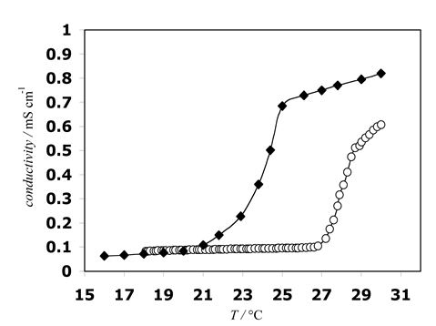

Fig 2. Conductivity vs. temperature curves of aqueous CTAB solution obtained at different heating rate. The onset of micelle formation appears at 27°C for a higher heating rate (open circle), and at 21°C for a lower heating rate (solid rhombus); concentration of CTAB is 30cmc

Similar to the previous comment, new Figure should be:
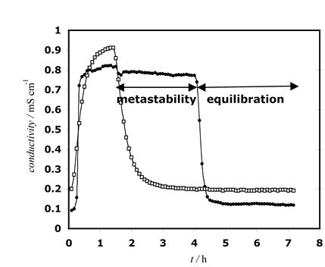
Also, it seems that a more adequate figure caption is:
Fig 3. Dependence of both, conductivity (solid circle) of 30cmc CTAB and temperature (open circle) on the required equilibration time; the “conductivity equilibration curve” obtained at 20°C
I accepted the suggestion.
I have removed legends

The right axis is also removed, because the results have been obtained at 20°C

Fig 3. Dependence of both, conductivity (solid circle) and temperature (open square) on the required equilibration time. The “equilibration curve” at 20°C for aqueous CTAB solution, with nominal concentration of 30cmc

- Page 6, line 7
Instead: … in figures above,
there should be:
…..in figures 1 and 2
I accepted the suggestion
in Fig 1 and Fig 2

- Page 7, fig. 4. Similarly to comments 4 and 5, the legend of figure is unnecessary.
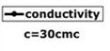
I accepted the suggestion
I have removed the legend
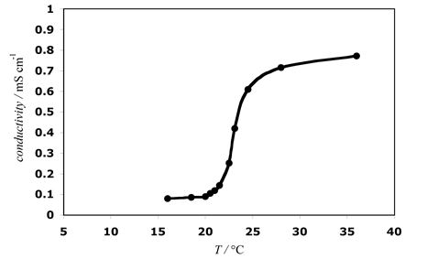

- The term ″equilibrium curve″ is unclear. Namely, the same term is used in fig. 3 as well as in fig. 4. Also, part of the text related to Fig. 4, i.e. ″The equilibration was achieved by waiting at a constant temperature for certain time. (The temperature stability was better than ±0.05°C)″, should be shifted before the Figure 4, and behind the text in third paragraph on the pg. 6.
Based on all this, figure caption for fig. 4, shoul be:
Figure 4. An “equilibrium conductivity curve” is showing the conductivity as a function of temperature after thermodynamic equilibration; concentration of CTAB is 30cmc
I accepted the suggestion.
Fig 4. An “equilibrium conductivity curve” is showing the conductivity as a function of temperature after thermodynamic equilibration; concentration of CTAB is 30cmc
- Figure caption for Fig. 5 is inappropriate. First of all, the part of the text (″Two groups of curves are observed, which indicates the presence of at least two different structural regimes below 90cmc and above 135cmc. This structural transition and the concentration at which it occurs was not further investigated in this work″) should be shifted and incorporated in text of the manuscript. Secondly, curves denotations should be omitted, and they denotations ought to be, for example 1, 2, 3 and 4. Thus, the new figure caption should be, for instance:
Figure 5. Normalized conductivity for various different CTAB nominal concentrations: 30cmc (1), 45cmc (2), 90cmc (3), 135cmc (4) and 180cmc (5) 180cmc (5)
I have decided to keep symbols for chosen concentration, because I have improved the quality of this figure and it is easier to follow the results of realized measurements.
Fig 5. Normalized conductivity vs. temperature curves for various different nominal concentrations of aqueous CTAB solution
- Figure 6. Instead:

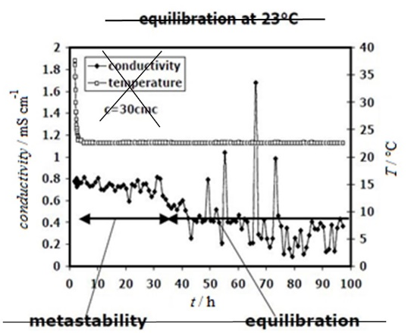

There shoud be:
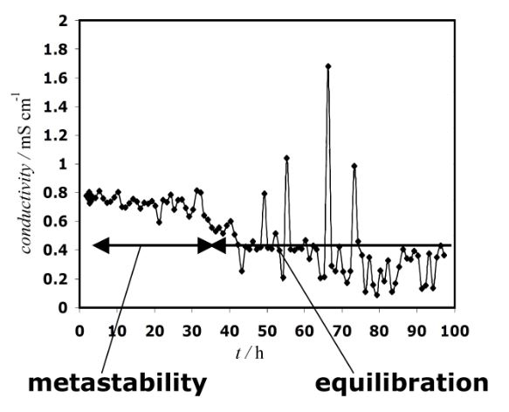

I accept the suggestion, and removed the right axis too, because the measurement has been realized at the constant temperature 23°C.

- Figure 7. There should be:

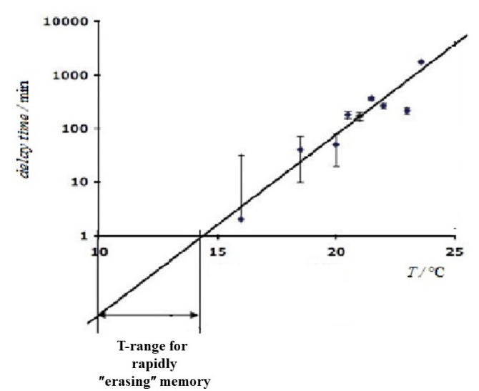
I have removed the legend on the figure
Moreover, figure caption (fig. 7), should be:
Fig 7. Delay time (the time to equilibration) as a function of the equilibration temperature; each bar represents the mean ± standard deviations
Also, some part of the text (″The extrapolation to low temperatures can be used to predict how rapidly one can “erase“ the structural memory″) should be shifted and incorporated in text of the manuscript.
The part of this text I have deleted, because it seems some additional explanation has to be added and I am on the limit with 15 pages for this paper.
The caption of fig7 I have changed:
Fig 7. The dependence of the time to equilibration on the equilibration temperature

