The DFT-based calculations of silicon complex structures in the KF-KCl-K₂SiF₆ and KF-KCl-K₂SiF₆-SiO₂ melts
ALEXEY S. VOROB’EV¹, ANDREY V. ISAKOV¹*, ALEXANDER Y. GALASHEV¹ ², YURI P. ZAIKOV¹ ²
¹Institute of High Temperature Electrochemistry, Ural Branch of Russian Academy of Sciences
S. Kovalevskaya St., 22, 620990, Ekaterinburg, Russian Federation
²Ural Federal University named after the first President of Russia B. N. Yeltsin,
Ekaterinburg 620002, Russian Federation.

Abstract: The length and energy of bonds in complex anions of silicon, formed in the KF−KCl−K₂SiF₆ and KF−KCl−K₂SiF₆–SiO₂ melts, have been evaluated using method of the first - principles molecular dynamics, accomplished by means of the Siesta program. The effect of the K⁺ ions (from the second coordination sphere) on the stability of these complexes has been studied. The bond length in the silicon complexes was found to be changed with increasing amount of the potassium ions. It was established that the following complexes [SiO₄]⁴⁻, [SiO₃F]³⁻, [SiF₆]²⁻ are the most stable in the KF−KCl−K₂SiF₆ and KF−KCl−K₂SiF₆−SiO₂ melts. The [SiO₄]⁴⁻ and [SiF₆]²⁻ complexes are thermally stable in the molten salt in the temperature range of 923-1073 K, whereas the [SiF₇]³⁻ structure, which is typical for the lattice of crystalline K₃SiF₇, is unstable in this temperature range. In the KF−KCl−K₂SiF₆−SiO₂ melts, the conditions above 1043 K were created allowing the transformation of [SiО₃F]³⁻ into [SiO₄]⁴⁻. Within the studied temperature mode, the Si-F bond length is in the range of 1.5-1.9 Å, and the Si-O bond lengths is 1.5-1.7 Å. The obtained results are in a good agreement with the data in situ of the Raman spectroscopy for the KF−KCl−K₂SiF₆ and KF−KCl−K₂SiF₆−SiO₂ melts.
Keywords: molten salts, silicon complexes, structure, DFT calculations

RUNNING TITLE: SILICON COMPLEXES STRUCTURE IN MOLTEN SALTS

INTRODUCTION
Nowadays, molten salts are used as electrolytes for a significant number of industrial electrochemical processes intended for the metals production. Moreover, the molten salts are of great importance for the development of nuclear energy¹ and the spent nuclear fuel reprocessing². They can be employed for producing materials for chemical current sources and solar power³. An important direction of the chemical research in the field of solvents based on the molten salts is studying a structure of the complex groups. The physicochemical properties of the molten salts, the morphological structure, and the chemical composition of the electrode products largely depend on the composition, structure, and concentration of the complex groups⁴. Studying the electrode processes, especially in cases of the presence of a redox couple^{5, 6}, the interpretation of the polarization data depends on the identification of the complex groups. The information regarding the structure of melts allows understanding the mechanisms of physicochemical processes during the interaction of the substances with the molten salts. Knowledge of the structure and stability of the complexes is necessary in order to express the overall reactions in the electrochemical cell as well as to determine the mechanisms of the electrode reactions.
The molten salts are the aggressive media. Their use requires a careful selection of the construction materials. The molten salts containing the compounds of metals can interact with the moisture and oxygen of ambient air. This interaction can lead to a change in the composition, structure of the complexes, and to the alteration in the physicochemical properties of the molten media. An atmosphere of inert gases is required in order to use the hygroscopic melts. The specific properties of media necessitate a development of the model approaches to their study. The experimental study of the complex compounds structure is difficult and not always solvable task in attempts to explain the processes occurring in the molten salts⁷⁻⁹. There are a number of approaches providing an opportunity to consider the structure of the complex groups and explore the processes of the substances interaction in molten salts. The study of the melts structure can be carried out on the quenched melt samples⁷. Moreover, at room temperature the Raman data of the solid samples may not take into account a destruction of the individual components during melting the sample, as well as instability of the particles at high temperature. The study of the melts structure^{8, 10}, including the alkali halides⁹, can be carried out in situ at high temperatures. The Raman spectroscopy study of the molten salts gives sufficiently clear idea regarding the complexes structure. However, there are some limitations for applying this approach to the halide molten salt. The concentrations of the complex groups should be significant for registration of the vibrational bands with a high spectral peak. A substantial uncertainty may arise when studying the melts with a low concentration of complexes. The evaporation of molten salts makes it difficult to record the scattered radiation. A condensation of the melt vapors on the cold parts of the experimental installation can cause damage to the equipment.
The DFT-based calculations can be applied for determining the structures of complex groups and evaluating the interactions in the melts¹¹. This method is widely used for studying the structure and interaction in the low-temperature systems¹². The DFT calculations are in a good agreement with the results obtained for the rapidly frozen samples of the high-temperature silicate systems³. Based on the calculations, it is possible to conceptualize the molten salt structure¹. An advantage of the simulation approach is a possibility of studying the structure and stability of the molten alkali halide complexes with a complicated composition in a certain temperature range. The data obtained by simulation can significantly complete the experimental results. Nevertheless, the conclusions of such calculations should be verified by experiment. The ionic melts of the alkali halides based on the KF-KCl containing K₂SiF₆ and SiO₂ are quite widespread in the electrochemical processes for producing silicon. They are well studied by the direct method (in situ) of the Raman spectroscopy. The high-temperature Raman spectra of the KF−KCl−K₂SiF₆ and KF−KCl−K₂SiF₆−SiO₂ melts were obtained in literature⁹, where the process of the silicon oxide dissolution was considered. It was established that complexes of the [SiF₆]²⁻ type are common for the KF−KCl−K₂SiF₆ melt. The complexes [SiO₄]⁴⁻, [SiO₃F]³⁻ were revealed to be formed in the KF−KCl−K₂SiF₆−SiO₂ melts. These data can be specified using the DFT calculations. A comparison of the calculated data with the experiment⁹ verifies the proposed model. The previous experimental studies⁹ allowed the determination of the SiO₂ dissolution mechanism in KF-KCl-K₂SiF₆ melts. It is accompanied by the formation of isolated silicate tetrahedrons, silicon oxyfluoride groups, and gaseous silicon tetrafluoride. The thermal gravimetry method determined that SiO₂ addition to the KF-KCl-K₂SiF₆ melt leads to an increased mass loss at temperatures higher than the melting point of the mixture. The mass spectrometry method detected that the mass loss occurred due to SiF₄ formation.
The purpose of this work is to investigate the structure of the complexes in the KF−KCl−K₂SiF₆ and KF−KCl−K₂SiF₆−SiO₂ molten systems applying the DFT calculations and to reveal the effect of the temperature change on the silicon complexes stability.

COMPUTATION AND MATERIALS
The molten salts possess an ionic conductivity. The structural units of the molten salts are ions, and the ionic complexes are in a constant electrostatic interaction.
Theoretical background
We investigated the energy properties of the silicon complexes by performing the generalized gradient approximation (GGA) within the framework of the density functional theory¹³. The GGA was used to calculate the exchange-correlation potential, which in this case is represented as a function of density and its first derivative. We used the PBE functional developed on the basis of the rational expansion function of the reduced gradient¹⁴. This functionality does not contain empirically optimized parameters and allows to accurately calculate the energy characteristics of the investigated complexes^{14,15}. The standard procedure for the decomposition of the orbitals in a basis was used. The plane waves were chosen as the basis.

Materials
In this work, a stability of the silicon complexes, formed in the KF-KCl-K₂SiF₆ and KF-KCl-K₂SiF₆-SiO₂ melts, was studied using the quantum mechanics method, implemented in the Siesta software package¹². The calculations were performed for the silicon complexes: fluoride (SiF_{x}, where the integer x = 4 ... 7), oxyfluoride (SiO₃F, SiO₂F₂, SiOF₃), and oxide SiO_{X} and Si₂O_{Y} (where x = 2 ... 4; y = 4 .. .7). The effect of a whole number of the potassium cations K⁺ (from 1 to 3) on the complexes structure as part of the second coordination sphere was investigated.
The geometric optimization with the use of the generalized gradient approximation in the form of PBE was performed for all considered complexes. The dynamic relaxation of atoms was carried out until the change in the total energy of the system was less than 0.001 eV. The energy of cutting the plane waves basis was assumed to be equal to 300 Ry.
The thermal stability of the silicon complexes was studied in a Nose-Hoover thermostat after the geometric optimization. The silicon complexes were placed in the thermostat and sustained at temperatures of 923, 1023, 1043, and 1073 K during 2000 time steps (One step - 1 fs).
The bond energies in the silicon complexes were calculated by the equation:

(5)

where the E_{SiOF}, E_{Si}, E_{F} and E_{O} are the total energy of the complex, and the energies of a single silicon ion (Si^{4 +),} fluorine (F⁻) and oxygen (O²⁻), respectively, the N_{Si}, N_{F}, N_{O} is the amount of the silicon ions, fluorine and oxygen in the system, respectively.

RESULTS AND DISCUSSION
The KF−KCl−K₂SiF₆ and KF−KCl−K₂SiF₆−SiO₂ melts are essentially different due to the fact, that one of them includes oxygen-containing SiO₂ compound. The silicon dioxide is a covalently bonded compound. Thus, there are only compounds with an ionic bond type in the KF−KCl−K₂SiF₆ system. The KF−KCl−K₂SiF₆−SiO₂ system includes components with the ionic and covalent bond types. In practice, in the presented systems, the different types of the electrode deposits and various types of complexes were found in experimental investigation⁹.
When studying the bond energies in complexes, the principle expressed by the equation (6) was applied. According to the equation (6), the bond energy is equivalent to the energy required to divide the entire system into separate parts. A compound can be stable if the total potential energy of its parts is negative. The most preferred is the state with the most negative energy.
The silicon complexes in KF-KCl-K₂SiF₆
We accomplished the DFT calculations of the bond energy for the silicon complexes of various structures that can be formed in the KF-KCl-K₂SiF₆ melts. The silicon complexes of the [SiF₆]²⁻ and [SiF₇]³⁻ types were considered as the main structures. Under normal conditions, such structures can be distinguished in the K₂SiF₆ and K₃SiF₇ crystal lattices. These components may be present in the composition of the melts under study.
The K₂SiF₆ is a component of the initial KF−KCl−K₂SiF₆ melt, and the K₃SiF₇ can be formed as a result of interactions occurring in the melts of this type. There is a crystallization field of K₃SiF₇ in the KF−KCl−K₂SiF₆ phase diagram¹⁶. The K₃SiF₇ was found in the KF−KCl−K₂SiF₆ melts by the X-ray phase analysis⁹. The calculation results of the bond energies for the Si⁴ ⁺ cations in the silicon complexes are presented in Table I.

Table I. Total energies, bond energies, and lengths of the fluoride complexes [SiF₆]²⁻
Species | The number of K ⁺ in the second coordination sphere | Total energy, eV | Bond energies, eV | Average bond length of Si-F, Å | Average bond length of K-F, Å
[SiF₆]²⁻ | - | -4149.995 | -113.195 | 1.765 | -
[SiF₆]²⁻ | 1 | -4168.484 | -122.591 | 1.774 | 2.397
[SiF₆]²⁻ | 2 | -4170.318 | -124.852 | 1.727 | 2.434
[SiF₆]²⁻ | 3 | -4194.061 | -129.981 | 1.766 | 2.466
[SiF₇]³⁻ | - | destruction of complex at [SiF₆]²⁻ and F⁻
[SiF₇]³⁻ | 1 | -4836.636 | -122.915 | 1.770 | 2.321
[SiF₇]³⁻ | 2 | -4853.940 | -131.125 | 1.767 | 2.324
[SiF₇]³⁻ | 3 | -4866.793 | -134.885 | 1.711 | 2.287

The silicon complex in the melt as a part of the second coordination sphere may contain the potassium cations. The introduction of K⁺ into the environment of the [SiF₆]²⁻ and [SiF₇]³⁻ complexes was also investigated. The structure of the complex compounds [SiF₆]²⁻ and [SiF₇]³⁻ with the addition of two potassium cations to the second coordination sphere is shown in Figure 1.
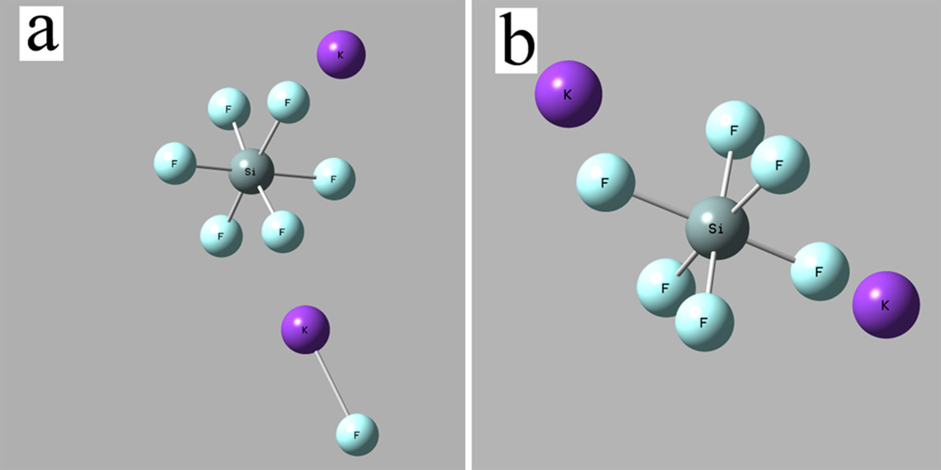

Fig. 1. Complexes (a) [SiF₇]³⁻ and (b) [SiF₆]²⁻ in the presence of two K⁺ ions

The calculations revealed (Figure 1a) that the K⁺ ion captures the fluorine atom. The interaction of K ⁺ with the fluorine atom leads to the destruction of the [SiF₇]³⁻ complex. The destruction of the complex [SiF₇]³⁻ occurs with the formation of [SiF₆]²⁻ and [KF]⁰. The addition of two potassium cations (Figure 1b) does not cause the destruction of the [SiF₆]²⁻ structural unit. The [SiF₆]²⁻ complex remains stable with the addition of two K⁺.
According to investigation⁸, the considered structural units of the KF−KCl−K₂SiF₆ melt can only be represented as the silicon fluoride complexes. Calculation in the absence of K ⁺ ions established the lengths of the Si-F bonds in the [SiF₇]³⁻ and [SiF₆]²⁻ complexes. The result obtained correlates with the data regarding the structure of K₃SiF₇ [17] and K₂SiF₆ [18]. Under the same conditions, the [SiF₇]³⁻ structure has the most negative total energy. The bond energies for the [SiF₇]³⁻ and [SiF₆] ²⁻ groups are comparable. However, the [SiF₆] ²⁻ group with an average bond energy of -113.195 eV is the most probable. The introduction of the potassium cations affects the total energy of the system and the bond energy in the silicon complex groups. The bond length becomes longer in the presence of K⁺ in the second coordination sphere. When K⁺ is introduced into the second coordination sphere of the [SiF₇]³⁻, the K – F bond is formed, and the Si – F bond length increases. In all cases considered, the bond angles of the F-Si-F in the [SiF6]²⁻ and [SiF7]³⁻ complexes are close to 90.
With the addition of K⁺ to the [SiF₆]²⁻ complex the bond length can either increase or decrease, and only a small change in the magnitude of the angles in the range from 86 to 94̊ occurs. The introduction of K ⁺ into the environment of the [SiF₇]³⁻ complex affects the bond energy more significantly than the corresponding addition of K ⁺ ions to the [SiF₆]²⁻ complex. In this case, the bond energies in the [SiF₇]³⁻ become more negative than the corresponding bond energies in the [SiF₆]²⁻. For both types of complexes, when K⁺ appears, there is a change in the bond lengths and angles. Such a change in the bond lengths may be caused by a temperature alteration. The F-K-F bond angle is close to 60̊ with a deviation of ±2°. However, if the potassium is added to the second coordination sphere of the [SiF₇]³⁻ complex, the compound is stabilized by forming the F-K-F bond, with an angle, which ranges from 130 to 140̊, and the K-F bond length is approximately 2.3 Å. The broadening of the vibrational bands for silicon complexes in the Raman spectra was associated with a change in the angles between the bonds and the lengths of the bonds⁹. The [SiF₆]²⁻ and [SiF₇]³⁻ complexes were tested for the thermal stability in the Nose-Hoover thermostat. The results are presented in table II.

Table II. Thermal stability of the silicon fluoride complexes
Species | Temperature, K | Total energy, eV | Bond energies, eV | Average bond length Si-F, Ȧ
[SiF₆]²⁻ | 973 | -4148.870 | -112.086 | 1.760
[SiF₆]²⁻ | 1023 | -4147.864 | -113.485 | 1.770
[SiF₆]²⁻ | 1043 | -4147.527 | -111.058 | 1.811
[SiF₆]²⁻ | 1073 | -4148.144 | -111.345 | 1.827
[SiF₇]³⁻ | 973-1073 | destruction of complex at [SiF₆]²⁻ and F⁻

The [SiF₆]²⁻ remained the only stable complex in the temperature range of 973-1073 K. A general view of the [SiF₆]²⁻ complex after 2000 fs at 973 K is given in Fig. 2.
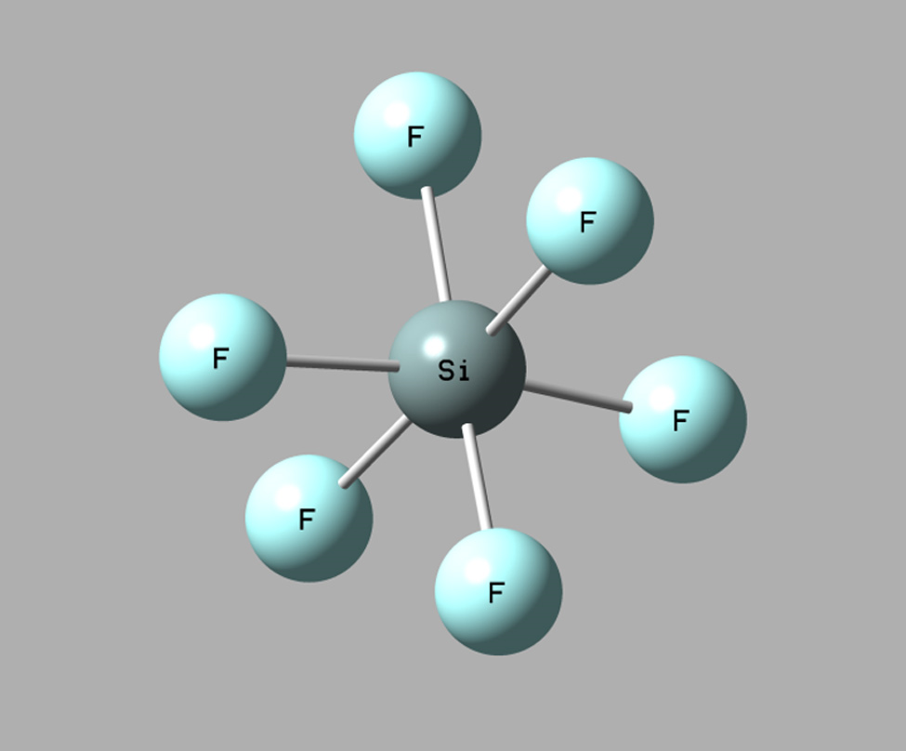

Fig. 2. Silicon complex [SiF₆] ²⁻ at 973 K (2000 fs).

The [SiF₇]³⁻ complex was unstable. We observed its destruction with the formation of the [SiF₆]²⁻ and F- ion. This is in a good agreement with the data of work⁹, where bonds oscillations were registered only for the [SiF₆]^{2–} groups, that was reflected in the spectra at 988 and 1043 K. Moreover, in work⁹ the K₃SiF₇ presence was determined only in the solid sample by means of the X-ray phase analysis. The data proves that as the temperature increases the bond length in the [SiF₆]²⁻ complex rises, while the bond energy experiencing vibrations. Checking the temperature stability has not led to a change in bond angles.
Thus, the obtained results indicate the stability of the [SiF₆]²⁻ complex groups in the KF−KCl−K₂SiF₆ melt within the range of 973-1073 K. The study of the thermal stability allowed identifying the unstable complex [SiF₇]³⁻. Such calculations for the structure of melts are likely to help predicting the transformations of complexes in the halide melts, associated with an increase in temperature.

The silicon complexes in KF−KCl−K₂SiF₆−SiO₂
The melts based on the KF−KCl−K₂SiF₆−SiO₂ contain oxyfluoride and silicate silicon complexes of different composition. According to the results of the high-temperature Raman spectroscopy⁹, the following silicon complexes were identified: [SiO₃F]³⁻; [SiO₄]⁴⁻. Some conclusions were made in works^{19, 20} regarding the presence of the [SiO₂F₂]^{2–} groups in the products of the silicon dioxide and alkali fluorides interaction.
However, the vibrational bands for the silicon complexes of the [SiO₂F₂]^{2–} type were not registered in article⁹. The processes of the interaction between SiO₂ and KF−KCl−K₂SiF₆ in the molten media can be specified based on the quantum chemical reports data. Such studies will allow drawing conclusions related to the possibility of the existence and stability of the silicon oxide-fluoride complexes. In this work the results for the oxyfluoride and silicate complexes of silicon are presented. The bond energies of the [SiO₂]⁻ complexes (with one terminal oxygen atom], the [SiO₃]²⁻ (with two terminal oxygen bonds), the [SiO₄]⁴⁻ (with four terminal oxygen atoms) allow making a suggestion about the most probable complex in the KF−KCl−K₂SiF₆−SiO₂ melt. The calculation results of the bond energies of the silicate complex groups of silicon are presented in Fig. 3.

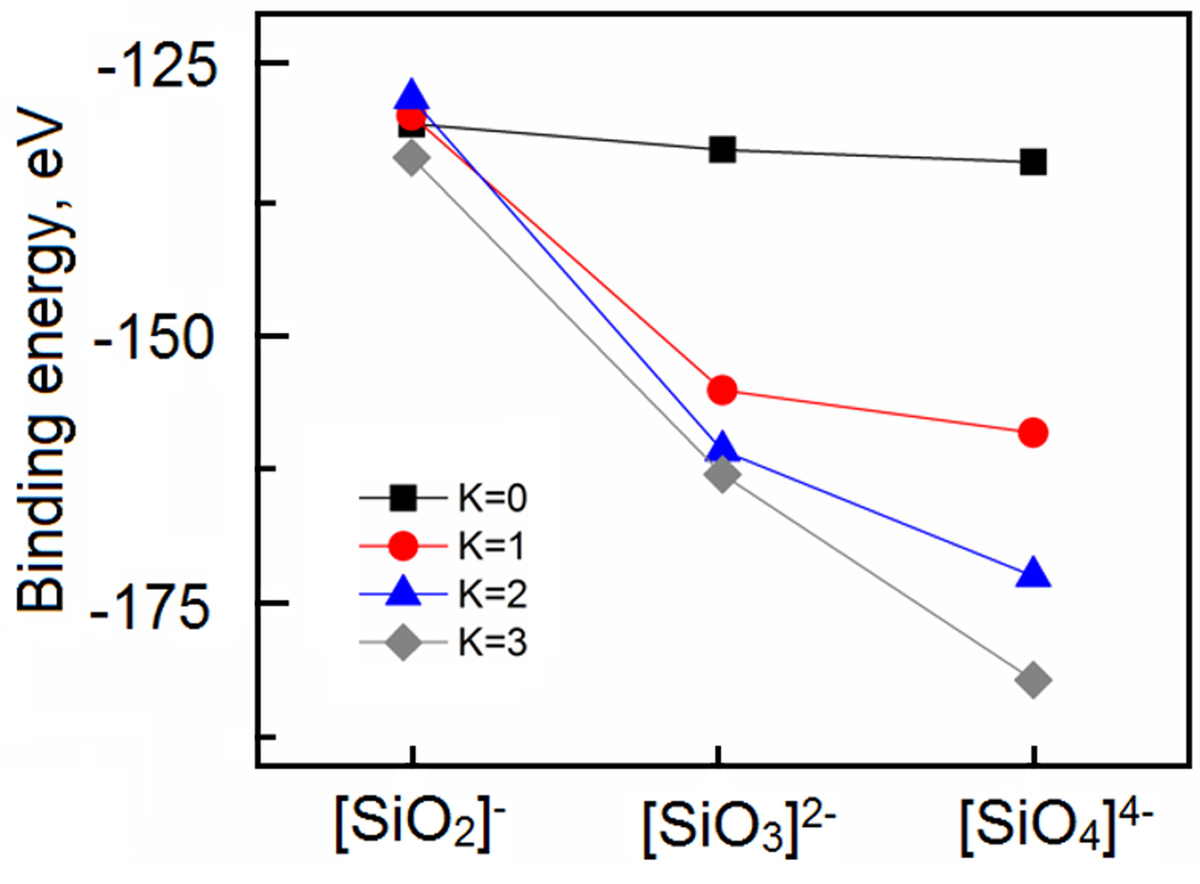

Fig. 3. Calculations of the bond energy in the oxide complexes of silicon [SiO₂] ⁻; [SiO₃] ²⁻; [SiO₄] ⁴⁻.

An increase in the oxygen content and a rise of the excess negative charge of the silicate complexes results in a decrease in the bond energy. Moreover, it was found that the K⁺ addition to the environment of the possible silicate complexes of silicon lead to an even more significant decrease in the Si – O bond energy. According to the calculations of the average bond energy of the complexes, the [SiO₄]^{4–} complex with four terminal oxygen atoms is the most probable among the silicon oxide groups embedded in the ionic melt. The bond energies were calculated for the oxyfluoride silicon complexes [SiO₃F]³⁻; [SiO₂F₂]²⁻; [SiOF₃]⁻. The complexes composition effect on the energy characteristics and the Si-F bond length was determined for the oxyfluoride complexes in comparison with the corresponding data for [SiO₄]⁴⁻. The results are listed in tables III and IV.
According to the simulation, the total energies of the silicon fluoride and silicate complexes ([SiO₃F]³⁻; [SiO₂F₂]²⁻; [SiOF₃]⁻; [SiO₄]⁴⁻) have negative values comparable in magnitude. The presence of fluorine in the silicon complexes leads to a change in the bond energy. In the absence of K ⁺ ions in the neighborhood of the complexes, the transition from [SiO₄]⁴⁻ to [SiO₃F]³⁻ results in a decrease in the bond energy of the silicon complex and the appearance of a more compact package with a shorter bond length.

Table III. Total energies, and bond energies and lengths of fluoride, oxyfluoride, and oxygen complexes of silicon
Species | The K⁺ number in the second coordination sphere | Total energy, eV | Bond energies, eV | The bond length of Si-F, Ȧ | The bond length of Si-O, Ȧ
[SiO₄]⁴⁻ | - | -1837.328 | -133.840 | - | 1.743
[SiO₄]⁴⁻ | 1 | -1871.646 | -159.064 | - | 1.690
[SiO₄]⁴⁻ | 2 | -1894.075 | -172.400 | - | 1.695
[SiO₄]⁴⁻ | 3 | -1912.837 | -182.068 | - | 1.707
[SiО₃F]³⁻ | - | -2090.455 | -137.553 | 1.680 | 1.567
[SiО₃F]³⁻ | 1 | -2115.860 | -183.692 | 1.754 | 1.666
[SiО₃F]³⁻ | 2 | -2135.396 | -164.307 | forms K-F | 1.620
[SiО₃F]³⁻ | 3 | -2149.738 | -169.556 | 1.946 | 1.653
[SiO₂F₂]²⁻ | - | -2337.260 | -134.944 | 1.775 | 1.610
[SiO₂F₂]²⁻ | 1 | -2355.875 | -144.466 | 1.770 | 1.620
[SiO₂F₂]²⁻ | 2 | -2334.200 | -113.698 | 1.736 | 1.573
[SiO₂F₂]²⁻ | 3 | [SiO₂F]⁻ formation and [KF]⁰ complex
[SiOF₃]⁻ | - | -2577.480 | -125.752 | 1.939 | 1.664
[SiOF₃]⁻ | 1 | -2591.096 | -130.273 | 1.674 | 1.585
[SiOF₃]⁻ | 2 | -2601.174 | -131.258 | 1.698 | 1.572
[SiOF₃]⁻ | 3 | -2608.313 | -129.304 | 1.687 | 1.567

Table IV. Bond angles and lengths of fluoride, oxyfluoride and oxygen complexes of silicon
Species | The K⁺ number in the second coordination sphere | The F-Si-F  bond angle  range, ° | The F-Si-O  bond angle  range, ° | The O-Si-O  bond angle  range, ° | The bond length of K-F, Ȧ | The bond length of K-O, Ȧ
[SiO₄]⁴⁻ | - | - | - | 109.5 | -  -  -  -
[SiO₄]⁴⁻ | 1 | - | - | 104.7-111.2 | -  -  -  - | 2.623
[SiO₄]⁴⁻ | 2 | - | - | 108.3-111.6 | -  -  -  - | 2.530
[SiO₄]⁴⁻ | 3 | - | - | 98.1-114.8 | -  -  -  - | 2.542
[SiО₃F]³⁻ | - | - | 101.1 | 116.62 | - | -
[SiО₃F]³⁻ | 1 | - | 105.2 | 109-115.54 | - | 2.547
[SiО₃F]³⁻ | 2 | - | - | 115.6-126.4 | 2.410 | 2.652
[SiО₃F]³⁻ | 3 | - | 92.84-104.43 | 118.36 | 2.561 | 2.538
[SiO₂F₂]²⁻ | - | 94.58 | 107.22 | 128.25
[SiO₂F₂]²⁻ | 1 | 92.67 | 109.72 | 126.91 | 2.411 | 2.445
[SiO₂F₂]²⁻ | 2 | 83.39 | 94.77 | 133.50 | 2.475 | 2.464
[SiO₂F₂]²⁻ | 3 | [SiO₂F]⁻ formation and [KF]⁰ complex
[SiOF₃]⁻ | - | 99.22 | 118.13 | - | - | -
[SiOF₃]⁻ | 1 | 100.15 | 108.41-121.8 | - | 2.586 | 2.526
[SiOF₃]⁻ | 2 | 93.3-101.77 | 117.25 | - | 2.517 | 2.426
[SiOF₃]⁻ | 3 | 94.7-102.69 | 116.34-121.1 | - | 2.546 | 2.460

A further increase of the fluorine content in the complexes leads to a bond energy rise. The minimum of the bond energy characterizes the [SiO₃F] ³⁻ as the most stable complex, since oxide-fluoride group has stronger bonds. Thus, the conversion of the [SiO₄]⁴⁻ to [SiO₃F]³⁻ becomes possible, which is confirmed by the high-temperature Raman spectra.
The length of potassium bonds is in the range from 2.4 to 2.6 and does not depend on the number of potassium in the second coordination sphere of the complex compound. Complex compounds that do not contain potassium in the second coordination sphere are symmetric because compound [SiO₄]⁴⁻ has six approximately equal bond angles equal to 109.5̊. While the addition of potassium leads to a change in bond angles in the complex compound. For example, in the same compound [SiO4]⁴⁻ one angle decreased to 104.7̊, two angles remained in the region of 109̊, and three angles increased to 110-111̊.
The structure of the complex compounds [SiO₄]⁴⁻, [SiO₃F]³⁻; [SiO₂F₂]²⁻; [SiOF₃]⁻ , when adding three potassium cations is shown in Fig. 4.
The results of the structure calculation reveal (Figure 4, c) that the addition of the potassium ions leads to the destruction of the [SiO₂F₂]²⁻ and formation of the [SiO₂F] - and [KF]⁰ complex. In the cases of [SiO₄]⁴⁻, [SiO₃F]³⁻; [SiOF₃]⁻ (Figure 4 a, b, d), the hardening of the compound occurs (data in Table 3).
The addition of the K⁺ ions to the environment of the considered complexes (Table 3), as a rule, leads to a decrease in the total energy. At the same time, the nature of the change in the bond length is debatable. The appearance of the potassium cation in the neighborhood of the [SiO₄]⁴⁻ complex creates a decrease in the Si – O bond length. With the addition of the next K⁺ ions, the Si – O bond length no longer decreases. The presence of the K⁺ ion near the [SiO₃F]³⁻ complex leads to an increase in the length of the Si-F and Si-O bonds. However, with further K⁺ ions addition, a consistent increase in the length of these bonds is not observed. In the [SiO₂F₂]²⁻ system with the addition of K⁺ ions, a wave-like change in the length of the Si – O and Si – F bonds occurs. The addition of K⁺ ions to the [SiOF₃]⁻ system leads to a consistent decrease in the length of the Si−F and Si−O.

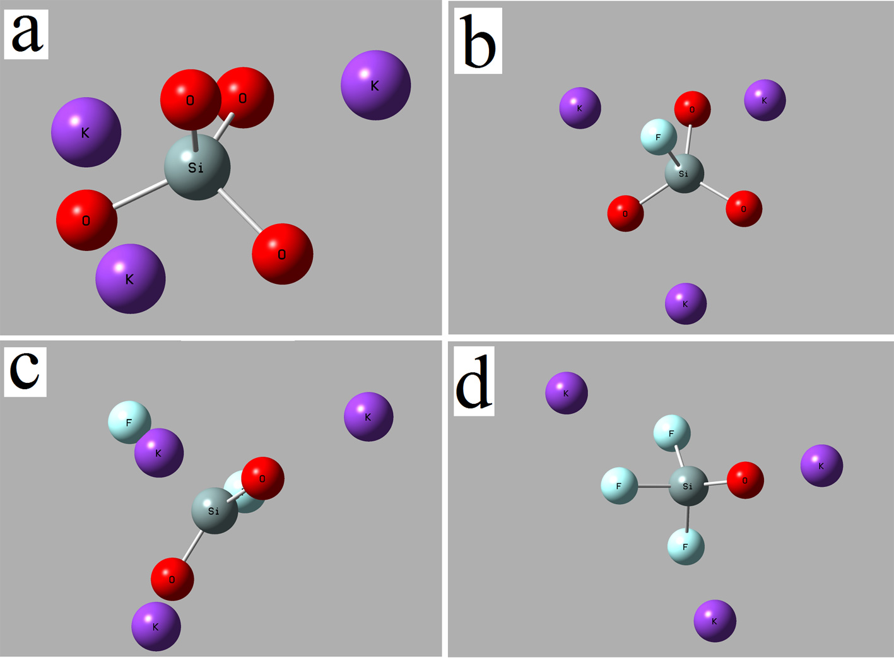

Fig. 4. Geometric structure of silicon complexes: (a) [SiO₄]⁴⁻, (b) [SiO₃F]³⁻, (c) [SiO₂F₂]²⁻, (d) [SiOF₃]¹⁻ with the addition of three potassium cations to the second coordination sphere
Thus, calculations revealed that the most probable silicon complexes are [SiO₃F]³⁻ and [SiO₄]⁴⁻. The thermal stability was investigated precisely for these complexes. The results are presented in table V.

Table V. The results of studying the thermal stability of the complexes [SiO₃F]³⁻ and [SiO₄]⁴⁻
Species | Temperature, K | Total energy, eV | Bond energies, eV | Average bond length of Si-F, Ȧ | Average bong length of Si-O, Ȧ
[SiО₃F]³⁻ | 973 | -2088.946 | -139.169 | 2.1984 | 1.670
[SiО₃F]³⁻ | 1023 | -2089.249 | -139.467 | 1.886 | 1.617
[SiО₃F]³⁻ | 1043 | segregates into SiO₃²⁻ and F⁻
[SiО₃F]³⁻ | 1073
[SiO₄]⁴⁻ | 973 | -1836.157 | -136.832 |  | 1.763
[SiO₄]⁴⁻ | 1023 | -1836.254 | -136.926 |  | 1.750
[SiO₄]⁴⁻ | 1043 | -1835.846 | -137.105 |  | 1.781
[SiO₄]⁴⁻ | 1073 | -1835.966 | -136.671 |  | 1.761

The [SiO₃F]³⁻ complex groups demonstrate a thermal stability at temperature below 1043 K. There are the conditions for the transformation of the [SiO₄]⁴⁻ to [SiO₃F]³⁻in the temperature range under study. However, due to the close values of the bond energy, this transformation is likely to be slowed down. It was reported²¹ about such a chemical reaction during the cathode process when studying the mechanism of the silicon electroreduction in the KF−KCl−K₂SiF₆ melts, which was attended with the SiO₂ dissolution.
The temperature increase above 1043 K resulted in the destruction of the [SiO₃F]³⁻ silicon complex with the formation of the [SiO₃]²⁻ and F⁻. The conditions when [SiO₄]⁴⁻ becomes the most possible are created at temperatures of 1043 K and 1073 K. Presumably, under these conditions the decomposition of the KF−KCl−K₂SiF₆−SiO₂ melt can proceed due to the conversion of the oxyfluoride complexes to the silicate one:

SiO₃F³⁻ → SiO₃²⁻ + F⁻ (6)

SiO₃²⁻ + SiF₆²⁻ → SiO₃F³⁻ + SiF₄ + F⁻ (7)

2SiO₃F³⁻ → 2SiO₃²⁻ + 2F⁻ → 2SiO₂F₂↑ + 2O²⁻ (8)

SiO₃²⁻ + O²⁻ → SiO₄⁴⁻ (9)

In general, this was confirmed by the DSC data of the KF-KCl-K₂SiF₆-SiO₂ melt presented in work⁹. It was found that the intensive SiF₄ gas evaporation from the melt began, accompanied by a mass loss, after reaching 1033 K. The research results revealed that in the molten KF-KCl-K₂SiF₆-SiO₂ system the complexes [SiF₆]²⁻; [SiO₄]⁴⁻; [SiO₃F]³⁻ can be considered relatively stable in the temperature range of 973-1023 K. The most probable group for the KF-KCl-K₂SiF₆ melts is [SiF₆]²⁻ in the temperature range of 973–1073 K. The stable silicon complexes for the KF-KCl-K₂SiF₆ and KF-KCl-K₂SiF₆-SiO₂ melts are presented in Fig. 5.
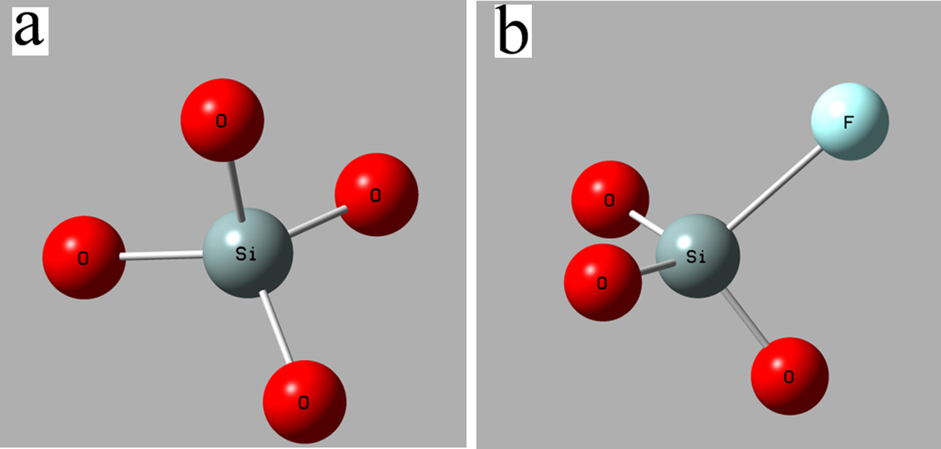

Fig. 5. Complex compounds SiO₄⁴⁻ and SiO₃F at 973 K

It was demonstrated that the oxide complexes [SiO₄]⁴⁻ and [SiF₆]²⁻ are approximately comparable in size. However, the [SiO₃F]³⁻ oxide-fluoride complex of silicon is larger than [SiF₆]²⁻. Consequently, an increase in the complexes size should be expressed in a rise of diffusion difficulties. An increase in the diffusion difficulties with the appearance of the oxygen in the KF-KCl-K₂SiF₆ melt was reported in work²⁰. In general, the obtained data is in a good agreement with the results of work⁹ and supplement them in terms of the cause of the thermal instability of the KF-KCl-K₂SiF₆-SiO₂ melts at temperature above 1033 K.

CONCLUSIONS
The structure of complexes in the KF-KCl-K₂SiF₆ and KF-KCl-K₂SiF₆-SiO₂ systems was studied using the DFT calculations; the effect of temperature change on the stability of the silicon complexes was found. The bond energies of the silicon complexes were calculated and their structure was considered. It was established that the appearance of fluorine in the composition of silicon oxide complexes leads to a decrease in the bond energy. Increasing the fluorine content in the series [SiO₃F]³⁻ → [SiO₂F₂]²⁻ → [SiOF₃]⁻ leads to a rise in the bond energy. The effect of the potassium ions introduction into the second coordination sphere of the silicon complexes was discussed. The introduction of the K⁺ ions excess into the environment of the complexes changes the bond energy. In the case of [SiO₃F]³⁻, the excess of K⁺ leads to the complex destruction. It was found that in the presence of K⁺ in the environment of the [SiO₃F]³⁻ complexes, an increase in the Si-F bond length occurs. The addition of the K⁺ to the environment of the [SiOF₃]⁻ and [SiO₄]⁴⁻ complexes leads to a decrease in the length of the Si-F and Si-O bonds. In the [SiO₂F₂] ²⁻ system with the addition of K ⁺ a minimal change in the lengths of the Si – O and Si – F bonds was observed.
It was determined that the most stable complex groups in the KF-KCl-K₂SiF₆ melt are silicon fluoride complexes of the [SiF₆]²⁻ type. It was proved that the [SiF₆]²⁻ complexes were thermally stable in the range of 973-1073 K. It was also revealed that the [SiF₆]²⁻, [SiO₄]⁴⁻, and [SiО₃F]³ complexes can be typical for the KF-KCl-K₂SiF₆-SiO₂ melts. The study of the thermal stability indicated that the most probable is the [SiO₃F]³⁻ complex at temperatures below 1043 K. At temperature as high as 1043 K, the [SiO₃F]³⁻ was destroyed and the [SiO₄]⁴⁻ became the most probable complex of silicon. The process of converting [SiO₃F]³⁻ to [SiO₄]⁴⁻ is accompanied by a mass loss of the melt.
The obtained data of the DFT calculations are in a good agreement with the experimental study of the KF-KCl-K₂SiF₆ and KF-KCl-K₂SiF₆-SiO₂ melts. Such a calculation method in addition to experiment can be used to estimate the stability of the melt structural units. The basis for the modeling can be the data related to the structure of both solid and liquid samples. The understanding of the temperature effect on the structures stability allows taking into account the transformations associated with the complexes reconstruction.
Acknowledgements: The work is accomplished with the financial support of the Russian Science Foundation, project No. 18-73-00227.
REFERENCES
1. J. Dai, H. Han, Q. Li, P. Huai, Journal of Molecular Liquids. 213 (2016) 17
2. A. Salyulev, A. Potapov, V. Khokhlov, V. Shishkin, Electrochimica Acta. 257 (2017) 510
3. K. Yasuda, K. Saeki, T. Kato, R. Hagiwara, T. Nohira, J. Electrochem. Soc. 165 16 (2018) D825
4. A.N. Baraboshkin Electroctystalization of metals in molten salts, Nauka, Moscow, 1976, p. 280 (in Russian)
5. D.A. Vetrova, A.V. Popova, S.A. Kuznetsov, ECS Transactions. 86 14 (2018) 69
6. D.A. Vetrova, S.A. Kuznetsov, Russian Metallurgy (Metally). 2 (2017) 100
7. A.A. Kataev, O.Yu. Tkacheva, I.D. Zakiryanova, A.P. Apisarov, A.E. Dedyukhin, Yu.P. Zaykov. Journal of Molecular Liquids. 231 (2017) 149
8. J. Shen, H. Hu, M. Xu, H. Liu, K. Xu, X. Zhang, H. Yao, I. Naruse. Fuel. 207 (2017) 365
9. Y.P. Zaykov, A.V. Isakov, I.D. Zakiryanova, O.V. Chemezov, A.A. Redkin. Journal of Physical Chemistry B. 118 (2014) 1584
10. A. G. Kalampounias, G. Tsilomelekis, S. Boghosian. Vibrational Spectroscopy. 97 (2018) 85
11. J-B. Liu, X. Chen, Y-H. Qiu, C-F. Xu, W.H. Eugen Schwarz, J. Li. Journal of Physical Chemistry B. 118 (2014) 13954
12. C. Dong, X. Song, J. Zhang, D. Liu, E. J. Meijer, J. Yu. Thermochimica Acta. 670 (2018) 35
13. J. M. Soler, E. Artacho, J. D. Gale, A. Garcıa, J. Junquera, P. Ordejon, D. Sanchez-Portal. J. Phys.: Condens. Matter. 14 (2002) 2745
14. C. J. Cramer, John Wiley & Sons, Ltd., Minneapolis, 2004, p. 596
15. M. Ernzerhof, G. E. Scuseria, Journal of chemical physics Journal of Molecular Liquids. 110(11) (1999) 5029
16. O.I. Boyko, R.V. Chernov. Ukrainian chemistry journal. 49 5 (1983) 548 (in russian)
17. D.L. Deadmore, W.F. Bradley. Acta Cryst. 15 (1962) 186
18. J.H. James. Acta Cryst. C40 (1984) 570
19. R.V. Chernov, V.M. Moshnenko. Ukrainian chemistry journal 42 11 (1976) 1137 (in russian)
20. R.V. Chernov, L.D. Dyubova. Russ. J. Chem. Technol. 2 (1989) 16
21. S.I. Zhuk, V.A. Isaev, O.V. Grishenkova, A.V. Isakov, A.P. Apisarov, Yu.P. Zaykov. J. Serb. Chem. Soc. 82 1 (2017) 51

*Corresponding author. E-mail: ihte_uran@mail.com

