Supplementary Material

Photodegradation of selected pesticides: Photocatalytic activity of bare and PANI-modified TiO₂ under simulated solar irradiation
MARINA J. LAZAREVIĆ^{1#}, VESNA N. DESPOTOVIĆ^{1#}, DANIELA V. ŠOJIĆ MERKULOV^{1#}, NEMANJA D. BANIĆ^{1#}, NINA L. FINČUR^{1#}, DRAGANA D. ČETOJEVIĆ-SIMIN², MIRJANA I. ČOMOR³, BILJANA F. ABRAMOVIĆ^{1#}
¹University of Novi Sad Faculty of Sciences, Department of Chemistry, Biochemistry and Environmental Protection, Trg D. Obradovića 3, 21000 Novi Sad, Serbia;
²University of Novi Sad, Faculty of Medicine, Oncology Institute of Vojvodina, Dr Goldmana 4, 21204 Sremska Kamenica, Serbia;
³University of Belgrade, Vinča Institute of Nuclear Sciences, P. O. Box 522, 11001 Belgrade, Serbia

EXPERIMENTAL

Chemicals
All chemicals were of reagent grade and were used without further purification. Insecticide thiacloprid ((Z)-3-(6-chloro-3-pyridylmethyl)-1,3-thiazolidin-2-ylidenecyanamide), CAS No. 111988-4998, C₁₀H₉ClN₄S, M_{r} = 252.8, PESTANAL®, analytical standard, 99.9% purity) was purchased from Riedel-de Haën, herbicides clomazone (2-[(2-chlorophenyl)methyl]-4,4-dimethyl-3-isoxazolidinone, CAS No. 81777-89-1, C₁₂H₁₄ClNO₂, M_{r} = 239.7, PESTANAL®, analytical standard, 98.8% purity), quinmerac ((7-chloro-3-methylquinoline-8-carboxylic acid), CAS No. 90717-03-6, C₁₁H₈ClNO₂, M_{r} = 221.64, PESTANAL®, analytical standard, 98.2% purity) and sulcotrione (2-(2-chloro-4-(methylsulfonyl)benzoyl)-1,3-cyclohexanedione, CAS No. 99105-77-8, C₁₄H₁₃ClO₅S, M_{r} = 328.8, PESTANAL®, analytical standard, 99.9% purity) were purchased from Fluka. Other chemicals are also used without further purification and were p.a. purity. Namely, 35% HCl and 85% H₃PO₄, Lachema, Neratovice, Czech Republic; NaOH, ZorkaPharm, Šabac, Serbia; CaO, Carlo Erba, Milano, Italy; HPLC gradient grade methanol, J.T. Baker; KBrO₃ and 60% HClO₄, Merck, Darmstadt, Germany; Na₂SO₄, NaHCO₃, Ba(OH)₂, and NaF, Kemika, Zagreb, Croatia; SrSO₄, BDH Laboratory, Safat, Kuwait; Disodium ethylenediaminetetraacetic acid (EDTA), Dojindo, Rockville, MD USA; humic acid, 30% H₂O₂, and tert-butanol, 99.9% acetonitrile (ACN), sulforhodamine B (SRB) and antibiotic/antimycotic solution, Sigma−Aldrich, St. Louis; fetal calf serum (FCS) and Dulbeco’s Modified Essential Medium (DМEМ), PAA Laboratories GmbH, Pasching, Austria; penicillin and streptomycin, Galenika, Belgrade, Serbia; trypsin, Serva, Heidelberg, Germany; EDTA, Laphoma, Skopje, FYROM were used in experiments.

The river water samples were collected from Danube (Petrovaradin, Serbia), Tisa (Titel, Serbia), and Begej (Zrenjanin, Serbia) in November 2014. The lake water samples from Lake Moharač (Erdevik, Serbia) and Sot lake (Sot, Serbia) also were taken in November 2014 (Table S1). The samples of environmental waters were filtered through filter paper (Whatman, diameter of 125 mm pore size 0.1 µm).

Table S1. The physicochemical characteristics of the analyzed environmental waters.
Parameter | Water type
 | Danube | Tisa | Begej | Lake Moharač | Sot lake
pH | 7.92 | 7.60 | 7.61 | 8.20 | 7.91
El. conductivity at 25 °C (mS cm⁻¹) | 0.400 | 0.385 | 0.575 | 0.570 | 0.503
TOC (mg L⁻¹) | 5.17 | 6.43 | 9.75 | 9.47 | 7.73
(mg L⁻¹) | 209 | 155 | 240 | 329 | 293
Fluoride (μg L⁻¹) | 69.0 | 69.0 | 37.0 | 67.0 | 68.0
Chloride (mg L⁻¹) | 4.91 | 4.92 | 3.23 | 4.71 | 4.87
Sulphate (mg L⁻¹) | 27.71 | 27.08 | 14.44 | 26.76 | 27.13
Nitrate (mg L⁻¹) | 1.74 | 1.85 | 2.13 | 1.59 | 1.42
Calcium (mg L⁻¹) | 47.9 | 35.4 | 39.6 | 31.6 | 33.0
Potassium (mg L⁻¹) | 2.79 | 4.08 | 6.98 | 5.134 | 1.76
Magnesium (mg L⁻¹) | 12.6 | 7.62 | 13.48 | 32.6 | 28.6
Sodium (mg L⁻¹) | 10.85 | 20.87 | 45.98 | 20.20 | 12.64
Arsenic (µg L⁻¹) | 2.7 | 2.5 | 3.6 | 5.9 | 3.3
Barium (µg L⁻¹) | 21.2 | 21.1 | 24.2 | 14.0 | 14.4
Cadmium (µg L⁻¹) | 0.6 | 0.4 | 0.6 | 0.75 | 0.65
Chrome (µg L⁻¹) | 0.7 | 0.5 | 0.9 | 0.5 | 0.7
Copper (µg L⁻¹) | 3.8 | 3.0 | 5.3 | 1.1 | 7
Iron (µg L⁻¹) | < DL | 14.5 | 2.5 | 2.5 | 1.4
Manganese (µg L⁻¹) | < DL | 0.32 | < DL | 2.4 | 0.7
Nickel (µg L⁻¹) | 0.2 | 2.4 | 0.8 | 0.3 | 0.8
Strontium (µg L⁻¹) | 223.2 | 153.6 | 189.2 | 184.5 | 170.0
Zinc (µg L⁻¹) | 6.0 | 1.7 | 6.8 | 1.1 | 2.2

Analytical procedures
For the kinetic studies of pesticides removal from water, samples of about 0.5 cm³ of the reaction suspension were taken at the beginning of the experiment, as well as at regular time intervals of irradiation (volume variation ca. 10%), and after that filtered through Millipore (Millex-GV, 0.22 µm) membrane filters. The absence of adsorption of pesticide on the filter was confirmed by a preliminary test.
For the UFLC–DAD monitoring of thiacloprid 20-µl sample was injected and analysed using a Shimadzu UFLC–DAD, equipped with an Eclipse XDB-C18 column (150 mm × 4.6 mm i.d., particle size 5 µm, 25 °C). The UV/Vis DAD detector was set at 242 nm (wavelength of thiacloprid maximum absorption). The mobile phase (flow rate 1.0 cm³ min⁻¹) was a mixture of ACN and 0.1% aqueous H₃PO₄ (30:70, v/v, pH 2.25). The retention time for thiacloprid was 5.9 min. In the case of photocatalytic degradation of clomazone a 10-µl sample was injected. The UV/Vis DAD detector was set at 210 nm (wavelength of clomazone maximum absorption). The mobile phase (flow rate 1.0 cm³ min⁻¹) was a mixture of ACN and 0.1% aqueous H₃PO₄ (60:40, v/v, pH 2.65). The retention time for clomazone was 3.6 min. In the case of photocatalytic degradation of quinmerac a 20-µl sample was injected. The UV/Vis DAD detector was set at 224 nm (wavelength of quinmerac maximum absorption). The mobile phase (flow rate 1.0 cm³ min⁻¹) was a mixture of ACN and 0.1% aqueous H₃PO₄ (50:50, v/v, pH 2.54). The retention time for quinmerac was 2.2 min. In the case of photocatalytic degradation of sulcotrione a 10-µl sample was injected. The UV/Vis DAD detector was set at 231 nm (wavelength of sulcotrione maximum absorption). The mobile phase (flow rate 1.0 cm³ min⁻¹) was a mixture of ACN and 0.1% aqueous H₃PO₄ (40:60, v/v, pH 2.50). The retention time for sulcotrione was 5.8 min.
For TOC analysis, aliquots of 10 cm³ of the reaction suspension were taken before the beginning of the experiments (0 min of irradiation) and after 60 min of irradiation (each separate probe is performed). After that aliquots diluted to 25 cm³ and analyzed on an Elementar Liqui TOC II analyzer according to Standard US 120 EPA Method 9060A.
In repeated runs, the results agreed within 3−10%.
pH of suspension was measured using a combined glass electrode (pH-Electrode SenTix 20, WTW) connected to the pH-meter (pH/Cond 340i, WTW).

Toxicity tests
For the estimation of cytotoxic effect on the growth of mammalian cell lines, aliquots of 2 cm³ suspension of sulcotrione (c₀ = 50 µmol dm^{3}) was taken at the beginning of the experiment, as well as at different time during the irradiation and after that filtered through 0.22 μm membrane filters (Sartorius, Goettingen, Germany). The cell lines H-4-II-E (ATCC CRL-1548), HT-29 (ECACC 91072201), MRC-5 (ECACC 05090501), and Neuro-2a (ATCC CCL-131) were grown in DMEM medium, supplemented with 10% heat inactivated FCS, 100 IU cm^{3} of penicillin, 100 μg cm^{3} of streptomycin, and 0.25 μg cm^{3} of amphotericin B. Cells were cultured in 25 cm³ flasks (Corning, New York, USA) at 37 °C in the atmosphere of 5% CO₂ and high humidity, and sub-cultured twice a week. A single cell suspension was obtained using 0.1% trypsin with 0.04% EDTA.
Reaction mixtures after filtration of sulcotrione and catalyst (20 µl) were added to 180 μl of the culture medium with cells. The same volume (20 μl) of DDW was added to the control wells. Thus, the final concentration of all substrates (c_{f}) was 5 μmol dm^{3}. The blank tests were performed using the aqueous suspension of bare TiO₂ (0.05 mg cm^{3} without substrate), that were sonicated in the dark for 15 min and filtered through 0.22 μm membrane filters.
INTRODUCTION

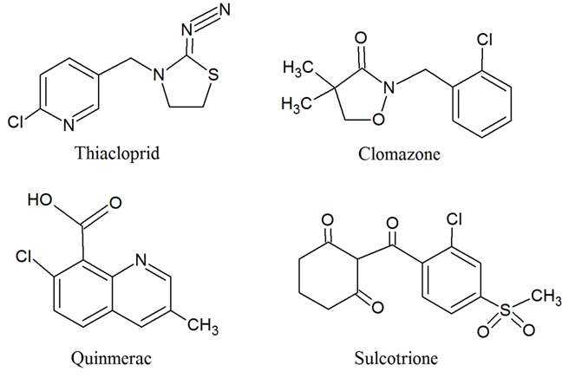
Fig. S1. Structures of the pesticides.

RESULTS AND DISCUSSION

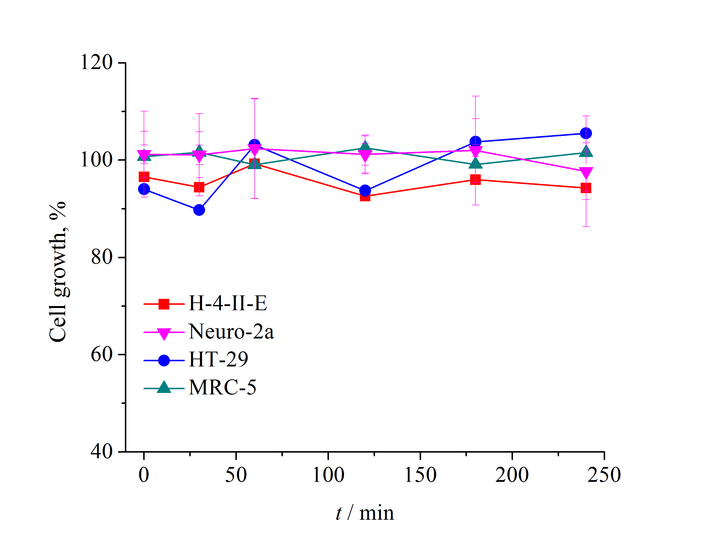

Fig. S2. Effect of reaction mixtures of sulcotrione and formed intermediates on the growth of selected mammalian cell lines using bare TiO₂ after different irradiation times. Values represent mean ± SD of at least four measurements (n = 4).

Cytotoxic effects of 5 μmol dm^{3} sulcotrione, as well as aqueous suspension of 0.05 mg cm^{–3} bare TiO₂, depended on the histologic type of cell line. The obtained results show that the highest inhibition of cell growth in the case of sulcotrione and bare TiO₂ was obtained in Neuro-2a (5.8%) and H-4-II-E (8.8%) cell lines, respectively (Fig. S2).
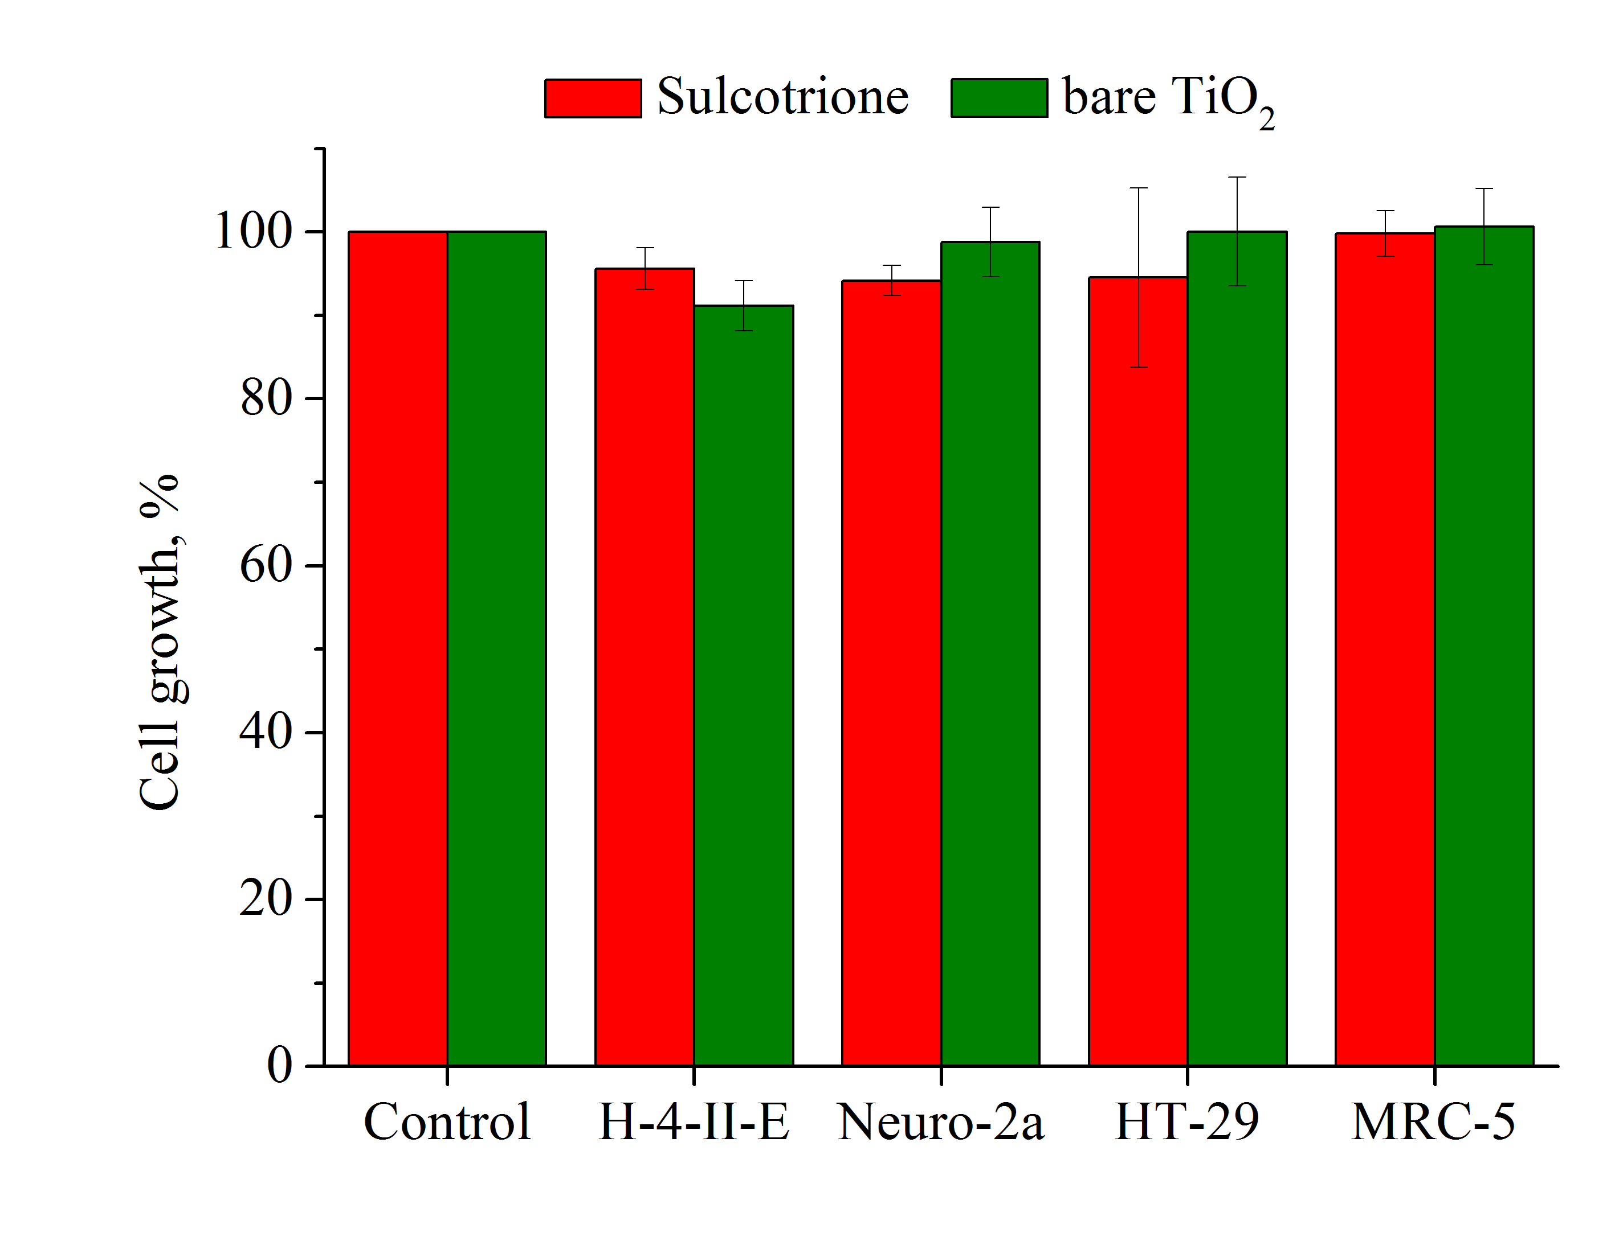
Fig. S3. Effects of sulcotrione solution and filtered aqueous suspension of bare TiO₂ nanocomposite on the growth of selected mammalian cell lines. Values represent mean ± SD of at least four measurements (n = 4).

Table S2. The mineralization degree of sulcotrione in the presence of bare TiO₂/TP nanocomposite suspension.
Type of catalyst | Mineralization degree (%)
Bare TiO₂ | 40.45
TP-50 | 31.27
TP-100 | 10.62
TP-150 | 36.63

Corresponding author E-mail: daniela.sojic@dh.uns.ac.rs

