In silico studies on smoothened human receptor and its antagonists in search of anticancer effects

ANA BOROTA*, SORIN AVRAM, RAMONA CURPAN, ALINA BORA, DANIELA VARGA, LILIANA HALIP, and LUMINITA CRISAN

“Coriolan Dragulescu” Institute of Chemistry, Romanian Academy, 24 Mihai Viteazul Avenue, RO-300223, Timisoara, Romania

Pharmacophore generation protocol
The ligands preparation for in silico studies was realized using LigPrep (Schrödinger)¹, by following the steps: optimization of the structures with the OPLS_2005 force field, ionization with Epik at pH=7.0, and generation of stereoisomers for the structures with unspecified chiralities.
ConfGen (Schrödinger)² was engaged in the generation of multiple conformers for each compound using default settings. The compounds were considered active if the pIC50 value is > 6.3 and inactive if the pIC50 value is <5.8. The maximum number of pharmacophore sites was set to four and all the active compounds matched the common pharmacophore hypotheses further obtained.

TABLE S1. The structure of the compounds and their experimental SMO inhibitory activity expressed in logarithmic units (pIC₅₀)^{[a]}.
No | Structure |  | pIC₅₀ | No | Structure | pIC₅₀
1 |  |  | 6.161 | 2^{[b]} |  | 5.568
3 |  |  | 5.886 | 4 |  | 5.283
5^{[b][c]} |  |  | 5.387 | 6^{[b]} |  | 6.568
7 |  |  | 6.102 | 8 |  | 6.259
9 |  |  | 5.920 | 10 |  | 5.823
11^{[c][b]} |  |  | 6.522 | 12^{[b]} |  | 6.455
13^{[b]} |  |  | 7.060 | 14^{[b]} |  | 6.356
15^{[c][b]} |  |  | 6.376 | 16^{[b]} |  | 6.568
17^{[c][b]} |  |  | 6.698 | 18^{[b]} |  | 6.420
19^{[b]} |  |  | 6.568 | 20 |  | 6.130
21 |  |  | 6.017 | 22^{[b]} |  | 5.387
23^{[c]} |  |  | 6.040 | 24^{[b]} |  | 5.744
25 |  |  | 6.050 | 26^{[c]} |  | 6.187
^{[a]}The compounds structures were drawn with MarvinSketch (ChemAxon) [http://www.chemaxon.com]. ^{[b]}The compounds used for decoys generation. ^{[c]}The test set compounds of the 3D-QSAR model.

Test set selection
In order to split the dataset in training and test sets, we followed the recommendation of Golbraikh papers^{3,4,5}:
(1) “On the basis of our analysis, we suggest that the test set must include no less than five compounds, whose activities and structures must cover the range of activities (see Figure S1) and structures of compounds from the training set.”
(2) “Ideally, the division into the training and test set must satisfy the following three conditions: (i) All representative compound-points of the test set in the multidimensional descriptor space must be close to those of the training set. (ii) All representative points of the training set must be close to those of the test set. (iii) The representative points of the training set must be distributed within the whole area occupied by the entire dataset.” To verify this in our case we have calculated the similarity between our training and test sets:

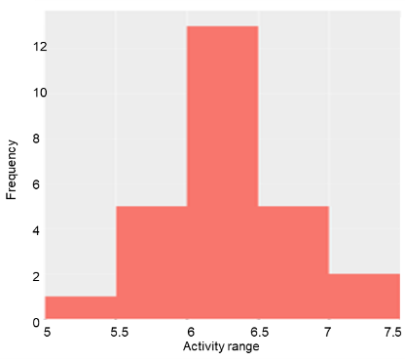
Figure S1. Histogram of dataset pIC50 distribution.

Peter Willett⁶ demonstrates that the well-known Tanimoto coefficient remains the method of choice for the computation of fingerprint-based similarity. The Tanimoto coefficient was calculated in order to have a quantitative basis, a similarity measure, and to assess the degree of resemblance between the training set and the test set. The Tanimoto similarity was computed using MACCS fingerprints, calculated with KNIME⁷. The test - training pairwise similarity values display a distribution shifted toward high values (0.85–1) (Figure S2).

Figure S2. The distribution of 2D Tanimoto coefficients values for training and test sets

In addition, we used the Euclidean Distance algorithm to work out the similarity between each two pairs of compounds by computing the score for each pair of nodes. The zero value for Euclidean Distance means absolute identity. For the training and test sets the distribution of values for Euclidean Distance are similar ((Figure S3).

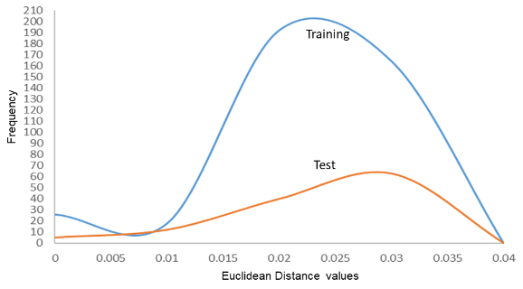

Figure S3. The distribution of Euclidean Distance values for training and test sets

Furthermore, the median values for the most important 2D properties (FILTER ( OpenEye))⁸ of molecules were calculated. In our case, the median value for training and test denote that the two sets of molecules are rather similar in character (Table S2).

Table S2. Characteristics (minim, maxim and median values) of the training and test set molecules

 | Name | MW | NRS | RBN | RB | XLogP | 2d PSA
TRAINING  SET | MIN | 370.86 | 3 | 3 | 26 | 1.41 | 68.32
 | MAX | 482.02 | 4 | 6 | 34 | 4.12 | 90.08
 | MEDIAN | 452.405 | 4 | 5 | 31 | 2.865 | 77.19
TEST SET | MIN | 425.93 | 3 | 4 | 27 | 1.24 | 60.51
 | MAX | 495.93 | 4 | 6 | 34 | 3.93 | 90.08
 | MEDIAN | 450.94 | 4 | 5 | 31.5 | 2.75 | 77.19
MW- molecular weight; NRS - number of ring systems; RBN -rotatable bonds; RB - rigid bonds

Building of the external validation dataset
The external validation dataset was assembled by extracting data from the ChEMBL database⁹. Firstly, 818 compounds having inhibitory activity against SMO receptor were extracted. Then, the compounds with unspecified bioactivity IC50 against SMO receptor, as well as those having IC50 values expressed with a qualifier of type “<” and “>” were removed. Finally, the duplicates were discarded using Instant JChem software [Instant JChem v. 17.17.0, https://chemaxon.com/] and 689 active compounds were retained. Subsequently, drug-like filtering criteria, e.g., HBA (hydrogen bond acceptors) = 3–4, HBD (hydrogen bond donors) = 0–3, MW (molecular weight) = 371–496, RBN (number of rotatable bonds) = 3–6, XLogP = −0.4–3.7, 2dPSA (2d polar surface area) = 60–90 were applied, resulting 179 compounds which have been designated as actives in the evaluation procedure⁹⁻¹¹. In order to select the decoys, a free on-line automated tool from the Directory of Useful Decoys, enhanced (DUD-E), (http://decoys.docking.org), was used¹². The decoys set was compiled based on the similarities with the compounds used for pharmacophore generation (Table I), employed as queries. Thus, 50 decoys were selected for each query, with the exception of compounds 2 and 22, (for which 100 decoys were identified for each of them). The extracted decoys have similar physicochemical properties (MW, HBA, HBD, logP and RBN) with queries but dissimilar 2-D topology. Therefore, 179 compounds designated as actives and 1350 decoys entitled as inactive were used for virtual screening (VS) experiments in order to find matches over the obtained pharmacophore hypotheses. The fitness scores were used for the ranking of the compounds over the best pharmacophore hypothesis.

References
1. Schrödinger Release 2016-1: LigPrep v3.1 (2016) Schrödinger, LLC, New York, NY
2. K.S.Watts, P. Dalal, R. B. Murphy, W. Sherman, R.A. Friesner, J.C. Shelley, J.Chem. Inf. Model. 50 (2010) 534 (https://doi.org/10.1021/ci100015j)
3. A. Golbraikh, A. Tropsha, J. Mol. Graph. Model. 20 (2002) 269 (https://doi.org/10.1016/S1093-3263(01)00123-1)
4. A. Golbraikh, A. Tropsha, J. Comput. Aided Mol. Des. 16 (2002) 357 (https://doi.org/10.1023/A:1020869118689)
5. A. Golbraikh, M. Shen, Z. Xiao, Y.-D. Xiao, K.-H. Lee, A. Tropsha, J. Comput. Aid. Mol. Des. 17 (2003) 241 (https://doi.org/10.1023/A:1025386326946)
6. P. Willett, Drug. Discov. Today. 11 (2006) 1046 10.1016/j.drudis.2006.10.005
7. S. Beisken, T. Meinl, B. Wiswedel, L. F. de Figueiredo, M. Berthold, C. Steinbeck, BMC Bioinformatics 14 (2013) 257 https://doi.org/10.1186/1471-2105-14-257
8. FILTER (2009) version 2.0.2 OpenEye Scientific Software, Inc. Santa Fe, NM, USA. www.eyesopen.com
9. A. P. Bento, A. Gaulton, A. Hersey, L. J. Bellis, J. Chambers, M. Davies, et al., Nucleic Acids Res. 42 (2014) 1083 (http://dx.doi.org/10.1093/nar/gkt1031)
10. D. F. Veber, S. R. Johnson, H. Y. Cheng, B. R. Smith, K. W. Ward, K. D. Kipple, J. Med. Chem. 45 (2002) 2615 (http://dx.doi.org/10.1021/jm020017n)
11. Y. C. Martin, J. Med. Chem. 48 (2005) 3164 (http://dx.doi.org/10.1021/jm0492002)
12. M. M. Mysinger, M. Carchia, J. J. Irwin, B. K. Shoichet, J. Med. Chem. 55 (2012) 6582 (http://dx.doi.org/10.1021/jm300687e)

* ana_borota@acad-icht.tm.edu.ro
* lumi_crisan@acad-icht.tm.edu.ro

