Synthesis and efficacy of copper(II) complexes bearing N(4)-substituted thiosemicarbazide and diimine co-ligands on plasmid DNA and HeLa cell lines
NEELAVENI RAJENDRAN¹, ABIRAMI PERIYASAMY ², NITHYA KAMATCHI ³ and VASANTHA SOLOMON *
¹PG and Research Department of Chemistry, Lady Doak College, Madurai − 625002, Tamil Nadu, India ² Department of Biotechnology, Lady Doak College, Madurai − 625002, Tamil Nadu, India and ³PG and Research Department of Zoology, Lady Doak College, Madurai − 625002, Tamil Nadu, India
SUPPLEMENTARY DATA
Synthesis of thiosemicarbazone ligands
Preparation of 1-phenyl-2-((5-(pyridin-3-yl)-4H-1,2,4-triazol-3-yl)thio)ethanone HL
Color: Colorless; Yield: 68%; m.p 190 − 192°C ; Anal.Calcd for C₁₅H₁₂N₄OS: C, 60.79; H, 4.08; N, 18.19; S, 10.82%; Found: C, 60.68; H, 4.02; N, 18.25; S, 10.77%; Ʌ_{m} (Ω⁻¹cm² mol⁻¹): 5; ¹H NMR (300 MHz, DMSO): δ_{H} 9.15 (s, 1H), 8.59 (s, 1H), 8.26 (d, J = 6.0 Hz, 1H), 8.06 (d, J = 6.0 Hz, 2H), 7.66 − 7.61 (m, 1H), 7.54−7.49 (m, 2H), 7.39 (s, 2H), 4.87 (s, 2H).
General method of preparation of H(L1) − H(L3)
(E)-N-methyl-2-(1-phenyl-2-((5-(pyridin-3-yl)-4H-1,2,4-triazol-3-yl)thio)ethylidene) hydrazinecarbothioamide H(L1)
Color: Yellow; Yield: 74%; m.p 212 − 214°C; Anal.Calcd for C₁₇H₁₇N₇S₂: C, 53.24; H, 4.47; N, 25.57; S, 16.72 %. Found: C, 53.36; H, 4.44; N, 25.61; S, 16.80 %; Ʌ_{m} (Ω⁻¹cm² mol⁻¹): 4; ¹H NMR (300 MHz, DMSO): δ_{H} 10.88 (s, 1H), 9.32 (s, 1H), 9.23 (d, J = 15 Hz, 1H), 8.66 (s, 1H), 8.54 (d, J = 9.0 Hz, 1H), 8.25 (d, J = 3.0 Hz, 1H), 8.10 (s, 1H), 7.85 (t, J = 3.0 Hz, 1H), 7.56 – 7.52 (m, 1H), 7.43 (d, J = 3.0 Hz, 3H), 4.59 (s, 2H), 3.19 (d, J = 6.0 Hz, 3H); ¹³C NMR (75 MHz, DMSO): δ_{C} 179.5, 162.9, 151.0, 148.2, 147.8, 145.5, 136.4, 134.9, 133.8, 130.0, 129.3, 128.9, 127.3, 124.1, 36.8, 31.7, 26.8; FT−IR (KBr; cm⁻¹): 3340 (s, N(4)H), 3199, (s, N(2)H), 1554 (s, C=N), 813 (s, C=S), 987 (s, N−N); UV−Vis: λ_{max} (DMF) nm: 225, 295 and 355.
(E)-N-ethyl-2-(1-phenyl-2-((5-(pyridin-3-yl)-4H-1,2,4-triazol-3-yl)thio)ethylidene) hydrazinecarbothioamide H(L2)
Color: Yellow; Yield: 70%; m.p 222 − 224°C; Anal.Calcd for C₁₈H₁₉N₇S₂: C, 54.39; H, 4.82; N, 24.66; S, 16.13 %. Found: C, 54.42; H, 4.91; N, 24.79; S, 16.09 %; Ʌ_{m} (Ω⁻¹cm² mol⁻¹): 7; ¹H NMR (300 MHz, DMSO): δ_{H} 11.08 (s, 1H), 9.51 (s, 1H), 8.85 (d, J = 30.0 Hz, 2H), 8.53 – 8.51 (m, 1H), 8.14 – 8.11 (m, 1H), 7.96 – 7.94 (m, 2H), 7.86 (s, 1H), 7.62 – 7.60 (m, 3H), 4.75 (s, 2H), 3.95 – 3.93 (m, 2H), 1.46 (t, J = 6.0 Hz, 3H); ¹³C NMR (75 MHz, DMSO): δ_{C} 179.7, 160.1, 157.8, 157.4, 155.3, 154.9, 148.0, 136.9, 134.2, 131.8, 128.9, 128.8, 128.4, 128.1, 124.3, 38.1, 39.9, 15.8; FT−IR (KBr; cm⁻¹): 3240 (m, N(4)H), 2970 (s, N(2)H), 1518 (s, C=N), 808 (s, C=S), 977 (s, N−N); UV−Vis: λ_{max} (DMF) nm: 280 and 360.
(E)-N-phenyl-2-(1-phenyl-2-((5-(pyridin-3-yl)-4H-1,2,4-triazol-3-yl)thio)ethylidene) hydrazinecarbothioamide H(L3)
Color: Yellow; Yield: 61%; m.p 235 − 237°C; Anal.Calcd for C₂₂H₁₉N₇S₂: C, 59.30; H, 4.30; N, 22.01; S, 14.39%. Found: C, 59.26; H, 4.21; N, 22.11; S, 14.38 %; Ʌ_{m} (Ω⁻¹cm² mol⁻¹): 11;¹H NMR (300 MHz, DMSO): δ_{H} 11.60 (s, 1H), 10.02 (s, 1H), 9.74 (s, 1H), 9.61 (s, 2H), 8.99 – 8.96 (m, 1H), 8.90 (d, J = 6.0 Hz, 1H), 8.65 (d, J = 6.0 Hz, 1H), 8.43 (d, J = 9.0 Hz, 1H), 8.35 (s, 2H), 8.03 – 7.95 (m, 1H), 7.91 – 7.86 (m, 1H), 7.81 – 7.72 (m, 1H), 7.70 – 7.63 (m, 1H), 7.59 – 7.57 (m, 1H), 7.32 – 7.27 (m, 1H), 5.17 (s, 2H); ¹³C NMR (75 MHz, DMSO): δ_{C} 184.7, 155.1, 157.9, 157.5, 155.4, 148.1, 138.7, 135.8, 135.8, 132.7, 133.1, 131.2, 129.2, 129.0, 128.9, 128.8, 128.5, 128.4, 128.2, 126.9, 124.1, 38.4; FT−IR (KBr; cm⁻¹): 3290 (s, N(4)H), 3147 (s, N(2)H), 1534 (s, C=N), 826 (s, C=S), 973 (s, N−N); UV−Vis: λ_{max} (DMF) nm: 310 and 345.
Synthesis of copper(II) bis complexes (C1 − C3)
[Cu(L1)₂] (C1)
Color: Green; Yield: 69%; Anal.Calcd for: C₃₄H₃₂CuN₁₄S₄: C, 49.29; H, 3.89; N, 25.67; S, 15.48%; Found: C, 49.17; H, 3.81; N, 23.62; S, 15.39%; Ʌ_{m} (Ω⁻¹cm² mol⁻¹):16; FT−IR (KBr; cm⁻¹): 3059 (s, N(4)H), 1562 (s, C=N), 738 (s, C−S), 1047 (s, N−N), 425 (m, Cu−N) and 612 (m, Cu−S); UV−Vis: λ_{max} (DMF) nm: 295, 360 and 635 (d−d transition); EPR: A|| = 158 x 10⁻⁴ cm⁻¹; g|| = 2.252; g⊥ = 2.057; g _{ll} /A_{ll} = 140 cm; G = 4.38.The similar method was applied for the synthesis of complexes 2 and 3 using H(L2) and H(L3) instead of H(L1).
[Cu(L2)₂] (C2)
Color: Green; Yield: 62%; Anal.Calcd for: C₃₆H₃₆CuN₁₄S₄: C, 50.48; H, 4.24; N, 22.89; S, 14.97%; Found: C, 50.54; H, 4.29; N, 22.95; S, 14.89%; Ʌ_{m} (Ω⁻¹cm² mol⁻¹): 17; FT−IR (KBr; cm⁻¹): 3061 (s, NH), 1556 (s, C=N), 738 (s, C−S), 1012 (s, N−N), 430 (m, Cu−N) and 621 (s, Cu−S); UV−Vis: λ_{max} (DMF) nm: 290, 412 and 645 (d−d transition); EPR: A|| = 162 x 10⁻⁴ cm⁻¹; g|| = 2.249; g⊥ = 2.056; g _{ll} /A_{ll} = 138 cm; G = 4.59.
[Cu(L3)₂] (C3)
Color: Green; Yield: 58%; Anal.Calcd for: C₄₄H₃₆CuN₁₄S₄: C, 55.47; H, 3.81; N, 20.58; S, 13.46%; Found: C, 55.56; H, 3.75; N, 20.51; S, 13.49%; Ʌ_{m} (Ω⁻¹cm² mol⁻¹): 18; FT−IR (KBr; cm⁻¹): 3091(s, NH), 1572 (s, C=N), 745 (s, C−S), 1131 (s, N−N), 618 (s, Cu−N) and 428 (s, Cu−S); UV−Vis: λ_{max} (DMF) nm: 318, 380 and 715 (d−d transition); EPR: A|| = 160 x 10⁻⁴ cm⁻¹; g|| = 2.258; g⊥ = 2.062; g _{ll} /A_{ll} = 141 cm; G = 4.28.
Synthesis of mixed ligand copper(II) complexes (C4−C9)
[Cu(L1)(bpy)]Cl (C4)
To the 2 mmol ethanolic solution of ligand H(L1), solution of 2,2’-bipyridyl (1 mmol in ethanol) was added by constant stirring for 1 h. To this solution, copper(II) chloride dihydrate was added dropwise and again stirred for 30 min. Subsequently, the green precipitate obtained was washed several times with cold ethanol and dried. Color: Green; Yield: 61%; Anal.Calcd for: C₂₇H₂₄ClCuN₉S₂: C, 50.86; H, 3.79; N, 19.77; S, 10.06%; Found: C, 50.92; H, 3.71; N, 19.84; S, 50.88%; Ʌ_{m} (Ω⁻¹cm² mol⁻¹): 83; FT−IR (KBr; cm⁻¹): 3098 (s, NH), 1553 (s, C=N), 761 (s, C−S), 1115 (s, N−N), 461 (s, Cu−N) , 641 (s, Cu−S); UV−Vis: λ_{max} (DMF) nm: 310, 395 and 745 (d−d transition); EPR: A|| = 163 x 10⁻⁴ cm⁻¹; g|| = 2.257; g⊥ = 2.074; g _{ll} /A_{ll} = 139 cm; G = 4.55.
The similar method was applied for the synthesis of complexes 5 and 6 using H(L2) and H(L3) instead of H(L1).
[Cu(L2)(bpy)]Cl (C5)
Color: Green; Yield: 72%; Anal.Calcd for: C₂₈H₂₆ClCuN₉S₂: C, 51.60; H, 4.02; N, 19.34; S, 9.84%; Found: C, 51.70; H, 3.97; N, 19.34; S, 9.81%; Ʌ_{m} (Ω⁻¹cm² mol⁻¹): 89; FT−IR (KBr; cm⁻¹): 3074 (s, NH), 1559 (s, C=N), 758 (s, C−S), 1109 (s, N−N), 456 (s, Cu−N) and 643 (s, Cu−S); UV−Vis: λ_{max} (DMF) nm: 295, 415 and 725 (d−d transition); EPR: A|| = 160 x 10⁻⁴ cm⁻¹; g|| = 2.268; g⊥ = 2.063; g _{ll} /A_{ll} = 141 cm; G = 4.38.
[Cu(L3)(bpy)]Cl (C6)
Color: Green; Yield: 68%; Anal.Calcd for: C₃₂H₂₆ClCuN₉S₂: C, 54.93; H, 3.75; N, 18.02; S, 9.16%; Found: C, 54.89; H, 3.70; N, 18.07; S, 9.15%; Ʌ_{m} (Ω⁻¹cm² mol⁻¹): 96; FT−IR (KBr; cm⁻¹): 3088 (s, NH), 1549 (s, C=N), 752 (s, C−S), 1008 (s, N−N), 441 (s, Cu−N), 628 (s, Cu−S); UV−Vis: λ_{max} (DMF) nm: 335, 370 and 758 (d−d transition); EPR: A|| = 162 x 10⁻⁴ cm⁻¹; g|| = 2.254; g⊥ = 2.071; g _{ll} /A_{ll} = 139 cm; G = 3.66.
Complexes 7, 8 and 9 was prepared in a similar manner to complex 4, using 1,10-phenanthroline instead of 2,2’-bipyridyl.
[Cu(L1)(phen)]Cl (C7)
Color: Green; Yield: 75%; Anal.Calcd for: C₂₉H₂₄ClCuN₉S₂: C, 52.64; H, 3.66; N, 19.05; S, 9.69%; Found: C, 52.70; H, 3.61; N, 19.11; S, 9.74%; Ʌ_{m} (Ω⁻¹cm² mol⁻¹): 93; FT−IR (KBr; cm⁻¹): 3055 (s, NH), 1568 (s, C=N), 775 (s, C−S), 1045 (s, N−N), 424 (s, Cu−N), 642 (s, Cu−S); UV−Vis: λ_{max} (DMF) nm: 290, 335 and 685 (d−d transition); EPR: A|| = 163 x 10⁻⁴ cm⁻¹; g|| = 2.257; g⊥ = 2.059; g _{ll} /A_{ll} = 141 cm; G = 4.49.
[Cu(L2)(phen)]Cl (C8)
Color: Green; Yield: 68%; Anal.Calcd for: C₃₀H₂₆ClCuN₉S₂: C, 53.32; H, 3.88; N, 18.66; S, 9.49%; Found: C, 53.29; H, 3.81; N, 18.70; S, 9.43%; Ʌ_{m} (Ω⁻¹cm² mol⁻¹): 98; FT−IR (KBr; cm⁻¹): 3055 (s, NH), 1516 (s, C=N), 777 (s, C−S), 998 (s, N−N), 426 (s, Cu−N), 653 (s, Cu−S); UV−Vis: λ_{max} (DMF) nm: 295, 390 and 725 (d−d transition); EPR: A|| = 162 x 10⁻⁴ cm⁻¹; g|| = 2.258; g⊥ = 2.064; g _{ll} /A_{ll} = 140 cm; G = 4.14.
[Cu(L3)(phen)]Cl (C9)
Color: Green; Yield: 60%; Anal.Calcd for: C₃₄H₂₆ClCuN₁₄S₄: C, 56.42; H, 3.62; N, 17.42; S, 8.86%; Found: C, 56.46; H, 3.59; N, 17.49; S, 8.89%; Ʌ_{m} (Ω⁻¹cm² mol⁻¹): 103; FT−IR (KBr; cm⁻¹): 3059 (s, NH), 1543 (s, C=N), 771 (s, C−S), 1103 (s, N−N), 423 (s, Cu−N), 632 (s, Cu−S); UV−Vis: λ_{max} (DMF) nm: 335, 430 and 735 (d−d transition); EPR: A|| = 162 x 10⁻⁴ cm⁻¹; g|| = 2.260; g⊥ = 2.059; g _{ll} /A_{ll} = 139 cm; G = 4.54; HRMS Calculated for 768.12; Found 765.17.

Fig. 1. ¹H NMR spectrum of H(L1) in DMSO-d₆
Fig. 2. ¹³C NMR spectrum of H(L1) in DMSO-d₆

Fig. 3. Electronic spectra of ligand H(L1) in DMF

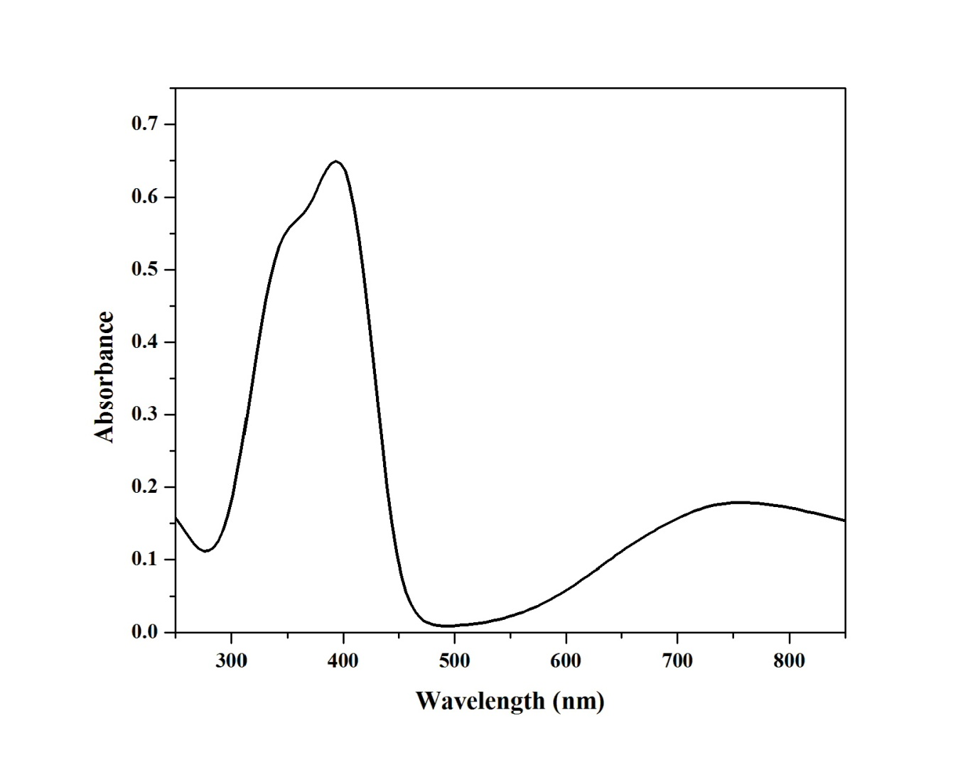
Fig. 4. Electronic spectra of complex C5 in DMF

Fig. 5. X-band EPR spectrum of complex C7 in frozen DMF solution
Fig.6. HRMS spectrum of complex C9

Fig. 7. Cyclic voltammogram of complex C2
Table I. Electrochemical data of thiosemicarbazone copper(II) complexes 1 − 9
Complexes | Cyclic voltammogram ª |  |  | Differential pulse voltammogram ª | Redox process
 | E_{pa}  (V) | E_{pc}  (V) | E_{1/2}  (V) | E_{1/2} (DPV)  (V)
[Cu(L1)₂] (C1) | 0.309 | 0.572 | 0.441 | 0.601 | Cu(II) → Cu(I)
[Cu(L2)₂] (C2) | 0.324 | 0.542 | 0.433 | 0.529 | Cu(II) → Cu(I)
[Cu(L3)₂] (C3) | 0.332 | 0.498 | 0.415 | 0.471 | Cu(II) → Cu(I)
[Cu(L1)(bpy)]Cl (C4) | 0.327 | 0.598 | 0.463 | 0.637 | Cu(II) → Cu(I)
[Cu(L2)(bpy)]Cl (C5) | 0.258 | 0.662 | 0.460 | 0.598 | Cu(II) → Cu(I)
[Cu(L3)(bpy)]Cl (C6) | 0.572 | 0.598 | 0.345 | 0.446 | Cu(II) → Cu(I)
[Cu(L1)(phen)]Cl (C7) | 0.327 | 0.559 | 0.659 | 0.643 | Cu(II) → Cu(I)
[Cu(L2)(phen)]Cl (C8) | 0.247 | 0.576 | 0.640 | 0.612 | Cu(II) → Cu(I)
[Cu(L3)(phen)]Cl (C9) | 0.022 | 0.551 | 0.638 | 0.587 | Cu(II) → Cu(I)
ª DMF (1 x 10⁻³ M), E_{1/2} = 0.5 (E_{pa} + E_{pc}), ∆E_{p} = E_{pa} − E_{pc}, where E_{pa} and E_{pc} were anodic and cathodic peak potentials respectively (Scan rate 50mVs⁻¹)
Table II. Diameter of zone of inhibition of thiosemicarbazone ligands and copper(II) complexes
Ligand  and  Complexes | Diameter of inhibition zone (mm)ª
 | E. coli |  | Bacillus sp.
 | 5 (μg / ml) | 50 (μg / ml) | 5 (μg / ml) | 50 (μg / ml)
H(L1) | 1 | 2 | 0 | 1
H(L2) | 1 | 4 | 0 | 1
H(L3) | 1 | 2 | 0 | 1
[Cu(L1)₂] (C1) | 3 | 5 | 4 | 5
[Cu(L2)₂] (C2) | 3 | 6 | 2 | 4
[Cu(L3)₂] (C3) | 2 | 5 | 1 | 3
[Cu(L1)(bpy)]Cl (C4) | 2 | 4 | 4 | 6
[Cu(L2)(bpy)]Cl (C5) | 2 | 5 | 5 | 7
[Cu(L3)(bpy)]Cl (C6) | 3 | 6 | 6 | 8
[Cu(L1)(phen)]Cl (C7) | 5 | 8 | 7 | 10
[Cu(L2)(phen)]Cl (C8) | 7 | 9 | 6 | 11
[Cu(L3)(phen)]Cl (C9) | 3 | 5 | 5 | 8
(positive control)^{b}  (Negative control)^{c} | 9  NA | 9  NA | 13  NA | 13  NA
ª Mean zone of inhibition in mm ^{b} standard antibacterial agent used was chloramphenicol (positive control) ^{c} Dimethyl formamide (negative control), NA = No activity
Table III. Percentage of cytotoxicity of the thiosemicarbazone ligands and its copper(II) complexes
Compounds | Cytotoxicity ª , %
 | HeLa ^{b}
H(L1) | 56.38 ± 0.31
H(L2) | 34.00 ± 0.10
H(L3) | 46.00 ± 0.01
[Cu(L1)₂] (C1) | 21.62 ± 0.10
[Cu(L2)₂] (C2) | 66.00 ± 0.21
[Cu(L3)₂] (C3) | 54.00 ± 0.09
[Cu(L1)(bpy)]Cl (C4) | 60.84 ± 0.36
[Cu(L2)(bpy)]Cl (C5) | 59.00 ± 0.05
[Cu(L3)(bpy)]Cl (C6) | 60.00 ± 0.12
[Cu(L1)(phen)]Cl (C7) | 81.79 ± 0.26
[Cu(L2)(phen)]Cl (C8) | 84.00 ± 0.04
[Cu(L3)(phen)]Cl (C9) | 73.00 ± 0.04
Cisplatin ^{c} | 96.00 ± 0.01
ª Percentage of cytotoxicity at 5 μM for 24 h with standard error values ^{b} Cervical cancer cell lines ^{c} Positive control

* Corresponding author E-mail: vasantha@ldc.edu.in (Tel:+919976366463)

