SUPPLEMENTARY MATERIAL
HPTLC-Direct Bioautography-Guided Isolation of Isogeranic Acid as the Main Antibacterial Constituent of Artemisia santonicum Essential Oil

JOVANA STANKOVIĆ¹, MIROSLAV NOVAKOVIĆ¹, VELE TEŠEVIĆ², ANA ĆIRIĆ³, MARINA SOKOVIĆ³, GORDANA ZDUNIĆ⁴, ZORA DAJIĆ-STEVANOVIĆ⁵ and DEJAN GOĐEVAC¹*

¹Institute of Chemistry, Technology and Metallurgy, National Institute, Njegoseva 12, 11000 Belgrade, Serbia, ²University of Belgrade -Faculty of Chemistry, Studentski trg 12-16, 11000 Belgrade, Serbia, ³Institute for Biological Research “Siniša Stanković”, University of Belgrade, Department of Plant Physiology, Bulevar Despota Stefana 142, 11000 Belgrade, Serbia, ⁴Institute for Medicinal Plant Research “Dr. Josif Pančić”, Tadeuša Košćuška 1, 11000 Belgrade, Serbia, ⁵Faculty of Agriculture, University of Belgrade, Nemanjina Street 6, 11080 Zemun,, Serbia
*Corresponding author, e-mail:dgodjev@chem.bg.ac.rs

Figure S1. GC/FID chromatogram of the essential oil (up) and pure isogeranic acid (down)

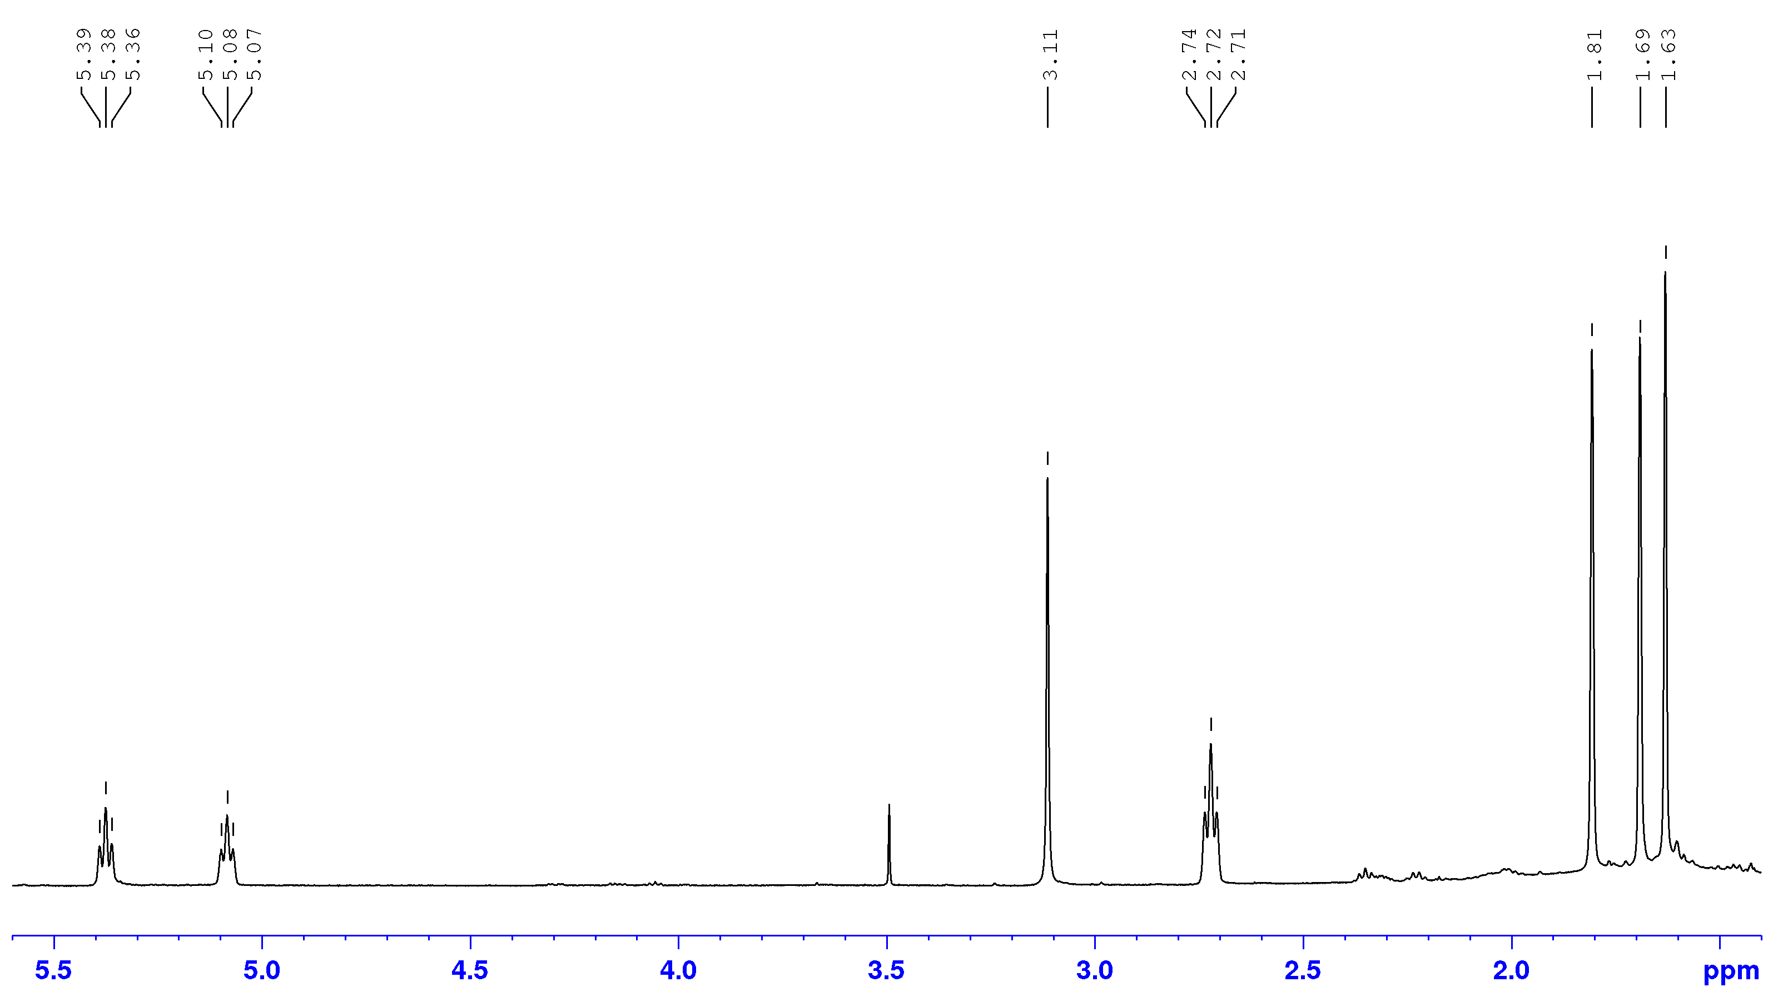
Figure S2. ¹H NMR spectrum of Z isogeranic acid
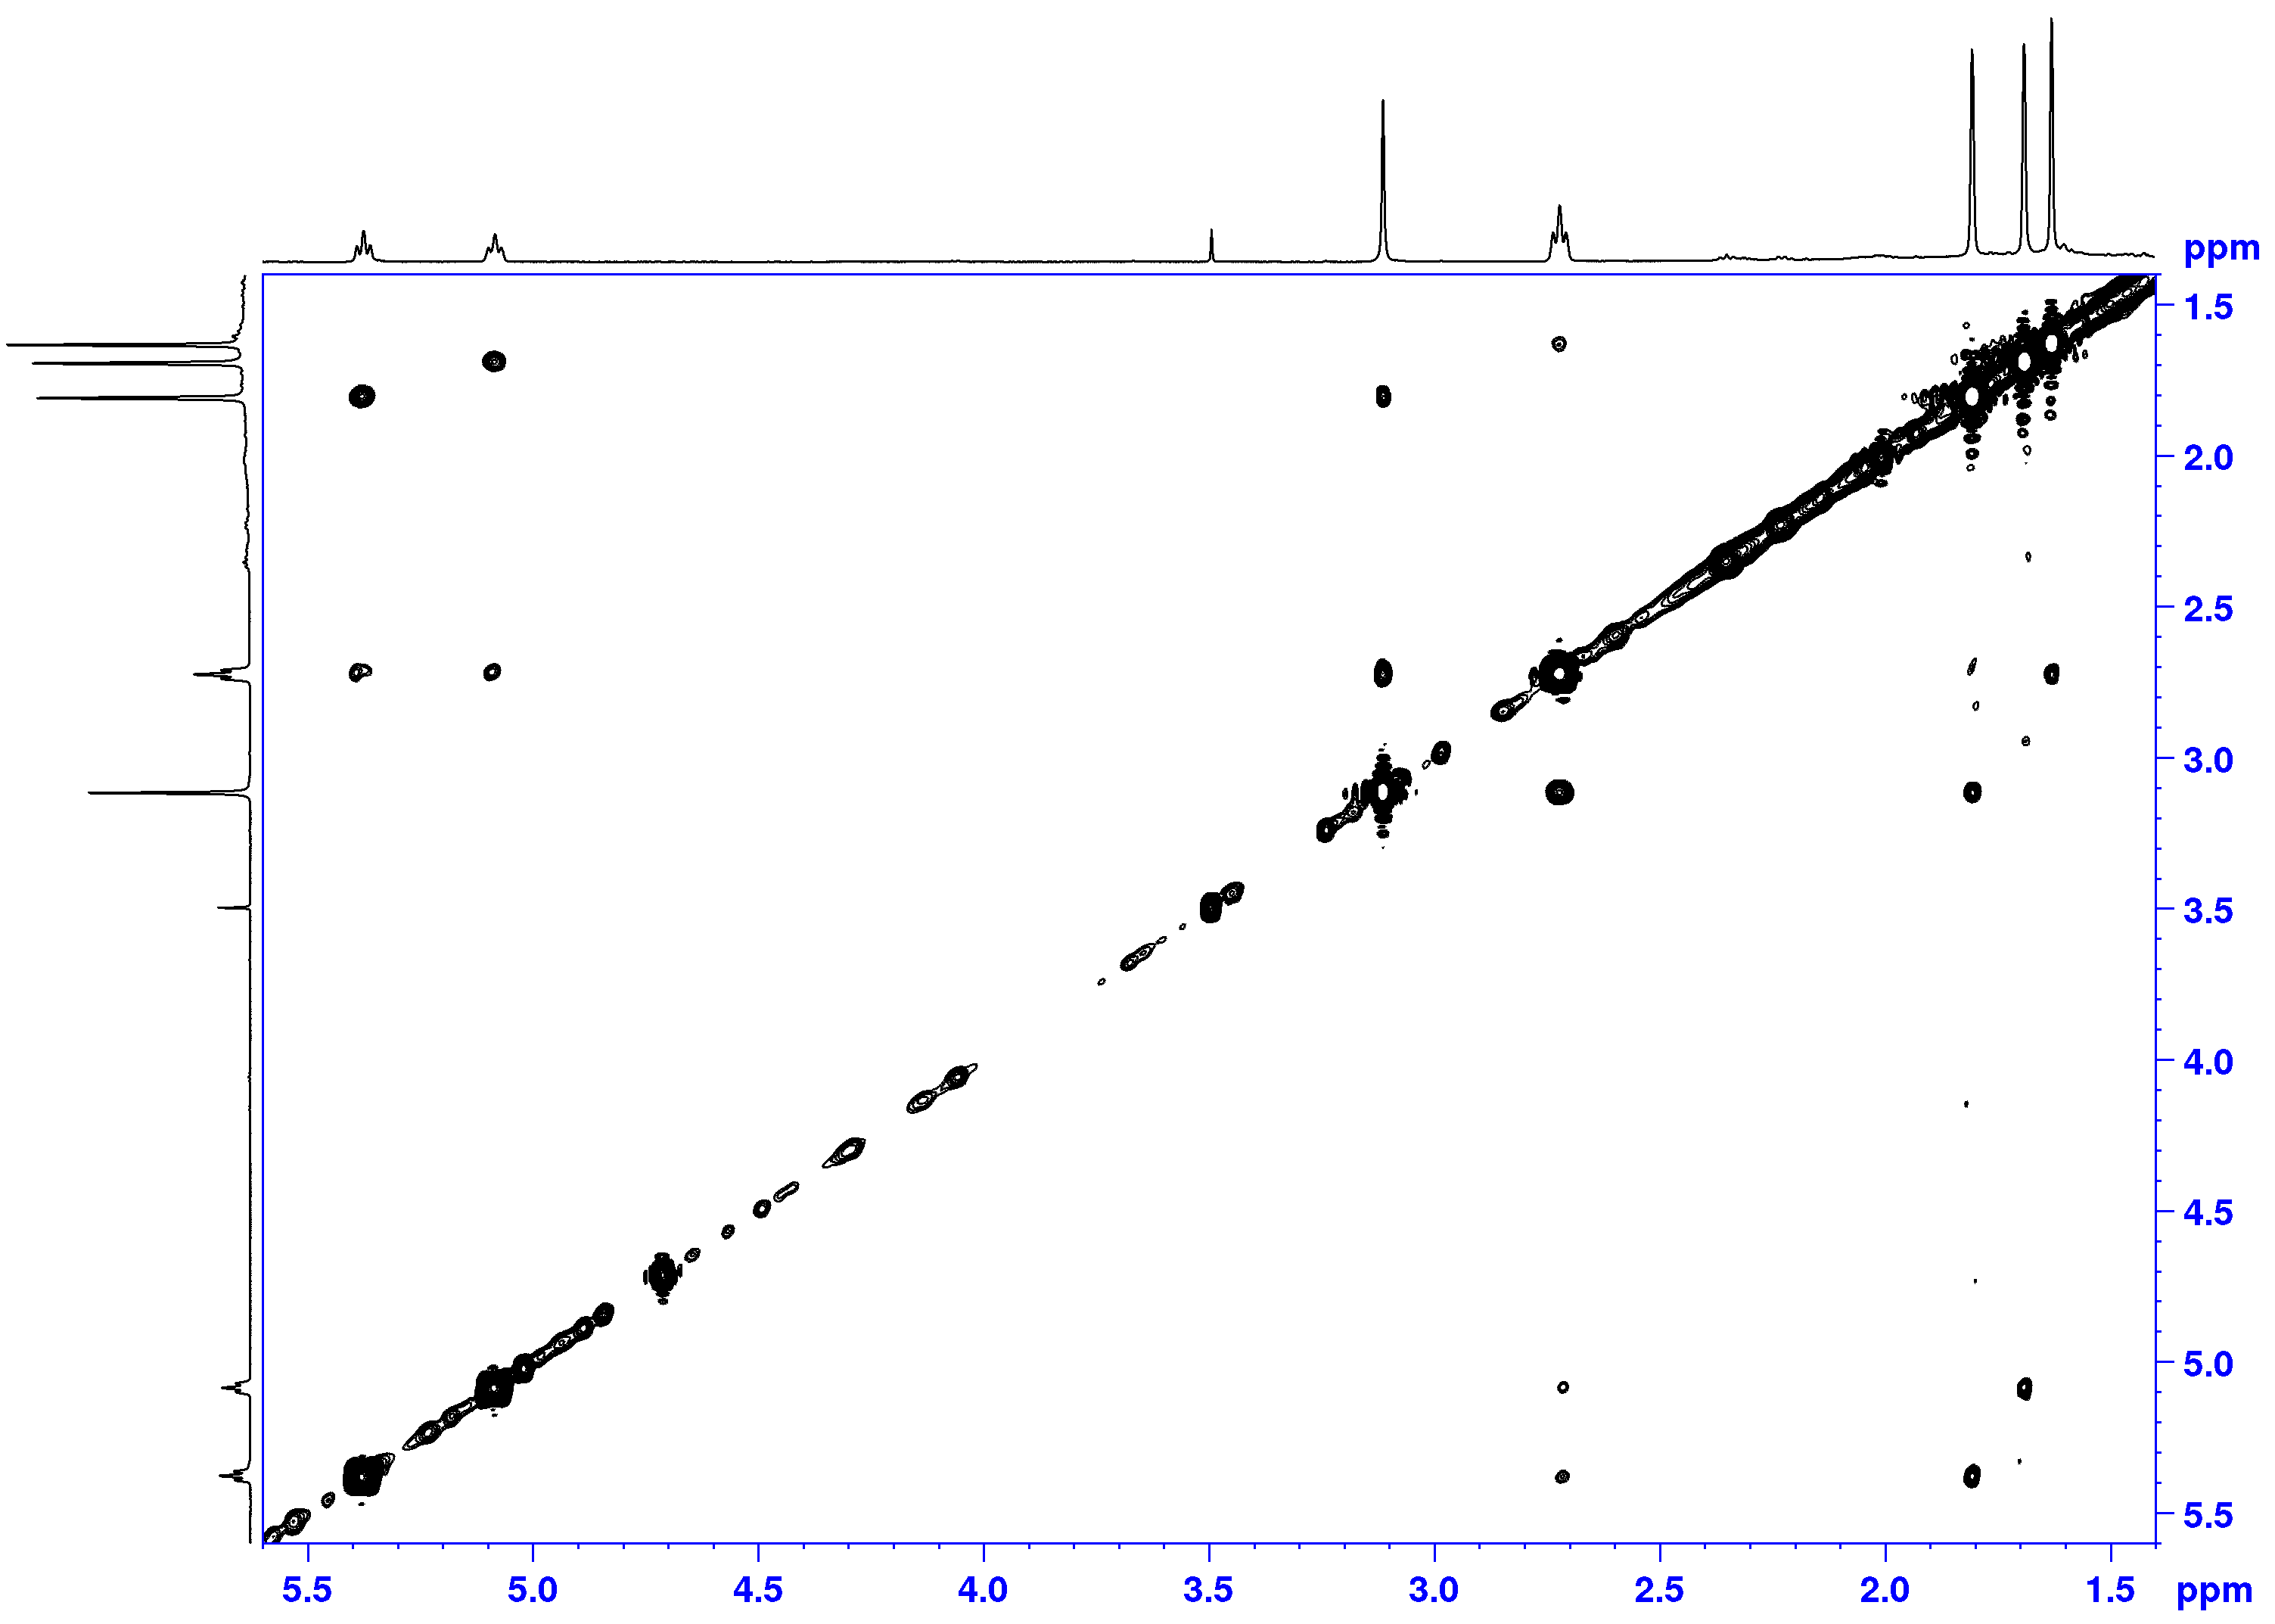
Figure S3. NOESY spectrum of Z isogeranic acid
Figure S4. DEPT spectrum of Z isogeranic acid

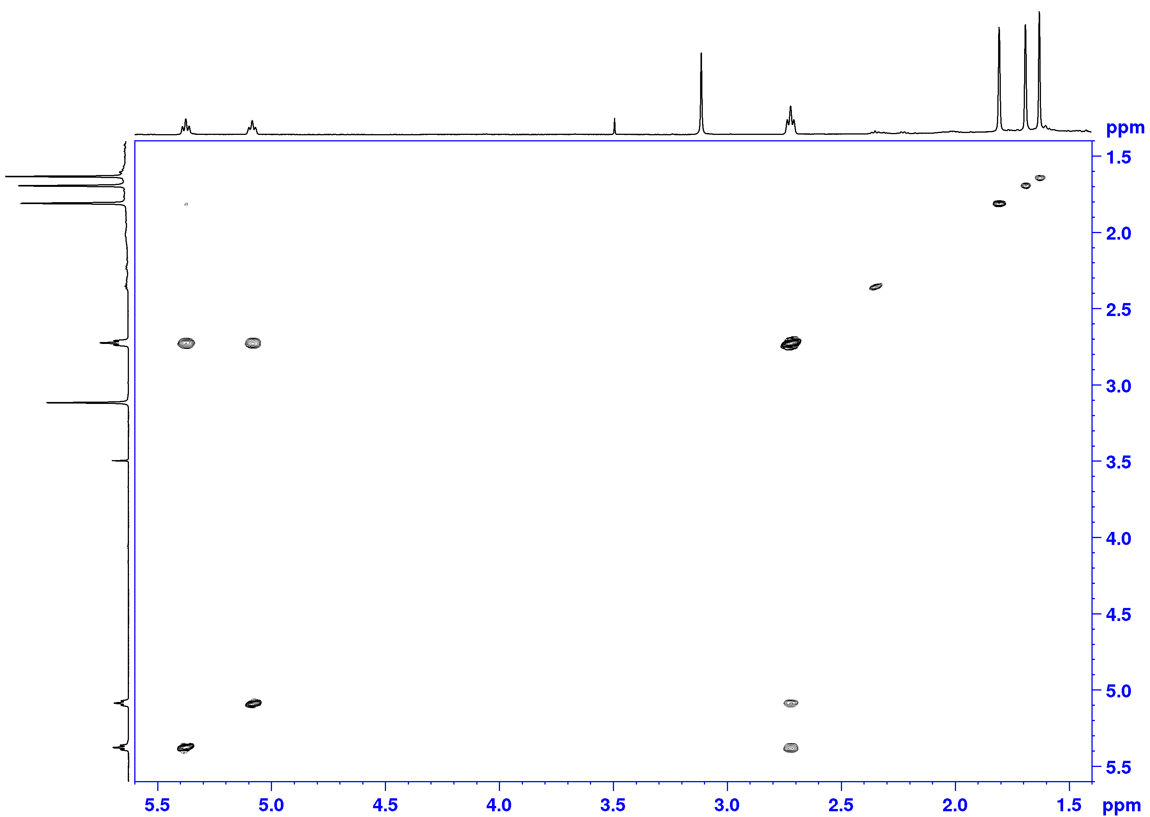
Figure S5. COSY spectrum of Z isogeranic acid

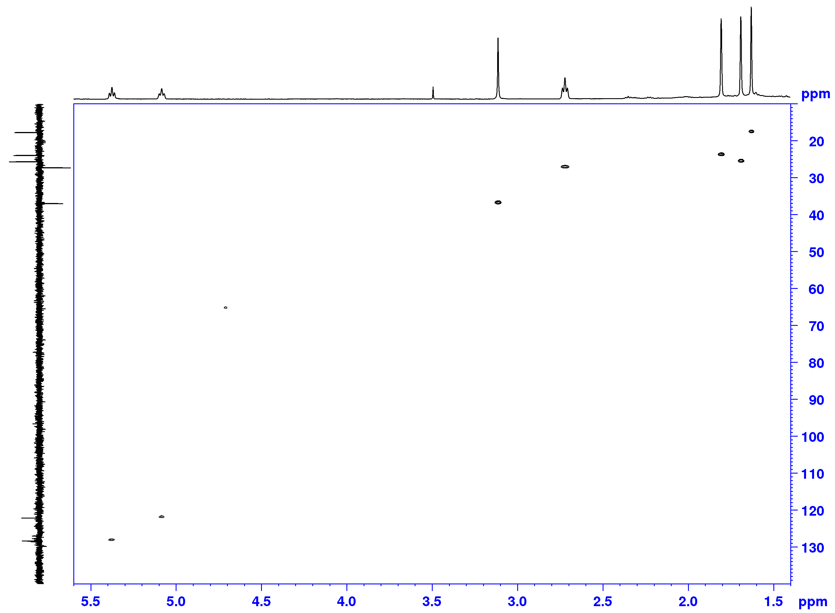
Figure S6. HSQC spectrum of Z isogeranic acid

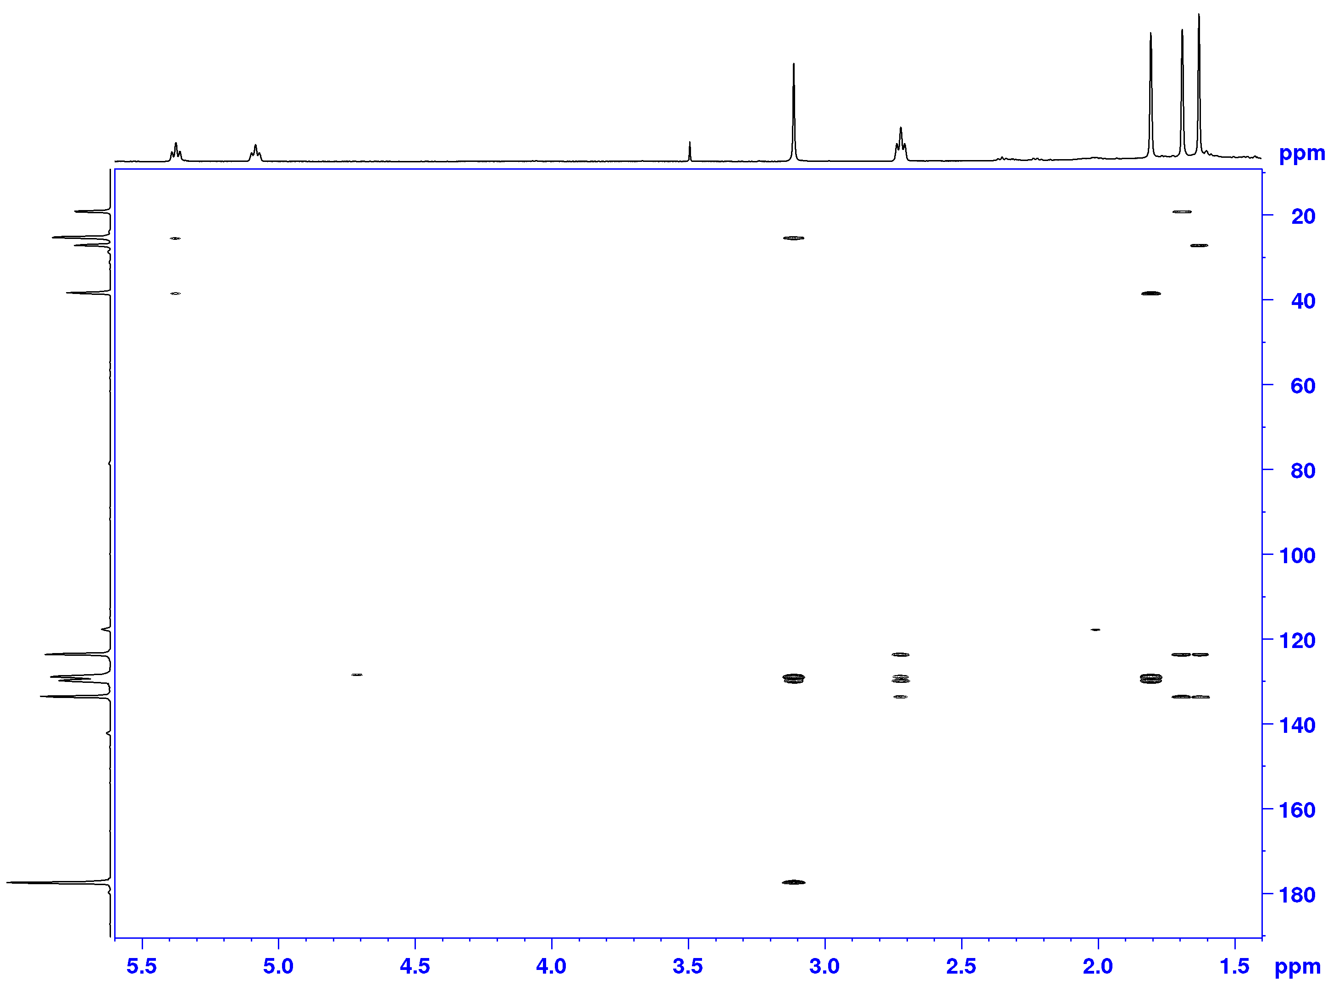
Figure S7.HMBC spectrum of Z isogeranic acid

Table S1. Compositionª of the Essential Oil from A. santonicum
No. | Compound | RI^{b} | Rt^{c}(min) | %ª
1 | 1,2,5,5-Tetramethyl-1,3-cyclopentadiene | 817 | 3.741 | 0.4
2 | NI | 868 | 4.599 | 0.1
3 | Tricyclene | 906 | 5.489 | 0.2
4 | α-Thujene | 914 | 5.579 | 0.2
5 | α-Pinene | 921 | 5.771 | 1.1
6 | Camphene | 936 | 6.171 | 0.8
7 | Thuja-2,4(10)-diene | 942 | 6.315 | 0.4
8 | Sabinene | 966 | 6.852 | 0.8
9 | β-Pinene | 971 | 6.972 | 0.3
10 | 1,8-Dehydro cineole | 985 | 7.379 | 0.3
11 | Mesitylene | 991 | 7.457 | 1.3
12 | Yomogi alcohol | 996 | 7.58 | 0.4
13 | α-Phellandrene | 999 | 7.808 | 0.2
14 | NI | 1006 | 8.081 | 0.1
15 | α-Terpinene | 1010 | 8.206 | 0.5
16 | 1,2,4-Trimethylbenzene | 1015 | 8.425 | 0.6
17 | p-Cymene | 1016 | 8.473 | 2.8
18 | 1,8-Cineole | 1022 | 8.739 | 18.8
19 | Santolina alcohol | 1026 | 8.848 | 0.3
21 | NI | 1036 | 9.300 | 0.1
22 | γ-Terpinene | 1046 | 9.698 | 0.9
23 | cis-Sabinene hydrate | 1056 | 10.006 | 0.3
24 | Artemisia alcohol | 1070 | 10.623 | 0.4
25 | NI | 1074 | 10.821 | 0.9
26 | NI | 1082 | 11.137 | 0.1
27 | Linalool | 1091 | 11.298 | 1.6
28 | Filifolone | 1094 | 11.455 | 2.6
29 | cis-Thujone | 1097 | 11.559 | 8.4
30 | trans-Thujone | 1110 | 11.969 | 1.6
31 | Isophorone | 1111 | 12.123 | 2.0
32 | Chrysanthenone | 1117 | 12.367 | 13.3
33 | trans-Sabinol | 1131 | 12.938 | 2.9
34 | Camphor | 1136 | 13.124 | 3.0
35 | p-Mentha-1,7-dien-8-ol | 1140 | 13.29 | 0.4
36 | NI | 1147 | 13.583 | 0.1
37 | Sabina ketone | 1150 | 13.669 | 0.2
38 | Pinocarvone | 1155 | 13.881 | 0.6
39 | Borneol | 1160 | 14.014 | 0.2
40 | p-Mentha-1,5-dien-8-ol | 1155 | 14.063 | 0.5
41 | Santolinyl acetate | 1159 | 14.253 | 0.2
42 | Terpinen-4-ol | 1171 | 14.522 | 1.5
43 | Thuj-3-en-10-al | 1178 | 14.848 | 0.4
44 | α-Terpineol | 1185 | 15.098 | 0.7
45 | Myrtenal | 1191 | 15.338 | 0.4
46 | Verbenone | 2004 | 15.898 | 0.8
47 | Cumin aldehyde | 1237 | 17.278 | 0.4
48 | Carvone | 1240 | 17.441 | 0.2
49 | Piperitone | 1250 | 17.891 | 0.3
50 | cis-Chrysanthenyl acetate | 1258 | 18.215 | 0.7
51 | p-Mentha-1,8-dien-3-one | 1268 | 18.673 | 0.5
52 | NI | 1276 | 19.013 | 0.1
53 | Bornyl acetate | 1277 | 19.303 | 0.3
54 | trans-Sabinyl acetate | 1285 | 19.636 | 3.3
55 | Terpinen-4-ol acetate | 1296 | 19.940 | 0.2
56 | Carvacrol | 1300 | 20.076 | 0.2
57 | NI | 1305 | 20.307 | 0.1
58 | NI | 1310 | 20.505 | 0.4
59 | Filifolide A | 1316 | 20.783 | 1.4
60 | NI | 1319 | 20.935 | 0.1
61 | NI | 1334 | 21.607 | 0.1
62 | Piperitenone | 1338 | 21.759 | 0.1
63 | Isogeranic acid | 1343 | 21.993 | 0.2
64 | α-Terpinyl acetate | 1345 | 22.127 | 0.1
65 | NI | 1348 | 22.205 | 0.1
66 | NI | 1352 | 22.371 | 0.2
67 | Eugenol | 1359 | 22.504 | Tr
68 | α-Copaene | 1368 | 23.296 | 0.3
69 | NI | 1373 | 23.51 | 0.1
70 | β-Bourbonene | 1381 | 23.689 | 0.1
71 | NI | 1391 | 24.172 | 3.3
72 | (Z)-Jasmone | 1394 | 24.293 | 1.0
73 | NI | 1401 | 24.587 | 0.1
74 | NI | 1411 | 25.028 | 0.2
75 | (E)-Caryophyllene | 1415 | 25.184 | 1.2
76 | α-Humulene | 1449 | 26.641 | 0.1
77 | (E)-β-Farnesene | 1453 | 26.803 | Tr
78 | Dehydro sesquicineole | 1464 | 27.303 | 0.3
79 | NI | 1471 | 27.586 | 0.6
80 | Germacrene D | 1479 | 27.837 | 1.8
81 | β-Selinene | 1482 | 28.033 | 1.6
82 | Chrysanthenyl pentanoate | 1486 | 28.174 | 0.8
83 | Bicyclogermacrene | 1494 | 28.48 | 0.4
84 | NI | 1501 | 28.742 | 0.3
85 | NI | 1512 | 29.247 | 0.3
86 | δ-Cadinene | 1516 | 29.597 | 0.1
87 | NI | 1534 | 30.304 | 0.1
88 | NI | 1550 | 30.818 | 0.1
90 | NI | 1562 | 31.359 | 0.1
91 | NI | 1571 | 31.691 | 0.2
92 | Spathulenol | 1574 | 31.81 | 1.1
93 | Caryophyllene oxide | 1580 | 32.023 | 0.5
94 | NI | 1587 | 32.382 | 0.6
95 | Ledol | 1599 | 32.842 | 0.1
96 | NI | 1604 | 33.073 | 0.1
97 | NI | 1607 | 33.172 | 0.1
98 | NI | 1609 | 33.282 | 0.1
99 | NI | 1619 | 33.636 | 0.1
100 | NI | 1624 | 33.855 | 0.2
101 | γ-Eudesmol | 1627 | 33.952 | 0.1
102 | NI | 1634 | 34.183 | 0.1
103 | epi-α-Murrolol | 1638 | 34.359 | 0.1
104 | α-Cadinol andNI | 1651 | 34.824 | 0.1
105 | NI | 1655 | 34.962 | 0.1
106 | NI | 1662 | 35.251 | 0.1
107 | 2,4-Dimethylether-phloroacetophenone | 1671 | 35.552 | 0.1
108 | NI | 1672 | 35.633 | 0.1
109 | Mustakone | 1675 | 35.748 | 0.1
110 | NI | 1677 | 35.883 | 0.1
111 | NI | 1764 | 39.008 | 0.1
112 | NI | 1782 | 39.684 | 0.1
113 | NI | 1798 | 40.263 | 0.1
Monoterpene hydrocarbons |  |  |  | 8.2
Oxygenated monoterpenes |  |  |  | 67.5
Sesquiterpene hydrocarbons |  |  |  | 5.6
Oxygenated sesquiterpenes |  |  |  | 3.3
Normonoterpenes |  |  |  | 2.6
Homomonoterpenes |  |  |  | 1.0
Aromatics |  |  |  | 1.9
Total |  |  |  | 90.1

ªRelative percentages obtained by FID peak area normalization;^{b}RI: Non-ishothermal Kovats retention indices on HP-5 MS (from temperature programming, using definition of Van den Dool and Kratz);^{c}Rt: Retention time; tr: Trace (compound present in an amount less than 0.1 %);NI: Not identified.

Table S2. NMR Spectroscopic Data of Isogeranic Acid in CDCl₃
Atom No | ¹H,δ (mult, Jin Hz), integral | ¹³C, δ | NOESY | HMBC
1 | 1.69 (s), 3H | 25.6 | H-3 | C-10
2 | / | 133.7 | / | H-10, H-1, H-4
3 | 5.08 (t, 7.1), 1H | 122.1 | H-1, H-4 | C-10, C-4, C-1
4 | 2.72 (t, 7.1), 2H | 27.2 | H-10,H-7, H-5,H-3 | C-3,C-5, C-6, C-2
5 | 5.37 (t, 7.2), 1H | 128.3 | H-9, H-4 | C-9, C-4, C-7
6 | / | 129.8 | / | H-9, H-4
7 | 3.11 (s), 2H | 36.9 | H-9, H-4 | C-5,C-6
8 | / | 177.6 | / | H-7
9 | 1.80 (s), 3H | 23.9 | H-7, H-5 | C-7
10 | 1.63 (s), 3H | 17.7 | H-4 | C-4

Table S3. Minimum Inhibitory (MIC) and Bactericidal Concentration (MBC) of A. santonicum Essential Oil and Isogeranic Acid
Bacteria | Essential oil MIC  MBC  mg/mL | Isogeranic acid MIC  MBC  mg/mL | Streptomycin  MIC  MBC  mg/mL | Ampicillin  MIC  MBC  mg/mL
Staphylococcus aureus | 15±2  50±3 | / | 0.04±0.003  0.10±0.006 | 0.25±0.008  0.40±0.009
Bacillus  cereus | 2±0.1  4±0.2 | / | 0.10±0.005  0.20±0.006 | 0.25±0.006  0.40±0.008
Micrococcus  flavus | 25±4  50±5 | 0.05  0.10 | 0.20±0.006  0.30±0.008 | 0.25±0.005  0.40±0.005
Listeria  monocytogenes | 15±6  50±3 | 0.05  0.10 | 0.20±0.006  0.30±0.005 | 0.40±0.005  0.50±0.006
Pseudomonas aeruginosa | 4±0.3  6±0.3 | 0.075  0.10 | 0.20±0.003  0.30±0.002 | 0.75±0.008  1.25±0.040
Salmonella typhimurium | 25±4  50±6 | / | 0.15±0.004  0.30±0.006 | 0.40±0.003  0.75±0.003
Escherichia  coli | 6±0.5  12±0.4 | 0.05  0.10 | 0.20±0.004  0.30±0.006 | 0.25±0.002  0.50±0.030
Enterobacter cloacae | 6±0.4  12±0.6 | / | 0.25±0.006  0.50±0.008 | 0.40±0.003  0.75±0.020
/ - not tested
Table S4. Effects of Essential Oil and Isogeranic Acid on Inhibition of Biofilm Formation of P.aeruginosa (PAO1)
Samples | Inhibition of biofilm formation*
 | 0.5MIC  (%±SE) | 0.25MIC  (%±SE) | 0.125MIC  (%±SE)
Essential oil | - | 1.52±0.62 | 42.54±2.77
Isogeranic acid | 46.77±0.82 | 34.82±0.32 | 18.41±0.19
Ampicillin | 65.28±0.65 | 58.94±0.46 | 85.24±0.37
Streptomyicin | 52.46±0.46 | 74.57±0.36 | 89.31±0.43
*Inhibition of biofilm formation values were calculated as: (mean A₆₂₀ control well -mean A₆₂₀ treated well)/(mean A₆₂₀ control well) ×100. Values are expressed as means ± SE.
- not activity

Table S5. Effects of Artemisia santonicum Essential Oil and Isogeranic Acid on Twitching and Protrusions Motility of Pseudomonas aeruginosa PAO1.
Agents | Colony diameter  (mm ± SD) | Protrusions diameter  (μm) | Colony  Colour | Colony edge on microscope
Essential oil | 11.00±2.65 | - | white | reduced protrusion
Ampicillin | 8.33±1.53 | - | white | reduced protrusion
Streptomycin | 6.00±1.73 | - | white | reduced protrusion
Control (PAO1) | 29.34±3.05 | 96-160 | green | regular protrusion
Isogeranic acid | 10.67±1.15 | - | white | reduced protrusion

Table S6. Reduction of the Pyocyanin Production
Isogeranic acid | 62.8 | 0.5
A. santonicumessential oil | 60.6 | 1.9
Streptomycin | 23.8 | 3.3
Ampicillin | 32.5 | 1.5
Control (PAO1) | 79.3 | 2.3

