PEG mediated synthesis of 6-pyrazinyl- / fused pyrazinylquinazolin-4(3H)-ones using Castro-Stephen coupling, oxidation and cyclocondensationreactions
SHANKARAIAH PAGILLA¹, KISHORE KUMAR ANGAJALA¹, SUNITHA VIANALA² AND KANAKA DURGA BHAVANI ANAGANI³ *
¹Department of Humanities and Sciences, Vardhaman College of Engineering,Shamshabad, Hyderabad-501218, Telangana, India
²Department of Chemistry, University College of Science, Osmania University, Saifabad, Hyderabad-500004, Telangana, India
³*Department of Chemistry, University College of Science, Osmania University, Hyderabad, India-500007.
Corresponding Author: Mobile: +919948942010; E-mail: durgabhavani237@gmail.com

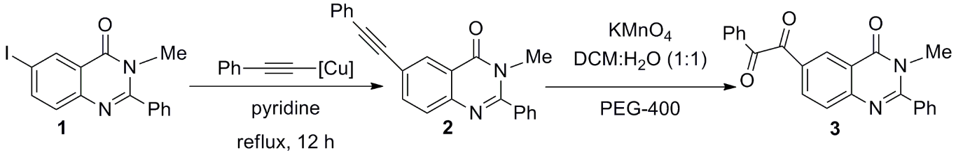
Scheme 1. Preparation of 1-(3-methyl-4-oxo-2-phenyl-3,4-dihydroquinazolin-6-yl)-2-phenylethane-1,2-dione (3)
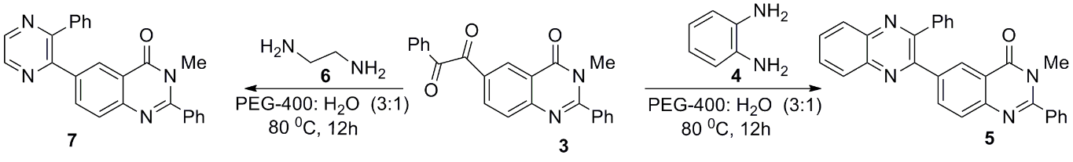
Scheme 2. Synthesis of 3-methyl-2-phenyl-6-pyrazinyl / fused pyrazinylquinazolin-4(3H)-ones (5 and 7)

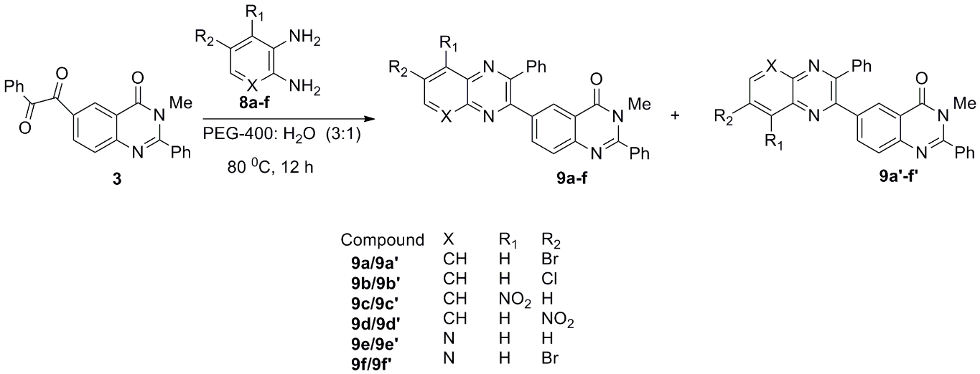
Scheme 4. Synthesis of 3-methyl-2-phenyl-6-fused pyrazinylquinazolin-4(3H)-one regioisomers (9a-f and 9a’-f’)

