High – temperature and high-pressure (p,ρ,T) measurements and derived thermodynamic properties of 1-octyl-3-methylimidazolium hexafluorophosphate

Javid Safarov^{a,b,}, Christoffer Bussemerª, Abilgani Aliyev^{b}, Gorica Ivaniš^{c},
Mirjana Kijevčanin^{c}, Ivona Radović^{c}, Egon Hasselª, Ilmutdin Abdulagatov^{d,}

ª Institute of Technical Thermodynamics, University of Rostock, Albert-Einstein-Str. 2, D-18059 Rostock, Germany
^{b} Department of Heat Energy, Azerbaijan Technical University, H. Javid Avn. 25, AZ1073 Baku, Azerbaijan
^{c} Faculty of Technology and Metallurgy, University of Belgrade, Karnegijeva 4, 11120 Belgrade, Serbia
d Physical and Organic Chemistry Department, Dagestan State University, Makhachkala, Russian Federation

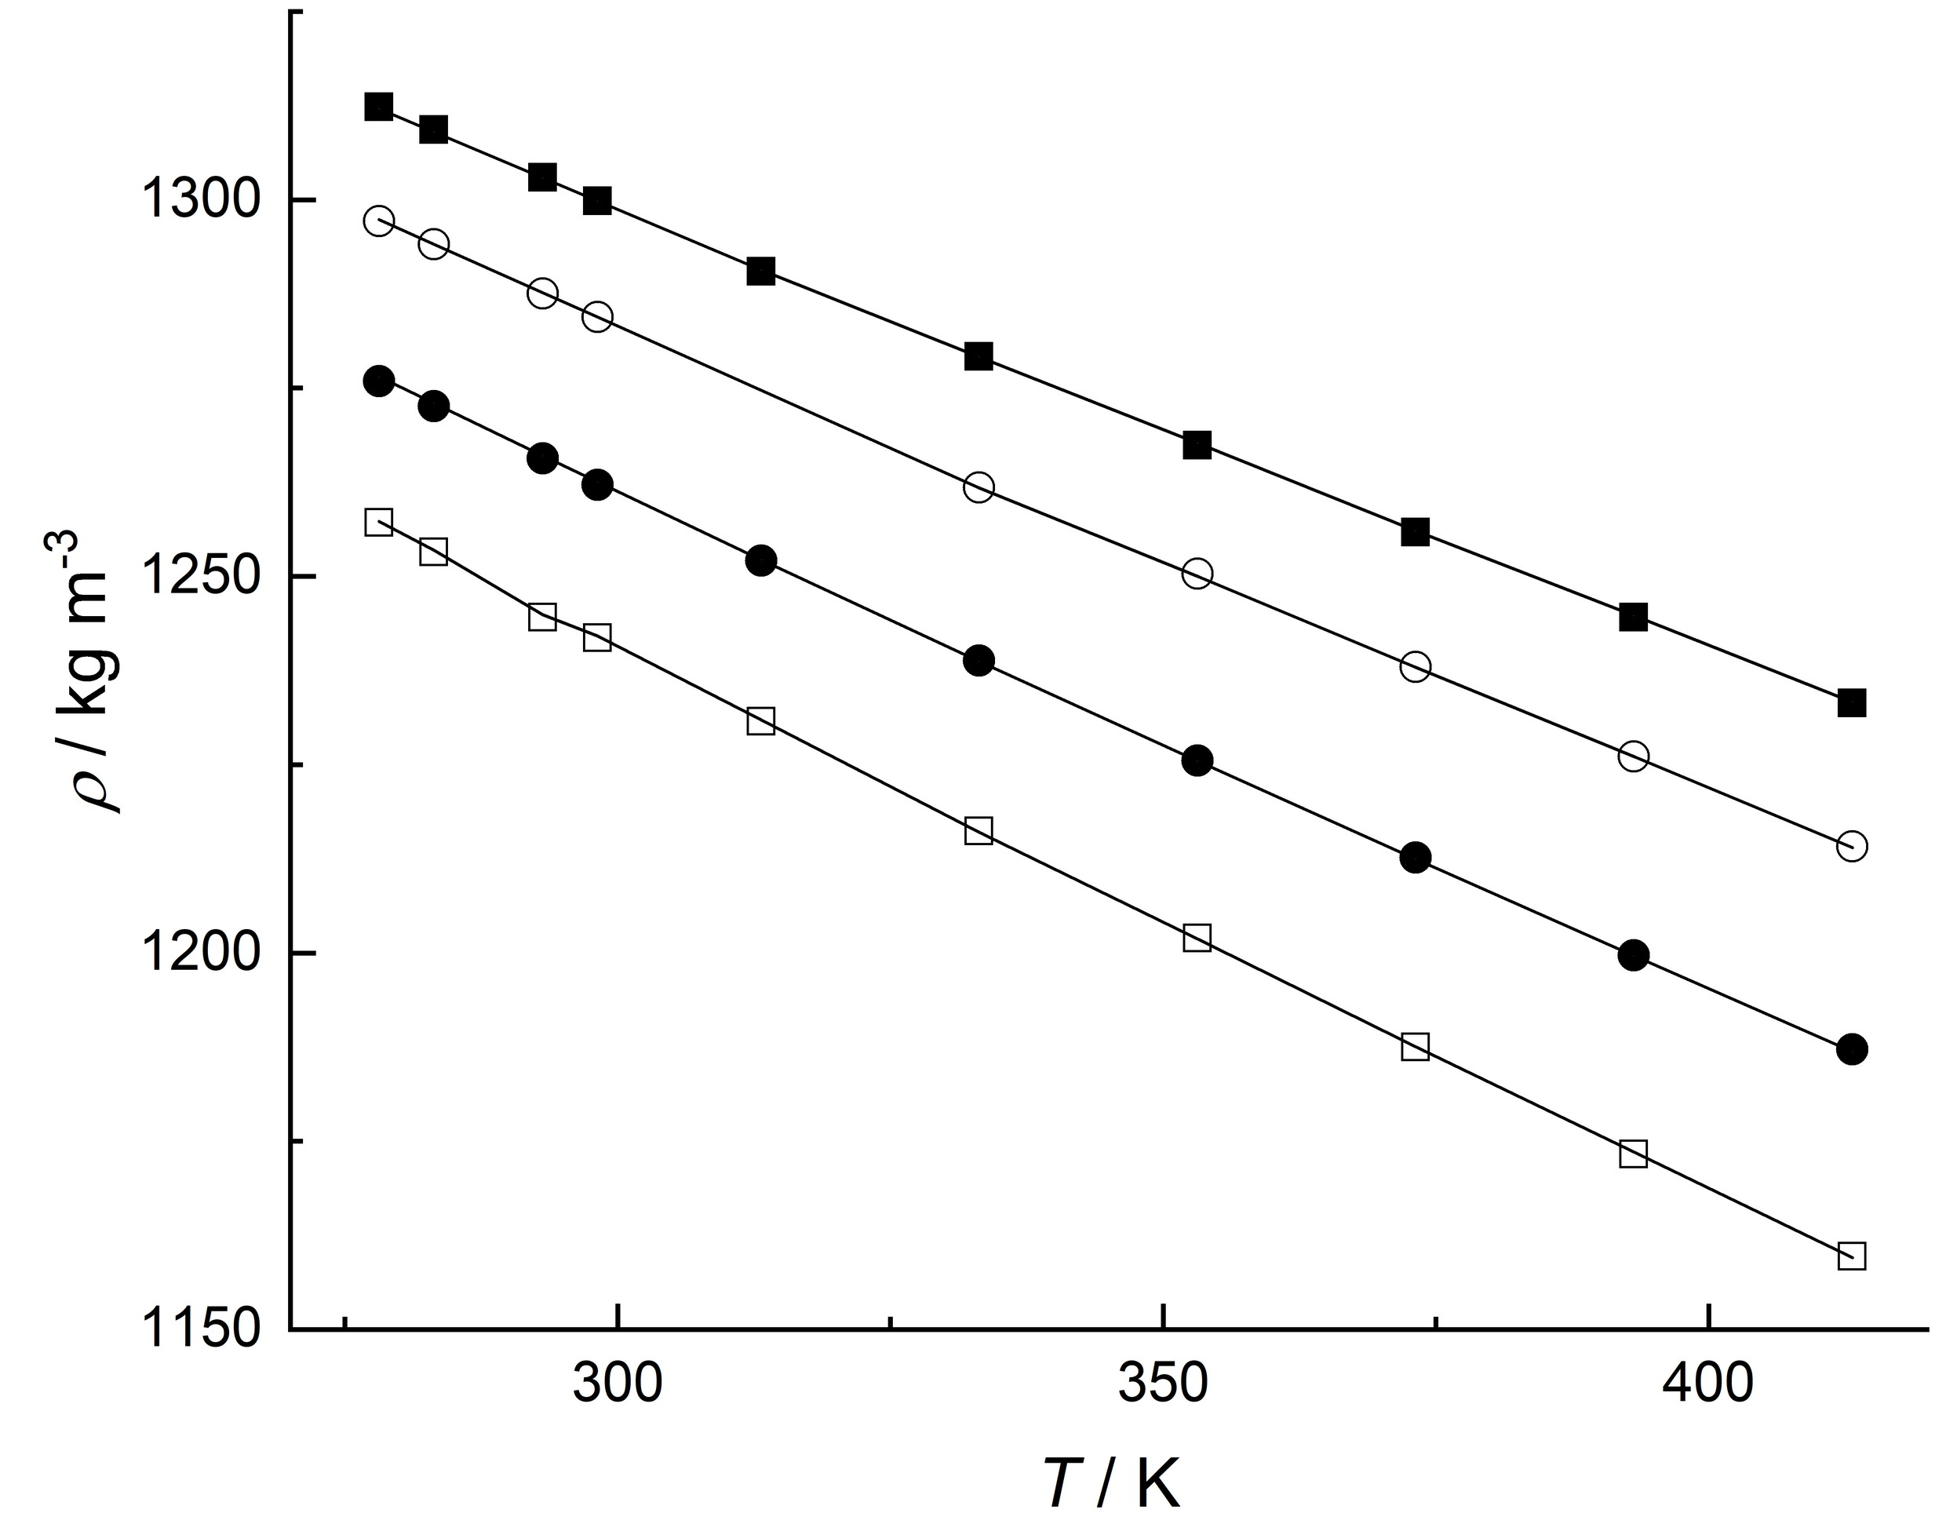
Fig. S1. Measured densities of [OMIM][PF₆] at high pressures as a function of temperature. () 10 MPa, () 50 MPa, () 100 MPa and () 140 MPa. Solid lines represent values calculated using the modified Tammann-Tait EOS.

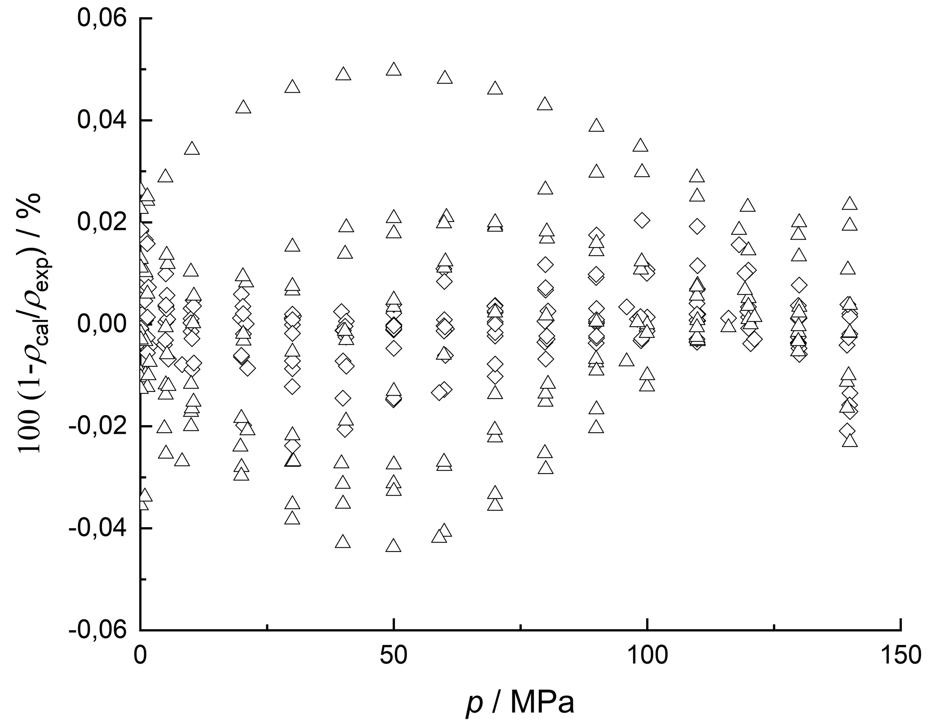
Fig. S2. Deviations between experimental densities and values calculated using: () multiparametric polynomial-type EOS (Eq. (2)) and () the modified Tammann-Tait equation (Eq. (4)).
Table SI Summary of reported density data of [OMIM][PF6]
First author | Method ª | Properties^{b} | Temperature,  T / K | Pressure,  p / MPa | Uncertainty | Purity,  mass % | Source
Taguchi [16] | BD | p,ρ,T | 312.8-472.3 | 0.1- 200 | 0.1 % | 98 | Acros Organics
Gu [17] | UHPD | p,ρ,T | 298.2-323.2 | 0.1- 204 | 0.05-1.3 % | 99.5 | SACHEM
Tomida [18] | GP | p,ρ,T,η | 293.15-353.15 | 0.1- 20 | 0.2 % | >99 | Prepared by the authors
Gardas [19] | VTD | p,ρ,T | 293.15-393.15 | 0.1- 10 | 1.0 kg∙m⁻³ | >98 | Solvent Innovation
Tomida [20] | GP | p,ρ,T,λ | 295.1-335.2 | 0.1- 20 | 0.2 % | >99 | Prepared by the authors
Harris^{c} [21] | FB | p,ρ,T,η | 273.15-353.15 | 0.1- 176 | 0.5 % | >95 | Cannon
Safarov (this work) | VTD | p,ρ,T | 278.15-413.15 | 0.1- 140 | 0.01- 0.08 % | 99 | Iolitech
ª BD-bellows dilatometer; UHPD –ultrahigh-pressure density apparatus; GP-glass piezometer; VTD-vibrating tube densimeter DMA 512P; FB-falling body.
^{b} η, viscosity; λ, thermal conductivity.
^{c} High pressure density values calculated from atmospheric pressure densities.

Table SII Experimental values of pressure p/MPa, density ρ/kg⋅m⁻³, temperature T/K, calculated values of isothermal compressibility κ_{T}⋅10⁶/MPa⁻¹, isobaric thermal expansibility α_{p}⋅10⁶/K⁻¹, difference in isobaric and isochoric heat capacities (c_{p}-c_{v})/J⋅kg⁻¹⋅K⁻¹, thermal pressure coefficient γ/MPa⋅K⁻¹, internal pressure p_{int}/MPa, isobaric heat capacity c_{p}/J⋅kg⁻¹⋅K⁻¹, isochoric heat capacity c_{v}/J⋅kg⁻¹⋅K⁻¹, speed of sound u/m⋅s⁻¹ and isentropic exponent κ_{s} of 1-octyl-3-methylimidazolium hexafluorophosphate [OMIM][PF₆].
p ρ T κ_{T} α_{p} c_{p}-c_{v} γ p_{int} c_{p} c_{v} u κ_{s}
0.101 1252.21 278.15 418.2 636.2 215.04 1.5213 423.1 1655.27 1440.23 1481.59 27210.34
1.002 1252.66 278.15 416.8 634.5 214.51 1.5224 422.4 1655.35 1440.84 1483.59 2751.202
5.021 1254.66 278.15 410.5 626.8 212.19 1.5270 419.7 1655.72 1443.53 1492.46 556.541
10.003 1257.12 278.15 402.9 617.6 209.45 1.5327 416.3 1656.18 1446.73 1503.33 284.014
19.953 1261.96 278.15 388.8 600.4 204.33 1.5442 409.6 1657.05 1452.71 1524.66 147.031
29.957 1266.72 278.15 375.7 584.5 199.65 1.5559 402.8 1657.84 1458.18 1545.62 101.028
39.956 1271.38 278.15 363.5 569.8 195.38 1.5677 396.1 1658.51 1463.13 1566.12 78.057
49.928 1275.92 278.15 352.1 556.2 191.49 1.5796 389.4 1659.04 1467.54 1586.15 64.304
59.956 1280.39 278.15 341.5 543.6 187.93 1.5917 382.8 1659.40 1471.47 1605.85 55.077
70.006 1284.76 278.15 331.5 531.8 184.65 1.6040 376.1 1659.57 1474.92 1625.24 48.481
79.958 1288.99 278.15 322.3 520.9 181.68 1.6164 369.6 1659.55 1477.87 1644.10 43.579
89.925 1293.12 278.15 313.5 510.7 178.95 1.6289 363.2 1659.31 1480.35 1662.66 39.754
99.957 1297.17 278.15 305.3 501.2 176.44 1.6418 356.7 1658.84 1482.40 1681.03 36.672
109.953 1301.11 278.15 297.5 492.3 174.15 1.6548 350.3 1658.13 1483.98 1699.03 34.159
119.987 1304.96 278.15 290.1 483.9 172.05 1.6680 344.0 1657.18 1485.13 1716.82 32.056
129.953 1308.69 278.15 283.2 476.1 170.14 1.6814 337.7 1655.98 1485.84 1734.23 30.287
139.962 1312.32 278.15 276.5 468.7 168.39 1.6950 331.5 1654.53 1486.13 1751.46 28.763
0.101 1248.02 283.15 428.0 632.1 211.80 1.4769 418.1 1665.26 1453.46 1464.55 26503.93
1.023 1248.52 283.15 426.4 630.3 211.28 1.4780 417.5 1665.35 1454.07 1466.67 2625.304
5.021 1250.63 283.15 419.8 622.7 209.09 1.4831 414.9 1665.73 1456.64 1475.78 542.473
10.020 1253.24 283.15 411.9 613.5 206.48 1.4896 411.8 1666.22 1459.74 1487.04 276.573
19.925 1258.33 283.15 397.1 596.6 201.72 1.5025 405.5 1667.20 1465.48 1508.97 143.792
29.928 1263.19 283.15 383.3 580.9 197.39 1.5158 399.3 1668.14 1470.75 1530.62 98.883
39.954 1267.94 283.15 370.4 566.5 193.49 1.5294 393.1 1669.01 1475.52 1551.86 76.427
49.952 1272.57 283.15 358.5 553.3 189.99 1.5432 387.0 1669.77 1479.78 1572.60 63.005
59.986 1277.11 283.15 347.4 541.1 186.83 1.5574 381.0 1670.41 1483.58 1593.02 54.028
70.002 1281.53 283.15 337.1 529.8 184.00 1.5718 375.1 1670.89 1486.89 1612.95 47.626
79.924 1285.80 283.15 327.4 519.5 181.48 1.5864 369.3 1671.21 1489.73 1632.38 42.866
89.923 1289.99 283.15 318.3 509.8 179.21 1.6014 363.5 1671.35 1492.15 1651.64 39.129
99.957 1294.08 283.15 309.7 500.8 177.17 1.6168 357.8 1671.30 1494.14 1670.63 36.13
109.928 1298.04 283.15 301.7 492.4 175.36 1.6323 352.3 1671.05 1495.69 1689.22 33.69
119.953 1301.91 283.15 294.0 484.6 173.76 1.6483 346.8 1670.59 1496.83 1707.61 31.645
129.986 1305.67 283.15 286.8 477.4 172.35 1.6646 341.4 1669.91 1497.56 1725.76 29.913
139.954 1309.29 283.15 280.0 470.7 171.12 1.6812 336.1 1669.01 1497.89 1743.53 28.438
0.101 1240.23 293.15 447.7 624.4 205.85 1.3947 408.8 1685.48 1479.63 1432.36 25192.74
1.392 1240.92 293.17 445.3 621.8 205.16 1.3965 408.0 1685.61 1480.45 1435.45 1836.853
4.759 1242.71 293.16 439.1 615.4 203.45 1.4015 406.1 1685.85 1482.40 1443.65 544.248
8.248 1244.56 293.15 432.8 608.9 201.75 1.4068 404.2 1686.11 1484.36 1452.08 318.186
19.746 1250.75 293.14 413.6 589.1 196.68 1.4244 397.8 1687.11 1490.43 1479.27 138.606
30.203 1256.07 293.14 397.7 573.0 192.69 1.4409 392.2 1688.10 1495.41 1503.36 93.99
39.693 1260.75 293.14 384.3 559.7 189.53 1.4564 387.2 1689.02 1499.48 1524.75 73.841
49.997 1265.66 293.14 370.9 546.5 186.55 1.4737 382.0 1689.98 1503.44 1547.50 60.621
58.939 1269.61 293.13 360.0 536.1 184.29 1.4891 377.6 1690.76 1506.47 1566.90 52.894
69.996 1274.65 293.14 347.5 524.3 181.89 1.5087 372.3 1691.69 1509.80 1590.39 46.064
79.792 1278.98 293.15 337.2 514.8 180.09 1.5264 367.7 1692.41 1512.32 1610.77 41.59
89.997 1283.37 293.15 327.2 505.6 178.52 1.5456 363.1 1693.04 1514.53 1631.70 37.967
99.996 1287.53 293.15 317.9 497.5 177.25 1.5648 358.7 1693.54 1516.29 1651.87 35.134
109.993 1291.58 293.15 309.2 490.0 176.22 1.5846 354.5 1693.91 1517.68 1671.74 32.816
119.993 1295.49 293.15 301.0 483.1 175.43 1.6048 350.5 1694.13 1518.71 1691.31 30.884
129.998 1299.28 293.15 293.3 476.7 174.85 1.6256 346.5 1694.21 1519.37 1710.63 29.248
140.001 1302.95 293.15 285.9 470.9 174.46 1.6469 342.8 1694.14 1519.68 1729.68 27.847
0.101 1236.47 298.15 457.7 621.2 203.33 1.3573 404.6 1695.62 1492.29 1417.06 24580.68
1.005 1236.97 298.15 455.9 619.4 202.86 1.3587 404.1 1695.66 1492.81 1419.33 2479.267
5.023 1239.15 298.15 448.1 611.6 200.84 1.3649 401.9 1695.88 1495.03 1429.39 504.021
10.006 1241.83 298.15 438.8 602.3 198.50 1.3727 399.3 1696.19 1497.68 1441.72 257.972
19.924 1247.07 298.16 421.5 585.3 194.32 1.3887 394.1 1696.93 1502.61 1465.80 134.49
30.002 1252.25 298.15 405.3 569.7 190.65 1.4057 389.1 1697.74 1507.09 1489.75 92.642
40.001 1257.26 298.15 390.6 555.7 187.52 1.4230 384.3 1698.62 1511.10 1512.97 71.953
50.006 1262.14 298.13 376.9 543.1 184.85 1.4410 379.6 1699.48 1514.63 1535.77 59.533
59.924 1266.83 298.15 364.4 531.7 182.59 1.4591 375.1 1700.39 1517.80 1557.84 51.306
69.928 1271.43 298.15 352.6 521.2 180.69 1.4782 370.8 1701.24 1520.55 1579.74 45.373
79.941 1275.91 298.14 341.6 511.7 179.12 1.4979 366.6 1702.01 1522.90 1601.30 40.923
89.924 1280.23 298.15 331.4 503.1 177.86 1.5179 362.6 1702.75 1524.89 1622.32 37.467
99.924 1284.42 298.15 321.8 495.2 176.88 1.5387 358.8 1703.39 1526.51 1643.12 34.7
109.925 1288.48 298.12 312.8 488.0 176.15 1.5601 355.2 1703.87 1527.72 1663.64 32.439
119.957 1292.41 298.15 304.3 481.3 175.67 1.5819 351.7 1704.37 1528.70 1683.84 30.546
129.953 1296.19 298.15 296.3 475.3 175.41 1.6044 348.4 1704.69 1529.29 1703.73 28.954
139.924 1299.83 298.15 288.7 469.8 175.35 1.6274 345.3 1704.90 1529.55 1723.31 27.592
0.101 1224.93 313.15 488.8 615.6 198.17 1.2593 394.2 1725.62 1527.45 1373.55 22881.41
1.840 1225.95 313.12 484.7 611.9 197.28 1.2624 393.4 1725.47 1528.18 1378.42 1266.009
5.531 1228.08 313.14 476.3 604.3 195.46 1.2686 391.7 1725.33 1529.88 1388.45 428.069
10.195 1230.75 313.15 466.1 595.1 193.31 1.2767 389.6 1725.20 1531.89 1401.03 236.981
21.171 1236.89 313.18 443.9 575.5 188.90 1.2964 384.8 1725.13 1536.23 1430.02 119.484
29.997 1241.68 313.17 427.6 561.5 185.94 1.3131 381.2 1725.20 1539.26 1452.86 87.379
40.566 1247.25 313.16 409.7 546.4 182.99 1.3338 377.1 1725.45 1542.47 1479.59 67.311
49.996 1252.07 313.16 395.0 534.4 180.83 1.3529 373.7 1725.82 1544.98 1502.92 56.565
59.861 1256.95 313.17 380.8 523.0 179.02 1.3735 370.3 1726.30 1547.28 1526.82 48.944
69.994 1261.62 313.16 367.3 512.6 177.57 1.3956 367.0 1726.82 1549.25 1550.94 43.356
80.400 1266.37 313.16 354.5 502.9 176.48 1.4189 364.0 1727.42 1550.94 1575.24 39.083
89.996 1270.63 313.15 343.4 494.9 175.80 1.4412 361.3 1727.98 1552.19 1597.28 36.02
95.950 1273.21 313.15 336.9 490.3 175.52 1.4553 359.8 1728.35 1552.83 1610.77 34.428
109.806 1279.05 313.15 322.8 480.7 175.26 1.4890 356.5 1729.19 1553.93 1641.62 31.39
119.272 1282.98 313.16 313.9 474.9 175.38 1.5128 354.5 1729.77 1554.39 1662.35 29.722
129.807 1286.99 313.16 304.6 469.1 175.77 1.5401 352.5 1730.38 1554.61 1685.12 28.155
139.445 1290.50 313.16 296.5 464.2 176.35 1.5657 350.9 1730.92 1554.57 1705.68 26.93
0.101 1209.93 333.15 534.6 618.6 197.09 1.1571 385.4 1763.38 1566.30 1319.26 20849.84
1.417 1210.75 333.11 530.6 615.4 196.36 1.1598 384.9 1763.02 1566.67 1323.43 1496.618
5.405 1213.36 333.12 519.2 606.2 194.27 1.1674 383.5 1762.23 1567.96 1335.62 400.458
9.966 1216.18 333.14 506.9 596.1 192.07 1.1762 381.9 1761.42 1569.35 1349.37 222.197
20.867 1222.73 333.14 479.6 574.6 187.55 1.1981 378.3 1759.72 1572.17 1381.57 111.845
29.997 1227.97 333.15 459.0 558.7 184.47 1.2170 375.5 1758.61 1574.14 1407.81 81.133
40.643 1233.74 333.15 437.3 542.3 181.56 1.2400 372.5 1757.56 1576.00 1437.66 62.746
49.996 1238.79 333.15 419.9 529.5 179.55 1.2609 370.1 1756.85 1577.30 1463.27 53.054
59.965 1243.99 333.15 402.9 517.3 177.89 1.2839 367.8 1756.25 1578.36 1489.98 46.052
69.995 1248.83 333.15 387.2 506.4 176.67 1.3077 365.7 1755.81 1579.14 1516.30 41.021
80.064 1253.62 333.15 372.7 496.6 175.85 1.3324 363.8 1755.49 1579.65 1542.19 37.239
89.993 1258.18 333.15 359.5 488.0 175.39 1.3574 362.2 1755.29 1579.90 1567.25 34.341
98.039 1261.78 333.15 349.5 481.6 175.26 1.3782 361.1 1755.20 1579.94 1587.24 32.424
109.797 1266.87 333.15 335.8 473.3 175.42 1.4094 359.7 1755.16 1579.74 1615.98 30.131
116.024 1269.50 333.15 329.1 469.3 175.66 1.4262 359.1 1755.19 1579.53 1630.98 29.106
129.796 1275.14 333.15 315.1 461.4 176.53 1.4644 358.1 1755.35 1578.82 1663.60 27.189
139.953 1279.17 333.15 305.5 456.2 177.46 1.4935 357.6 1755.54 1578.08 1687.28 26.02
0.101 1195.16 353.15 586.1 629.6 199.89 1.0742 379.3 1797.87 1597.99 1267.46 19006.01
1.356 1195.98 353.18 581.5 626.3 199.20 1.0769 379.0 1797.56 1598.37 1271.70 1426.142
5.209 1198.50 353.15 567.7 616.3 197.16 1.0857 378.2 1796.45 1599.29 1284.94 379.877
10.555 1201.95 353.16 549.8 603.5 194.62 1.0977 377.1 1795.09 1600.47 1302.79 193.291
20.386 1208.12 353.18 519.7 582.2 190.63 1.1203 375.3 1792.82 1602.19 1334.88 105.621
29.996 1213.97 353.17 493.4 563.9 187.47 1.1429 373.7 1790.79 1603.32 1365.38 75.467
40.360 1220.07 353.17 468.1 546.6 184.76 1.1679 372.1 1788.84 1604.07 1397.29 59.033
49.997 1225.54 353.16 446.8 532.4 182.81 1.1916 370.8 1787.19 1604.38 1426.19 49.866
60.201 1231.12 353.15 426.4 519.1 181.24 1.2173 369.7 1785.60 1604.36 1456.03 43.357
69.996 1236.27 353.15 408.6 507.6 180.17 1.2424 368.8 1784.24 1604.07 1483.99 38.895
79.895 1241.29 353.15 392.1 497.3 179.46 1.2684 368.0 1782.98 1603.52 1511.62 35.497
89.996 1246.19 353.15 376.6 487.8 179.09 1.2953 367.4 1781.83 1602.74 1539.24 32.802
98.966 1250.37 353.15 363.9 480.2 179.02 1.3197 367.1 1780.90 1601.88 1563.30 30.871
109.854 1255.22 353.15 349.6 471.9 179.24 1.3498 366.8 1779.90 1600.65 1591.97 28.953
118.122 1258.75 353.16 339.5 466.2 179.61 1.3730 366.8 1779.23 1599.62 1613.37 27.734
129.856 1263.50 353.15 326.2 458.8 180.40 1.4066 366.9 1778.37 1597.98 1643.25 26.274
139.988 1267.38 353.15 315.5 453.1 181.31 1.4362 367.2 1777.76 1596.45 1668.61 25.212
0.101 1179.97 373.15 641.1 635.7 199.37 0.9917 369.9 1829.60 1630.23 1218.10 17333.39
1.607 1181.09 373.17 634.3 631.6 198.74 0.9958 370.0 1829.51 1630.77 1223.80 1100.673
5.269 1183.79 373.16 618.3 622.1 197.32 1.0061 370.2 1829.18 1631.86 1237.52 344.055
10.434 1187.50 373.16 597.3 609.6 195.52 1.0206 370.4 1828.70 1633.18 1256.51 179.677
20.223 1194.24 373.15 561.2 588.2 192.66 1.0482 370.9 1827.66 1635.00 1291.51 98.498
29.997 1200.60 373.15 529.5 569.5 190.42 1.0757 371.4 1826.50 1636.08 1325.25 70.292
40.626 1207.16 373.15 499.0 551.7 188.58 1.1057 372.0 1825.12 1636.55 1360.70 55.015
49.997 1212.67 373.15 475.0 537.8 187.38 1.1323 372.5 1823.83 1636.46 1391.02 46.932
60.377 1218.50 373.15 451.0 524.0 186.45 1.1619 373.2 1822.35 1635.89 1423.69 40.907
69.994 1223.66 373.15 431.0 512.7 185.92 1.1893 373.8 1820.94 1635.01 1453.07 36.914
80.229 1228.94 373.15 411.7 501.7 185.65 1.2187 374.5 1819.42 1633.76 1483.62 33.718
89.996 1233.79 373.15 394.8 492.3 185.65 1.2469 375.3 1817.97 1632.32 1512.09 31.346
98.774 1237.99 373.15 380.8 484.5 185.83 1.2724 376.0 1816.68 1630.85 1537.14 29.615
109.807 1243.08 373.16 364.6 475.7 186.28 1.3046 377.0 1815.12 1628.84 1567.97 27.833
120.387 1247.78 373.17 350.4 468.0 186.92 1.3356 378.0 1813.67 1626.75 1596.89 26.432
129.806 1251.84 373.16 338.6 461.7 187.64 1.3635 379.0 1812.39 1624.75 1622.17 25.378
139.394 1255.84 373.16 327.5 455.8 188.51 1.3920 380.0 1811.17 1622.65 1647.46 24.453
0.101 1165.20 393.15 691.5 614.8 184.42 0.8890 349.4 1860.87 1676.45 1173.73 15892.67
0.893 1165.82 393.17 687.4 613.0 184.38 0.8918 349.7 1861.38 1676.99 1176.94 1808.296
5.065 1169.12 393.15 666.0 604.3 184.40 0.9074 351.7 1863.67 1679.28 1193.89 328.998
10.495 1173.27 393.15 640.3 593.7 184.46 0.9272 354.0 1866.35 1681.88 1215.42 165.14
20.293 1180.39 393.15 598.7 576.3 184.77 0.9626 358.1 1870.25 1685.48 1253.05 91.329
29.996 1187.05 393.14 562.9 561.1 185.27 0.9969 361.9 1873.10 1687.83 1288.79 65.731
40.382 1193.78 393.14 529.1 546.6 185.97 1.0331 365.8 1875.28 1689.31 1325.66 51.952
49.996 1199.70 393.14 501.5 534.6 186.75 1.0660 369.1 1876.63 1689.88 1358.65 44.295
59.923 1205.52 393.15 475.9 523.3 187.65 1.0996 372.4 1877.49 1689.84 1391.63 38.962
69.995 1211.17 393.14 452.5 512.9 188.66 1.1333 375.5 1877.82 1689.16 1424.15 35.096
80.176 1216.62 393.14 431.2 503.2 189.76 1.1669 378.6 1877.78 1688.02 1456.09 32.174
89.996 1221.67 393.14 412.6 494.7 190.87 1.1990 381.4 1877.43 1686.55 1486.04 29.978
98.911 1226.08 393.14 397.1 487.5 191.93 1.2278 383.8 1876.89 1684.96 1512.62 28.363
109.816 1231.28 393.14 379.6 479.4 193.28 1.2628 386.6 1876.02 1682.74 1544.38 26.743
121.147 1236.47 393.14 363.1 471.6 194.72 1.2987 389.4 1874.91 1680.19 1576.55 25.369
129.816 1240.31 393.14 351.4 466.0 195.85 1.3260 391.5 1873.96 1678.11 1600.65 24.48
139.721 1244.55 393.15 339.0 460.0 197.17 1.3570 393.8 1872.84 1675.67 1627.65 23.598
0.101 1151.59 413.15 722.5 541.8 145.76 0.7499 309.7 1902.78 1757.02 1140.85 14840.51
1.358 1152.62 413.18 715.4 540.7 146.49 0.7558 310.9 1905.06 1758.57 1146.18 1115.08
4.968 1155.56 413.17 695.7 538.0 148.78 0.7734 314.6 1911.06 1762.29 1161.42 313.764
10.185 1159.69 413.16 669.2 534.2 151.96 0.7984 319.7 1919.04 1767.08 1182.96 159.344
20.328 1167.32 413.16 623.3 527.0 157.74 0.8456 329.0 1932.49 1774.75 1223.36 85.944
29.994 1174.16 413.15 585.3 520.5 162.87 0.8893 337.4 1943.05 1780.18 1260.27 62.177
40.069 1180.90 413.15 550.5 513.9 167.83 0.9335 345.6 1952.18 1784.34 1297.29 49.601
49.996 1187.20 413.15 520.2 507.6 172.38 0.9758 353.1 1959.54 1787.16 1332.38 42.155
60.072 1193.27 413.15 492.9 501.5 176.70 1.0176 360.3 1965.64 1788.94 1366.82 37.11
69.993 1198.98 413.15 468.7 495.7 180.67 1.0577 367.0 1970.49 1789.82 1399.68 33.56
79.817 1204.39 413.15 447.1 490.2 184.36 1.0964 373.2 1974.33 1789.97 1431.22 30.909
89.996 1209.76 413.15 426.8 484.6 187.94 1.1355 379.2 1977.45 1789.51 1463.00 28.771
98.652 1214.16 413.15 410.9 480.0 190.80 1.1681 384.0 1979.51 1788.71 1489.35 27.3
109.797 1219.61 413.15 392.2 474.3 194.27 1.2092 389.8 1981.48 1787.21 1522.45 25.746
119.806 1224.33 413.13 376.9 469.3 197.18 1.2452 394.6 1982.55 1785.37 1551.33 24.593
129.797 1228.87 413.14 362.7 464.4 199.90 1.2803 399.1 1983.37 1783.47 1579.51 23.619
139.562 1233.15 413.15 350.0 459.8 202.41 1.3139 403.3 1983.82 1781.41 1606.44 22.801

ª Standard uncertainties u are:$u\left(T\right)$=0.0075 K; $u_{r}\left(P\right)$==0.05 %

Corresponding author: Tel: 49 (381) 498 9415, E-Mail: javid.safarov@uni-rostock.de
Corresponding author: Tel: 7 (967) 401 0039, E-Mail: ilmutdina@gmail.com

