Accepted Manuscript

This is an early electronic version of an as-received manuscript that has been accepted for publication in the Journal of the Serbian Chemical Society but has not yet been subjected to the editing process and publishing procedure applied by the JSCS Editorial Office.

Please cite this article as: J. Safarov, C. Bussemera, A. Aliyev, G. Ivaniš,
M. Kijevčanin, I. Radović, E. Hassel, I. Abdulagatov, J. Serb. Chem. Soc. (2019) https://doi.org/10.2298/JSC190528076S

This “raw” version of the manuscript is being provided to the authors and readers for their technical service. It must be stressed that the manuscript still has to be subjected to copyediting, typesetting, English grammar and syntax corrections, professional editing and authors’ review of the galley proof before it is published in its final form. Please note that during these publishing processes, many errors may emerge which could affect the final content of the manuscript and all legal disclaimers applied according to the policies of the Journal.

High – temperature and high-pressure (p, ρ, T) measurements and derived thermodynamic properties of 1-octyl-3-methylimidazolium hexafluorophosphate
Javid Safarov^{1,2,}, Christoffer Bussemer¹, Abilgani Aliyev²,
Gorica Ivaniš³, Mirjana Kijevčanin³, Ivona Radović³, Egon Hassel¹, Ilmutdin Abdulagatov^{4,}
1Institute of Technical Thermodynamics, University of Rostock, Albert-Einstein-Str. 2,
D-18059 Rostock, Germany; ²Department of Heat Energy, Azerbaijan Technical University,
H. Javid Avn. 25, AZ1073 Baku, Azerbaijan; ³Faculty of Technology and Metallurgy,
University of Belgrade, Karnegijeva 4, 11120 Belgrade, Serbia; ⁴Physical and Organic Chemistry Department, Dagestan State University, Makhachkala, Russian Federation
(Received 28 May; accepted 16 July 2019)
Abstract: Densities of ionic liquid (IL) 1-octyl-3-methylimidazolium hexafluorophosphate [OMIM][PF₆] at high temperatures and high pressures were measured. The measurements were made along 10 isotherms over a temperature range T = 278.15 to 413.15 K at pressures up to 140 MPa by means of an Anton Paar DMA HPM vibration tube densimeter (VTD). The combined expanded relative uncertainties of the density, pressure and temperature measurements at the 95 % confidence level with a coverage factor of k = 2 are estimated to be (0.03 to 0.08) % (depending on temperature and pressure ranges), 0.1 %, and 0.015 K, respectively. We have critically assessed all of the reported high-pressure densities for [OMIM][PF₆], together with the presented results, to carefully select primary data for development of reference wide-ranging equation of state. Values of ρ – T isobars curvatures, (∂²ρ / ∂T²)_{P}, were estimated using the present high-pressure ρ - T measurements and they were pretty low (0.78 10⁻⁷ to 1.50·10⁻⁷ m³ kg⁻¹ K⁻¹) indicating that heat capacity of [OMIM][PF₆] very weakly depends on pressure, since (∂C_{P} / ∂P)_{T} ≈ (∂²ρ / ∂T²)_{P}. Density data were fitted to the modified Tammann-Tait equation and multiparametric polynomial-type equation of state (EOS) for the IL was developed using the measured high-pressure and high-temperature (p, ρ, T) data. This EOS, together with our previous measured heat capacity data at atmospheric pressure, was used to calculate high-pressure and high-temperature derived thermodynamic properties, such as isothermal compressibility, isentropic compressibility, isobaric thermal expansion coefficient, heat capacities etc.
Keywords: density; high-pressure; high-temperature; ionic liquid, equation of state.
INTRODUCTION
During our continuous experimental studying of the thermodynamic (density, heat capacity, vapour pressure), acoustic (speed of sound), and transport (viscosity) properties of ILs and their mixtures with alcohols, we reported the thermophysical properties of several ILs. We have examined [EMIM][EtSO₄], [EMIM][MeSO₃], [BMIM][NTf₂], [BMIM][FAP], and [HMIM][NTf₂]¹⁻⁹ and binary mixtures containing ILs: ethanol+[BMIM][BF₄], methanol++[BMIM][BF₄], methanol+
+[BMIM][PF₆], and methanol+[BMIM][OcSO₄]¹⁰⁻¹⁴, at high temperatures and pressures. Experimental density data of [OMIM][PF₆] sample at ambient pressure have been reported in our previous publication¹⁵. where we provided comprehensive evaluation of all reported densities and other thermodynamic properties (heat capacity, speed of sound, and viscosity) for [OMIM][PF₆] in the wide temperature range T = 278.15 to 413.15 K. In this study, high-pressure density data, (p, ρ, T) properties, for [OMIM][PF₆] were measured over a temperature range T = 278.15 to 413.15 K and at pressures up to 140 MPa. The measured (p, ρ, T) data were used to develop accurate multiparametric polynomial equation of state and calculate various thermodynamic properties of OMIM][PF₆], such as adiabatic coefficient of bulk compressibility, isothermal coefficient of bulk compressibility, thermal expansion coefficient, thermal pressure coefficient, internal pressure, enthalpy difference, entropy difference, isochoric heat capacity, isobaric heat capacity, and speed of sound. The present results complement previous high-pressure (p, ρ, T) measurements for [OMIM][PF₆] and they are good contribution to the field, i.e., expanding of the available data base for [OMIM][PF₆] (Supplementarmaterial, Table SI). Literature survey revealed that very restricted high-pressure and high-temperature (p,ρ,T) data were reported for [OMIM][PF₆]. Namely, only six data sources¹⁶⁻²¹ for the high-pressure density of [OMIM][PF₆] were found in the literature (Table SI), and one of them, Harris et al.²¹, reported data calculated using densities measured at atmospheric pressure. Density measurements for [OMIM][PF₆] at temperatures below T = 293.15 K are given for the first time in this work. The literature search was based on the SciFinder and TRC/NIST archive²². Mentioned papers are listed in Table SI (Supplementary material) together with the method employed, uncertainty of the measurements, purity of the samples, and the temperature and pressure ranges. The quoted uncertainties of the reported density data at high pressures are within ∆ρ/ρ = ±0.05 to ±1.3 %. The reported experimental data sets cover temperature range T = 293.15 to 473.15 K and pressures up to p = 204 MPa and were measured using various methods such as bellows dilatometer¹⁶, ultrahigh-pressure density apparatus¹⁷, glass piezometer¹⁸, and VTD (DMA 512P)¹⁹. The reported high-pressure (p, ρ, T) data for [OMIM][PF₆]¹⁶⁻²¹ were correlated using the Tait –type EOS.
Experimental
Material
The IL sample 1-octyl-3-methylimidazolium hexafluorophosphate, [OMIM][PF₆], (Chemical formula: C₁₂H₂₃N₂F₆P; product number IL-0020-HP-0100; CAS: 304680-36-2) used in this work was supplied by Iolitech GmbH, Germany. The supplier reported its purity assay (NMR)>0.99 mass fraction. Before use, the IL sample was degassed under vacuum and dried at about T = 423.15 K for a minimum period of 48 h. Water content was determined using Karl Fischer titration and found to be less than 227 ppm.
High-pressure density measurements
Density of [OMIM][PF₆] as a function of temperature and pressure was measured using a modernized high-pressure and high-temperature Anton Paar DMA HPM vibration tube densimeter (VTD)^{9,23-24}. The apparatus and the experimental method (the physical basis and theory of the method, procedures, uncertainty assessment) were successfully employed and described in details previously^{3,6,9,10,13,23-26} for measurements of the densities of ILs, ILs containing binary mixtures, ocean and geothermal waters at high temperatures and high pressures, so only a brief review will be given here. The temperature in the measuring cell, where the U–tube is located, was controlled using a thermostat (F32 - ME Julabo, Germany) within 0.01 K and was measured with the (ITS-90) Pt100 thermometer (Type 2141) with an expanded absolute uncertainty of 0.015 K. Pressure was measured using transmitters P-30 (max. pressure 2.5 and 25 bar), P-10 (max. pressure 1000 bar), all with an expanded relative uncertainty of 0.1 %, and HP-1 (max. pressure 1600 bar) with an expanded relative uncertainty of 0.5 %. The mPDS2000V3 control unit measures the vibration period with an accuracy of Δτ = ±0.001 μs. According to the specifications of Anton Paar and calibration procedures performed in our laboratory²³, the observed repeatability of the density measurements at temperatures T = 273.15 to 413.15 K and pressures up to p = 140 MPa is within ∆ρ = ±0.1 to ±0.3 kg m⁻³. The measuring system of the DMA HPM VTD was calibrated using various standard fluids (double- distilled water, NaCl (aq), methanol, ethanol, toluene, acetone etc.) with well-known density data (REFPROP, NIST Standard Reference Database 23)²⁷. During the oscillation of the measuring U-tube in DMA HPM device, the effect of damping of the oscillation has been noticed. Since density is a function of viscosity (see also²⁸⁻³⁰), it has been concluded that the density values of more viscous samples measured using the described method are higher than their actual densities. Therefore, all measured density data should be corrected for the effect of viscosity on density determination with a VTD instruments^{30,31} using the equation:
(1)
where ρ_{cor} is the “corrected”, ρ_{unc} is the ”uncorrected” densities, and η / mPa s) is the dynamic viscosity of the sample, so, the correction can easily be estimated if the sample’s viscosity is known^{30,31}. All Anton Paar VTD Instruments which are used to measure the density at atmospheric pressure (DSA 5000 M, SVM 3000, DMA 5000M) automatically correct the effect of viscosity on the measured values of density. In order to apply Eq. (1) to the present density measurements at high pressures using DMA HPM densimeter, the viscosities η of the [OMIM][PF₆] at the same experimental temperatures and pressures are required. We have reported dynamic viscosity, η, of [OMIM][PF₆] measured at atmospheric pressure over the experimental temperature range from T = 270.15 to 414.15 K using an Anton Paar SVM 3000 Stabinger Viscometer (accuracy of viscosity measurements according the manufacturer’s instructions is ± 0.35 %) and Anton Paar Rheometer MCR 302.⁸ High-pressure viscosity data, needed to estimate high-pressure corrections to the measured densities of [OMIM][PF₆], were taken from Tomida et al.¹⁸ and Harris et al.²¹. In the present experimental temperature and pressure ranges the relative percentage deviations between the “corrected” densities and the ”uncorrected” values, calculated from Eq. (1) vary from 0.01 % at high temperatures (at 413.15 K) to 1.01 % (at low temperatures 275.15 K and high-pressures 140 MPa). It is apparent that increasing the pressure and lowering the temperature leads to increase in the viscosity and, therefore, to higher corrections of the measured densities.
The uncertainties of temperature and pressure measurements, as well as density correction due to damping effect, were taken into account and the estimated expanded relative uncertainty of the experimental density data reported here is within ∆ρ/ρ = 0.03 to 0.08 % (depending on pressure and temperature), at a 95 % confidence level, a coverage factor k = 2.
In order to verify the reliability of the measured densities for [OMIM][PF₆] and correctness of the calibration procedure of the high-pressure and high-temperature DMA HPM VTD, the densities of the same IL sample at atmospheric pressure were measured using various Anton Paar densimeters: DMA 5000, DMA 4500, SVM 3000, and DSA 5000M¹⁵ with the uncertainties of ∆ρ = ±5·10⁻³ to ±3·10⁻¹ kg m⁻³ and compared with the DMA HPM VTD results in the temperature range from T = 273.15 to 413.15 K. The detailed evaluation of densities at atmospheric pressure and comparison with data reported in literature were provided in our recent publication¹⁵. Deviations between the reported data for [OMIM][PF₆]¹⁵ and the densities measured by means of DMA HPM VTD at atmospheric pressure are: average absolute percentage deviation, AAD = 0.06 % and maximum absolute percentage deviation MD = 0.23 %. The discrepancy between the present density measurements at atmospheric pressure and the most reliable reported data^{16,17,19-21} is within 0.01 to 0.05 %, which confirmes accuracy of the high-pressure (p, ρ, T) measurements for [OMIM][PF₆] using DMA HPM desimeter.
Results and discussions
High pressure density data
Measurements of the (p, ρ, T) data for [OMIM][PF₆] were made along 10 isotherms between T = 278.15 to 413.15 K as a function of pressure in the range p = 0.101 to 140 MPa, which is presented in Table I. The expected behaviour can be noticed, density increases when pressure goes up and decreases with increase in temperature (Fig. S1).
Density correlation
Multiparametric polynomial- type EOS
For practical use and to facilitate calculation of the derived properties (caloric properties, for example) the multiparametric EOS³² for [OMIM][PF₆] was developed on the bases of present high-pressure and high-temperature (p,ρ,T) data:
p(ρ, T) / MPa = A(T) / (ρ / g cm⁻³)^{k} + B(T) (ρ / g cm⁻³)^{m} + C(T) (ρ / g cm⁻³)^{n} (2)
where: the coefficients of A(T), B(T) and C(T) are temperature dependent fitting parameters:
Table I Experimental values of (p,ρ,T) data of [OMIM][PF₆] at various temperatures, T, and pressures, p.
Tª / K | p^{b} / MPa | ρ^{c}/  kg m⁻³ | Tª / K | p^{b} / MPa | ρ^{c}/  kg m⁻³ | Tª / K | p^{b} / MPa | ρ^{c}/  kg m⁻³ | Tª / K | p^{b} / MPa | ρ^{c}/  kg m⁻³
278.15 | 0.101 | 1252.2 | 293.14 | 70.00 | 1274.7 | 333.15 | 0.101 | 1209.9 | 373.15 | 69.99 | 1223.7
278.15 | 1.00 | 1252.7 | 293.15 | 79.79 | 1279.0 | 333.11 | 1.42 | 1210.8 | 373.15 | 80.23 | 1228.9
278.15 | 5.02 | 1254.7 | 293.15 | 90.00 | 1283.4 | 333.12 | 5.41 | 1213.4 | 373.15 | 90.00 | 1233.8
278.15 | 10.00 | 1257.1 | 293.15 | 100.00 | 1287.5 | 333.14 | 9.97 | 1216.2 | 373.15 | 98.77 | 1238.0
278.15 | 19.95 | 1262.0 | 293.15 | 109.99 | 1291.6 | 333.14 | 20.87 | 1222.7 | 373.16 | 109.81 | 1243.1
278.15 | 29.96 | 1266.7 | 293.15 | 119.99 | 1295.5 | 333.15 | 30.00 | 1228.0 | 373.17 | 120.39 | 1247.8
278.15 | 39.96 | 1271.4 | 293.15 | 130.00 | 1299.3 | 333.15 | 40.64 | 1233.7 | 373.16 | 129.81 | 1251.8
278.15 | 49.93 | 1275.9 | 293.15 | 140.00 | 1303.0 | 333.15 | 50.00 | 1238.8 | 373.16 | 139.39 | 1255.8
278.15 | 59.96 | 1280.4 | 298.15 | 0.101 | 1236.5 | 333.15 | 59.97 | 1244.0 | 393.15 | 0.101 | 1165.2
278.15 | 70.01 | 1284.8 | 298.15 | 1.01 | 1237.0 | 333.15 | 70.00 | 1248.8 | 393.17 | 0.89 | 1165.8
278.15 | 79.96 | 1289.0 | 298.15 | 5.02 | 1239.2 | 333.15 | 80.06 | 1253.6 | 393.15 | 5.07 | 1169.1
278.15 | 89.93 | 1293.1 | 298.15 | 10.01 | 1241.8 | 333.15 | 89.99 | 1258.2 | 393.15 | 10.50 | 1173.3
278.15 | 99.96 | 1297.2 | 298.16 | 19.92 | 1247.1 | 333.15 | 98.04 | 1261.8 | 393.15 | 20.29 | 1180.4
278.15 | 109.95 | 1301.1 | 298.15 | 30.00 | 1252.3 | 333.15 | 109.80 | 1266.9 | 393.14 | 30.00 | 1187.1
278.15 | 119.99 | 1305.0 | 298.15 | 40.00 | 1257.3 | 333.15 | 116.02 | 1269.5 | 393.14 | 40.38 | 1193.8
278.15 | 129.95 | 1308.7 | 298.13 | 50.01 | 1262.1 | 333.15 | 129.80 | 1275.1 | 393.14 | 50.00 | 1199.7
278.15 | 139.96 | 1312.3 | 298.15 | 59.92 | 1266.8 | 333.15 | 139.95 | 1279.2 | 393.15 | 59.92 | 1205.5
283.15 | 0.101 | 1248.0 | 298.15 | 69.93 | 1271.4 | 353.15 | 0.101 | 1195.2 | 393.14 | 70.00 | 1211.2
283.15 | 1.02 | 1248.5 | 298.14 | 79.94 | 1275.9 | 353.18 | 1.36 | 1196.0 | 393.14 | 80.18 | 1216.6
283.15 | 5.02 | 1250.6 | 298.15 | 89.92 | 1280.2 | 353.15 | 5.21 | 1198.5 | 393.14 | 90.00 | 1221.7
283.15 | 10.02 | 1253.2 | 298.15 | 99.92 | 1284.4 | 353.16 | 10.56 | 1202.0 | 393.14 | 98.91 | 1226.1
283.15 | 19.93 | 1258.3 | 298.12 | 109.93 | 1288.5 | 353.18 | 20.39 | 1208.1 | 393.14 | 109.82 | 1231.3
283.15 | 29.93 | 1263.2 | 298.15 | 119.96 | 1292.4 | 353.17 | 30.00 | 1214.0 | 393.14 | 121.15 | 1236.5
283.15 | 39.95 | 1267.9 | 298.15 | 129.95 | 1296.2 | 353.17 | 40.36 | 1220.1 | 393.14 | 129.82 | 1240.3
283.15 | 49.95 | 1272.6 | 298.15 | 139.92 | 1299.8 | 353.16 | 50.00 | 1225.5 | 393.15 | 139.72 | 1244.6
283.15 | 59.99 | 1277.1 | 313.15 | 0.101 | 1224.9 | 353.15 | 60.20 | 1231.1 | 413.15 | 0.101 | 1151.6
283.15 | 70.00 | 1281.5 | 313.12 | 1.84 | 1226.0 | 353.15 | 70.00 | 1236.3 | 413.18 | 1.36 | 1152.6
283.15 | 79.92 | 1285.8 | 313.14 | 5.53 | 1228.1 | 353.15 | 79.90 | 1241.3 | 413.17 | 4.97 | 1155.6
283.15 | 89.92 | 1290.0 | 313.15 | 10.20 | 1230.8 | 353.15 | 90.00 | 1246.2 | 413.16 | 10.19 | 1159.7
283.15 | 99.96 | 1294.1 | 313.18 | 21.17 | 1236.9 | 353.15 | 98.97 | 1250.4 | 413.16 | 20.33 | 1167.3
283.15 | 109.93 | 1298.0 | 313.17 | 30.00 | 1241.7 | 353.15 | 109.85 | 1255.2 | 413.15 | 29.99 | 1174.2
283.15 | 119.95 | 1301.9 | 313.16 | 40.57 | 1247.3 | 353.16 | 118.12 | 1258.8 | 413.15 | 40.07 | 1180.9
283.15 | 129.99 | 1305.7 | 313.16 | 50.00 | 1252.1 | 353.15 | 129.86 | 1263.5 | 413.15 | 50.00 | 1187.2
283.15 | 139.95 | 1309.3 | 313.17 | 59.86 | 1257.0 | 353.15 | 139.99 | 1267.4 | 413.15 | 60.07 | 1193.3
293.15 | 0.101 | 1240.2 | 313.16 | 69.99 | 1261.6 | 373.15 | 0.101 | 1180.0 | 413.15 | 69.99 | 1199.0
293.17 | 1.39 | 1240.9 | 313.16 | 80.40 | 1266.4 | 373.17 | 1.61 | 1181.1 | 413.15 | 79.82 | 1204.4
293.16 | 4.76 | 1242.7 | 313.15 | 90.00 | 1270.6 | 373.16 | 5.27 | 1183.8 | 413.15 | 90.00 | 1209.8
293.15 | 8.25 | 1244.6 | 313.15 | 95.95 | 1273.2 | 373.16 | 10.43 | 1187.5 | 413.15 | 98.65 | 1214.2
293.14 | 19.75 | 1250.8 | 313.15 | 109.81 | 1279.1 | 373.15 | 20.22 | 1194.2 | 413.15 | 109.80 | 1219.6
293.14 | 30.20 | 1256.1 | 313.16 | 119.27 | 1283.0 | 373.15 | 30.00 | 1200.6 | 413.13 | 119.81 | 1224.3
293.14 | 39.69 | 1260.8 | 313.16 | 129.81 | 1287.0 | 373.15 | 40.63 | 1207.2 | 413.14 | 129.80 | 1228.9
293.14 | 50.00 | 1265.7 | 313.16 | 139.45 | 1290.5 | 373.15 | 50.00 | 1212.7 | 413.15 | 139.56 | 1233.2
293.13 | 58.94 | 1269.6 |  |  |  | 373.15 | 60.38 | 1218.5
ªU(T) = 0.015 K; ^{b}U_{r}(p) = 0.1 - 0.5 %; ^{c}U_{r}(ρ) = 0.03 - 0.08 %
(3)
This EOS was successfully used for accurate representation of the experimental high-pressure and high-temperature (p, ρ, T) data for various pure liquids, binary mixtures and sea water in the liquid phase^{23-26,33-35}. The theoretical bases of the EOS Eq. (2) was developed by Putilov³⁶ using Gabriel³⁷, Me³⁸, Grüneisen³⁹ intermolecular potential function. Unfortunately, theory cannot predict the values of exponents k, m, and n, these values can be estimated only using fitting procedure on the bases of direct experimental high-pressure (p, ρ, T) data⁴⁰⁻⁴². The derived optimal values of k, m, and n for [OMIM][PF₆] are 2, 8, and 12, respectively⁴³, similar to most studied liquids^{23,33-35}. The coefficients a_{i}, b_{i}, c_{i} were determined by least-squares method and are given in Table II. Standard deviation of values calculated using Eq. (2), ρ_{cal}, from experimental densities, ρ_{exp}, was σ = 0.3 kg m⁻³, AAD = 0.005 %, MD = 0.02 % and average percentage deviation, Bias = 0.0. The plot of pressure of [OMIM][PF₆] versus density are shown in Figure 1.
Table II. Values of fitting parameters a_{i}, b_{i}, c_{i} of the Eq. (3) for [OMIM][PF₆].
a_{i} |  | b_{i} |  | c_{i}
a₁ | -4.27944 | b₀ | -9.79224·10² | c₀ | 2.90243·10² | AAD = 0.005 %
a₂ | 0.12825·10⁻³ | b₁ | 10.52682 | c₁ | -2.860582 | σ = 0.1 kg m⁻³
a₃ | 0.59225·10⁻⁵ | b₂ | -0.033937 | c₂ | 0.90228·10⁻² | MD = 0.02 %
a₄ | -0.34158·10⁻⁷ | b₃ | 0.35151·10⁻⁴ | c₃ | -0.91062·10⁻⁵ | Bias = 0.0 %
; ;
;
We have critically assessed all of the reported¹⁶⁻²¹ and the present high-pressure density data for [OMIM][PF₆] for their agreement and consistence. All previously reported Tait-type EOS¹⁶⁻²¹ were fitted to authors’ own experimental data only. Therefore, these EOS are based on the restricted data and cover very limited temperature and pressure ranges. In most cases the direct comparison of the present results and other reported data is somewhat inconvenient because of experimental temperature differences between the various data sources. The best way to compare such data is using the correlation or EOS. For this purposes the present high-pressure density data and other reported data¹⁶⁻²¹ (Table SI) were compared with the values calculated from wide-ranged Tait–type EOS by Taguchi et al.¹⁶ The direct comparison of the present high-pressure results for [OMIM][PF₆] and the values calculated from EOS by Taguchi et al.¹⁶ showed that the values of calculated densities are systematically lower than experimental results by AAD=0.09 %. The results of the detailed quantitative comparisons, deviation statistics for the present and each reported data source, are given in Table III.

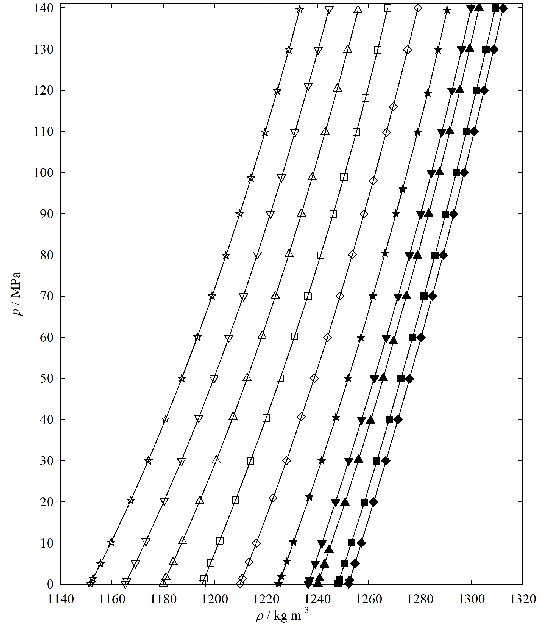
Figure 1: Plot of pressure p of [OMIM][PF₆] versus density ρ:  - 278.16 K;  - 283.15 K; ▲ - 293.15 K; ▼ - 298.15 K;  - 313.16 K;  - 333.14 K;  - 353.16 K;  - 373.16 K;
- - 393.15 K;  , 413.15 K; Solid lines represent values calculated using Eq. (2).
Table III. Deviation statistics between the present and densities reported in the literature.
First author | Temperature range, K | Pressure range, MPa | AAD, % | Bias, % | σ / kg m⁻³ | MD, %
Taguchi¹⁶ | 312.80-472.30 | 0.1-200 | 0.02 | -0.01 | 0.03 | 0.10
Gu¹⁷ | 298.20-323.20 | 0.1-200 | 1.01 | -1.01 | 0.19 | 1.44
Gardas¹⁹ | 293.15-393.15 | 0.1-10 | 0.08 | 0.06 | 0.09 | 0.25
Tomida²⁰ | 295.10-335.20 | 0.1-20 | 0.07 | -0.04 | 0.02 | 0.15
Harris²¹ | 273.15-353.15 | 0.1-176 | 0.08 | 0.08 | 0.05 | 0.24
This work | 278.15-413.15 | 0.1-140 | 0.09 | 0.09 | 0.04 | 0.18
Modified Tammann-Tait equation
The measured density values were fitted to the modified Tammann-Tait equation:
(4)
where C is temperature independent parameter while parameter B(T) depends on temperature as follows:
(5)
ρ^{ref} denotes density at reference pressure, p^{ref}, and it can be calculated from the polynom:
(6)
In Eqs. (4)-(6) a_{i}, b_{i} and C are adjustable parameters and they were optimized using standard deviation as the objective function. First, parameters a_{i} were obtained by fitting density data at p^{ref} (0.1 MPa), and, further, parameters b_{i} and C were gained in the correlation of the entire density data set by Eq. (4). Parameters of the modified Tammann-Tait equation, as well as deviations criteria between measured and calculated densities are presented in Table IV. The average absolute percentage deviation, AAD, of 0.014 % between measured and calculated densities confirmed the accuracy of the chosen correlation method.
Table IV. The parameters of the modified Tammann-Tait equation
a₀ = 1495.020 kg m⁻³ | AAD = 0.014%
a₁ = -0.96034 kg m⁻³ K⁻¹ | MD = 0.048 %
a₂ = 0.312464·10⁻³ kg m⁻³ K⁻² | Bias = -0.004 %
b₀ = 582.365 MPa | σ = 0.23 kg m⁻³
b₁ = -1.86907 MPa K⁻¹
b₂ = 0.00183746 MPa K⁻²
C = 0.0878587

Figure S1 depicts temperature dependences measured densities of [OMIM][PF₆] along four selected isobars of p = 10, 50, 100, 140 MPa. As one can see, the ρ - T dependence for various isobars is almost linear, i.e. shows very small curvature, (∂²ρ/∂T²)_{P} (slopes of the isobars hardly change). This means that the pressure influence on the heat capacity, (∂c_{p}/∂p)_{T}, is also small (almost independent on pressure) (see, for example experimental results by Gardas et al.¹⁹). We estimated the values of isobar’s curvature, (∂²ρ/∂T²)_{P}, using the present high-pressure the ρ – T measurements, and it was shown that the values of (∂²ρ/∂T²)_{P} for [OMIM][PF₆] at pressures between p = 0.101 and 140 MPa changed from 0.46 10⁻³ to 0.52 10⁻³ kg m⁻³ K⁻². Thus, the average value of derivative (∂c_{p}/∂p)_{T} in the pressure range from p = 0.101 to 140 MPa is about 0.78 10⁻⁷ to 1.50 10⁻⁷ m³ kg⁻¹ K⁻¹.
The agreement of experimentally determined densities and values calculated using the multiparametric polynomial EOS and modified Tammann-Tait equation is presented in Fig. S2, while the deviations between the high-pressure data reported in literature¹⁶⁻²¹ and the values calculated from multiparametric polynomial EOS Eq. (2) are depicted in Fig. 2.

Fig. 2. Percentage deviations of the values calculated using multiparametric polynomial-type EOS (Eq. (2)) for [OMIM][PF₆] from literature high-pressure densities: () Taguchi et al.¹⁶, () Gu et al.¹⁷, () Gardas et al.¹⁹, () Tomida et al.²⁰, () Harris et al.²¹, () presented results.
The percentage average absolute deviations between the values calculated using Eq. (2) and reported data sources are: 0.09¹⁹, 0.13¹⁶, 0.15²⁰, 0.05²¹, 1.12 %¹⁷. As one can see, the agreement is within the experimental uncertainties, except the data reported by Gu and Brennecke¹⁷. As Fig. 2 shows, the density data reported by Gu et al.¹⁷ systematically deviate from all other reported data by about 1.0 %. In most cases the deviations between the various data sources are systematical (Table III) AAD and Bias are very close, although within their experimental uncertainties. The reason for systematic deviations could be difference in water contents or incorrect calibration of the instrument, i. e. incorrect reference data (or reference fluid) used for the calibration.
Derived volumetric properties
The modelling of high pressure densitiese, using Eqs. (2) and (4), enabled calculation of derived volumetric properties. The multiparametric polynomial-type EOS (Eq,(2)) was used to calculate various thermodynamic properties, such as isothermal compressibility, thermal expansion coefficient, thermal pressure coefficient, internal pressure, isochoric heat capacity, isobaric heat capacity, speed of sound, isentropic exponent of [OMIM][PF₆] over the experimental temperature range T = 278.15 to 413.15 K and at pressures p = 0.101 to 140 MPa using well-known thermodynamic relations⁴⁴ (Supplementary material, Table SII). Our previous heat capacity measurements at atmospheric pressure [15] have been used as a reference data to calculate high -pressure heat capacities using equation of state Eq. (2). The present heat capacity data calculated from EOS Eq. (2) for [OMIM][PF₆] are in excellent agreement (deviations within 0.1 %) with the values reported by Gardas et al.¹⁹. Unfortunately, there are no reported direct experimental thermodynamic data for [OMIM][PF₆] to compare with the present results and validate the accuracy and reliability of the developed EOS Eq. (2).
The optimized parameters of the modified Tammann-Tait equation were, also, used for calculation of derived volumetric properties isothermal compressibility and isobaric thermal expansivity (Eqs. (7) and (8)) and obtained results are presented in Figure 3.

a b
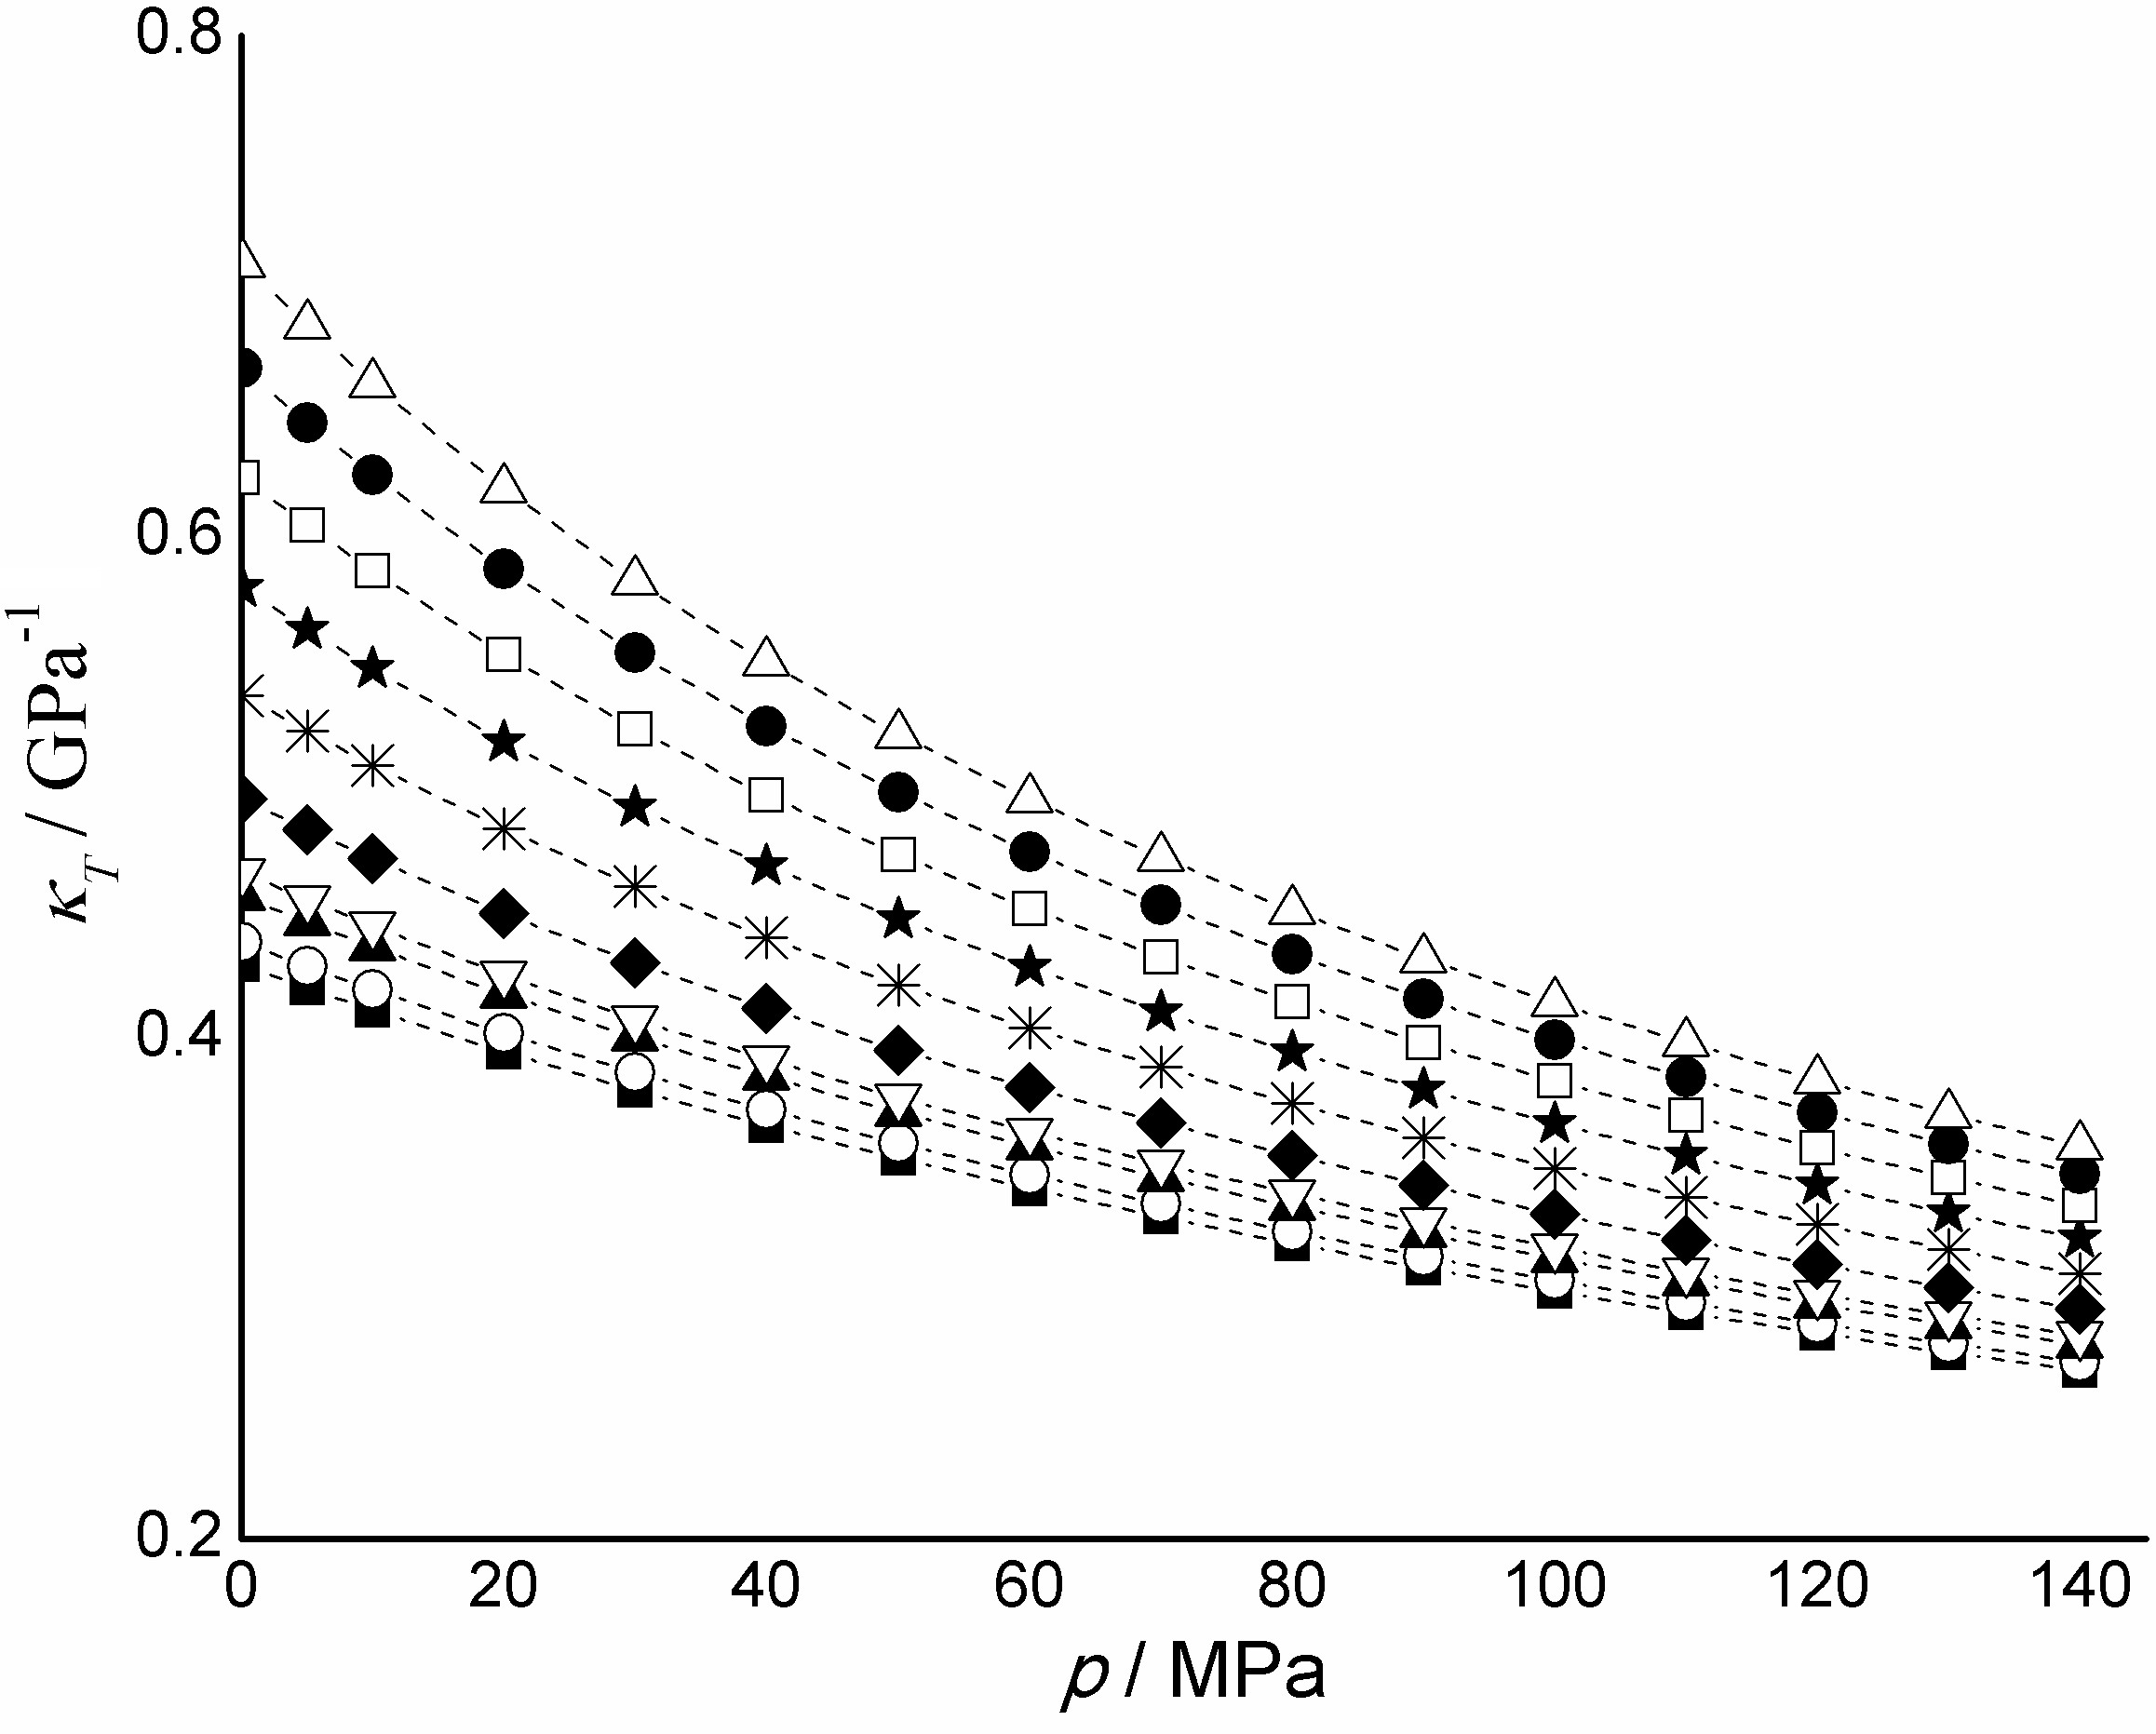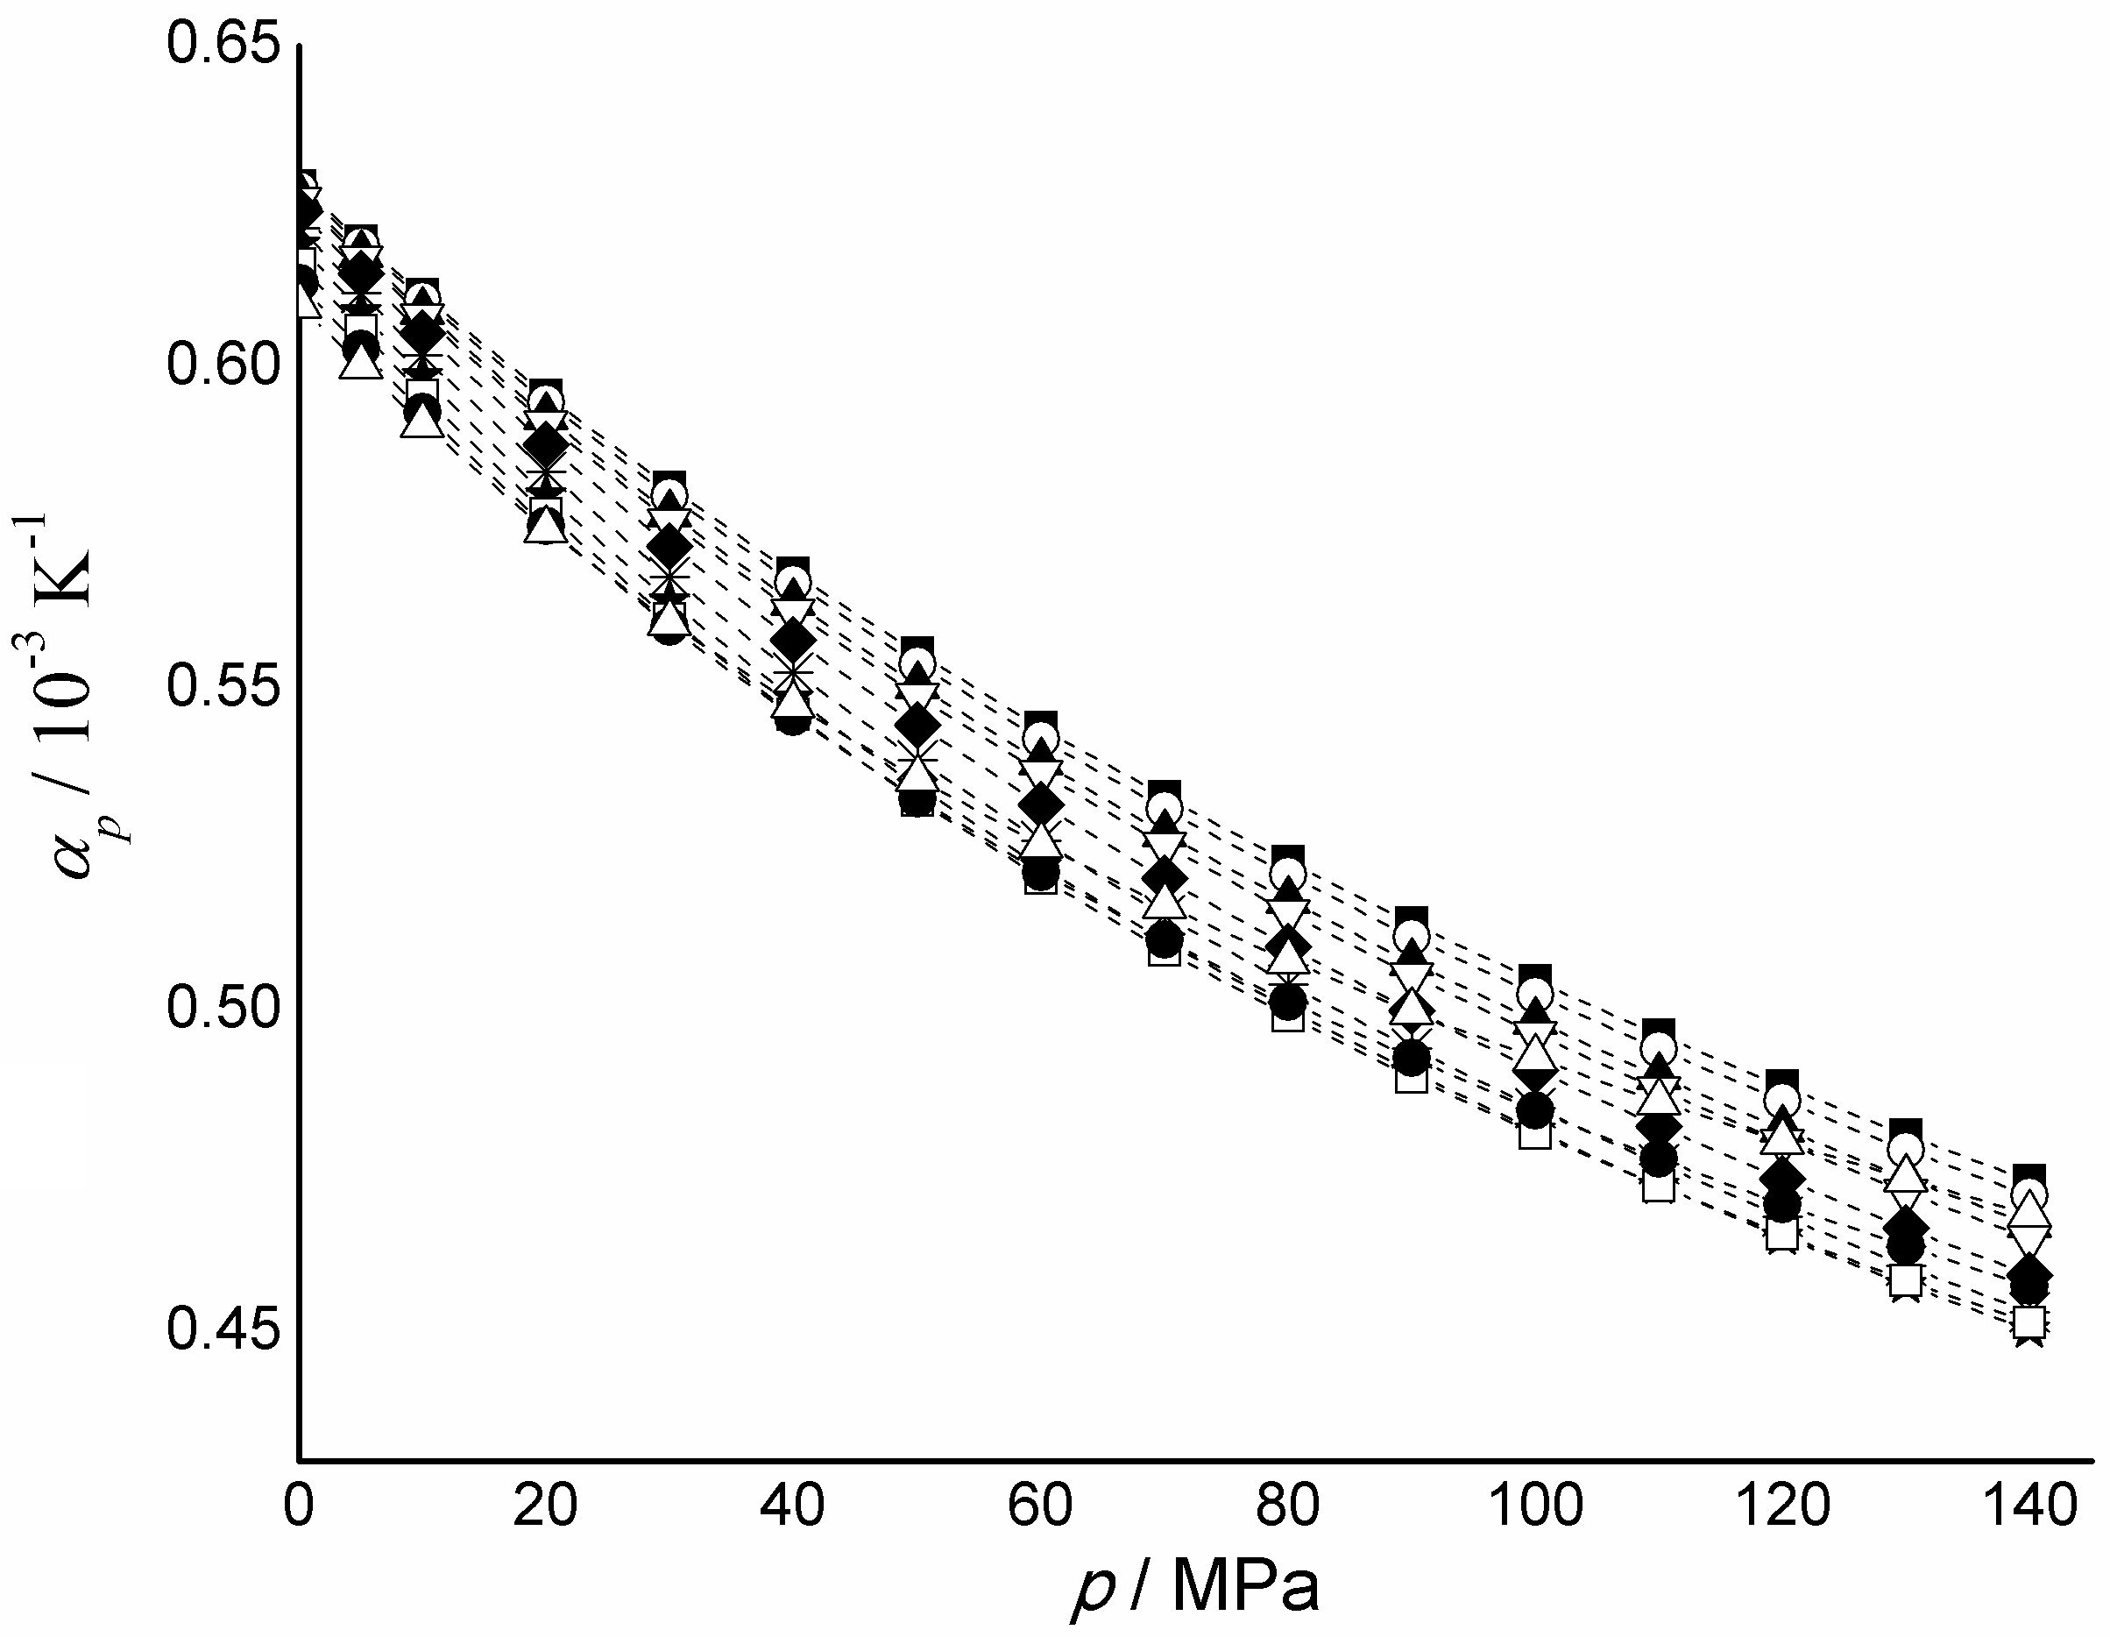
Fig. 3. a) The isothermal compressibilities and b) the isobaric thermal expansivity of [OMIM][PF₆] at: () 278.15 K, () 283.15 K, () 293.15 K, () 298.15 K, () 313.15 K, () 333.15 K, (⬆) 353.15 K, () 373.15 K, () 393.15 K and () 413.15 K.
Lines are guides for eyes.
The isothermal compressibility, κ_{T}, of the examined ionic liquid shows behaviour characteristic for this property, it decreases with temperature drop at constant pressure and decreases along isotherms when pressure goes up. The influence of pressure on density is higher at higher temperatures and a bit more noticeable at lower pressures close to atmospheric. On the other hand, behaviour of the isobaric thermal expansivity, α_{p}, is not really typical for this property but it is quite common for ionic liquids^{45,46}. It goes down along isotherms when pressure increases and rises with temperature drop at constant pressure.
Conclusions
A total of 170 high-pressure and high-temperature data are reported for (p, ρ, T) of [OMIM][PF₆] in the liquid phase over the temperature range from T = 278.15 to 413.15 K at pressures up to 140 MPa. The experimental data reported here have an expanded uncertainty at a 95 % confidence level within ∆ρ/ρ = ±0.03 to ±0.08) %. The present high-pressure ρ / T data were used to estimate the real curvature, (∂²ρ / ∂T²)_{P} of the experimental isobars. We found that the slopes of the isobars hardly change. For various isobars between 0.101 and 140 MPa, the values of (∂²ρ / ∂T²)_{P} are changing from 0.00046 to 0.00052 kg m⁻³ K⁻². This means that pressure dependence of the heat capacity, (∂c_{p} / ∂p)_{T}, is also small (almost independent on pressure), i.e., heat capacity of [OMIM][PF₆] c_{p} very poorly depends on pressure. The average value of derivative (∂c_{p}/∂p)_{T} in the pressure range from p = 0.101 to 140 MPa is about 0.78 10⁻⁷ to 1.50 10⁻⁷ m³ kg⁻¹ K⁻¹.
Experimentally determined density values were fitted to the modified Tammann-Tait equation and obtained parameters were used for calculation of isothermal compressibility and isobaric thermal expansivity. While κ_{T} showed characteristic changes as response to temperature and pressure changes, behaviour of α_{p} wasn’t typical for this property but similar dependence on temperature and pressure has been noticed for other ionic liquids.
Based on the present measurements, multiparametric polynomial type EOS was developed for the (p,ρ,T) surface of liquid [OMIM][PF₆]. Developed EOS represents the present density measurements in the whole experimental range with an AAD of 0.005 % (standard deviation of 0.01 %). The derived EOS was used to calculate various thermodynamic properties of [OMIM][PF₆] in the experimental pressure and temperature ranges, such as adiabatic coefficient of bulk compressibility, isothermal coefficient of bulk compressibility, thermal expansion coefficient, thermal pressure coefficient, internal pressure, enthalpy difference, entropy difference, isochoric heat capacity, isobaric heat capacity, and speed of sound.
SUPPLEMENTARY MATERIAL
The derived thermodynamic properties of [OMIM][PF₆] in the experimental pressure and temperature ranges are available electronically on the pages of journal website: http://www.shd.org.rs/JSCS/, or from the corresponding author on request.
Acknowledgements: University of Rostock and Azerbaijan Technical University thanks for the support of research investigations.
ИЗВОД
•
JAVID SAFAROV^{1,2}, CHRISTOFFER BUSSEMER¹, ABILGANI ALIYEV², ГОРИВА ИВАНИШ³, МИРАЈАНА КИЈЕВЧАНИН³, ИВОНА РАДОВИЋ³, EGON HASSEL¹ и ILMUTDIN ABDULAGATOV⁴
¹Institute of Technical Thermodynamics, University of Rostock, Albert-Einstein-Str. 2, D-18059 Rostock, Germany; ²Department of Heat Energy, Azerbaijan Technical University, H. Javid Avn. 25, AZ1073 Baku, Azerbaijan; ³Faculty of Technology and Metallurgy, University of Belgrade, Karnegijeva 4, 11120 Belgrade, Serbia; ⁴Physical and Organic Chemistry Department, Dagestan State University, Makhachkala, Russian Federation

(Примљено 28. маја; прихваћено 16. јула 2019)
REFERENCES
- H. Schmidt, M. Stephan, J. Safarov, I. Kul, J. Nocke, I. M. Abdulagatov, E. Hassel, J. Chem. Thermodyn. 47 (2012) 68 (https://doi.org/10.1016/j.jct.2011.09.027)
- J. Safarov, R. Hamidova, S. Zepik, H. Schmidt, I. Kul, A. Shahverdiyev, E. Hassel, J. Mol. Liq. 187 (2013) 137 (https://doi.org/10.1016/j.molliq.2013.05.032)
- R. Hamidova, I. Kul, J. Safarov, A. Shahverdiyev, E. Hassel, Brazilian J. Chem. Eng. 32 (2015) 303 (http://dx.doi.org/10.1590/0104-6632.20150321s00003120)
- G. Huseynova, R. Hamidova, J. Safarov, M. Bashirov, E. Hassel, Transactions of Azerbaijan National Academy of Sciences, Series of Physical-mathematical and Technical Sciences 5 (2016) 128 (http://www.physics.gov.az/Transactions/2016/journal2016(5).pdf)
- N. G. Polikhronidi, R.G. Batyrova, I. M. Abdulagatov, J. W. Magee, J. T. Wu, Phys. Chem. Liq. 52 (2014) 657 (https://doi.org/10.1080/00319104.2014.924381)
- J. Safarov, G. Huseynova, M. Bashirov, E. Hassel, I. Abdulagatov, J Mol. Liquids 238 (2017) 347 (https://doi.org/10.1016/j.molliq.2017.05.013)
- N. G. Polikhronidi, R. G. Batyrova, I. M. Abdulagatov, J. W. Magee, J. Wu, Int. J. Thermophys. 37 (2016) 103 (https://doi.org/10.1007/s10765-016-2109-2)
- J. Safarov, F. Lesch, Kh. Suleymanli, A. Aliyev, A. Shahverdiyev, E. Hassel, I. M. Abdulagatov, J. Chem. Eng. Data 62 (2017) 3620 (https://doi.org/10.1021/acs.jced.7b00618)
- J. Safarov, F. Lesch, Kh. Suleymanli, A. Aliyev, A. Shahverdiyev, E. Hassel, I.Abdulagatov, Thermochimica Acta 658 (2017) 14 (https://doi.org/10.1016/j.tca.2017.10.022)
- I.M. Abdulagatov, A. Tekin, J. Safarov, A. Shahverdiyev, E.Hassel, Int. J. Thermophys. 29 (2008) 505 (https://doi.org/10.1007/s10765-008-0410-4)
- I. M. Abdulagatov, A. Tekin, J. Safarov, A. Shahverdiyev, E. Hassel, J. Sol. Chem. 37 (2008) 801 (https://doi.org/10.1007/s10953-008-9278-y)
- I. M. Abdulagatov, A. Tekin, J. Safarov, A. Shahverdiyev, E. Hassel, J. Chem. Thermodyn. 40 (2008) 1386 (https://doi.org/10.1016/j.jct.2008.05.005)
- I. M. Abdulagatov, J. Safarov, T. Guliyev, A. Shahverdiyev, E. Hassel, Phys. Chem. Liquids 47 (2009) 9 (https://doi.org/10.1080/00319100802372106)
- J. Safarov, I. Kul, M. A. Talibov, A. Shahverdiyev, E. Hassel, J. Chem. Eng. Data 60 (2015) 1648 (https://doi.org/10.1021/je501033z)
- J. Safarov, Ch. Bussemer, A. Aliyev, C. Lafuente, E. Hassel, I. Abdulagatov, J. Chem. Thermodyn. 124 (2018) 49 (https://doi.org/10.1016/j.jct.2018.04.018)
- R. Taguchi, H. Machida, Y. Sato, R. L. Smith, J. Chem. Eng. Data 54 (2009) 22 (https://doi.org/10.1021/je800224k)
- Z. Gu, J. F. Brennecke, J. Chem. Eng. Data 47 (2002) 339 (https://doi.org/10.1021/je010242u)
- D. Tomida, A. Kumagai, S. Kenmochi, K. Qiao, C. Yokoyama, J. Chem. Eng. Data 52 (2007) 577 (https://doi.org/10.1021/je060464y)
- R. L. Gardas, M. G. Freire, P. J. Carvalho, I. M. Marrucho, I. M. A. Fonseca, A. G. M. Ferreira, J. A. P. Coutinho, J. Chem. Eng. Data 52 (2007) 80 (https://doi.org/10.1021/je060247x)
- D. Tomida, S. Kenmochi, T. Tsukada, K. Qiao, C. Yokoyama, Int. J. Thermophys. 28 (2007) 1147 (https://doi.org/10.1007/s10765-007-0241-8)
- K. R. Harris, M. Kanakubo,, L. A. Woolf, J. Chem. Eng. Data 51 (2006) 1161 (https://doi.org/10.1021/je060082s)
- M. Frenkel, R. Chirico, V. Diky, C. D. Muzny, A. Kazakov, J. W. Magee, I. M. Abdulagatov, Jeong Won Kang, NIST Thermo Data Engine, NIST Standard Reference Database 103b- Pure Compound, Binary Mixtures, and Chemical Reactions, Version 5.0, National Institute Standards and Technology, Boulder, Colorado-Gaithersburg, MD, 2010.
- J. Safarov, F. J. Millero,, R. Feistel,, A. Heintz,, E. Hassel, Ocean Sci. 5 (2009) 235 (https://doi.org/10.5194/os-5-235-2009)
- N. Nabiyev, M. Bashirov, J. Safarov, A. Shahverdiyev, E. Hassel, J. Chem. Eng. Data 54 (2009) 1799 (https://doi.org/10.1021/je800840m)
- I. M. Abdulagatov, J. Safarov, T. Guliyev, A. Shahverdiyev, E. Hassel J. Chem. Eng. Data 54 (2009) 248 (https://doi.org/10.1021/je800234h)
- I. M. Abdulagatov, A. Tekin, J. Safarov, A. Shahverdiyev, E. Hassel, Thermochimica Acta 476 (2008) 51 (https://doi.org/10.1016/j.tca.2008.07.011)
- E. W. Lemmon, M. L. Huber, M. O. McLinden, NIST Standard Reference Database 25, REFPROP, Reference Fluid Thermodynamic and Transport Properties. 2010, NIST: Gaithersburg, MD.
- K. Harris, M. Kanakubo, J. Chem. Eng. Data 61 (2016) 2399 (https://doi.org/10.1021/acs.jced.6b00021)
- H. Stabinger, Density Measurement using Modern Oscillating Transducers, South Yorkshire Trading Standards Unit, Sheffield, 1994.
- S. J. Aschcroft, D. R. Booker, J. C. R. Turner, Faraday Transactions 86 (1990) 145 (https://doi.org/10.1039/FT9908600145)
- J. J. Segovia, O. Fandiño, E. R. López, L. Lugoa, M. C. Martín, J. Fernández, J. Chem. Thermodynamics 41 (2009) 632 (https://doi.org/10.1016/j.jct.2008.12.020)
- J. T. Safarov, J. Chem. Thermodyn. 35 (2003) 1929 (https://doi.org/10.1016/j.jct.2003.08.015)
- J. Safarov, F. J. Millero, R. Feistel, A. Heintz, E. Hassel, Ocean Science 6 (2009) 689 (www.ocean-sci-discuss.net/6/689/2009)
- J. Safarov, S. Berndt, F.J. Millero, R. Feistel, A. Heintz , E.P. Hassel, Deep-Sea Research I 65 (2012) 146 (https://doi.org/10.1016/j.dsr.2012.03.010 )
- J. Safarov, S. Berndt, F. J. Millero, R. Feistel, A. Heintz , E. P. Hassel, Deep-Sea Research I 78 (2013) 95 (https://doi.org/10.1016/j.dsr.2013.04.004)
- K. A. Putilov, Thermodynamics of sample liquids / In book: Researches in Thermodynamics, М.: Nauka, 1973, p.105-130.
- S. Gabriel, Chemische Berichte 21 (1888) 2669 (https://doi.org/10.1002/cber.18880210288)
- G. Mie, Annalen der Physik 11 (1903) 657 (https://doi.org/10.1002/andp.19033160802)
- E. Grüneisen, Annalen der Physik 39 (1912) 257 (https://doi.org/10.1002/andp.19123441202)
- A. Eucken, Forschung auf dem Gebiete des Ingenieurwesens 12 (1941) 113 (https://doi.org/10.1007/BF02584929)
- R. Plank, Brennstoff, Wärme, Kraft 12 (1960) 302
- T. C. Akhundov, Sh.Y. Imanov, Izvestiya VUZov, Neft i Gas 12 (1969) 100
- D. S. Kurumov, Russian Journal of High Temperature 30 (1992) 1080 (http://www.mathnet.ru/links/09e8a3e534aa1aeeb5e3cf0b1eff7b54/tvt3685.pdf)
- J. Safarov,, R. Hamidova,, S. Zepik,, H. Schmidt,, I. Kul,, A. Shahverdiyev,, E. Hassel, Journal of Molecular Liquids 187 (2013) 137 (https://doi.org/10.1016/j.molliq.2013.05.032)
- J. S. Rowlinson, F. L. Swinton, Liquids and Liquid Mixtures, 3rd edn., Elsevier, Butterworth-Heinemann, 1982, 336 p.
- O. G. Sas, G. R. Ivaniš, M. Lj. Kijevčanin, B. Gonzales, A. Dominiguez, I. R. Radović, J. Chem. Eng. Data 63 (2018) 954 (https://doi.org/10.1021/acs.jced.7b00771)

SUPPLEMENTARY MATERIAL TO
High – temperature and high-pressure (p, ρ, T) measurements and derived thermodynamic properties of 1-octyl-3-methylimidazolium hexafluorophosphate
Javid Safarov^{1,2}, Christoffer Bussemer¹, Abilgani Aliyev²,
Gorica Ivaniš³, Mirjana Kijevčanin³, Ivona Radović³, Egon Hassel¹, Ilmutdin Abdulagatov⁴
1Institute of Technical Thermodynamics, University of Rostock, Albert-Einstein-Str. 2,
D-18059 Rostock, Germany; ²Department of Heat Energy, Azerbaijan Technical University,
H. Javid Avn. 25, AZ1073 Baku, Azerbaijan; ³Faculty of Technology and Metallurgy,
University of Belgrade, Karnegijeva 4, 11120 Belgrade, Serbia; ⁴Physical and Organic Chemistry Department, Dagestan State University, Makhachkala, Russian Federation

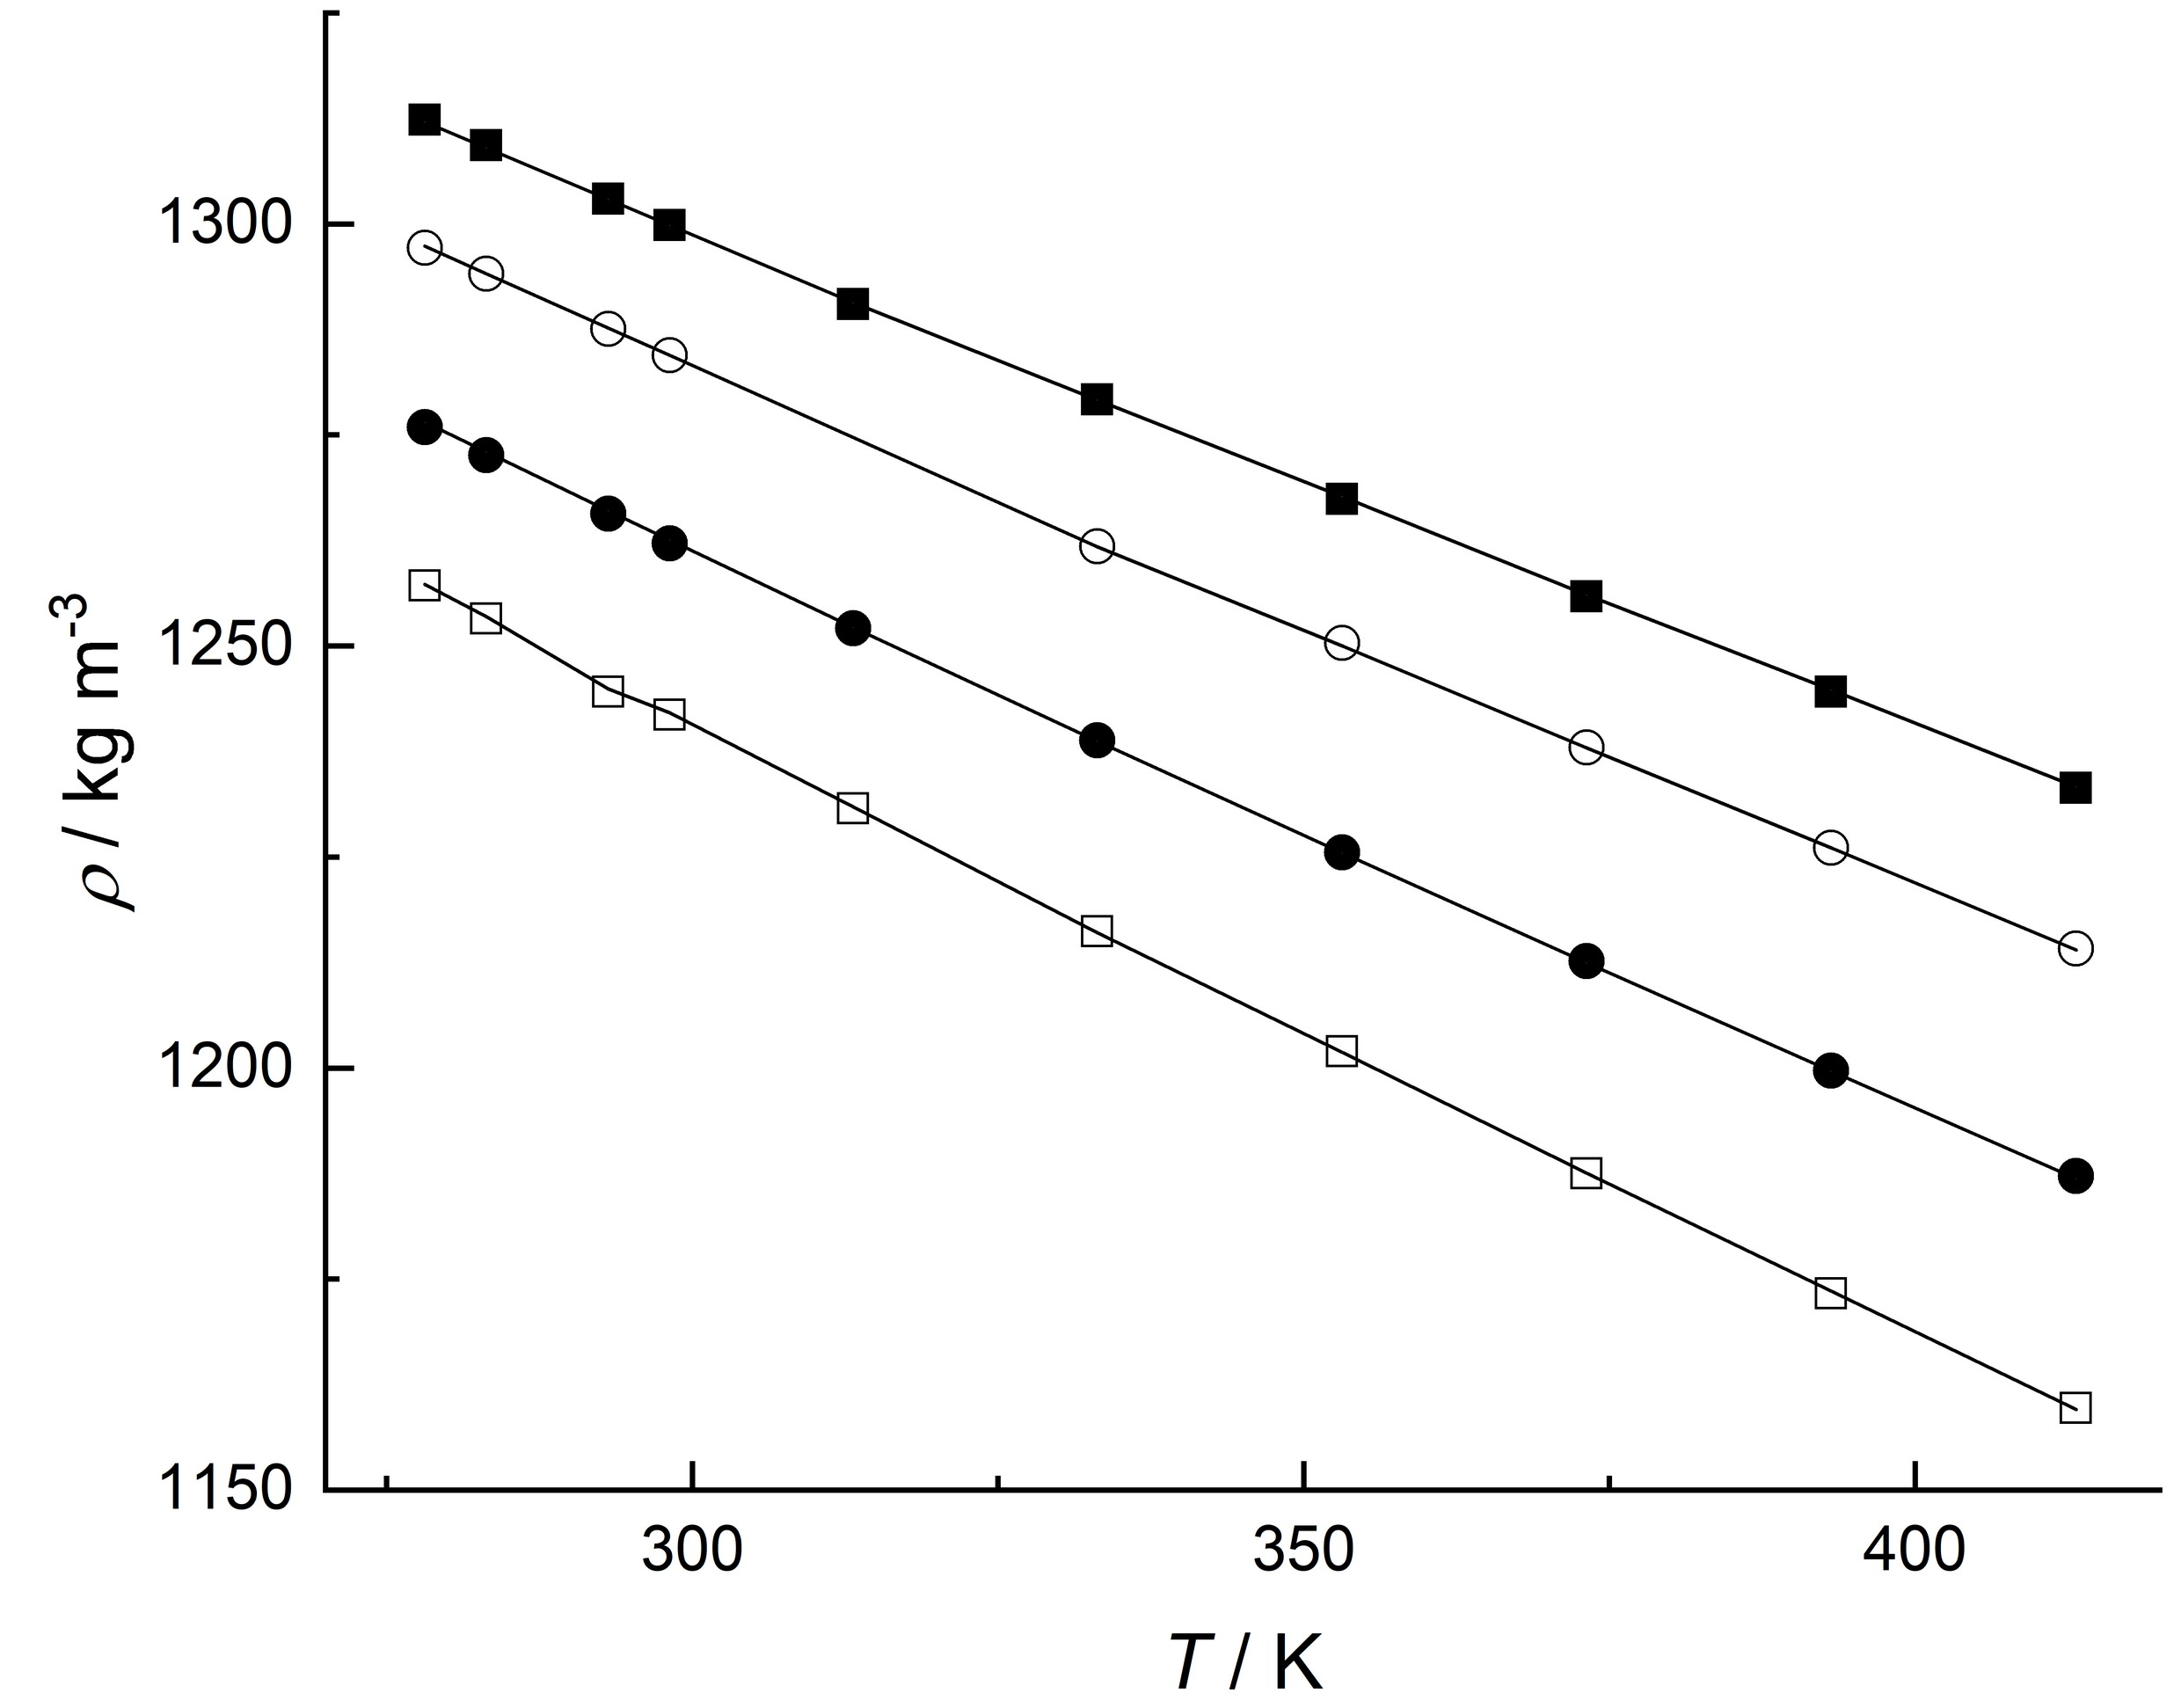
Fig. S1. Measured densities of [OMIM][PF₆] at high pressures as a function of temperature. () 10 MPa, () 50 MPa, () 100 MPa and () 140 MPa. Solid lines represent values calculated using the modified Tammann-Tait EOS.
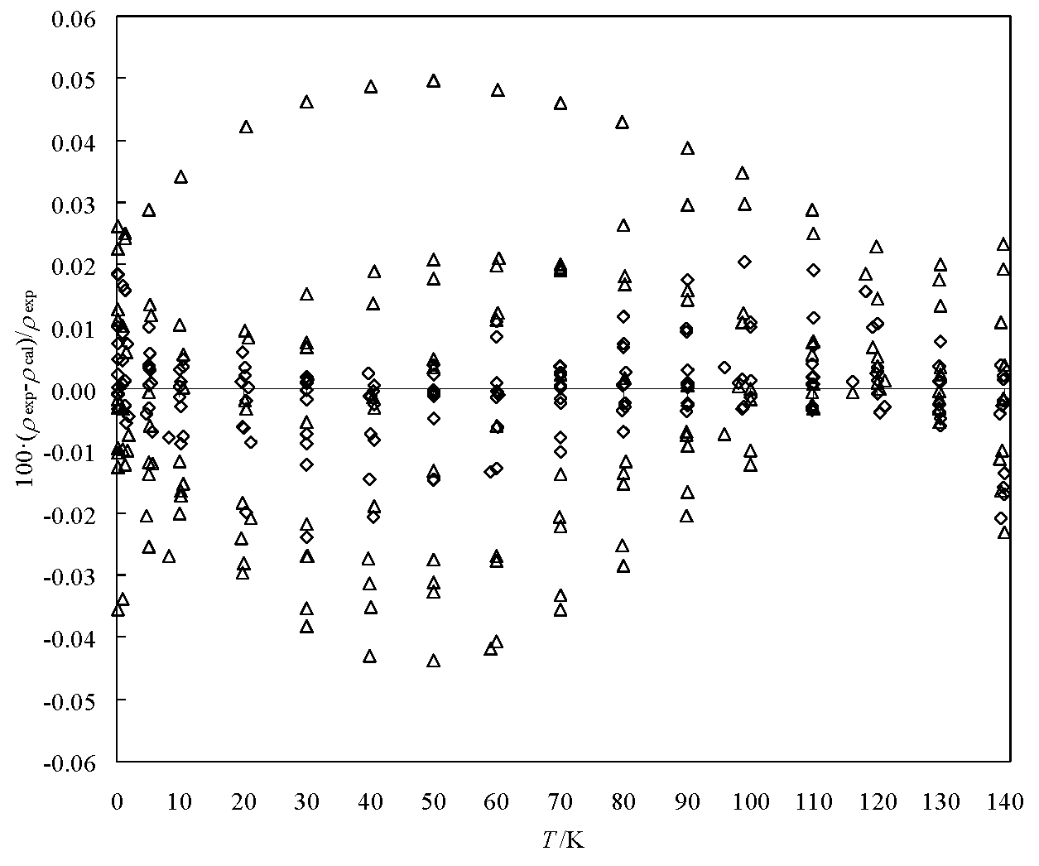
Fig. S2. Deviations between experimental densities and values calculated using: () multiparametric polynomial-type EOS (Eq. (2)) and () the modified Tammann-Tait equation (Eq. (4))

Table SI. Summary of reported density data of [OMIM][PF6]
First author | Method ª | Properties^{b} | T / K | p / MPa | Uncertainty | Purity, mass % | Source
Taguchi¹ | BD | p, ρ, T | 312.8-472.3 | 0.1- 200 | 0.1 % | 98 | Acros Organics
Gu² | UHPD | p, ρ, T | 298.2-323.2 | 0.1- 204 | 0.05-1.3 % | 99.5 | SACHEM
Tomida³ | GP | p, ρ, T, η | 293.15-353.15 | 0.1- 20 | 0.2 % | >99 | Prepared by the authors
Gardas⁴ | VTD | p, ρ, T | 293.15-393.15 | 0.1- 10 | 1.0 kg∙m⁻³ | >98 | Solvent Innovation
Tomida⁵ | GP | p, ρ, T, λ | 295.1-335.2 | 0.1- 20 | 0.2 % | >99 | Prepared by the authors
Harris^{c,6} | FB | p, ρ, T, η | 273.15-353.15 | 0.1- 176 | 0.5 % | >95 | Cannon
Safarov (this work) | VTD | p, ρ, T | 278.15-413.15 | 0.1- 140 | 0.01- 0.08 % | 99 | Iolitech
ª BD-bellows dilatometer; UHPD –ultrahigh-pressure density apparatus; GP-glass piezometer; VTD-vibrating tube densimeter DMA 512P; FB-falling body.
^{b} η, viscosity; λ, thermal conductivity.
^{c} High pressure density values calculated from atmospheric pressure densities.
Table SII. Experimental values of pressure (p), density (ρ), temperature (T), calculated values of isothermal compressibility (κ_{T}), isobaric thermal expansibility (α_{p}), difference in isobaric and isochoric heat capacities (c_{p}-c_{v}), thermal pressure coefficient (γ), internal pressure (p_{int}), isobaric heat capacity (c_{p}), isochoric heat capacity (c_{v}), speed of sound (u) and isentropic exponent (κ_{s}) of 1-octyl-3-methylimidazolium hexafluorophosphate [OMIM][PF₆].
p / MPa | ρ /  kg m⁻³ | T / K | κ_{T} 10⁶ / MPa⁻¹ | α_{p} / 10⁶/K⁻ | c_{p}-c_{v} /  J kg⁻¹ K⁻¹ | γ /  MPa K⁻¹ | p_{int} / MPa | c_{p} /  J kg⁻¹ K⁻¹ | c_{v} /  J kg⁻¹ K⁻¹ | u / m s⁻¹ | κ_{s}
0.101 | 1252.21 | 278.15 | 418.2 | 636.2 | 215.04 | 1.5213 | 423.1 | 1655.27 | 1440.23 | 1481.59 | 27210.34
1.002 | 1252.66 | 278.15 | 416.8 | 634.5 | 214.51 | 1.5224 | 422.4 | 1655.35 | 1440.84 | 1483.59 | 2751.202
5.021 | 1254.66 | 278.15 | 410.5 | 626.8 | 212.19 | 1.5270 | 419.7 | 1655.72 | 1443.53 | 1492.46 | 556.541
10.003 | 1257.12 | 278.15 | 402.9 | 617.6 | 209.45 | 1.5327 | 416.3 | 1656.18 | 1446.73 | 1503.33 | 284.014
19.953 | 1261.96 | 278.15 | 388.8 | 600.4 | 204.33 | 1.5442 | 409.6 | 1657.05 | 1452.71 | 1524.66 | 147.031
29.957 | 1266.72 | 278.15 | 375.7 | 584.5 | 199.65 | 1.5559 | 402.8 | 1657.84 | 1458.18 | 1545.62 | 101.028
39.956 | 1271.38 | 278.15 | 363.5 | 569.8 | 195.38 | 1.5677 | 396.1 | 1658.51 | 1463.13 | 1566.12 | 78.057
49.928 | 1275.92 | 278.15 | 352.1 | 556.2 | 191.49 | 1.5796 | 389.4 | 1659.04 | 1467.54 | 1586.15 | 64.304
59.956 | 1280.39 | 278.15 | 341.5 | 543.6 | 187.93 | 1.5917 | 382.8 | 1659.40 | 1471.47 | 1605.85 | 55.077
70.006 | 1284.76 | 278.15 | 331.5 | 531.8 | 184.65 | 1.6040 | 376.1 | 1659.57 | 1474.92 | 1625.24 | 48.481
79.958 | 1288.99 | 278.15 | 322.3 | 520.9 | 181.68 | 1.6164 | 369.6 | 1659.55 | 1477.87 | 1644.10 | 43.579
89.925 | 1293.12 | 278.15 | 313.5 | 510.7 | 178.95 | 1.6289 | 363.2 | 1659.31 | 1480.35 | 1662.66 | 39.754
99.957 | 1297.17 | 278.15 | 305.3 | 501.2 | 176.44 | 1.6418 | 356.7 | 1658.84 | 1482.40 | 1681.03 | 36.672
109.953 | 1301.11 | 278.15 | 297.5 | 492.3 | 174.15 | 1.6548 | 350.3 | 1658.13 | 1483.98 | 1699.03 | 34.159
119.987 | 1304.96 | 278.15 | 290.1 | 483.9 | 172.05 | 1.6680 | 344.0 | 1657.18 | 1485.13 | 1716.82 | 32.056
129.953 | 1308.69 | 278.15 | 283.2 | 476.1 | 170.14 | 1.6814 | 337.7 | 1655.98 | 1485.84 | 1734.23 | 30.287
139.962 | 1312.32 | 278.15 | 276.5 | 468.7 | 168.39 | 1.6950 | 331.5 | 1654.53 | 1486.13 | 1751.46 | 28.763
0.101 | 1248.02 | 283.15 | 428.0 | 632.1 | 211.80 | 1.4769 | 418.1 | 1665.26 | 1453.46 | 1464.55 | 26503.93
1.023 | 1248.52 | 283.15 | 426.4 | 630.3 | 211.28 | 1.4780 | 417.5 | 1665.35 | 1454.07 | 1466.67 | 2625.304
5.021 | 1250.63 | 283.15 | 419.8 | 622.7 | 209.09 | 1.4831 | 414.9 | 1665.73 | 1456.64 | 1475.78 | 542.473
10.020 | 1253.24 | 283.15 | 411.9 | 613.5 | 206.48 | 1.4896 | 411.8 | 1666.22 | 1459.74 | 1487.04 | 276.573
19.925 | 1258.33 | 283.15 | 397.1 | 596.6 | 201.72 | 1.5025 | 405.5 | 1667.20 | 1465.48 | 1508.97 | 143.792
29.928 | 1263.19 | 283.15 | 383.3 | 580.9 | 197.39 | 1.5158 | 399.3 | 1668.14 | 1470.75 | 1530.62 | 98.883
39.954 | 1267.94 | 283.15 | 370.4 | 566.5 | 193.49 | 1.5294 | 393.1 | 1669.01 | 1475.52 | 1551.86 | 76.427
49.952 | 1272.57 | 283.15 | 358.5 | 553.3 | 189.99 | 1.5432 | 387.0 | 1669.77 | 1479.78 | 1572.60 | 63.005
59.986 | 1277.11 | 283.15 | 347.4 | 541.1 | 186.83 | 1.5574 | 381.0 | 1670.41 | 1483.58 | 1593.02 | 54.028
70.002 | 1281.53 | 283.15 | 337.1 | 529.8 | 184.00 | 1.5718 | 375.1 | 1670.89 | 1486.89 | 1612.95 | 47.626
79.924 | 1285.80 | 283.15 | 327.4 | 519.5 | 181.48 | 1.5864 | 369.3 | 1671.21 | 1489.73 | 1632.38 | 42.866
89.923 | 1289.99 | 283.15 | 318.3 | 509.8 | 179.21 | 1.6014 | 363.5 | 1671.35 | 1492.15 | 1651.64 | 39.129
99.957 | 1294.08 | 283.15 | 309.7 | 500.8 | 177.17 | 1.6168 | 357.8 | 1671.30 | 1494.14 | 1670.63 | 36.13
109.928 | 1298.04 | 283.15 | 301.7 | 492.4 | 175.36 | 1.6323 | 352.3 | 1671.05 | 1495.69 | 1689.22 | 33.69
119.953 | 1301.91 | 283.15 | 294.0 | 484.6 | 173.76 | 1.6483 | 346.8 | 1670.59 | 1496.83 | 1707.61 | 31.645
129.986 | 1305.67 | 283.15 | 286.8 | 477.4 | 172.35 | 1.6646 | 341.4 | 1669.91 | 1497.56 | 1725.76 | 29.913
139.954 | 1309.29 | 283.15 | 280.0 | 470.7 | 171.12 | 1.6812 | 336.1 | 1669.01 | 1497.89 | 1743.53 | 28.438
0.101 | 1240.23 | 293.15 | 447.7 | 624.4 | 205.85 | 1.3947 | 408.8 | 1685.48 | 1479.63 | 1432.36 | 25192.74
1.392 | 1240.92 | 293.17 | 445.3 | 621.8 | 205.16 | 1.3965 | 408.0 | 1685.61 | 1480.45 | 1435.45 | 1836.853
4.759 | 1242.71 | 293.16 | 439.1 | 615.4 | 203.45 | 1.4015 | 406.1 | 1685.85 | 1482.40 | 1443.65 | 544.248
8.248 | 1244.56 | 293.15 | 432.8 | 608.9 | 201.75 | 1.4068 | 404.2 | 1686.11 | 1484.36 | 1452.08 | 318.186
19.746 | 1250.75 | 293.14 | 413.6 | 589.1 | 196.68 | 1.4244 | 397.8 | 1687.11 | 1490.43 | 1479.27 | 138.606
30.203 | 1256.07 | 293.14 | 397.7 | 573.0 | 192.69 | 1.4409 | 392.2 | 1688.10 | 1495.41 | 1503.36 | 93.99
39.693 | 1260.75 | 293.14 | 384.3 | 559.7 | 189.53 | 1.4564 | 387.2 | 1689.02 | 1499.48 | 1524.75 | 73.841
49.997 | 1265.66 | 293.14 | 370.9 | 546.5 | 186.55 | 1.4737 | 382.0 | 1689.98 | 1503.44 | 1547.50 | 60.621
58.939 | 1269.61 | 293.13 | 360.0 | 536.1 | 184.29 | 1.4891 | 377.6 | 1690.76 | 1506.47 | 1566.90 | 52.894
69.996 | 1274.65 | 293.14 | 347.5 | 524.3 | 181.89 | 1.5087 | 372.3 | 1691.69 | 1509.80 | 1590.39 | 46.064
79.792 | 1278.98 | 293.15 | 337.2 | 514.8 | 180.09 | 1.5264 | 367.7 | 1692.41 | 1512.32 | 1610.77 | 41.59
89.997 | 1283.37 | 293.15 | 327.2 | 505.6 | 178.52 | 1.5456 | 363.1 | 1693.04 | 1514.53 | 1631.70 | 37.967
99.996 | 1287.53 | 293.15 | 317.9 | 497.5 | 177.25 | 1.5648 | 358.7 | 1693.54 | 1516.29 | 1651.87 | 35.134
109.993 | 1291.58 | 293.15 | 309.2 | 490.0 | 176.22 | 1.5846 | 354.5 | 1693.91 | 1517.68 | 1671.74 | 32.816
119.993 | 1295.49 | 293.15 | 301.0 | 483.1 | 175.43 | 1.6048 | 350.5 | 1694.13 | 1518.71 | 1691.31 | 30.884
129.998 | 1299.28 | 293.15 | 293.3 | 476.7 | 174.85 | 1.6256 | 346.5 | 1694.21 | 1519.37 | 1710.63 | 29.248
140.001 | 1302.95 | 293.15 | 285.9 | 470.9 | 174.46 | 1.6469 | 342.8 | 1694.14 | 1519.68 | 1729.68 | 27.847
0.101 | 1236.47 | 298.15 | 457.7 | 621.2 | 203.33 | 1.3573 | 404.6 | 1695.62 | 1492.29 | 1417.06 | 24580.68
1.005 | 1236.97 | 298.15 | 455.9 | 619.4 | 202.86 | 1.3587 | 404.1 | 1695.66 | 1492.81 | 1419.33 | 2479.267
5.023 | 1239.15 | 298.15 | 448.1 | 611.6 | 200.84 | 1.3649 | 401.9 | 1695.88 | 1495.03 | 1429.39 | 504.021
10.006 | 1241.83 | 298.15 | 438.8 | 602.3 | 198.50 | 1.3727 | 399.3 | 1696.19 | 1497.68 | 1441.72 | 257.972
19.924 | 1247.07 | 298.16 | 421.5 | 585.3 | 194.32 | 1.3887 | 394.1 | 1696.93 | 1502.61 | 1465.80 | 134.49
30.002 | 1252.25 | 298.15 | 405.3 | 569.7 | 190.65 | 1.4057 | 389.1 | 1697.74 | 1507.09 | 1489.75 | 92.642
40.001 | 1257.26 | 298.15 | 390.6 | 555.7 | 187.52 | 1.4230 | 384.3 | 1698.62 | 1511.10 | 1512.97 | 71.953
50.006 | 1262.14 | 298.13 | 376.9 | 543.1 | 184.85 | 1.4410 | 379.6 | 1699.48 | 1514.63 | 1535.77 | 59.533
59.924 | 1266.83 | 298.15 | 364.4 | 531.7 | 182.59 | 1.4591 | 375.1 | 1700.39 | 1517.80 | 1557.84 | 51.306
69.928 | 1271.43 | 298.15 | 352.6 | 521.2 | 180.69 | 1.4782 | 370.8 | 1701.24 | 1520.55 | 1579.74 | 45.373
79.941 | 1275.91 | 298.14 | 341.6 | 511.7 | 179.12 | 1.4979 | 366.6 | 1702.01 | 1522.90 | 1601.30 | 40.923
89.924 | 1280.23 | 298.15 | 331.4 | 503.1 | 177.86 | 1.5179 | 362.6 | 1702.75 | 1524.89 | 1622.32 | 37.467
99.924 | 1284.42 | 298.15 | 321.8 | 495.2 | 176.88 | 1.5387 | 358.8 | 1703.39 | 1526.51 | 1643.12 | 34.7
109.925 | 1288.48 | 298.12 | 312.8 | 488.0 | 176.15 | 1.5601 | 355.2 | 1703.87 | 1527.72 | 1663.64 | 32.439
119.957 | 1292.41 | 298.15 | 304.3 | 481.3 | 175.67 | 1.5819 | 351.7 | 1704.37 | 1528.70 | 1683.84 | 30.546
129.953 | 1296.19 | 298.15 | 296.3 | 475.3 | 175.41 | 1.6044 | 348.4 | 1704.69 | 1529.29 | 1703.73 | 28.954
139.924 | 1299.83 | 298.15 | 288.7 | 469.8 | 175.35 | 1.6274 | 345.3 | 1704.90 | 1529.55 | 1723.31 | 27.592
0.101 | 1224.93 | 313.15 | 488.8 | 615.6 | 198.17 | 1.2593 | 394.2 | 1725.62 | 1527.45 | 1373.55 | 22881.41
1.840 | 1225.95 | 313.12 | 484.7 | 611.9 | 197.28 | 1.2624 | 393.4 | 1725.47 | 1528.18 | 1378.42 | 1266.009
5.531 | 1228.08 | 313.14 | 476.3 | 604.3 | 195.46 | 1.2686 | 391.7 | 1725.33 | 1529.88 | 1388.45 | 428.069
10.195 | 1230.75 | 313.15 | 466.1 | 595.1 | 193.31 | 1.2767 | 389.6 | 1725.20 | 1531.89 | 1401.03 | 236.981
21.171 | 1236.89 | 313.18 | 443.9 | 575.5 | 188.90 | 1.2964 | 384.8 | 1725.13 | 1536.23 | 1430.02 | 119.484
29.997 | 1241.68 | 313.17 | 427.6 | 561.5 | 185.94 | 1.3131 | 381.2 | 1725.20 | 1539.26 | 1452.86 | 87.379
40.566 | 1247.25 | 313.16 | 409.7 | 546.4 | 182.99 | 1.3338 | 377.1 | 1725.45 | 1542.47 | 1479.59 | 67.311
49.996 | 1252.07 | 313.16 | 395.0 | 534.4 | 180.83 | 1.3529 | 373.7 | 1725.82 | 1544.98 | 1502.92 | 56.565
59.861 | 1256.95 | 313.17 | 380.8 | 523.0 | 179.02 | 1.3735 | 370.3 | 1726.30 | 1547.28 | 1526.82 | 48.944
69.994 | 1261.62 | 313.16 | 367.3 | 512.6 | 177.57 | 1.3956 | 367.0 | 1726.82 | 1549.25 | 1550.94 | 43.356
80.400 | 1266.37 | 313.16 | 354.5 | 502.9 | 176.48 | 1.4189 | 364.0 | 1727.42 | 1550.94 | 1575.24 | 39.083
89.996 | 1270.63 | 313.15 | 343.4 | 494.9 | 175.80 | 1.4412 | 361.3 | 1727.98 | 1552.19 | 1597.28 | 36.02
95.950 | 1273.21 | 313.15 | 336.9 | 490.3 | 175.52 | 1.4553 | 359.8 | 1728.35 | 1552.83 | 1610.77 | 34.428
109.806 | 1279.05 | 313.15 | 322.8 | 480.7 | 175.26 | 1.4890 | 356.5 | 1729.19 | 1553.93 | 1641.62 | 31.39
119.272 | 1282.98 | 313.16 | 313.9 | 474.9 | 175.38 | 1.5128 | 354.5 | 1729.77 | 1554.39 | 1662.35 | 29.722
129.807 | 1286.99 | 313.16 | 304.6 | 469.1 | 175.77 | 1.5401 | 352.5 | 1730.38 | 1554.61 | 1685.12 | 28.155
139.445 | 1290.50 | 313.16 | 296.5 | 464.2 | 176.35 | 1.5657 | 350.9 | 1730.92 | 1554.57 | 1705.68 | 26.93
0.101 | 1209.93 | 333.15 | 534.6 | 618.6 | 197.09 | 1.1571 | 385.4 | 1763.38 | 1566.30 | 1319.26 | 20849.84
1.417 | 1210.75 | 333.11 | 530.6 | 615.4 | 196.36 | 1.1598 | 384.9 | 1763.02 | 1566.67 | 1323.43 | 1496.618
5.405 | 1213.36 | 333.12 | 519.2 | 606.2 | 194.27 | 1.1674 | 383.5 | 1762.23 | 1567.96 | 1335.62 | 400.458
9.966 | 1216.18 | 333.14 | 506.9 | 596.1 | 192.07 | 1.1762 | 381.9 | 1761.42 | 1569.35 | 1349.37 | 222.197
20.867 | 1222.73 | 333.14 | 479.6 | 574.6 | 187.55 | 1.1981 | 378.3 | 1759.72 | 1572.17 | 1381.57 | 111.845
29.997 | 1227.97 | 333.15 | 459.0 | 558.7 | 184.47 | 1.2170 | 375.5 | 1758.61 | 1574.14 | 1407.81 | 81.133
40.643 | 1233.74 | 333.15 | 437.3 | 542.3 | 181.56 | 1.2400 | 372.5 | 1757.56 | 1576.00 | 1437.66 | 62.746
49.996 | 1238.79 | 333.15 | 419.9 | 529.5 | 179.55 | 1.2609 | 370.1 | 1756.85 | 1577.30 | 1463.27 | 53.054
59.965 | 1243.99 | 333.15 | 402.9 | 517.3 | 177.89 | 1.2839 | 367.8 | 1756.25 | 1578.36 | 1489.98 | 46.052
69.995 | 1248.83 | 333.15 | 387.2 | 506.4 | 176.67 | 1.3077 | 365.7 | 1755.81 | 1579.14 | 1516.30 | 41.021
80.064 | 1253.62 | 333.15 | 372.7 | 496.6 | 175.85 | 1.3324 | 363.8 | 1755.49 | 1579.65 | 1542.19 | 37.239
89.993 | 1258.18 | 333.15 | 359.5 | 488.0 | 175.39 | 1.3574 | 362.2 | 1755.29 | 1579.90 | 1567.25 | 34.341
98.039 | 1261.78 | 333.15 | 349.5 | 481.6 | 175.26 | 1.3782 | 361.1 | 1755.20 | 1579.94 | 1587.24 | 32.424
109.797 | 1266.87 | 333.15 | 335.8 | 473.3 | 175.42 | 1.4094 | 359.7 | 1755.16 | 1579.74 | 1615.98 | 30.131
116.024 | 1269.50 | 333.15 | 329.1 | 469.3 | 175.66 | 1.4262 | 359.1 | 1755.19 | 1579.53 | 1630.98 | 29.106
129.796 | 1275.14 | 333.15 | 315.1 | 461.4 | 176.53 | 1.4644 | 358.1 | 1755.35 | 1578.82 | 1663.60 | 27.189
139.953 | 1279.17 | 333.15 | 305.5 | 456.2 | 177.46 | 1.4935 | 357.6 | 1755.54 | 1578.08 | 1687.28 | 26.02
0.101 | 1195.16 | 353.15 | 586.1 | 629.6 | 199.89 | 1.0742 | 379.3 | 1797.87 | 1597.99 | 1267.46 | 19006.01
1.356 | 1195.98 | 353.18 | 581.5 | 626.3 | 199.20 | 1.0769 | 379.0 | 1797.56 | 1598.37 | 1271.70 | 1426.142
5.209 | 1198.50 | 353.15 | 567.7 | 616.3 | 197.16 | 1.0857 | 378.2 | 1796.45 | 1599.29 | 1284.94 | 379.877
10.555 | 1201.95 | 353.16 | 549.8 | 603.5 | 194.62 | 1.0977 | 377.1 | 1795.09 | 1600.47 | 1302.79 | 193.291
20.386 | 1208.12 | 353.18 | 519.7 | 582.2 | 190.63 | 1.1203 | 375.3 | 1792.82 | 1602.19 | 1334.88 | 105.621
29.996 | 1213.97 | 353.17 | 493.4 | 563.9 | 187.47 | 1.1429 | 373.7 | 1790.79 | 1603.32 | 1365.38 | 75.467
40.360 | 1220.07 | 353.17 | 468.1 | 546.6 | 184.76 | 1.1679 | 372.1 | 1788.84 | 1604.07 | 1397.29 | 59.033
49.997 | 1225.54 | 353.16 | 446.8 | 532.4 | 182.81 | 1.1916 | 370.8 | 1787.19 | 1604.38 | 1426.19 | 49.866
60.201 | 1231.12 | 353.15 | 426.4 | 519.1 | 181.24 | 1.2173 | 369.7 | 1785.60 | 1604.36 | 1456.03 | 43.357
69.996 | 1236.27 | 353.15 | 408.6 | 507.6 | 180.17 | 1.2424 | 368.8 | 1784.24 | 1604.07 | 1483.99 | 38.895
79.895 | 1241.29 | 353.15 | 392.1 | 497.3 | 179.46 | 1.2684 | 368.0 | 1782.98 | 1603.52 | 1511.62 | 35.497
89.996 | 1246.19 | 353.15 | 376.6 | 487.8 | 179.09 | 1.2953 | 367.4 | 1781.83 | 1602.74 | 1539.24 | 32.802
98.966 | 1250.37 | 353.15 | 363.9 | 480.2 | 179.02 | 1.3197 | 367.1 | 1780.90 | 1601.88 | 1563.30 | 30.871
109.854 | 1255.22 | 353.15 | 349.6 | 471.9 | 179.24 | 1.3498 | 366.8 | 1779.90 | 1600.65 | 1591.97 | 28.953
118.122 | 1258.75 | 353.16 | 339.5 | 466.2 | 179.61 | 1.3730 | 366.8 | 1779.23 | 1599.62 | 1613.37 | 27.734
129.856 | 1263.50 | 353.15 | 326.2 | 458.8 | 180.40 | 1.4066 | 366.9 | 1778.37 | 1597.98 | 1643.25 | 26.274
139.988 | 1267.38 | 353.15 | 315.5 | 453.1 | 181.31 | 1.4362 | 367.2 | 1777.76 | 1596.45 | 1668.61 | 25.212
0.101 | 1179.97 | 373.15 | 641.1 | 635.7 | 199.37 | 0.9917 | 369.9 | 1829.60 | 1630.23 | 1218.10 | 17333.39
1.607 | 1181.09 | 373.17 | 634.3 | 631.6 | 198.74 | 0.9958 | 370.0 | 1829.51 | 1630.77 | 1223.80 | 1100.673
5.269 | 1183.79 | 373.16 | 618.3 | 622.1 | 197.32 | 1.0061 | 370.2 | 1829.18 | 1631.86 | 1237.52 | 344.055
10.434 | 1187.50 | 373.16 | 597.3 | 609.6 | 195.52 | 1.0206 | 370.4 | 1828.70 | 1633.18 | 1256.51 | 179.677
20.223 | 1194.24 | 373.15 | 561.2 | 588.2 | 192.66 | 1.0482 | 370.9 | 1827.66 | 1635.00 | 1291.51 | 98.498
29.997 | 1200.60 | 373.15 | 529.5 | 569.5 | 190.42 | 1.0757 | 371.4 | 1826.50 | 1636.08 | 1325.25 | 70.292
40.626 | 1207.16 | 373.15 | 499.0 | 551.7 | 188.58 | 1.1057 | 372.0 | 1825.12 | 1636.55 | 1360.70 | 55.015
49.997 | 1212.67 | 373.15 | 475.0 | 537.8 | 187.38 | 1.1323 | 372.5 | 1823.83 | 1636.46 | 1391.02 | 46.932
60.377 | 1218.50 | 373.15 | 451.0 | 524.0 | 186.45 | 1.1619 | 373.2 | 1822.35 | 1635.89 | 1423.69 | 40.907
69.994 | 1223.66 | 373.15 | 431.0 | 512.7 | 185.92 | 1.1893 | 373.8 | 1820.94 | 1635.01 | 1453.07 | 36.914
80.229 | 1228.94 | 373.15 | 411.7 | 501.7 | 185.65 | 1.2187 | 374.5 | 1819.42 | 1633.76 | 1483.62 | 33.718
89.996 | 1233.79 | 373.15 | 394.8 | 492.3 | 185.65 | 1.2469 | 375.3 | 1817.97 | 1632.32 | 1512.09 | 31.346
98.774 | 1237.99 | 373.15 | 380.8 | 484.5 | 185.83 | 1.2724 | 376.0 | 1816.68 | 1630.85 | 1537.14 | 29.615
109.807 | 1243.08 | 373.16 | 364.6 | 475.7 | 186.28 | 1.3046 | 377.0 | 1815.12 | 1628.84 | 1567.97 | 27.833
120.387 | 1247.78 | 373.17 | 350.4 | 468.0 | 186.92 | 1.3356 | 378.0 | 1813.67 | 1626.75 | 1596.89 | 26.432
129.806 | 1251.84 | 373.16 | 338.6 | 461.7 | 187.64 | 1.3635 | 379.0 | 1812.39 | 1624.75 | 1622.17 | 25.378
139.394 | 1255.84 | 373.16 | 327.5 | 455.8 | 188.51 | 1.3920 | 380.0 | 1811.17 | 1622.65 | 1647.46 | 24.453
0.101 | 1165.20 | 393.15 | 691.5 | 614.8 | 184.42 | 0.8890 | 349.4 | 1860.87 | 1676.45 | 1173.73 | 15892.67
0.893 | 1165.82 | 393.17 | 687.4 | 613.0 | 184.38 | 0.8918 | 349.7 | 1861.38 | 1676.99 | 1176.94 | 1808.296
5.065 | 1169.12 | 393.15 | 666.0 | 604.3 | 184.40 | 0.9074 | 351.7 | 1863.67 | 1679.28 | 1193.89 | 328.998
10.495 | 1173.27 | 393.15 | 640.3 | 593.7 | 184.46 | 0.9272 | 354.0 | 1866.35 | 1681.88 | 1215.42 | 165.14
20.293 | 1180.39 | 393.15 | 598.7 | 576.3 | 184.77 | 0.9626 | 358.1 | 1870.25 | 1685.48 | 1253.05 | 91.329
29.996 | 1187.05 | 393.14 | 562.9 | 561.1 | 185.27 | 0.9969 | 361.9 | 1873.10 | 1687.83 | 1288.79 | 65.731
40.382 | 1193.78 | 393.14 | 529.1 | 546.6 | 185.97 | 1.0331 | 365.8 | 1875.28 | 1689.31 | 1325.66 | 51.952
49.996 | 1199.70 | 393.14 | 501.5 | 534.6 | 186.75 | 1.0660 | 369.1 | 1876.63 | 1689.88 | 1358.65 | 44.295
59.923 | 1205.52 | 393.15 | 475.9 | 523.3 | 187.65 | 1.0996 | 372.4 | 1877.49 | 1689.84 | 1391.63 | 38.962
69.995 | 1211.17 | 393.14 | 452.5 | 512.9 | 188.66 | 1.1333 | 375.5 | 1877.82 | 1689.16 | 1424.15 | 35.096
80.176 | 1216.62 | 393.14 | 431.2 | 503.2 | 189.76 | 1.1669 | 378.6 | 1877.78 | 1688.02 | 1456.09 | 32.174
89.996 | 1221.67 | 393.14 | 412.6 | 494.7 | 190.87 | 1.1990 | 381.4 | 1877.43 | 1686.55 | 1486.04 | 29.978
98.911 | 1226.08 | 393.14 | 397.1 | 487.5 | 191.93 | 1.2278 | 383.8 | 1876.89 | 1684.96 | 1512.62 | 28.363
109.816 | 1231.28 | 393.14 | 379.6 | 479.4 | 193.28 | 1.2628 | 386.6 | 1876.02 | 1682.74 | 1544.38 | 26.743
121.147 | 1236.47 | 393.14 | 363.1 | 471.6 | 194.72 | 1.2987 | 389.4 | 1874.91 | 1680.19 | 1576.55 | 25.369
129.816 | 1240.31 | 393.14 | 351.4 | 466.0 | 195.85 | 1.3260 | 391.5 | 1873.96 | 1678.11 | 1600.65 | 24.48
139.721 | 1244.55 | 393.15 | 339.0 | 460.0 | 197.17 | 1.3570 | 393.8 | 1872.84 | 1675.67 | 1627.65 | 23.598
0.101 | 1151.59 | 413.15 | 722.5 | 541.8 | 145.76 | 0.7499 | 309.7 | 1902.78 | 1757.02 | 1140.85 | 14840.51
1.358 | 1152.62 | 413.18 | 715.4 | 540.7 | 146.49 | 0.7558 | 310.9 | 1905.06 | 1758.57 | 1146.18 | 1115.08
4.968 | 1155.56 | 413.17 | 695.7 | 538.0 | 148.78 | 0.7734 | 314.6 | 1911.06 | 1762.29 | 1161.42 | 313.764
10.185 | 1159.69 | 413.16 | 669.2 | 534.2 | 151.96 | 0.7984 | 319.7 | 1919.04 | 1767.08 | 1182.96 | 159.344
20.328 | 1167.32 | 413.16 | 623.3 | 527.0 | 157.74 | 0.8456 | 329.0 | 1932.49 | 1774.75 | 1223.36 | 85.944
29.994 | 1174.16 | 413.15 | 585.3 | 520.5 | 162.87 | 0.8893 | 337.4 | 1943.05 | 1780.18 | 1260.27 | 62.177
40.069 | 1180.90 | 413.15 | 550.5 | 513.9 | 167.83 | 0.9335 | 345.6 | 1952.18 | 1784.34 | 1297.29 | 49.601
49.996 | 1187.20 | 413.15 | 520.2 | 507.6 | 172.38 | 0.9758 | 353.1 | 1959.54 | 1787.16 | 1332.38 | 42.155
60.072 | 1193.27 | 413.15 | 492.9 | 501.5 | 176.70 | 1.0176 | 360.3 | 1965.64 | 1788.94 | 1366.82 | 37.11
69.993 | 1198.98 | 413.15 | 468.7 | 495.7 | 180.67 | 1.0577 | 367.0 | 1970.49 | 1789.82 | 1399.68 | 33.56
79.817 | 1204.39 | 413.15 | 447.1 | 490.2 | 184.36 | 1.0964 | 373.2 | 1974.33 | 1789.97 | 1431.22 | 30.909
89.996 | 1209.76 | 413.15 | 426.8 | 484.6 | 187.94 | 1.1355 | 379.2 | 1977.45 | 1789.51 | 1463.00 | 28.771
98.652 | 1214.16 | 413.15 | 410.9 | 480.0 | 190.80 | 1.1681 | 384.0 | 1979.51 | 1788.71 | 1489.35 | 27.3
109.797 | 1219.61 | 413.15 | 392.2 | 474.3 | 194.27 | 1.2092 | 389.8 | 1981.48 | 1787.21 | 1522.45 | 25.746
119.806 | 1224.33 | 413.13 | 376.9 | 469.3 | 197.18 | 1.2452 | 394.6 | 1982.55 | 1785.37 | 1551.33 | 24.593
129.797 | 1228.87 | 413.14 | 362.7 | 464.4 | 199.90 | 1.2803 | 399.1 | 1983.37 | 1783.47 | 1579.51 | 23.619
139.562 | 1233.15 | 413.15 | 350.0 | 459.8 | 202.41 | 1.3139 | 403.3 | 1983.82 | 1781.41 | 1606.44 | 22.801
ª Standard uncertainties u are: u (T) = 0.0075 K; u_{r}(P) = 0.05 %
REFERENCES
- R. Taguchi, H. Machida, Y. Sato, R. L. Smith, J. Chem. Eng. Data 54 (2009) 22 (https://doi.org/10.1021/je800224k)
- Z. Gu, J. F. Brennecke, J. Chem. Eng. Data 47 (2002) 339 (https://doi.org/10.1021/je010242u)
- D. Tomida, A. Kumagai, S. Kenmochi, K. Qiao, C. Yokoyama, J. Chem. Eng. Data 52 (2007) 577 (https://doi.org/10.1021/je060464y)
- R. L. Gardas, M. G. Freire, P. J. Carvalho, I. M. Marrucho, I. M. A. Fonseca, A. G. M. Ferreira, J. A. P. Coutinho, J. Chem. Eng. Data 52 (2007) 80 (https://doi.org/10.1021/je060247x)
- D. Tomida, S. Kenmochi, T. Tsukada, K. Qiao, C. Yokoyama, Int. J. Thermophys. 28 (2007) 1147 (https://doi.org/10.1007/s10765-007-0241-8)
- K. R. Harris, M. Kanakubo,, L. A. Woolf, J. Chem. Eng. Data 51 (2006) 1161 (https://doi.org/10.1021/je060082s)

Corresponding authors: *javid.safarov@uni-rostock.de, Tel: 49 (381) 498 9415; ilmutdina@gmail.com, Tel: 7 (967) 401 0039 https://doi.org/10.2298/JSC190528076S

