Supplementary Material

Method for corrosion testing: Powder samples of Zn(Ta_{1-x}Nb_{x})₂O₆ (where x = 1; 0.5; 0.1; 0.05 and 0) were dissolved in a 1 M H₂SO₄ (96-98 % Merck) solution for 1 hour, at room temperature, the resulting solutions were used for treatment of OL surface.
Before each experiment the electrode surface was mechanically polished to a mirror-like surface finishing using emery paper of different grades, rinsed with double distilled water, degreased with ethanol and then immediately immersed in treatment solutions. Thus, passive layers containing the nanomaterials were formed on the surface of OL electrodes. The immersion time for each experiment was 5 minutes at room temperature. After immersion, the modified electrode was rinsed with water and transferred as rapidly as possible into the electrochemical cell for corrosion testing. In each case, the open circuit potential was monitored for 30 minutes before the recording of polarization curves. Control samples were subjected to the same procedure excepting the final step (treatment with the pseudo-binary oxides solutions).
A disk of carbon steel (OL), containing: 0.12 - 0.18 % C, 0.10 - 0.35 % Si, 0.70 - 1.10 % Mn, 0.03 % P, 0.07 - 0.13 % S and 98.21 - 98.98 % Fe, was employed as working electrode. The OL was mounted into a Teflon body used for ensuring a good electrical contact and an active constant surface of 0.28 cm².

Cell description: The experiments were carried out in a three-electrode cell using the OL working electrode, the saturated calomel electrode (SCE) as reference electrode and a platinum wire as counter electrode. The electrolyte solution was 0.1 M Na₂SO₄. All potentials reported in this article were referenced to the standard hydrogen electrode (SHE).
The potentiodynamic polarization measurements were performed by sweeping the potential between − 1.3 and 0.2 V, at a scan rate (v) of 1 mV / s.
The potentiodynamic polarization curves were analyzed by using VoltaMaster 4, v.7.09 software. This software performed the Tafel fitting and calculates the values of the corrosion potential (E_{corr}), corrosion current density (i_{corr}) and corrosion rate (v_{corr}) in µm per year.
The degree of inhibition efficiency IE (%) has been calculated on the basis of the equation (Eq. 1):
$\text{IE}\text{\%}=\left(1−\frac{i_{\text{corr}}}{i_{\text{corr}}^{0}}\right)×\text{100}$ (1)
where, $i_{\text{corr}}^{0}$ and $i_{\text{corr}}$ are the values of corrosion current density in the absence and in the presence of Zn(Ta_{1-x} Nb_{x})₂O₆ (where x = 1; 0.5; 0.1; 0.05 and 0) nanomaterials, respectively.

EDAX analysis

In Figure 1 (a-e) the EDAX analysis of the samples are presented. The EDAX analysis certified initial molar ratios between Zn, Nb and Ta (the lines corresponding to Zn, Ta, Nb and O have been identified). In the 8.5–10.5 keV energy range the K-lines of O and Zn are well defined and have been used for the quantitative analysis. In the range between 5 and 9 keV the energy L-lines of Ta and Nb are identified.
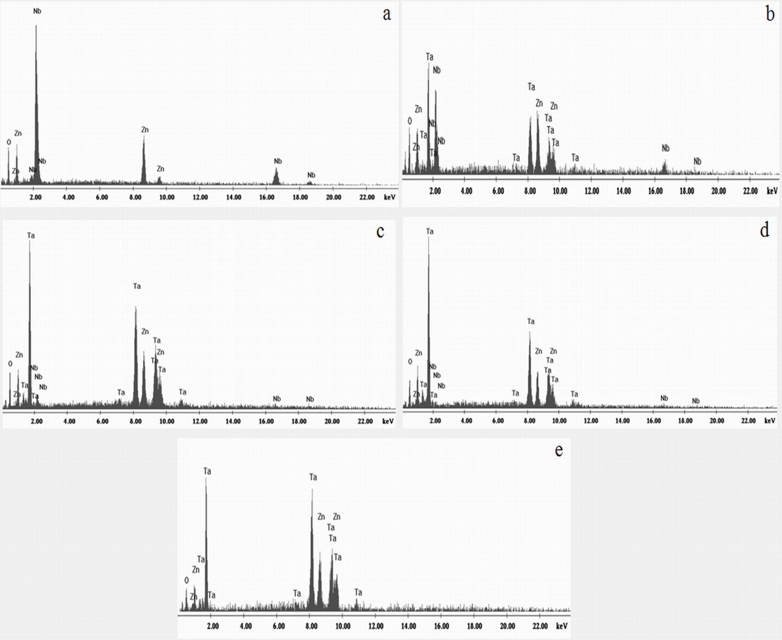
Fig. 1 The EDAX of: (a) ZnNb₂O₆, (b) Zn(Ta_{0.5}Nb_{0.5})₂O₆, (c) Zn(Ta_{0.9}Nb_{0.1})₂O₆, (d) Zn(Ta_{0.95}Nb_{0.05})₂O₆ and (e) ZnTa₂O₆

Optical properties
The diffuse reflectance spectra of the all nanomaterials in the UV-VIS region λ = 230-650 nm are represented in Figure 2.
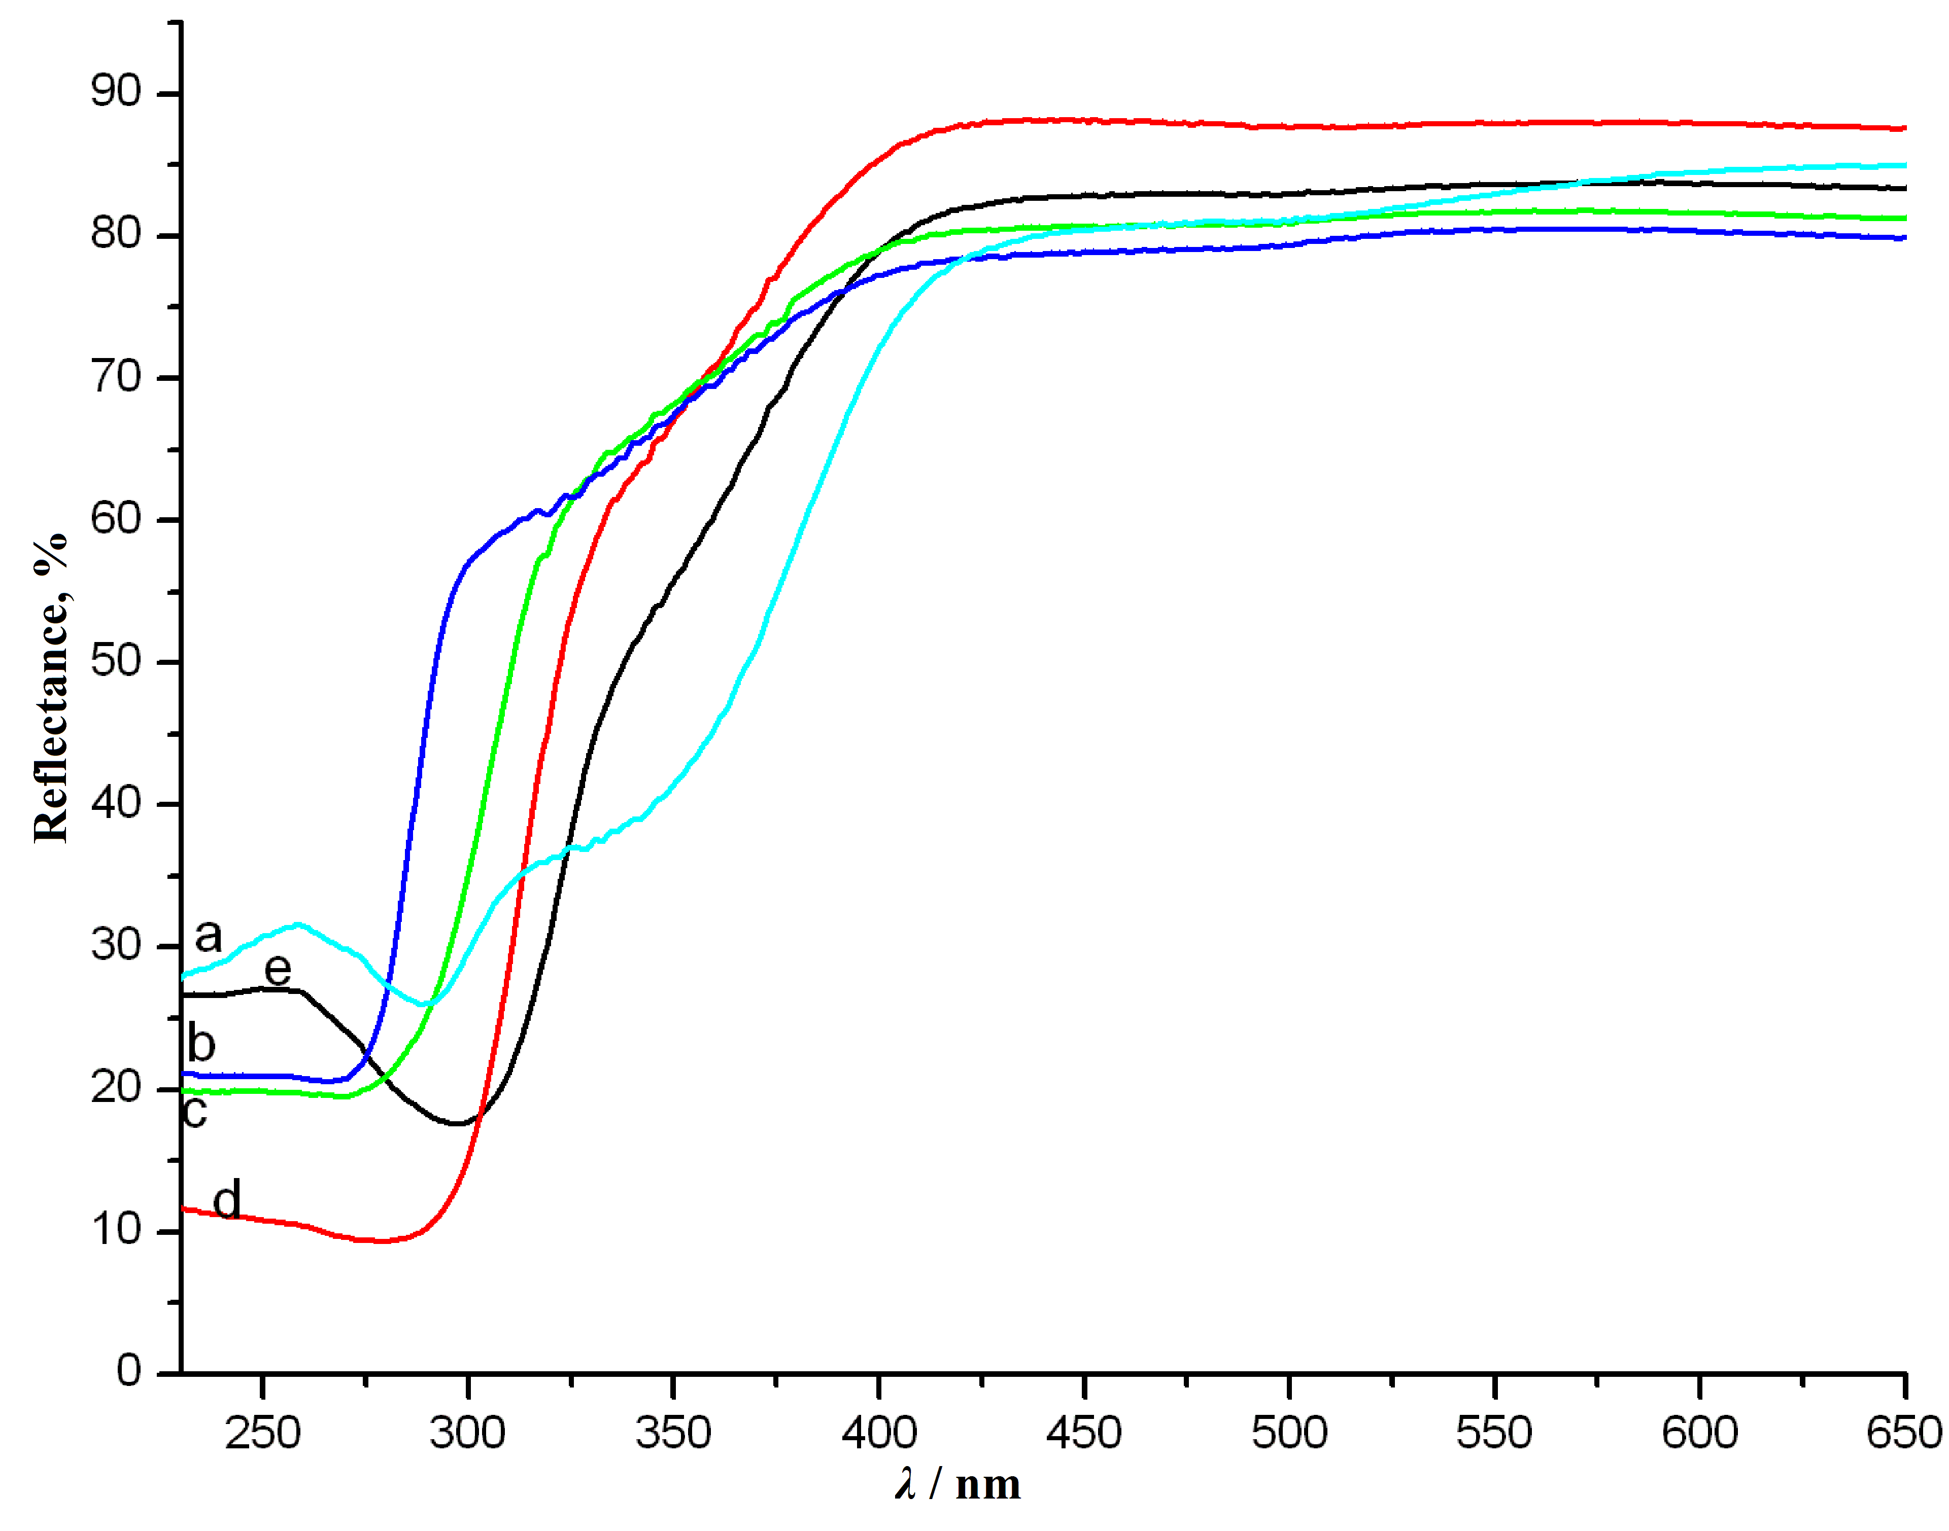
Fig.2 Diffuse reflectance spectra of: (a) ZnNb₂O₆, (b) ZnTa₂O₆, (c) Zn(Ta_{0.95}Nb_{0.05})₂O₆, (d) Zn(Ta_{0.9}Nb_{0.1})₂O₆ and (e) Zn(Ta_{0.5}Nb_{0.5})₂O₆

Open circuit potential (OCP)
OPC or free potential provides preliminary information on the nature of processes occurring at the interface of protective film/electrolyte. It is a qualitative indicator of the state of corrosion of a metal substrate in an electrolytic medium and it also helps to determine the immersion time required to establish the steady state. The OCP (U) versus time (t) measurements (Figure 3) were made in 0.1 M Na₂SO₄ electrolyte solution for 30 minutes.
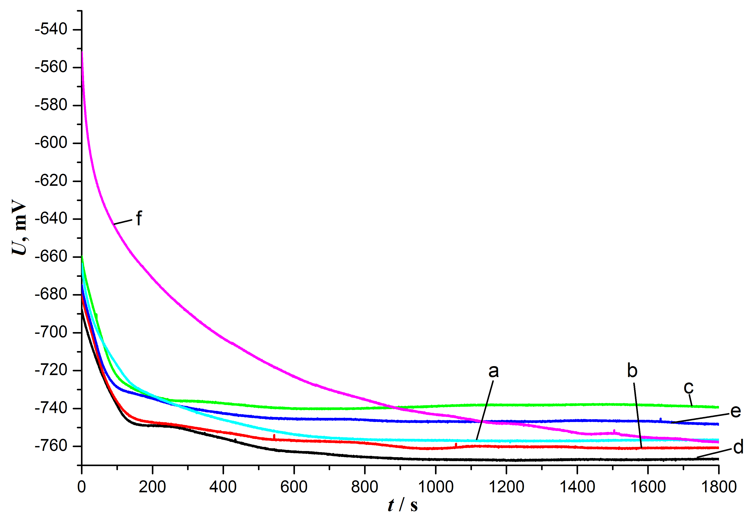
Fig. 3 Evolution of open circuit potential with time for investigated electrodes in
0.1M Na₂SO₄ electrolyte solution for: (a) ZnTa₂O_{6,} (b) Zn(Ta_{0.95}Nb_{0.05})₂O₆, (c) Zn(Ta_{0.9}Nb_{0.1})₂O₆, (d) Zn(Ta_{0.5}Nb_{0.5})₂O₆, (e) ZnNb₂O₆ and (f) OL

An initial analysis of these curves shows that in all cases, an exposure time of 30 minutes leads to a shift in free potential toward more negative values. Comparing the OCP profiles obtained for treated electrodes with the one obtained for the untreated electrode, it can be observed that the later shows a stronger decrease in potential until it reaches the same value as the ZnTa₂O₆, (after 30 minutes). The covered OL (abrubt decrease to the OPC) has a protective oxide film that improves its corrosion resistance. The uncovered OL reaches slower the stady-state. After 30 minutes exposure time, the free potential value of the ZnNb₂O₆ electrode shows the smallest decrease (∆_{OPC} = 73 mV) and that of the Zn(Ta_{0.9}Nb_{0.1})₂O₆ electrode is shifted toward more positive potentials, showing a different stability and protective behavior of the tested materials.

