SUPPLEMENTARY MATERIAL

Manuscript title: SPATIAL DISTRIBUTION OF PAHs IN RIVERBED SEDIMENTS OF THE DANUBE RIVER IN SERBIA: ANTHROPOGENIC AND NATURAL SOURCES

Authors: MAJA BRBORIĆ¹, BRANISLAV VRANA², JELENA RADONIĆ¹, MIRJANA VOJINOVIĆ MILORADOV¹, MAJA TURK SEKULIĆ^{1*}
Addresses:
¹University of Novi Sad, Faculty of Technical Sciences, Department of Environmental Engineering and Occupational Safety and Health, Novi Sad, Serbia
²Masaryk University, Faculty of Sciences, Research Centre for Toxic Compounds in the Environment RECETOX, Brno, Czech Republic
*Corresponding authors:
Maja Turk Sekulić, University of Novi Sad, Faculty of Technical Sciences, Department of Environmental Engineering and Occupational Safety and Health, Trg Dositeja Obradovića 6, 21000 Novi Sad, Serbia. Tel: +381(0)21 485 2498, e-mail: majaturk@uns.ac.rs.

Supporting Information:
Number of Tables: 5
Number of Figures: 8
Number of Pages: 11

Contents

SECTION S1 - Sediment sampling 2
SECTION S2 - Sample preparation and analysis 3

Experimental methodology 4
Fig. S1 Flowchart of the methodology applied for determining PAHs in the sediment of the Danube 5
Fig. S2 TOC content in sediments from the Danube, [%] 5
Fig. S3 Distribution of PAHs in the Danube sediment according to the number of rings 6
Fig. S4 LMW/HMW ratio for 29 PAHs detected in the Danube sediments 6
Fig. S5 The plot of the Phe/Ant values compared with the Flu/Pyr values 6
Fig. S6 PCA obtained by Varimax rotation for chosen PAHs in Danube riverbed sediments 7
Fig. S7 PCA Scores plot for (a) PAH profiles at studied sites and (b) PAHs (normalized data) 7
Fig. S8 HCA - dendrograms of 29 PAHs identified in sediments from 10 sites along the Danube associated with the previously defined PC1, PC2, and PC3 8

Table S1 The characteristics of sampling sites 8
Table S2 PAHs concentrations (μg/kg d.w.) in the sediment of Danube River, Serbia 9
Table S3 Different ratios and determine the source of PAHs in sediment 9
Table S4 Corresponding SQGs values for PAHs and relative percentage of samples amongst ranges of Sediment Quality Guidelines for Danube stations 10
Table S5 PAH compounds and their toxic equivalent factors (TEFs) 11

References 11

SECTION S1 - Sediment sampling

At each sampling point, six to eight subsamples of 1.0 to 1.5 kg were collected at 0–10 cm depth from the riverbed in a radius of 10 m and were included into a pooled sample. The samples were kept in vacuum sealed buckets (20 L in volume) and were transferred in appropriate cool boxes to the processing laboratory. No chemicals were used for preservation. The temperature of the samples during transport was maintained at 4 °C. Pre-treatment of the samples was included a wet sediment sieving (sieve of 2 mm) in order to remove leaves, stones, and roots (with local water). The sediments were well homogenized, and 50 g subsamples were collected in glass jars for freeze drying.

SECTION S2 - Sample preparation and analysis

Chemicals and Reagent

The organic solvents used during the Danube sediment analysis, dichloromethane, chloroform, and n-hexane, were supplied by Sigma-Aldrich, Czech Republic. Silica gel 60 was obtained from Merck, Czech Republic. Standards of 29 PAHs, (d8-naphthalene, d10-phenanthrene, d12-perylene) were obtained from Sigma-Aldrich, Czech Republic. For the GC/MS equipment, nitrogen and helium were used as the Electron capture detector (ECD) make-up gas, and as a carrier gas, respectively. Both were purchased from Messer Tatragas, Czech Republic. Terphenyl, the internal standard for instrumental analysis by GC/MS, was supplied by Sigma-Aldrich, Czech Republic.

Sediment analysis

About 7−8 g of the freeze-dried sediment samples of Danube river were spiked with 330 ng of surrogate recovery standards per sample (designated for PAH analysis). In addition to a set of 10 samples, blank and reference material were tested. Automated Soxhlet extraction of spiked sediment samples was performed using dichloromethane (DCM) (duration of 2 hours; Büchi B-811, Switzerland). Activated copper was added for desulfurization. For PAH analysis, 20% of the prepared sample was separated and was cleaned using activated silica, while the remaining 80% was exploited for analysis of other pollutants that are not subject of this paper. After a thorough cleaning, the sample volume was reduced to about 1.0−1.5 ml and transferred to hexane using azeotrope principle on Kuderna-Danish evaporation unit to a final 1 ml of extract in hexane. Extracts were quantitatively transferred to 2 ml GC-MS vials and the volume was reduced to approximately 1 ml. For the analysis of 29 PAHs Terphenyl (250 ng), an instrumental internal standard was added. Using a GC-MS systems (GC 7890/MS-MS Triple Quadrupole 7000B; Agilent) equipped with a J&W Scientific fused silica column DB-5MS (60 m × 25 µm × 0.25 µm), 29 PAHs (Nap, naphthalene; Acy, acenaphthylene; Ace, acenaphthene; Fl, fluorene; Phe, phenanthrene; Ant, anthracene; Flu, fluoranthene; Pyr, pyrene; B[a]A, benzo[a]anthracene; Chr, chrysene; B[b]Flu, benzo[b]fluoranthene; B[k]Flu, benzo[k]fluoranthene; B[a]P, benzo[a]pyrene; IP, indeno[1,2,3-cd]pyrene; DB[ah]A, dibenzo[ah]anthracene; B[ghi]P, benzo[ghi]perylene; Bip, Biphenyl; Ret, Retene; B[b]Fl, benzo[b]fluorene; Bnt, benzonaphtothiophene; B[ghi]Flu, benzo[ghi]fluoranthene; Cp[cd]P, cyclopenta[cd]pyrene; Tph, Triphenylene; B[j]Flu, benzo[j]fluoranthene; B[e]P, benzo[e]pyrene; Per, perylene; DB[ac]Ant, dibenzo[ac]anthracene; Anth, Anthanthrene; and Cor, Coronene) were quantified in all examine sediment samples.

Measurement of TOC in the sediments

The total organic carbon (TOC) was determined to apply a vario TOC Cube Manufacturer: Elementary Analysen Systeme, Germany. In preparation for TOC analyses, the samples were weighed into aluminium cups and acidified using a few drops of 6 mol/L HCl solution (1:1). The acidified samples were dried for one hour at 70 °C before packing and placing them into autosampler for analysis. Certified reference material sediment sample was analyzed in order to test the various TOC cube performance at 950 °C combustion temperature. The samples were decomposed by temperature on carbon dioxide, which was purified through a halogen trap and determined by Non-Dispersive Infrared (NDIR) photometer.

Experimental methodology
The chart shown in Figure S1 illustrate the workflow of the present study. The experimental methodology included acquiring basic information, implementation of analytical methods, processing of data for statistical analysis, as well as consideration of the consequences that PAHs could cause in aquatic systems.
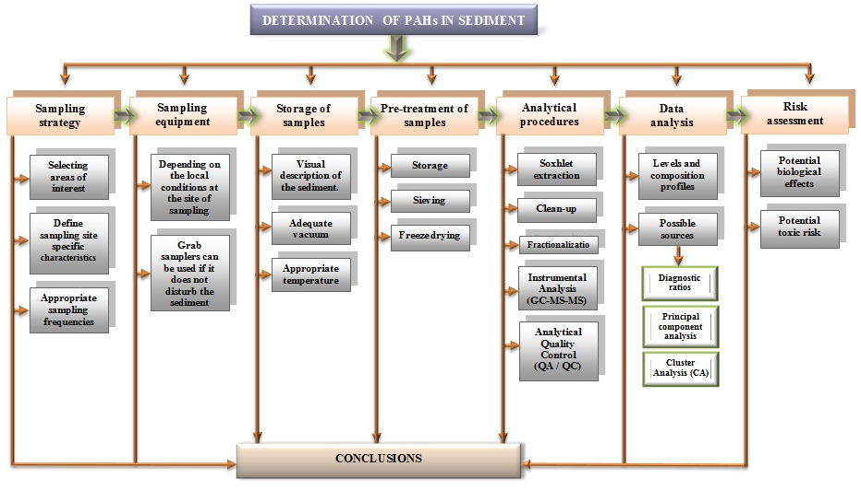

Fig. S1 Flowchart of the methodology applied for determining PAHs in the sediment of the Danube

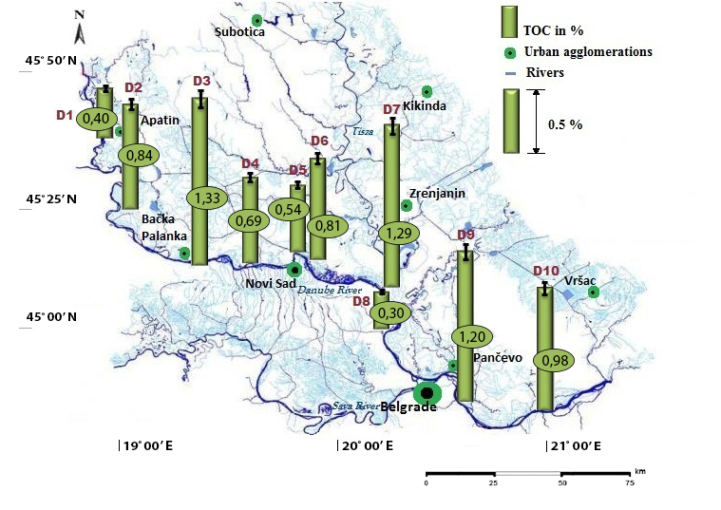

Fig. S2 TOC content in sediments from the Danube, [%]

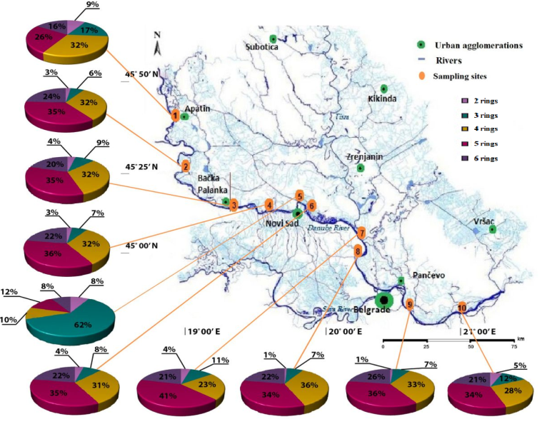

Fig. S3 Distribution of PAHs in the Danube sediment according to the number of rings

Fig. S4 LMW/HMW ratio for 29 PAHs detected in the Danube sediments

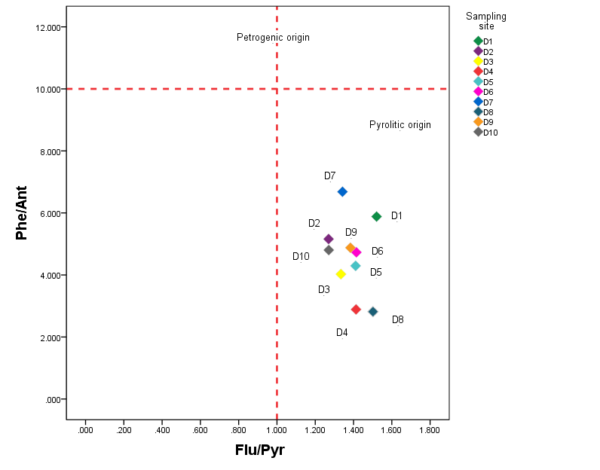

Fig. S5 The plot of the Phe/Ant values compared with the Flu/Pyr values

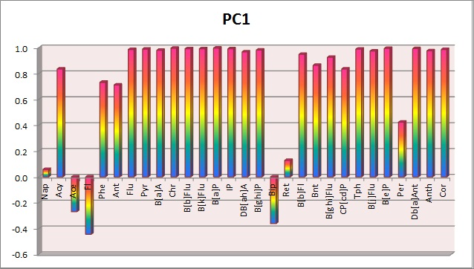
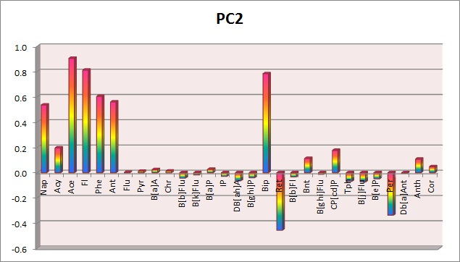
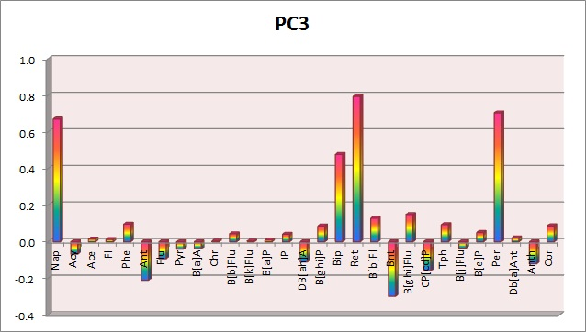

Fig. S6 PCA obtained by Varimax rotation for chosen PAHs in Danube riverbed sediments

a) 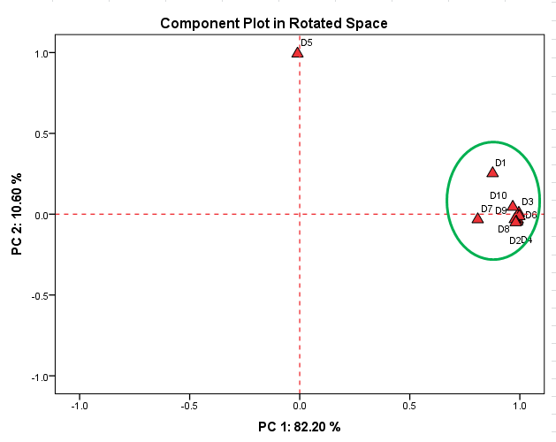 b)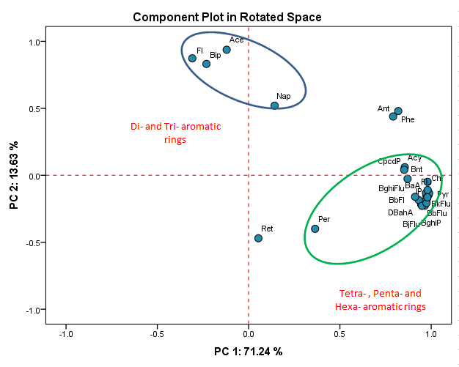

Fig. S7 PCA Scores plot for (a) PAH profiles at studied sites and (b) PAHs (normalized data)

a) 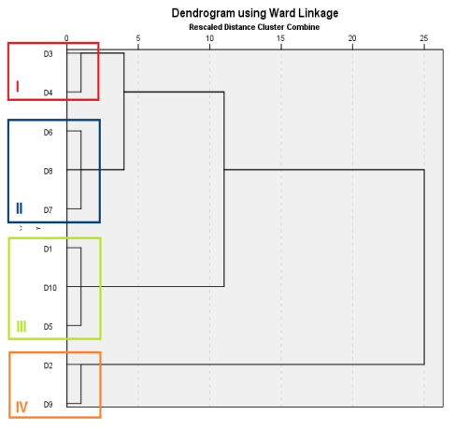 | b)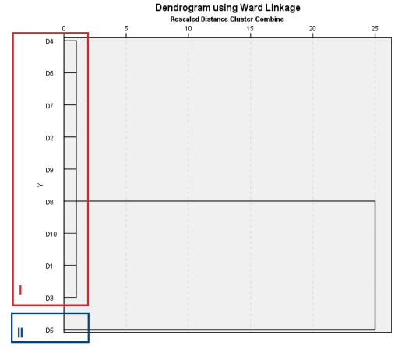 | c) 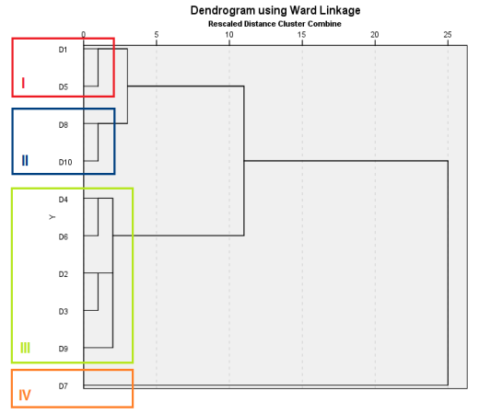

Fig. S8 HCA - dendrograms of 29 PAHs identified in sediments from 10 sites along the Danube associated with the previously defined PC1, PC2, and PC3

Table S1 The characteristics of sampling sites
Sample No. | Apatin | Labudnjača | Neštin | Begeč | Ratno ostrvo | Šangaj | Knićanin | Belegiš | Ritopek | Dubravica
 | D1 | D2 | D3 | D4 | D5 | D6 | D7 | D8 | D9 | D10
Latitude | 45˚40’12.59”N | 45˚25’12.63”N | 45˚13’50.25”N | 45˚13’54.20”N | 45˚15’48.02”N | 45˚14’08.33”N | 45˚07’40.34”N | 45˚00’34.70”N | 44˚44’39.99”N | 44˚42’49.35”N
Longitude | 18˚58’10.78”E | 19˚01’54.25”E | 19˚26’16.35”E | 19˚39’55.64”E | 19˚53’00.87”E | 19˚55’35.65”E | 20˚17’08.81”E | 20˚20’28.59”E | 20˚38’32.66”E | 21˚02’35.85”E
Elevation above sea level (m) | 81 | 77 | 107 | 76 | 75 | 72 | 71 | 68 | 134 | 68
Location characteristic | Urban zone- a residential area encircled by the industrial section, regional routes and “Danube river Goods-Transport Center”. | Rural/ industrial zone- area in the vicinity of the chemical industry. | Rural zone- an agricultural area encircled by local routes and residential buildings. | Rural/ industrial zone- a residential zone located in the vicinity of Beočin Cement Plants. | Urban/industrial zone- an area close to refinery and thermal power and heating plant. | Urban zone- an area surrounded by the industrial section, local and regional routes, and agricultural fields. | Rural/ industrial zone- the confluence of the Tisza into the Danube. | Rural/ industrial zone- area with developed agriculture. | Industrial zone- area in the vicinity of the chemical industry and refinery. | Rural/ industrial zone - area in the vicinity of plants for production of metal alloys (iron and steelmaking) and the confluence of the Velika Morava River into the Danube.

Table S2 PAHs concentrations (μg/kg d.w.) in the sediment of Danube River, Serbia
Sample No. | D1 | D2 | D3 | D4 | D5 | D6 | D7 | D8 | D9 | D10
Nap | 11.82 | 11.10 | 14.93 | 7.98 | 11.25 | 10.26 | 8.78 | 2.25 | 6.92 | 5.00
Acy | 0.88 | 1.54 | 1.29 | 1.68 | 0.65 | 0.75 | 0.97 | 0.46 | 3.80 | 0.69
Ace | 0.98 | 1.03 | 1.73 | 0.71 | 6.06 | 0.77 | 0.53 | 0.69 | 1.62 | 0.40
Fl | 6.00 | 3.81 | 5.01 | 2.49 | 88.37 | 2.66 | 2.86 | 1.42 | 3.35 | 1.87
Phe | 18.35 | 22.55 | 23.23 | 15.94 | 19.43 | 14.91 | 12.64 | 11.17 | 31.96 | 7.69
Ant | 3.12 | 4.37 | 5.77 | 5.52 | 4.52 | 3.15 | 1.89 | 3.97 | 6.55 | 1.60
Flu | 23.02 | 62.94 | 49.52 | 44.84 | 6.99 | 36.75 | 20.90 | 37.98 | 77.83 | 11.27
Pyr | 15.14 | 49.57 | 37.12 | 31.73 | 4.95 | 25.98 | 15.57 | 25.29 | 56.24 | 8.87
B[a]A | 7.00 | 24.37 | 24.18 | 23.19 | 2.47 | 14.92 | 8.28 | 12.73 | 32.32 | 5.47
Chr | 7.27 | 28.01 | 23.92 | 21.77 | 2.89 | 15.24 | 10.39 | 12.79 | 34.82 | 6.60
B[b]Flu | 11.21 | 48.90 | 39.31 | 35.07 | 5.86 | 28.93 | 20.37 | 23.74 | 54.29 | 12.21
B[k]Flu | 4.12 | 17.04 | 14.27 | 13.55 | 2.18 | 9.94 | 6.63 | 8.71 | 19.58 | 3.97
B[a]P | 9.45 | 42.72 | 33.91 | 32.97 | 4.20 | 22.65 | 15.17 | 19.27 | 51.67 | 6.15
IP | 15.16 | 74.16 | 50.68 | 51.40 | 8.59 | 40.01 | 29.43 | 31.89 | 80.58 | 15.60
DB[ah]A | 0.72 | 3.02 | 2.35 | 2.00 | 0.35 | 2.05 | 1.36 | 2.27 | 4.28 | 0.58
B[ghi]P | 10.49 | 51.96 | 32.98 | 31.67 | 6.31 | 26.57 | 22.51 | 20.61 | 54.67 | 11.51
Bip | 3.33 | 2.67 | 3.07 | 2.11 | 4.76 | 2.21 | 2.67 | 0.87 | 1.92 | 1.90
Ret | 1.35 | 2.97 | 3.69 | 2.43 | 0.89 | 4.13 | 8.84 | 0.72 | 3.27 | 2.85
B[b]Fl | 1.15 | 4.40 | 4.13 | 3.51 | 0.51 | 2.74 | 1.78 | 1.95 | 4.24 | 1.02
Bnt | 0.19 | 2.86 | 1.68 | 1.80 | 0.17 | 0.75 | 0.35 | 2.16 | 7.76 | 0.43
B[ghi]Flu | 1.46 | 7.24 | 4.68 | 3.83 | 0.69 | 3.25 | 2.20 | 2.17 | 5.57 | 1.52
CP[cd]P | 0.61 | 5.75 | 3.19 | 4.72 | 0.37 | 1.74 | 1.28 | 0.71 | 20.46 | 0.70
Tph | 1.95 | 8.18 | 5.91 | 5.68 | 0.94 | 4.55 | 3.99 | 3.46 | 9.20 | 2.25
B[j]Flu | 3.83 | 16.52 | 12.27 | 12.80 | 1.96 | 9.61 | 5.99 | 9.27 | 16.63 | 3.78
B[e]P | 8.40 | 35.58 | 27.50 | 26.74 | 4.20 | 20.25 | 16.05 | 16.65 | 40.78 | 8.89
Per | 4.12 | 17.34 | 16.66 | 11.75 | 2.78 | 12.77 | 38.46 | 6.70 | 21.01 | 3.95
DB[ac]Ant | 1.28 | 7.23 | 5.00 | 5.43 | 0.88 | 3.99 | 2.82 | 2.99 | 8.50 | 1.51
Anth | 1.00 | 6.45 | 5.72 | 5.07 | 0.77 | 3.55 | 1.73 | 4.03 | 10.75 | 0.00
Cor | 0.76 | 5.20 | 3.60 | 3.55 | 0.57 | 2.90 | 2.14 | 2.06 | 6.27 | 0.00
ΣPAHs | 174.16 | 569.47 | 457.32 | 411.96 | 194.55 | 327.98 | 266.56 | 268.94 | 676.85 | 128.27
Range | 0.19-23.02 | 1.03-74.16 | 1.29-50.68 | 0.71-51.40 | 0.17-88.37 | 0.75-40.01 | 0.35-38.46 | 0.46-37.98 | 1.62-80.58 | nd-15.60
Mean | 2.31 | 1.65 | 2.97 | 3.60 | 4.20 | 8.43 | 18.67 | 12.33 | 3.60 | 3.55
SD | 6.09 | 20.84 | 15.27 | 14.47 | 16.23 | 11.41 | 9.67 | 10.32 | 23.57 | 4.28
TOC (%) | 0.40 | 0.84 | 1.33 | 0.69 | 0.54 | 0.81 | 1.29 | 0.30 | 1.20 | 0.98

Table S3 Different ratios and determine the source of PAHs in sediment
RATIOS |  | RANGE |  | D1 | D2 | D3 | D4 | D5 | D6 | D7 | D8 | D9 | D10
LMW/HMW | Pyrol. |  | <1 | - | 0.77 | 0.93 | 0.81 | - | 0.83 | 0.74 | 0.88 | 0.84 | 0.84
 | Petrog. |  | >1 | 1.57 | - | - | - | 4.66 | - | - | - | - | -
Phe/Ant | Pyrol. |  | <10 | 5.88 | 5.16 | 4.03 | 2.89 | 4.29 | 4.73 | 6.68 | 2.82 | 4.88 | 4.8
 | Petrog. |  | >10 | - | - | - | - | - | - | - | - | - | -
Flu/Pyr | Pyrol. |  | >1 | 1.52 | 1.27 | 1.33 | 1.41 | 1.41 | 1.41 | 1.34 | 1.5 | 1.38 | 1.27
 | Petrog. |  | <1 | - | - | - | - | - | - | - | - | - | -
Fl/Fl+Pyr | Pyrol. |  | >0.5 | 0.6 | 0.56 | 0.57 | 0.59 | 0.59 | 0.59 | 0.57 | 0.6 | 0.58 | 0.56
 | Combustion products of liquid fuel and oil |  | 0.5-0.4 | - | - | - | - | - | - | - | - | - | -
 | Petrog. |  | <0.4 | - | - | - | - | - | - | - | - | - | -
Ant/178 | Pyrol. |  | < 0.1 | 0.15 | 0.16 | 0.20 | 0.26 | 0.19 | 0.17 | 0.13 | 0.26 | 0.17 | 0.17
 | Petrog. |  | > 0.1 | - | - | - | - | - | - | - | - | - | -
B(a)A / 228 | Pyrol. |  | >0.35 | 0.49 | 0.47 | 0.50 | 0.52 | 0.46 | 0.49 | 0.44 | 0.50 | 0.48 | 0.45
 | Mixed |  | 0.2-0.35 | - | - | - | - | - | - | - | - | - | -
 | Petrog. |  | <0.2 | - | - | - | - | - | - | - | - | - | -
IP/IP + B(ghi)P | Pyrol. (grass, wood and coal combustion) |  | >0.5 | 0.59 | 0.59 | 0.61 | 0.62 | 0.58 | 0.60 | 0.57 | 0.61 | 0.60 | 0.58
 | Fossil fuel combustion |  | 0.2-0.5 | - | - | - | - | - | - | - | - | - | -
 | Petrog. |  | <0.2 | - | - | - | - | - | - | - | - | - | -
Total PAHs index |  |  |  | 6.01 | 6.06 | 6.55 | 7.23 | 6.33 | 6.31 | 5.66 | 7.26 | 6.23 | 6.09
Origin of PAHs in this study |  |  |  | Pyrolytic/ petrogenic | Pyrolytic | Pyrolytic | Pyrolytic | Pyrolytic/ petrogenic | Pyrolytic | Pyrolytic | Pyrolytic | Pyrolytic | Pyrolytic

Table S4 Corresponding SQGs values for PAHs and relative percentage of samples amongst ranges of Sediment Quality Guidelines for Danube stations
Compound | SQGª ERL^{b}–ERM^{c} (ng/g d.w.) | No. of stations^{h} |  |  | SQGª TEL^{d}–PELe (ng/g d.w.) | No. of stations^{h}
 |  | <ERL | ERL–ERM | >ERM |  | <ТEL | ТEL –PEL | > PEL
Nap | 340–2100 | D3 | - | - | 35–391 | D3 | - | -
Acy | 44–640 | D9 | - | - | 6–128 | D9 | - | -
Ace | 16–500 | D5 | - | - | 7–89 | D5 | - | -
Fl | 35–640 | D1 | D5 | - | 21–144 | D1 | D5 | -
Phe | 225–1380 | D9 | - | - | 42-515 | D9 | - | -
Ant | 85–960 | D9 | - | - | 47–245 | D9 | - | -
Flu | 600–3600 | D9 | - | - | 111–2355 | D9 | - | -
Pyr | 350–2200 | D9 | - | - | 53–875 | D9 | - | -
B[a]A | 230–1600 | D9 | - | - | 75–693 | D9 | - | -
Chr | 400–2800 | D9 | - | - | 57–862 | D9 | - | -
B[b + k]Fl | – | - | - | - | - | - | - | -
B[a]P | 400–2500 | D9 | - | - | 32–782 | D9 | - | -
IP | – | - | - | - | - | - | - | -
DB[ah]A | 63–260 | D9 | - | - | 6–135 | D9 | - | -
B[ghi]P | – | - | - | - | - | - | - | -
∑₁₆PAHs | 4000–35000 | D9 | - | - | 655–6676 | D2 | D9 | -
LMW PAHs^{f} | 552-3160 | D9 | - | - | - | - | - | -
HMW PAHs^{g} | 1700- 9600 | D9 | - | - | - | - | - | -
ª SQG values taken from MacDonald et al. (2000) and MacDonald et al. (1996).
^{b} ERL = effects range-low value
^{c} ERM = effects range-median value
^{d} TEL= threshold effects level
^{e} PEL= probable effects level
^{f} LMW PAHs = the sum of the concentrations of low-molecular-weight PAHs
^{g}HMW PAHs = the sum of the concentrations of high-molecular-weight PAHs
^{h} Sampling point that has the highest value, ie. value that is closest to prescribed values of SQG sets.

Table S5 PAH compounds and their toxic equivalent factors (TEFs) (Tsai et al., 2004; Tsymbalyuk et al., 2011; US EPA, 1993)
PAH compound | TEFs used in this study | PAH compound | TEFs used in this study
Naphthalene (Nap) | 0.001 | Benzo(b)fluoranthene (B[b]Flu) | 0.1
Acenaphthylene (Acy) | 0.001 | Benzo(k)fluoranthene (B[k]Flu) | 0.1
Acenaphthene (Ace) | 0.001 | Benzo(a)pyearene (B[a]P) | 1
Fluorene (Fl) | 0.001 | Indeno pyearene (IP) | 0.1
Phenanthrene (Phe) | 0.001 | Dibenzo(a,h)anthracene (DB[ah]A) | 1
Anthracene (Ant) | 0.01 | Benzo(ghi)perylene (B[ghi]P) | 0.01
Fluoranthene (Flu) | 0.001 | Cyclopenta(cd)pyrene (Cp[cd]P) | 0.1
Pyrene (Pyr) | 0.001 | Benzo(e)pyearene (B[e]P) | 0.01
Benzo(a)anthracene (B[a]A) | 0.1 | Perylene (Per) | 0.001
Chrysene (Chr) | 0.01 | Coronene (Cor) | 0.001

References
MacDonald DD, Carr RS, Calder FD, Long ER, Ingersoll CG (1996) Development and evaluation of sediment quality guidelines for Florida coastal waters. Ecotoxicology 5:253–278.
Tsai PJ, Shih TS, Chen HL, Lee WJ, Laid CH, Liou SH (2004) Assessing and predicting the exposures of polycyclic aromatic hydrocarbons (PAHs) and their carcinogenic potencies from vehicle engine exhausts to highway toll station workers. Atmospheric Environment 38:333–343.
Tsymbalyuk K, Den’ga Y, Berlinsky N, Antonovich V (2011) Determination of 16 priority polycyclic aromatic hydrocarbons in bottom sediments of the Danube estuarine coast by GC/MS. Geo-Eco-Marina 17:67-72.
US EPA (1993) Provisional Guidance for Quantitative Risk Assessment of Polycyclic Aromatic Hydrocarbons, EPA/600/R-93/089. Washington, DC: Office of Research and Development, US Environment Protection Agency.

