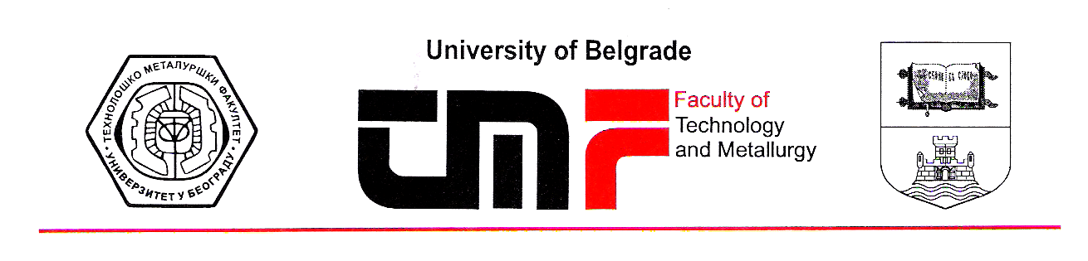
Belgrade, 09.07.2019.
Dear Editor,

Please find a paper entitled “Characteristics of the citrate based zinc-polyaniline secondary cell with supercapattery behavior” by B.N. Grgur, M.M. Gvozdenović, B.Z. Jugović, T.Lj. Trišović, which is submitted for consideration and possible publication in Journal of The Serbian Chemical Society for the issue dedicated to the prof. Konstantin I. Popov

The paper is original; it is not published previously and is not considered for publication elsewhere. The conflict of any kind of interest does not exist. Paper is prepared according to the journal Authors guidelines If accepted, the article or parts of the article will not be published elsewhere in the same form, in any language, without the written consent of the publisher.

Sincerely yours,


Professor Branimir N. Grgur
Faculty of Technology and Metallurgy
Department of Physical chemistry and electrochemistry
University of Belgrade
Karnegijeva 4
11020 Belgrade, Serbia
Phone/fax: +381 11 3303681
E-mail: BNGrgur@tmf.bg.ac.rs

Possible reviewers

Dr. Uroš Lačnjevac,
University of Belgrade, Institute for Multidisciplinary Research, Belgrade, Serbia
E-mail: uros.lacnjevac@imsi.bg.ac.rs

Dr. Maja Obradović,
Institute of Chemistry, Technology and Metallurgy, University of Belgrade
E-mail: obradovic@ihtm.bg.ac.rs

Prof. Dr. Vladimir Jović,
University of Belgrade, Institute for Multidisciplinary Research, Belgrade, Serbia
E-mail: vladajovic@imsi.bg.ac.rs

