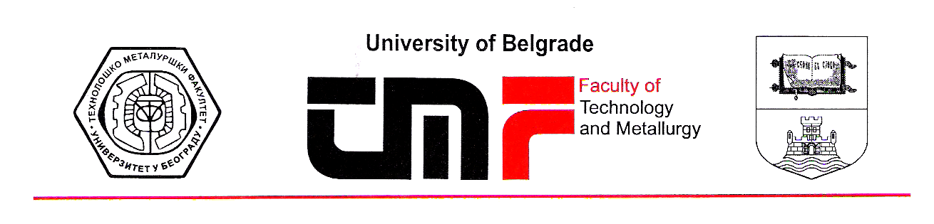
Belgrade, 19.07.2019.
Dear Editor,

Please find a revised paper entitled “Characteristics of the citrate based zinc-polyaniline secondary cell with supercapattery behavior” by B.N. Grgur, M.M. Gvozdenović, B.Z. Jugović, T.Lj. Trišović, which is submitted for possible publication in Journal of The Serbian Chemical Society for the issue dedicated to the prof. Konstantin I. Popov

We accepted all the Reviewer comments (highlighted in yellow).

Sincerely yours,


Professor Branimir N. Grgur
Faculty of Technology and Metallurgy
Department of Physical chemistry and electrochemistry
University of Belgrade
Karnegijeva 4
11020 Belgrade, Serbia
Phone/fax: +381 11 3303681
E-mail: BNGrgur@tmf.bg.ac.rs

