Binuclear copper(II) complexes: synthesis, structural characterization, DNA binding and *in silico* studies

Supplementary material





**Scheme S1.** Synthesis of complex 1

 **Scheme S2.** Synthesis of complex 2

Table S1. Crystal data and structure refinement parameters for complexes

|  |  |  |
| --- | --- | --- |
| Parameter | **1** | **2** |
| Empirical formula | C56H40Br4Cu2N4O8 | C56H40Br4Cu2N4O8 |
| Formula weight, g mol−1 | 1139.48 | 1343.64 |
| Temperature, K | 296(2) | 296(2) |
| Wavelength, Å | 0.71073 | 0.71073 |
| Crystal system | Triclinic | Monoclinic |
| Space group | P -1 | C 2/c |
| Unit cell dimensions |  |  |
| *a* / Å | 8.3934(8) | 29.194(3) |
| *b* / Å | 10.5368(9) | 10.9925(6) |
| *c* / Å | 12.8600(13) | 20.352(2) |
| *α* / ° | 89.424(3) | 90 |
| *β* / ° | 73.408(2) | 130.365(2) |
| *γ* / ° | 72.498(3) | 90 |
| Volume, Å3 | 1035.94(17) | 4976.4(8) |
| Z | 2 | 4 |
| Density (calculated), Mg/m3 | 1.827 | 1.793 |
| Absorption coefficient, mm-1 | 5.038 | 4.129 |
| F(000) | 562 | 2664 |
| Crystal size (mm3) | 0.44 × 0.32 × 0.28 | 0.38 × 0.18 × 0.16 |
| *θ* range for data collection (°) | 2.515 to 27.946 | 2.627 to 27.960 |
| Index ranges | -11 ≤ h ≤ 11  -12 ≤ k ≤ 13  -14 ≤ l ≤ 16 | -38 ≤ h ≤ 36  -14 ≤ k ≤ 11  -21 ≤ l ≤ 26 |
| Reflections collected | 11991 | 16671 |
| Independent reflections | 4912 [R(int) = 0.0465] | 5914 [R(int) = 0.0425] |
| Completeness to θ (%) | 99.4 | 99.6 |
| Refinement method | Full-matrix LS on F2 | Full-matrix LS on F2 |
| Data / restraints / parameters | 4912/ 0 / 246 | 5914/ 0 / 334 |
| Goodness-of-fit on F2 | 1.040 | 1.024 |
| Final R indices [I>2sigma(I)] | R1 = 0.0440, wR2 = 0.1087 | R1 = 0.0355, wR2 = 0.0801 |
| R indices (all data) | R1 =0.0664, wR2 = 0.1207 | R1 =0.0612, wR2 = 0.0886 |

Table S2: selected bond lengths and angles of complexes

|  |  |  |
| --- | --- | --- |
| Complex | **1** | **2** |
|  | Distances, Å | |
| Cu(1)-O(1) | 1.976(2) | 1.9298(17) |
| Cu(1)-O(2) | 1.967(2) | --- |
| Cu(1)-O(3) | 1.961(2) | 1.9547(17) |
| Cu(1)-O(4) | 1.959(2) | --- |
| Cu(1)-O(5) | 2.153(2) | --- |
| Cu(1)-N(1) | --- | 2.037(2) |
| Cu(1)-N(2) | --- | 2.037(2) |
|  | Angles, ° | |
| O(1)-Cu(1)-O(2) | 167.80(9) | --- |
| O(1)-Cu(1)-O(3) | 90.15(11) | 95.96(8) |
| O(1)-Cu(1)-N(2) | --- | 89.71(8) |
| O(3)-Cu(1)-N(2) | --- | 168.35(8) |
| O(1)-Cu(1)-N(1) | --- | 169.12(8) |
| O(3)-Cu(1)-N(1) | --- | 94.50(8) |
| N(2)-Cu(1)-N(1) | --- | 80.53(8) |
| O(1)-Cu(1)-O(4) | 88.69(11) | --- |
| O(3)-Cu(1)-O(4) | 167.91(9) | --- |
| O(2)-Cu(1)-O(4) | 89.50(11) | --- |
| O(2)-Cu(1)-O(3) | 89.10(11) | --- |
| O(5)-Cu(1)-O(3) | 94.04(10) | --- |
| O(5)-Cu(1)-O(4) | 98.03(10) | --- |
| O(5)-Cu(1)-O(1) | 98.93(10) | --- |
| O(5)-Cu(1)-O(2) | 93.27(10) | --- |

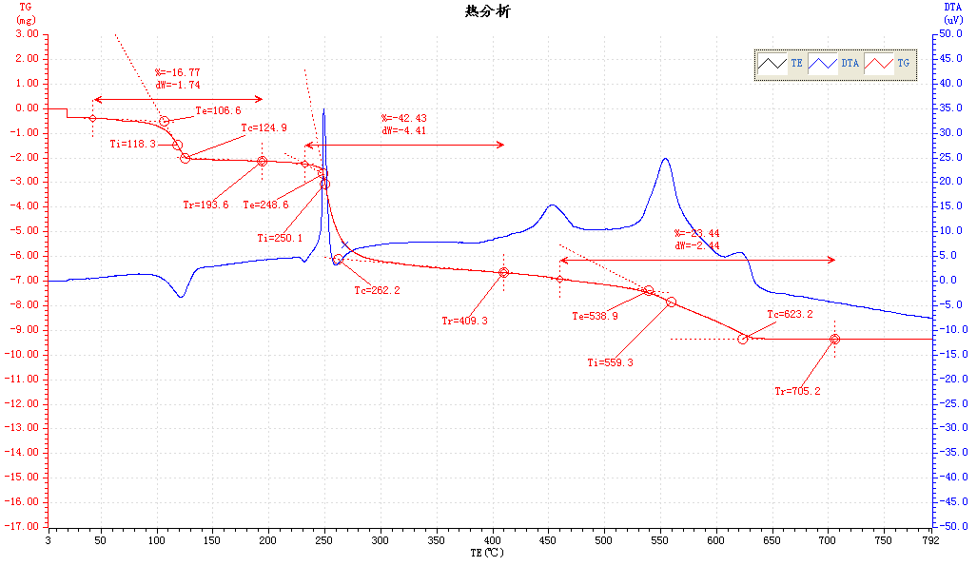Figure S1: TG curve of complex 1

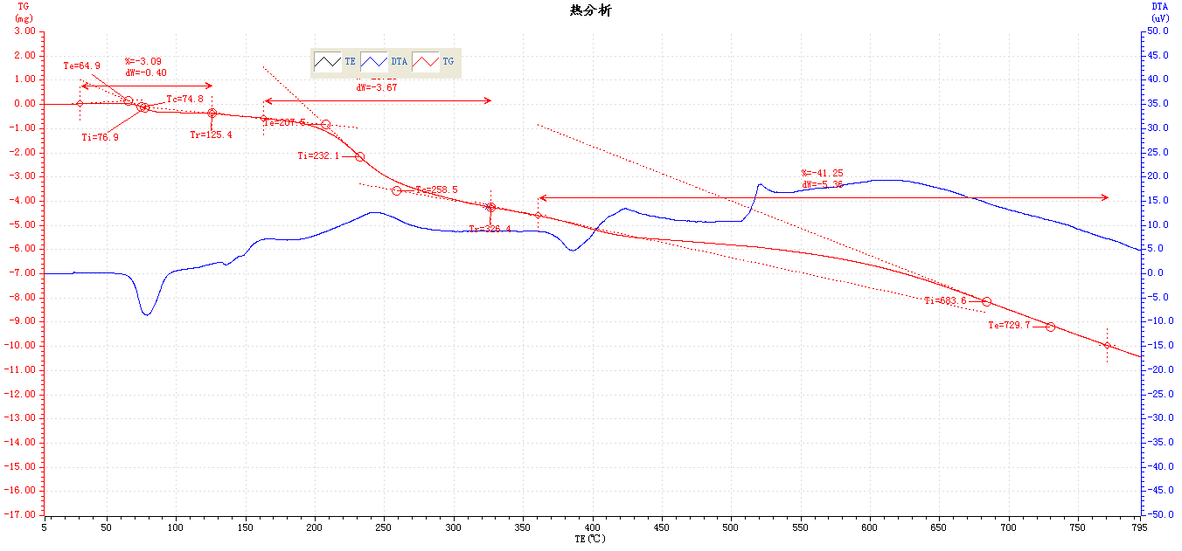

Figure S2: TG curve of complex 2