Binuclear copper(II) complexes: synthesis, structural characterization, DNA binding and in silico studies
Supplementary material
Scheme S1. Synthesis of complex 1

Scheme S2. Synthesis of complex 2

Table S1. Crystal data and structure refinement parameters for complexes
Parameter | 1 | 2
Empirical formula | C₅₆H₄₀Br₄Cu₂N₄O₈ | C₅₆H₄₀Br₄Cu₂N₄O₈
Formula weight, g mol⁻¹ | 1139.48 | 1343.64
Temperature, K | 296(2) | 296(2)
Wavelength, Å | 0.71073 | 0.71073
Crystal system | Triclinic | Monoclinic
Space group | P -1 | C 2/c
Unit cell dimensions
a / Å | 8.3934(8) | 29.194(3)
b / Å | 10.5368(9) | 10.9925(6)
c / Å | 12.8600(13) | 20.352(2)
α / ° | 89.424(3) | 90
β / ° | 73.408(2) | 130.365(2)
γ / ° | 72.498(3) | 90
Volume, Å³ | 1035.94(17) | 4976.4(8)
Z | 2 | 4
Density (calculated), Mg/m3 | 1.827 | 1.793
Absorption coefficient, mm-1 | 5.038 | 4.129
F(000) | 562 | 2664
Crystal size (mm3) | 0.44 × 0.32 × 0.28 | 0.38 × 0.18 × 0.16
θ range for data collection (°) | 2.515 to 27.946 | 2.627 to 27.960
Index ranges | -11 ≤ h ≤ 11  -12 ≤ k ≤ 13  -14 ≤ l ≤ 16 | -38 ≤ h ≤ 36  -14 ≤ k ≤ 11  -21 ≤ l ≤ 26
Reflections collected | 11991 | 16671
Independent reflections | 4912 [R(int) = 0.0465] | 5914 [R(int) = 0.0425]
Completeness to θ (%) | 99.4 | 99.6
Refinement method | Full-matrix LS on F2 | Full-matrix LS on F2
Data / restraints / parameters | 4912/ 0 / 246 | 5914/ 0 / 334
Goodness-of-fit on F2 | 1.040 | 1.024
Final R indices [I>2sigma(I)] | R1 = 0.0440, wR2 = 0.1087 | R1 = 0.0355, wR2 = 0.0801
R indices (all data) | R1 =0.0664, wR2 = 0.1207 | R1 =0.0612, wR2 = 0.0886

Table S2: selected bond lengths and angles of complexes
Complex | 1 | 2
 | Distances, Å
Cu(1)-O(1) | 1.976(2) | 1.9298(17)
Cu(1)-O(2) | 1.967(2) | ---
Cu(1)-O(3) | 1.961(2) | 1.9547(17)
Cu(1)-O(4) | 1.959(2) | ---
Cu(1)-O(5) | 2.153(2) | ---
Cu(1)-N(1) | --- | 2.037(2)
Cu(1)-N(2) | --- | 2.037(2)
 | Angles, °
O(1)-Cu(1)-O(2) | 167.80(9) | ---
O(1)-Cu(1)-O(3) | 90.15(11) | 95.96(8)
O(1)-Cu(1)-N(2) | --- | 89.71(8)
O(3)-Cu(1)-N(2) | --- | 168.35(8)
O(1)-Cu(1)-N(1) | --- | 169.12(8)
O(3)-Cu(1)-N(1) | --- | 94.50(8)
N(2)-Cu(1)-N(1) | --- | 80.53(8)
O(1)-Cu(1)-O(4) | 88.69(11) | ---
O(3)-Cu(1)-O(4) | 167.91(9) | ---
O(2)-Cu(1)-O(4) | 89.50(11) | ---
O(2)-Cu(1)-O(3) | 89.10(11) | ---
O(5)-Cu(1)-O(3) | 94.04(10) | ---
O(5)-Cu(1)-O(4) | 98.03(10) | ---
O(5)-Cu(1)-O(1) | 98.93(10) | ---
O(5)-Cu(1)-O(2) | 93.27(10) | ---

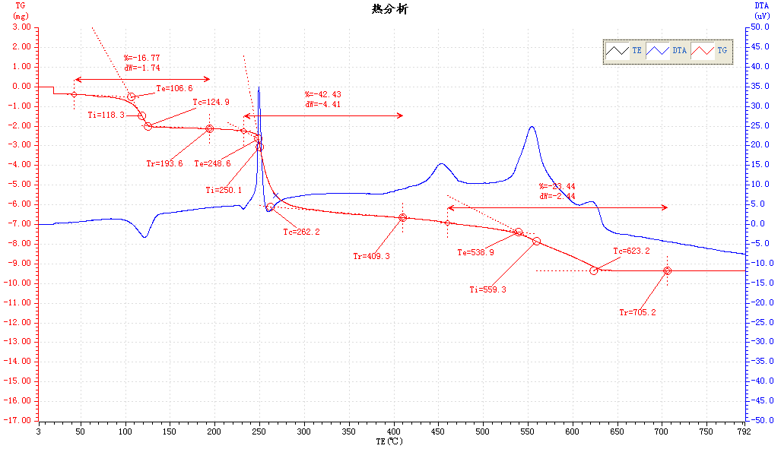
Figure S1: TG curve of complex 1

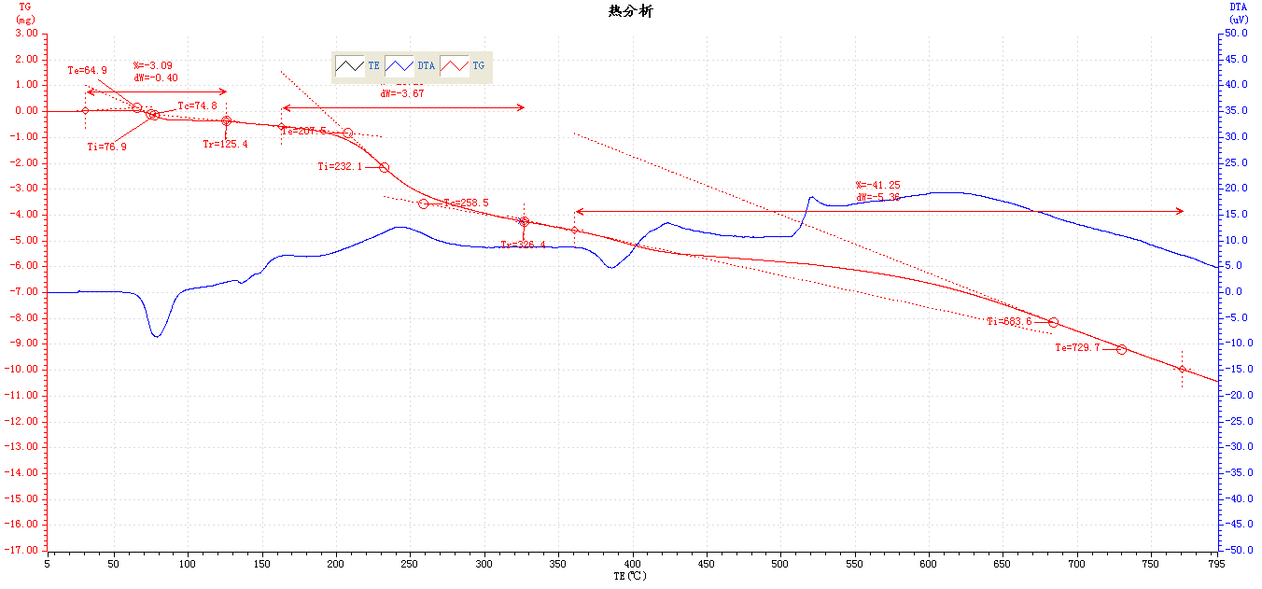
Figure S2: TG curve of complex 2

