To the editor of
Journal of the Serbian Chemical Society

Subject: Submission of the revised article for Journal of the Serbian Chemical Society

Dear Ladies and Gentlemen,

please find enclosed the revised manuscript for an article in the Journal of the Serbian Chemical Society:

“Fenton process combined with precipitation for the removal of Direct Blue 1 dye: A new approach” by Isabel Espinoza, Christian Sandoval Pauker, Luis Ramos Guerrero, Paul Vargas Jentzsch, Florinella Muñoz Bisesti

First of all, we like to thank the reviewers for the helpful comments.

We carefully considered all comments and changed the corresponding paragraphs in the text and answered the reviewer's comments. Please find below the answers to the reviewer’s comments.

Yours Sincerely,

Dr. P. Vargas Jentzsch

Concerning Reviewer A:

Whole of the manuscript should be revised for correction of the typesetting/grammatically wrong word etc. For instance, line 55: CO2, H2O and line 198: SO3.

Response: We acknowledge the reviewer's comments which contribute to improving the manuscript. The manuscript was revised to correct these details.

Line 143: spectrochemically measuring of the removal of the dye may not be adequate to claim the removal so that any bond break of the dye molecule directly contribute the percent of the removal. However, TOC, COD, etc, removal show the real removal values of the related compound. Thus, I recommend taking below given paper as an example and cite it, too, for TOC removal process. This paper is also related to the degradation of an azo dye, as the author mentioned azo dyes in line 53 with reference 8,9.(The paper given below should be cited along with references 8,9 in line 53). https://doi.org/10.1080/1093 4529.2019.1647749

Response: We appreciate the comment and concern of the reviewer. We have incorporated the citation as suggested by the reviewer.

Original text (page 2, line 53):

for the treatment of water that contains this kind of pollutants. ^{8,9}

Modified text (page 2, line 53):

for the treatment of water that contains this kind of pollutants. ^{8–10}

Accordingly, the references section was updated:

10. E. Yabalak, B. Külekçi, A. M. Gizir, J. Environ. Sci. Heal. Part A (2019) (https://doi.org/10.1080/10934529.2019.1647749)

The reviewer is right. Ideally, the goal of advanced oxidation processes is the total mineralization of the pollutants, i.e., the transformation of pollutants to the most stable inorganic species (CO₂, H₂O, NO₃⁻, etc.). The best parameter to evaluate the mineralization of the pollutant is the content of total organic carbon (TOC) before and after the treatment, then the difference in the content of TOC represents the mineralization. In this work, we have focused on the decolorization of the DB1 solution because this is kind of a first goal in the decontamination of an effluent containing dyes. Certainly, the simple decolorization of the aqueous solution not necessarily implies that the mineralization of the dye was achieved since degradation byproducts can still be present in the solution. However, we intended to demonstrate that the combination of Fenton (a chemical process that can lead in the formation of byproducts) and precipitation (a process that, actually, can remove the dye from the solution) can decolorate the DB1 solution with less iron than sole Fenton or precipitation.

Taking into account the mentioned aspects, we have incorporated some changes in the text. In many parts of the document was specified that the decolorization of the DB1 solution was achieved, thus making a differentiation among the terms “removal” and “decolorization”.

Concerning Reviewer B:

Minor corrections are needed. Instead of Fig 1 more properly is to write Fig.1. This suggestion is for the whole manuscript.

Response: Thank you for the remark. The whole manuscript was revised to include this observation.

Concerning Reviewer C:

Please see the file with suggestions and comments

Response: We appreciate the comments of the reviewer. The manuscript was revised, and the following changes were included.

- Keywords were corrected as suggested

Original text (page 1, lines 26 - 27):

Keywords: Advanced oxidation processes; azo dyes; degradation of dyes; precipitation of dyes, hydrogen peroxide, ferrous sulfate.

Modified text (page 1, lines 27 - 28):

Keywords: Advanced oxidation processes; azo dyes; degradation of dyes; hydrogen peroxide, ferrous sulfate.

- References 6, 7, 17 and 18 were updated.

Original references

6. E. Guivarch, S. Trevin, C. Lahitte, M. A. Oturan, Environ. Chem. Lett. 1 (2003) 38 (https://doi.org/10.1007/s10311-002-0017-0)
7. P. K. Malik, S. K. Saha, Sep. Purif. Technol. 31 (2003) 241 (https://doi.org/10.1016/S1383-5866(02)00200-9)
17. F. I. Hai, K. Yamamoto, K. Fukushi, Crit. Rev. Environ. Sci. Technol. 37 (2007) 315 (https://doi.org/10.1080/10643380601174723)
18. I. Oller, S. Malato, J. A. A. Sánchez-Pérez, Sci. Total Environ. 409 (2011) 4141 (https://doi.org/10.1016/j.scitotenv.2010.08.061)

Updated references (The numbering of references 17 and 18 changed because of the addition of other references)

6. Z. Liu, L. Zhang, F. Dong, J. Dang, K. Wang, D. Wu, J. Zhang, J. Fang, ACS Appl. Nano Mater. 1 (2018) 4170 (https://doi.org/10.1021/acsanm.8b00930)
7. H. T. Van, L. H. Nguyen, T. K. Hoang, T. P. Tran, A. T. Vo, T. T. Pham, X. C. Nguyen, Sep. Purif. Technol. 224 (2019) 431 (https://doi.org/10.1016/j.seppur.2019.05.048)
19. S. O. Ganiyu, E. D. Van Hullebusch, M. Cretin, G. Esposito, M. A. Oturan, Sep. Purif. Technol. 156 (2015) 891 (https://doi.org/10.1016/j.seppur.2015.09.059)
20. B. K. Shanmugam, S. N. Easwaran, A. S. Mohanakrishnan, C. Kalyanaraman, S. Mahadevan, J. Environ. Manage. 242 (2019) 106 (https://doi.org/10.1016/j.jenvman.2019.04.075)

- Some grammatical and typographical errors were revised through the text.

- Some data about the costs of Fenton treatments were provided in the introduction section as suggested.

Original text (page 2, lines 63 - 64):

However, its industrial application in some cases could be difficult due to the relatively high costs of the treatment. ^{1,16}

Modified text (page 3, lines 63 - 66):

However, its industrial application in some cases could be difficult due to the relatively high costs of the treatment. ^{1,17} For instance, Santiago et al. (2018) reported a price of 2.06 €/m³. From this, more than 60% of the operational costs were attributed to Fenton treatment. ¹⁸

The following reference was added to the reference list

18. D. E. Santiago, O. González-Díaz, J. Araña, E. Pulido Melián, J. Pérez-Peña, J. M. Doña-Rodríguez, J. Photochem. Photobiol. A Chem. 353 (2018) 240 (https://doi.org/10.1016/j.jphotochem.2017.11.038)

- Some details about the methodology section were clarified.

Original text (page 3, lines 88 - 89):

Direct Blue 1 (C₃₄H₂₄N₆Na₄O₁₆S₄, DB1) solutions (0.04 mmol/L and 0.09 mmol/L) were prepared using commercial Direct Blue 1

Modified text (page 3, lines 89 – 90):

0.04 mmol L⁻¹ (40 mg L⁻¹) and 0.09 mmol L⁻¹ (90 mg L⁻¹) solutions of Direct Blue 1 (C₃₄H₂₄N₆Na₄O₁₆S₄, DB1) were prepared using commercial Direct Blue 1

Original text (page 3, lines 91 - 93):

For all the experiments, a batch scale system (a vessel with a magnetic stirrer) was employed for the treatment of 250 mL of DB1 solutions.

Modified text (page 3, lines 92-94):

For all the experiments, a batch scale system that consisted of a vessel with a magnetic stirrer (400 rpm) was employed for the treatment of DB1 solutions (250 mL).

Original text (page 4, line 108):

Aliquots were taken each minute in order to follow the degradation reaction kinetics.

Modified text (page 4, lines 108-109):

Aliquots (5 ml) were taken each minute in order to follow the degradation reaction kinetics.

Original text (page 4, lines 119 - 121):
Then, the precipitation was promoted by adding sodium hydroxide (0.1 N) to increase the pH value. The remaining concentration of DB1 in the solution was measured spectrophotometrically. Three final pH values (6.0, 8.0, and 9.3) were tested.

Modified text (page 4, lines 120 - 122):

Then, the precipitation was promoted by adding sodium hydroxide (0.1 N) to increase the pH value. Three final pH values (6.0, 8.0, and 9.3) were tested. The remaining concentration of DB1 in the solution was spectrophotometrically measured.

- A more detailed explanation of Fe speciation versus the pH value was provided.

Modified text (page 7, lines 188 – 194)

Other studies have addressed the speciation of Fe²⁺ and Fe³⁺ as a function of the pH value. According to the data presented by Bokare and Choi (2014), both Fe²⁺ and Fe³⁺ species remain in their dissolved form at the pH of the Fenton treatment (2.8). When the pH value is in the range of 6.0 to 8.0, soluble Fe²⁺ species and insoluble Fe³⁺ hydroxides are present in the solution ³³. Due to the presence of this variety of chemical species, the precipitation phenomena can be understood as a combination of various mechanisms. Some of these mechanisms are explained in the following paragraphs.

Also, the following reference was added to the references section. This article shows the speciation of Fe²⁺ and Fe³⁺ in terms of pH value.

33. A. D. Bokare, W. Choi, J. Hazard. Mater. 275 (2014) 121 (https://doi.org/10.1016/j.jhazmat.2014.04.054)

- About the requirement of FTIR of the complexes. It is important to mention that not only one but more than one complexes could be formed by the interaction of iron and DB1. It was not the aim of this study to isolate each of the complexes, however, we have measured the resulting precipitates that we believe are the complexes. This powder had a dark blue color like DB1; Raman measurements of this powder and the pure DB1 were performed and the spectra are shown in the following.

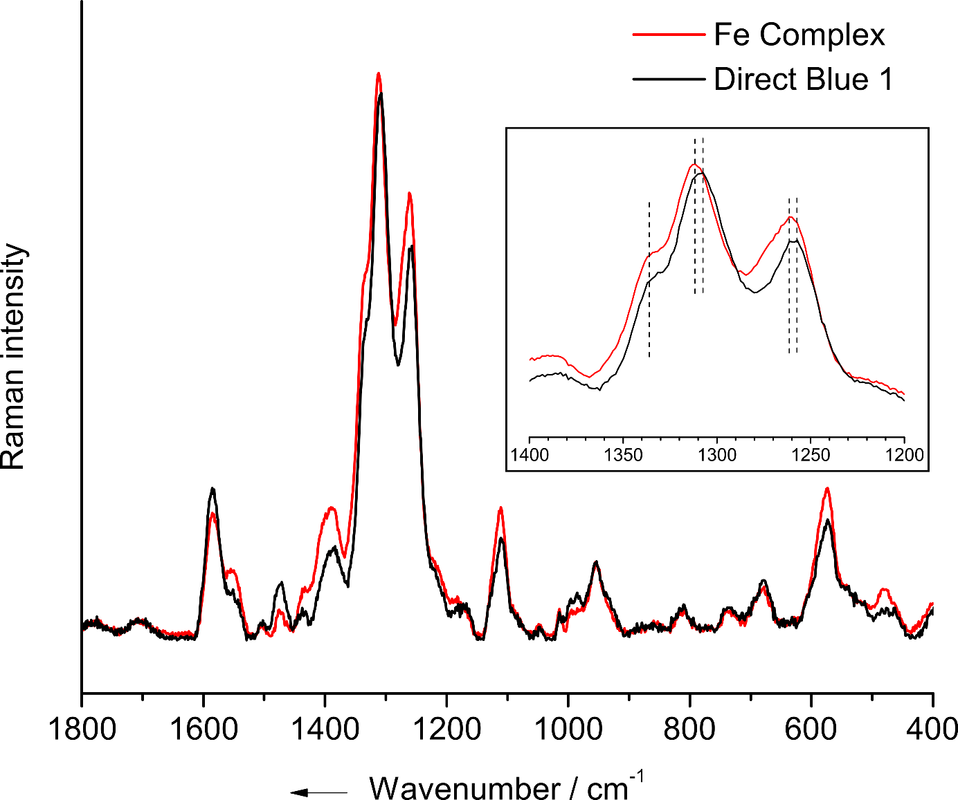

We preferred to measure the Raman spectra because infrared spectra usually have broad bands, and this makes difficult to observe differences. As can be observed in the comparison of the spectra, both substances have similar Raman features but certain changes in the intensity of the signals as well as shifts of the bands are noticeable. Such changes are consistent with the formation of a complex in which the dye (organic ligand) bonds with iron since the main vibrational modes may not change but the presence of the metal can interfere in the vibrations with consequent changes in the intensity of the Raman signal and/or the wavenumber of the band. The nature and geometry of such interactions are still unknown for us, and we are currently investigating these aspects with quantum chemical calculations. This is the reason why we did not present these measurements yet.

- A photograph of the Fenton assisted with the precipitation process was added to the text (see modified Figure 5).

