**SUPPLEMENTARY MATERIAL**

*for*

**Novel (−)-goniofufurone mimics: synthesis, antiproliferative activity and SAR analysis**

BOJANA SREĆO ZELENOVIĆ1, SLAĐANA KEKEZOVIĆ1, MIRJANA POPSAVIN1, VESNA KOJIĆ2, GORAN BENEDEKOVIĆ1 and VELIMIR POPSAVIN1,3*

*1Department of Chemistry, Biochemistry and Environmental Protection, Faculty of Sciences, University of Novi Sad, Trg Dositeja Obradovića 3, 21000 Novi Sad, Serbia*

*2Oncology Institute of Vojvodina, Put dr Goldmana 4, 21204 Sremska Kamenica, Serbia*

*3Serbian Academy of Sciences and Arts, Knez Mihajlova 35, 11000 Belgrade, Serbia*

TABLE OF CONTENTS

PHYSICAL AND SPECTRAL DATA OF SYNTHESIZED COMPOUNDS 2

NMR SPECTRA OF FINAL PRODUCTS 7

SAR ANALYSIS 24

# PHYSICAL AND SPECTRAL DATA OF SYNTHESIZED COMPOUNDS

**3,6-Anhydro-5-*O*-benzyl-7-*O*-hexyl-2-deoxy-l-*ido*-heptono-1,4-lactone (12)**. Colourless oil, [*α*]D = –17.4 (*c* 0.5, CHCl3); *Rf*= 0.14 (3:2 light petroleum/Et2O). IR (CHCl3): *ν*max 1790 (C=O). 1H NMR (400 MHz, CDCl3): δ 0.89 (t, 3H, *J=*6.8 Hz, CH3), 1.20–1.39 (m, 6H, 3×CH2 from side chain), 1.51–1.65 (m, 2H, OCH2C*H2*(CH2)3CH3), 2.69 (dd, 1H, *J*2a,3=2.7, *J*2a,2b=18.8 Hz, H-2a), 2.75 (dd, 1H, *J*2b,3=4.7, *J*2a,2b=18.8 Hz, H-2b), 3.46 (m, 2H, OC*H2*(CH2)4CH3), 3.75 (d,2H, *J*6,7=5.5 Hz, H-7), 4.21 (d, 1H, *J*5,6=4.1 Hz, H-5), 4.26 (td, 1H, *J*5,6=4.1, *J*6,7=5.5 Hz H-6), 4.60 and 4.70 (2×d, 2H, *J*gem=11.9 Hz, C*H2*Ph), 4.92 (d, 1H, *J*3,4=4.7 Hz, H-4), 4.98 (td, 1H, *J*3,4=4.7, *J*2a,3=2.9, *J*2b,3=4.6 Hz, H-3), 7.30–7.45 (m, 5H, Ph). 13C NMR (100 MHz, CDCl3): δ 14.06 (CH3), 22.61, 25.80, 29.62, 31.67 (4×*C*H2 from side chain), 36.03 (C-2), 68.57 (C-7), 71.86 (O*C*H2(CH2)4CH3), 72.76 (*C*H2Ph), 76.83 (C-3), 79.65 (C-6), 81.51 (C-5), 85.52 (C-4), 127.75, 128.17, 128.60, 137.17 (Ph), 175.35 (C=O). HRMS-Heated ESI-Orbitrap: *m/z* 371.18272 (M++Na), calcd. for C20H28NaO5: 371.18344.

**3,6-Anhydro-5-*O*-benzyl-7-*O*-heptyl-2-deoxy-l-*ido*-heptono-1,4-lactone (13)**. Colourless oil; [*α*]D = – 16.0 (*c* 0.5, CHCl3); *Rf*= 0.28 (1:1 light petroleum/Et2O).IR (CHCl3): *ν*max 1789 (C=O). 1H NMR (400 MHz, CDCl3): δ 0.89 (t, 3H, *J=*6.8 Hz, CH3), 1.19–1.41 (m, 8H, 4×CH2 from side chain), 1.58 (m, 2H, OCH2C*H2*(CH2)4CH3), 2.69 (dd, 1H, *J*2a,2b=18.9, *J*2a,3=2.6 Hz, H-2a), 2.74 (dd,1H, *J*2a,2b=18.9, *J*2b,3=4.7 Hz, H-2b), 3.38–3.54 (m, 2H, OC*H2*(CH2)5CH3), 3.65 (d, 2H, *J*6,7=5.5 Hz, H-7), 4.21 (d, 1H, *J*5,6=4.0 Hz, H-5), 4.27 (dd,1H, *J*5,6=4.1, *J*6,7=5.5 Hz, H-6), 4.60 and 4.70 (2×d, 2H, *J*gem=11.9 Hz, C*H2*Ph), 4.92 (d, 1H, *J*3,4=4.7 Hz, H-4), 4.98 (td, 1H, *J*3,4=4.6, *J*2a,3=2.9, *J*2b,3=4.6 Hz, H-3), 7.29–7.40 (m, 5H, Ph). 13C NMR (100 MHz, CDCl3): δ 14.10 (CH3), 22.62, 26.08, 29.14, 29.66, 31.81 (5×CH2 from side chain), 36.03 (C-2), 68.57 (C-7), 71.86 (O*C*H2(CH2)5CH3), 72.76 (CH2Ph), 76.83 (C-3), 79.65 (C-6), 81.51 (C-5), 85.53 (C-4), 127.75, 128.17, 128.60, 137.17 (Ph), 175.35 (C=O). HRMS-Heated ESI-Orbitrap: *m/z* 385.19874 (M++Na), calcd. for C21H30NaO5: 385.19909.

**3,6-Anhydro-5-*O*-benzyl-7-*O*-octyl-2-deoxy-l-*ido*-heptono-1,4-lactone (14)**. Colourless oil, [*α*]D = –14,8 (*c* 0.5, CHCl3); *Rf*= 0.25 (1:1 light petroleum/Et2O).IR (CHCl3): *ν*max 1790 (C=O). 1H NMR (400 MHz, CDCl3): δ 0.89 (t, 3H, *J=*6.9 Hz, CH3), 1.22–1.38 (m, 10H, 5×CH2 from side chain), 1.58 (m, 2H, OCH2C*H2*(CH2)5CH3), 2.68 (dd, 1H, *J*2a,2b=18.7, *J*2a,3=2.5 Hz, H-2a), 2.71 (dd, 1H, *J*2a,2b=18.7, *J*2b,3=4.8 Hz, H-2b), 3.37–3.54 (m, 2H, OC*H2*(CH2)6CH3), 3.65 (d, 2H, *J*6,7=5.5 Hz, H-7), 4.20 (d, 1H, *J*5,6=4.0 Hz, H-5), 4.25 (td,1H, *J*5,6=4.1, *J*6,7=5.5 Hz, H-6), 4.60 and 4.69 (2×d, 2H, *J*gem=11.9 Hz, C*H2*Ph), 4.92 (d, 1H, *J*3,4=4.7 Hz, H-4), 4.97 (td, 1H, *J*3,4=4.8, *J*2a,3=2.5, *J*2b,3=4.8 Hz, H-3), 7.29–7.43 (m, 5H, Ph). 13C NMR (100 MHz, CDCl3): δ 14.01 (CH3), 22.56, 26.02, 29.16, 29.33, 29.56, 31.73 (6×CH2 from side chain), 35.92 (C-2), 68.47 (C-7), 71.75 (O*C*H2(CH2)6CH3), 72.63 (CH2Ph), 76.73 (C-3), 79.54 (C-6), 81.40 (C-5), 85.40 (C-4), 127.64, 128.05, 128.49. 137.10 (Ph), 175.26 (C=O).HRMS-Heated ESI-Orbitrap: *m/z* 399.21400 (M++Na), calcd. for C22H32NaO5: 399.21474; *m/z* 415.18765 (M++K), calcd. for C22H32KO5: 415.18868.

**3,6-Anhydro-5-*O*-benzyl-7-*O*-nonyl-2-deoxy-l-*ido*-heptono-1,4-lactone (15)**. Colourless crystals, mp 34 °C (CH2Cl2/hexane), [*α*]D = –10.8 (*c* 0.75, CHCl3), R*f*=0.33 (1:1 Et2O/light petroleum). IR (film): *ν*max 1773 (C=O). 1H NMR (250 MHz, CDCl3): δ 0.89 (t, 3H, *J=*6.9 Hz, CH3), 1.18–1.39 (m, 12H, 6×CH2 from side chain), 1.57 (m, 2H, OCH2C*H2*(CH2)6CH3), 2.66–2.76 (*pseudo* d, 2H, 2×H-2), 3.45 (m, 2H, OC*H***2**(CH2)7CH3), 3.65 (d, 2H, *J*6,7=5.4 Hz, H-7), 4.20 (d, 1H, *J*5,6=4.3 Hz, H-5), 4.26 (m, 1H, *J*5,6=4.3, *J*6,7=5.4 Hz, H-6), 4.59 and 4.69 (2×d, 2H, *J*gem=11.9 Hz, C*H*2Ph), 4.92 (d, 1H, *J*3,4=4.1 Hz, H-4), 4.98 (m, 1H, *J*3,2a=2.8, *J*3,2b=3.1, *J*3,4=4.1 Hz, H-3), 7.29–7.43 (m, 5H, Ph). 13C NMR (62.9 MHz, CDCl3): δ 14.05 (Me), 22.60, 26.04, 29.20, 29.40, 29.48, 29.58 and 31.81 (7×CH2) 35.94 (C-2), 68.49 (C-7), 71.78 (O*C*H2(CH2)7CH3), 72.66 (*C*H2Ph), 76.75 (C-3), 79.57 (C-6), 81.42 (C-5), 85.44 (C-4), 127.67, 128.08, 128.51 and 137.10 (Ph), 175.29 (C-1). LRMS (ESI+): *m/z* 429 (M++K), 413 (M++Na), 391 (M++H). HRMS (ESI+): *m/z* 391.2482 (M++H), calcd. for C23H35O5: 391.2479; *m/z* 408.2745 (M++NH4), calcd. for C23H38NO5: 408.2744; *m/z* 413.2290 (M++Na), calcd. for C23H34NaO5: 413.2298; *m/z* 429.2034 (M++K), calcd. for C23H34KO5 429.2038.

**3,6-Anhydro-5-*O*-benzyl-7-*O*-decyl-2-deoxy-l-*ido*-heptono-1,4-lactone (16)**. Colourless oil, [*α*]D = −11.1 (*c* 0.63, CHCl3); R*f*=0.44 (1:1 light petroleum/Et2O). IR (film): *ν*max 1788 (C=O). 1H NMR (250 MHz, CDCl3): δ 0.89 (t, 3H, *J=*7.0 Hz, CH3), 1.21–1.41 (m, 14H, 7×CH2 from side chain), 1.49–1.64 (m, 2H, OCH2C*H2*(CH2)7CH3), 2.72 (*pseudo* d, 2H, 2×H-2), 3.46 (m, 2H, OCH2 from side chain), 3.65 (d, 2H, *J*6,7=5.3 Hz, 2×H-7), 4.21 (d, 1H, *J*5,6=4.1 Hz, H-5), 4.26 (m, 1H, *J*5,6=4.1, *J*6,7=5.3 Hz, H-6), 4.60 and 4.70 (2×d, 2H, *J*gem=11.9 Hz, C*H*2Ph), 4.92 (d, 1H, *J*3,4=4.7 Hz, H-4), 4.99 (m, 1H, *J*3,4=4.7 Hz, H-3), 7.30–7.42 (m, 5H, Ph). 13C NMR (62.9 MHz, CDCl3): δ 14.08 (Me), 22.66, 26.10, 29.30, 29.45, 29.55, 29.57, 29.63 and 31.87 (8×CH2 from side chain), 36.00 (C-2), 68.53 (C-7), 71.84 (C-9), 72.74 (**C**H2Ph), 76.79 (C-3), 79.62 (C-6), 81.50 (C-5), 85.51 (C-4), 127.71, 128.14, 128.56 and 137.15 (Ph), 175.29 (C-1). LRMS (CI): *m/z* 405 (M++H). Anal. Found: C, 71.60; H, 9.29. Calculated for C24H36O5: C, 71.26; H, 8.97.

**3,6-Anhydro-5-*O*-benzyl-7-*O*-undecyl-2-deoxy-l-*ido*-heptono-1,4-lactone (17)**. White crystals, mp 30–32 °C (CH2Cl2/hexane); [*α*]D –12.8 (*c* 0.5, CHCl3); *Rf*= 0.38 (3:2 light petroleum/Et2O). IR (CHCl3): *ν*max 1788 (C=O). 1H NMR (400 MHz, CDCl3): δ0.90 (t, 3H, *J=*7.0 Hz, CH3), 1.22–1.38 (m, 16H, 8×CH2 from side chain), 1.57 (m, 2H, OCH2C*H2*(CH2)8CH3), 2.69 (dd, 1H, *J*2a,2b=18.8, *J*2a,3=2.7 Hz, H-2a), 2.75 (dd,1H, *J*2a,2b=18.8, *J*2b,3=4.7 Hz, H-2b), 3.39–3.53 (m, 2H, OC*H2*(CH2)9CH3), 3.66 (d, 2H, *J*6,7=5.5 Hz, H-7), 4.21 (br. d, 1H, *J*5,6=4.0 Hz, H-5), 4.26 (td,1H, *J*5,6=4.0, *J*6,7=5.5 Hz, H-6), 4.62 and 4.71 (2×d, 2H, *J*gem=11.9 Hz, C*H2*Ph), 4.93 (dd, 1H, *J*3,4=4.7, *J*4,5=0.9 Hz, H-4), 4.98 (td, 1H, *J*3,4=4.7, *J*2a,3=2.8, *J*2b,3=4.7 Hz, H-3), 7.29–7.40 (m, 5H, Ph). 13C NMR (100 MHz, CDCl3):δ 14.08 (CH3), 22.64, 26.07, 29.29, 29.43, 29.55, 29.57, 29.60, 29.65 and 31.86 (9×CH2 from side chain), 35.97 (C-2), 68.51 (C-7), 71.81 (O*C*H2(CH2)9CH3), 72.70 (*C*H2Ph), 76.77 (C-3), 79.59 (C-6), 81.45 (C-5), 85.47 (C-4), 127.69, 128.11, 128.54 and 137.12 (Ph), 175.29 (C=O). HRMS-Heated ESI-Orbitrap: *m/z* 441.26129 (M++Na), calcd. for C25H38NaO5: 441.26169; *m/z* 457.23465 (M++K), calcd. for C25H38KO: 457.23563.

**3,6-Anhydro-5-*O*-benzyl-7-*O*-dodecyl-2-deoxy-l-*ido*-heptono-1,4-lactone (18)**. White needles, mp 45–46 °C (CH2Cl2/hexane); [*α*]D = –13.0 (*c* 0.5, CHCl3); *Rf*= 0.25 (3:2 light petroleum/Et2O). IR (CHCl3): *ν*max 1788 (C=O). 1H NMR (400 MHz, CDCl3):δ 0.89 (t, 3H, *J=*6.7 Hz, CH3), 1.19–1.37 (m, 18H, 9×CH2 from side chain), 1.57 (m, 2H, OCH2C*H2*(CH2)9CH3), 2.68 (dd, 1H, *J*2a,2b=18.8, *J*2a,3=2.7 Hz, H-2a), 2.74 (dd,1H, *J*2a,2b=18.8, *J*2b,3=4.8 Hz, H-2b), 3.40–3.52 (m, 2H, OC*H2*(CH2)10CH3), 3.64 (d,2H, *J*6,7=5.5 Hz, H-7), 4.21 (d, 1H, *J*5,6=4.1 Hz, H-5), 4.27 (td,1H, *J*5,6=4.1, *J*6,7=5.5 Hz, H-6), 4.60 and 4.70 (2×d, 2H, *J*gem=11.9 Hz, C*H2*Ph), 4.92 (dd, 1H, *J*3,4=4.7, *J*4,5=0.8 Hz, H-4), 4.97 (td, 1H, *J*3,4=4.7, *J*2a,3=2.8, *J*2b,3=4.7 Hz, H-3), 7.29–7.40 (m, 5H, Ph). 13C NMR (100 MHz, CDCl3): δ 14.07 (CH3), 22.63, 26.06, 29.29, 29.42, 29.55, 29.56, 29.58, 29.60, 29.61, 31.86 (10×CH2 from side chain), 35.96 (C-2), 68.50 (C-7), 71.79 (O*C*H2(CH2)10CH3), 72.68 (CH2Ph), 76.76 (C-3), 79.58 (C-6), 81.44 (C-5), 85.45 (C-4), 127.68, 128.09, 128.53, 137.12 (Ph), 175.28 (C=O). HRMS-Heated ESI-Orbitrap: *m/z* 455.27712 (M++Na), calcd. for C26H40NaO5: 455.27734; *m/z* 471.25088 (M++K), calcd. for C26H40KO5: 471.25128.

**3,6-Anhydro-5-*O*-benzyl-7-*O*-tridecyl-2-deoxy-l-*ido*-heptono-1,4-lactone (19)**. White needles, mp 44–46 °C (CH2Cl2/hexane), [*α*]D = –13.0 (*c* 0.5, CHCl3); *Rf*= 0.13 (7:3 light petroleum/Et2O). IR (KBr): *ν*max 1791 (C=O). 1H NMR (400 MHz, CDCl3):δ 0.89 (t, 3H, *J=*6.8 Hz, CH3), 1.20–1.37 (m, 20H, 10×CH2 from side chain), 1.58 (m, 2H, OCH2C*H2*(CH2)10CH3), 2.69 (dd, 1H, *J*2a,2b=18.9, *J*2a,3=2.9 Hz, H-2a), 2.74 (dd, 1H, *J*2a,2b=18.9, *J*2b,3=4.7 Hz, H-2b), 3.37–3.53 (m, 2H, OC*H2*(CH2)11CH3), 3.65 (d,2H, *J*6,7=5.5 Hz, H-7), 4.21 (d, 1H, *J*5,6=4.0 Hz, H-5), 4.26 (td,1H, *J*5,6=4.1, *J*6,7=5.5 Hz, H-6), 4.61 and 4.70 (2×d, 2H, *J*gem=11.9 Hz, C*H2*Ph), 4.93 (d, 1H, *J*3,4=4.7 Hz, H-4), 4.97 (ddd, 1H, *J*3,4=4.7, *J*2a,3=2.9, *J*2b,3=4.6 Hz, H-3), 7.30–7.41 (m, 5H, Ph). 13C NMR (100 MHz, CDCl3): δ 14.13 (CH3), 22.70, 26.13, 29.37, 29.41, 29.49, 29.56, 29.62, 29.63, 29.66, 29.68, 31.93 (11×CH2 from side chain), 36.03 (C-2), 68.57 (C-7), 71.87 (O*C*H2(CH2)11CH3), 72.76 (*C*H2Ph), 76.72 (C-3), 79.65 (C-6), 81.51 (C-5), 85.53 (C-4), 127.75, 128.17, 128.60, 137.17 (Ph), 175.34 (C=O). HRMS-Heated ESI-Orbitrap: *m/z* 469.29308 (M++Na); calcd. for C27H42NaO5: 469.29299; *m/z* 485.26669 (M++K), calcd. for C27H42KO5: 485.26693.

**3,6-Anhydro-2-deoxy-l-*ido*-heptono-1,4-lactone (2)**. White crystals, mp 73–75 °C (EtOAc/ pentane), lit.[1] mp 72–74 °C (EtOAc/pentane); [*α*]D = –25.0 (*c* 0.44, H2O), lit.1 [*α*]D20 = –32.0 (*c* 0.6, H2O); *Rf*= 0.16 (3:2 EtOAc/CH2Cl2). IR (CHCl3): *ν*max 3378 (OH), 1780 (C=O). 1H NMR (400 MHz, acetone-*d*6): δ 2.46 (d, 1H, *J*2a,2b=18.4 Hz, H-2a), 2.85 (dd, 1H, *J*2a,2b=18.4, *J*2b,3=6.2 Hz, H-2b), 2.89 (br. s, 2H, 2×OH), 3.77 (dd,1H, *J*6,7a=5.5, *J*7a,7b=11.0 Hz, H-7a), 3.83 (dd, 1H, *J*6,7b=5.3 Hz, *J*7a,7b=11.0 Hz, H-7b), 4.00 (td, 1H, *J*5,6=3.5, *J*6,7=5.0 Hz, H-6), 4.41 (t, 1H, *J*5,6=4.0 Hz, H-5), 4.88 (d, 1H, *J*3,4=4.3 Hz, H-4), 4.95 (dd, 1H, *J*3,4=4.4, *J*2b,3=6.1 Hz, H-3); 13C NMR (100 MHz, acetone-*d*6): δ 36.55 (C-2), 60.96 (C-7), 75.24 (C-5), 77.57 (C-3), 82.21 (C-6), 89.14 (C-4), 176.13 (C=O).HRMS (ESI+): *m/z* 175.06038 (M++H), calculated for C7H11O5: 175.06010.

**3,6-Anhydro-7-*O*-hexyl-2-deoxy-l-*ido*-heptono-1,4-lactone (3)**. White crystals, mp 47–49 °C (CH2Cl2/hexane); [*α*]D = –26.3 (*c* 0.3, CHCl3); *Rf*= 0.15 (7:3 Et2O/light petroleum). IR (KBr): *ν*max 3290 (OH), 1775 (C=O). 1H NMR (400 MHz, CDCl3):δ 0.89 (t, 3H, *J=*6.8 Hz, CH3), 1.22–1.38 (m, 6H, 3×C*H2* from side chain), 1.59 (m, 2H, OCH2C*H2*(CH2)3CH3), 2.67 (d, 1H, *J*2a,2b=18.7 Hz, H-2a), 2.75 (dd, 1H, *J*2a,2b=18.7, *J*2b,3=5.7 Hz, H-2b), 3.52 (m, 2H, OC*H2*(CH2)4CH3), 3.88 (dd, 1H, *J*6,7a=3.0, *J*7a,7b=11.2 Hz, H-7a), 3.91 (dd, 1H, *J*6,7b=3.4, *J*7a,7b=11.2 Hz, H-7b), 4.12 (m, 1H, H-6), 4.23 (d, 1H, *J*5,OH=3.6 Hz, OH), 4.54 (t, 1H, H-5), 4.87 (d, 1H, *J*3,4=4.2 Hz, H-4), 5.01 (t, 1H, *J*3,4=4.7 Hz, H-3). 13C NMR (100 MHz, CDCl3): δ 14.00 (CH3), 22.53, 25.63, 29.37, 31.53 (4×CH2 from side chain), 36.10 (C-2), 69.58 (C-7), 72.66 (O*C*H2(CH2)4CH3), 76.16 (C-5), 76.91 (C-3), 78.59 (C-6), 88.27 (C-4), 175.40 (C=O). HRMS-Heated ESI-Orbitrap: *m/z* 281.13567 (M++Na), calcd. for C13H22NaO5: 281.13649.

**3,6-Anhydro-7-*O*-heptyl-2-deoxy-l-*ido*-heptono-1,4-lactone (4)**. White crystals, mp 41–42 °C (CH2Cl2/hexane); [*α*]D = –33.2 (*c* 0.5, CHCl3); *Rf*= 0.15 (7:3 Et2O/light petroleum).IR (KBr): *ν*max 3434 (OH), 1784 (C=O). 1H NMR (400 MHz, CDCl3): δ 0.88 (t, 3H, *J=*6.9 Hz, CH3), 1.20–1.36 (m, 8H, 4×CH2 from side chain), 1.59 (m, 2H, OCH2C*H2*(CH2)4CH3), 2.67 (d, 1H, *J*2a,2b=18.7 Hz, H-2a), 2.75 (dd, 1H, *J*2a,2b=18.7, *J*2b,3=5.7 Hz, H-2b), 3.52 (m, 2H, OC*H2*(CH2)5CH3), 3.88 (dd,1H, *J*6,7a=3.1, *J*7a,7b=11.1 Hz, H-7a), 3.91 (dd, 1H, *J*6,7b=3.4, *J*7a,7b=11.1 Hz, H-7b), 4.12 (m, 1H, H-6), 4.23 (d, 1H, *J*5,OH=3.7 Hz, OH), 4.54 (t, 1H, *J*5,6=3.1 Hz, H-5), 4.87 (d, 1H, *J*3,4=4.2 Hz, H-4), 5.01 (m, 1H, H-3). 13C NMR (100 MHz, CDCl3): δ 14.06 (CH3), 22.58, 25.93, 29.02, 29.42, 31.71 (5×CH2 from side chain), 36.10 (C-2), 69.59 (C-7), 72.66 (O*C*H2(CH2)5CH3), 76.17 (C-5), 76.91 (C-3), 78.59 (C-6), 88.27 (C-4), 175.39 (C=O).HRMS-Heated ESI-Orbitrap: *m/z* 295.15146 (M++Na), calcd. for C14H24NaO5: 295.15214.

**3,6-Anhydro-7-*O*-octyl-2-deoxy-l-*ido*-heptono-1,4-lactone (5)**. White crystals, mp 51–53 °C (CH2Cl2/hexane); [*α*]D –26.2 (*c* 0.5, CHCl3); *Rf*= 0.19 (4:1 Et2O/light petroleum). IR (KBr): *ν*max 3430 (OH), 1777 (C=O). 1H NMR (400 MHz, CDCl3): δ 0.88 (t, 3H, *J=*6.9 Hz, CH3), 1.20–1.37 (m, 10H, 5×CH2 from side chain), 1.60 (m, 2H, OCH2C*H2*(CH2)5CH3), 2.68 (d, 1H, *J*2a,2b=18.6 Hz, H-2a), 2.76 (dd, 1H, *J*2a,2b=18.6, *J*2b,3=5.7 Hz, H-2b), 3.52 (m, 2H, OC*H2*(CH2)6CH3), 3.88 (dd,1H, *J*6,7a=3.0, *J*7a,7b=11.1 Hz, H-7a), 3.90 (dd, 1H, *J*6,7b=3.4, *J*7a,7b=11.1 Hz, H-7b), 4.12 (m, 1H, H-6), 4.25 (br. s, 1H, OH), 4.55 (d, 1H, *J*5,6=3.2 Hz, H-5), 4.88 (d, 1H, *J*3,4=4.2 Hz, H-4), 5.01 (m, 1H, H-3). 13C NMR (100 MHz, CDCl3): δ 14.05 (CH3), 22.60, 25.94, 29.14, 29.28, 29.38, 31.75 (6×CH2 from side chain), 36.07 (C-2), 69.56 (C-7), 72.65 (O*C*H2(CH2)6CH3), 76.15 (C-5), 76.88 (C-3), 78.54 (C-6), 88.23 (C-4), 175.34 (C=O).HRMS-Heated ESI-Orbitrap: *m/z* 309.16760 (M++Na), calcd. for C15H26NaO5: 309.16779.

**3,6-Anhydro-7-*O*-nonyl-2-deoxy-l-*ido*-heptono-1,4-lactone (6)**. Colourless crystals, mp 53 °C (CH2Cl2/hexane), [*α*]D = −35.0 (*c* 0.5, CHCl3), R*f*=0.32 (Et2O). IR (film): *ν*max 3277 (OH), 1774 (C=O). For 1H and 13C NMR spectra see, ref. [2]. HRMS: *m/z* 301.2000 (M++H), calcd. for C16H29O5: 301.2010; *m/z* 318.2266 (M++NH4), calcd. for C16H32NO5: 318.2275.

**3,6-Anhydro-7-*O*-decyl-2-deoxy-l-*ido*-heptono-1,4-lactone (7)**. White crystals, mp 59–60 °C (CH2Cl2/hexane), [*α*]D = −29.1 (*c* 1.0, CHCl3), R*f*=0.25 (9:1 CH2Cl2/EtOAc). IR (film): *ν*max 3481 (OH), 1773 (C=O). For NMR (1H and 13C) and LRMS spectra see, ref. 2. Anal. Found: C, 65.12; H, 9.56. Calculated for C24H36O5: C, 64.94; H, 9.62.

**3,6-Anhydro-7-*O*-undecyl-2-deoxy-l-*ido*-heptono-1,4-lactone (8)**. White crystals, mp 57 °C (CH2Cl2/hexane); [*α*]D –26.6 (*c* 0.5, CHCl3); *Rf*= 0.15 (7:3 Et2O/light petroleum).IR (KBr): *ν*max 3444 (OH), 1775 (C=O). 1H NMR (400 MHz, CDCl3):δ 0.88 (t, 3H, *J=*7.1 Hz, CH3), 1.21–1.34 (m, 16H, 8×CH2 from side chain), 1.59 (m, 2H, OCH2C*H2*(CH2)8CH3), 2.67 (d, 1H, *J*2a,2b=18.7 Hz, H-2a), 2.75 (dd, 1H, *J*2a,2b=18.7, *J*2b,3=5.7 Hz, H-2b), 3.52 (m, 2H, OC*H2*(CH2)9CH3), 3.87 (dd,1H, *J*6,7a=3.1, *J*7a,7b=11.1 Hz, H-7a), 3.90 (dd, 1H, *J*6,7b=3.4, *J*7a,7b=11.1 Hz, H-7b), 4.11 (m, 1H, H-6), 4.53 (d, 1H, *J*5,6=3.3 Hz, H-5), 4.87 (d, 1H, *J*3,4=4.3 Hz, H-4), 5.03 (m, 1H, H-3).13C NMR (100 MHz, CDCl3):δ 14.07 (CH3), 22.63, 25.92, 29.27, 29.32, 29.37, 29.47, 29.53, 29.54, 31.85, (9×CH2 from side chain), 36.05 (C-2), 69.52 (C-7), 72.61 (O*C*H2(CH2)9CH3), 76.09 (C-5), 76.86 (C-3), 78.56 (C-6), 88.23 (C-4), 175.37 (C=O). HRMS-Heated ESI-Orbitrap: *m/z* 351.21415 (M++Na), calcd. for C18H32NaO5: 351.21474.

**3,6-Anhydro-7-*O*-dodecyl-2-deoxy-l-*ido*-heptono-1,4-lactone (9)**. White needles, mp 69–70 °C (CH2Cl2/hexane); [*α*]D = –25.0 (*c* 0.5, CHCl3); *Rf*= 0.15 (3:2 Et2O/light petroleum). IR (KBr): *ν*max 3447 (OH), 1775 (C=O). 1H NMR (400 MHz, CDCl3):δ 0.88 (t, 3H, *J=*6.8 Hz, CH3), 1.20–1.36 (m, 18H, 9×CH2 from side chain), 1.59 (m, 2H, OCH2C*H2*(CH2)9CH3), 2.66 (d, 1H, *J*2a,2b=18.6 Hz, H-2a), 2.75 (dd, 1H, *J*2a,2b=18.6, *J*2b,3=5.7 Hz, H-2b), 3.52 (m, 2H, OC*H2*(CH2)10CH3), 3.86 (dd, 1H, *J*6,7a=3.1, *J*7a,7b=11.0 Hz, H-7a), 3.91 (dd, 1H, *J*6,7b=3.4, *J*7a,7b=11.1 Hz, H-7b), 4.11 (m, 1H, H-6), 4.22 (d, 1H, *J*5,OH=3.7 Hz, OH), 4.53 (t, 1H, *J*5,6=3.3 Hz, H-5), 4.86 (d, 1H, *J*3,4=4.1 Hz, H-4), 5.01 (m, 1H, H-3). 13C NMR (100 MHz, CDCl3): δ 14.08 (CH3), 22.64, 25.93, 29.30, 29.33, 29.38, 29.48, 29.54, 29.58, 29.60, 31.87 (10×CH2 from side chain), 36.06 (C-2), 69.54 (C-7), 72.62 (O*C*H2(CH2)10CH3), 76.11 (C-5), 76.86 (C-3), 78.56 (C-6), 88.23 (C-4), 175.35 (C=O). HRMS-Heated ESI-Orbitrap: *m/z* 365.23022 (M++Na), calcd. for C19H34NaO5: 365.23039.

**3,6-Anhydro-7-*O*-tridecyl-2-deoxy-l-*ido*-heptono-1,4-lactone (10)**. White needles, mp 63–65 °C (CH2Cl2/hexane); [*α*]D = –19.3 (*c* 0.5, CHCl3); *Rf*= 0.17 (7:3 Et2O/light petroleum). IR (KBr): *ν*max 3450 (OH), 1785 (C=O). 1H NMR (400 MHz, CDCl3): δ 0.89 (t, 3H, *J=*6.8 Hz, CH3), 1.21–1.34 (m, 20H, 10×CH2 from side chain), 1.59 (m, 2H, OCH2C*H2*(CH2)10CH3), 2.68 (d, 1H, *J*2a,2b=18.6 Hz, H-2a), 2.76 (dd, 1H, *J*2a,2b=18.6, *J*2b,3=5.6 Hz, H-2b), 3.52 (m, 2H, OC*H2*(CH2)11CH3), 3.88 (dd,1H, *J*6,7a=3.0, *J*7a,7b=11.1 Hz, H-7a), 3.92 (dd, 1H, *J*6,7b=3.4, *J*7a,7b=11.1 Hz, H-7b), 4.12 (m, 1H, H-6), 4.24 (d,1H, *J*5,OH=3.7 Hz, OH), 4.55 (t, 1H, *J*5,6=3.0 Hz, H-5), 4.88 (d, 1H, *J*3,4=4.1 Hz, H-4), 5.04 (m, 1H, H-3). 13C NMR (100 MHz, CDCl3): δ 14.12 (CH3), 22.70, 25.97, 29.36, 29.37, 29.42, 29.53, 29.59, 29.65, 29.67, 29.71, 31.92 (11×CH2 from side chain), 36.11 (C-2), 69.61 (C-7), 72.69 (O*C*H2(CH2)11CH3), 76.21 (C-5), 76.92 (C-3), 78.57 (C-6), 88.27 (C-4), 175.37 (C=O). HRMS-Heated ESI-Orbitrap: *m/z* 379.24528 (M++Na), calcd. for C20H36NaO5: 379.24604.

# NMR SPECTRA OF FINAL PRODUCTS



Fig. S-1. 1H-NMR spectrum of **12** (400 MHz, CDCl3).

Fig. S-2. 13C-NMR spectrum of **12** (100 MHz, CDCl3).



Fig. S-3. 1H-NMR spectrum of **3** (400 MHz, CDCl3).

Fig. S-4. 13C-NMR spectrum of **3** (100 MHz, CDCl3).



Fig. S-5. 1H-NMR spectrum of **13** (400 MHz, CDCl3).

Fig. S-6. 13C-NMR spectrum of **13** (100 MHz, CDCl3).



Fig. S-7. 1H-NMR spectrum of **4** (400 MHz, CDCl3).

Fig. S-8. 13C-NMR spectrum of **4** (100 MHz, CDCl3).



Fig. S-9. 1H-NMR spectrum of **14** (400 MHz, CDCl3).

Fig. S-10. 13C-NMR spectrum of **14** (100 MHz, CDCl3).



Fig. S-11. 1H-NMR spectrum of **5** (400 MHz, CDCl3).

Fig. S-12. 13C-NMR spectrum of **5** (100 MHz, CDCl3).

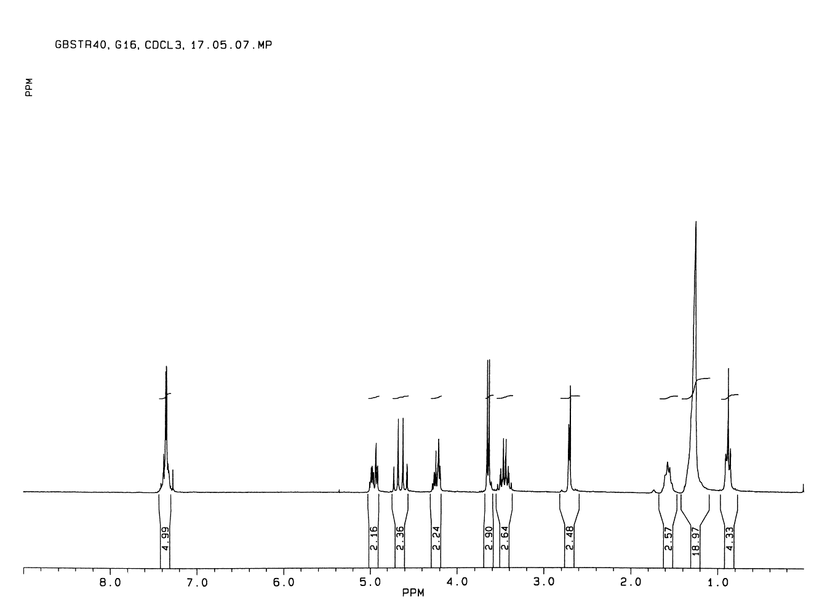



Fig. S-13. 1H-NMR spectrum of **15** (250 MHz, CDCl3)**.**

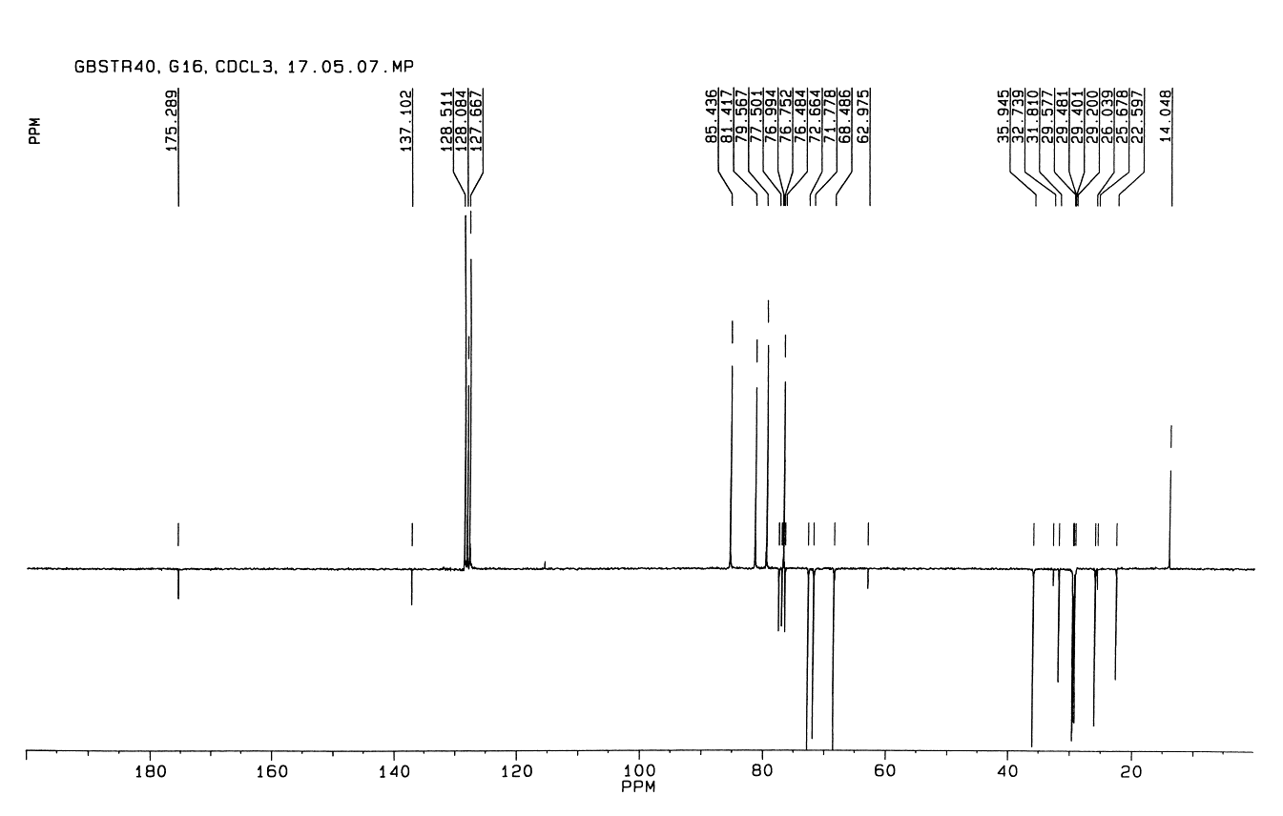

Fig. S-14. 13C-NMR spectrum of **15** (63.9 MHz, CDCl3).

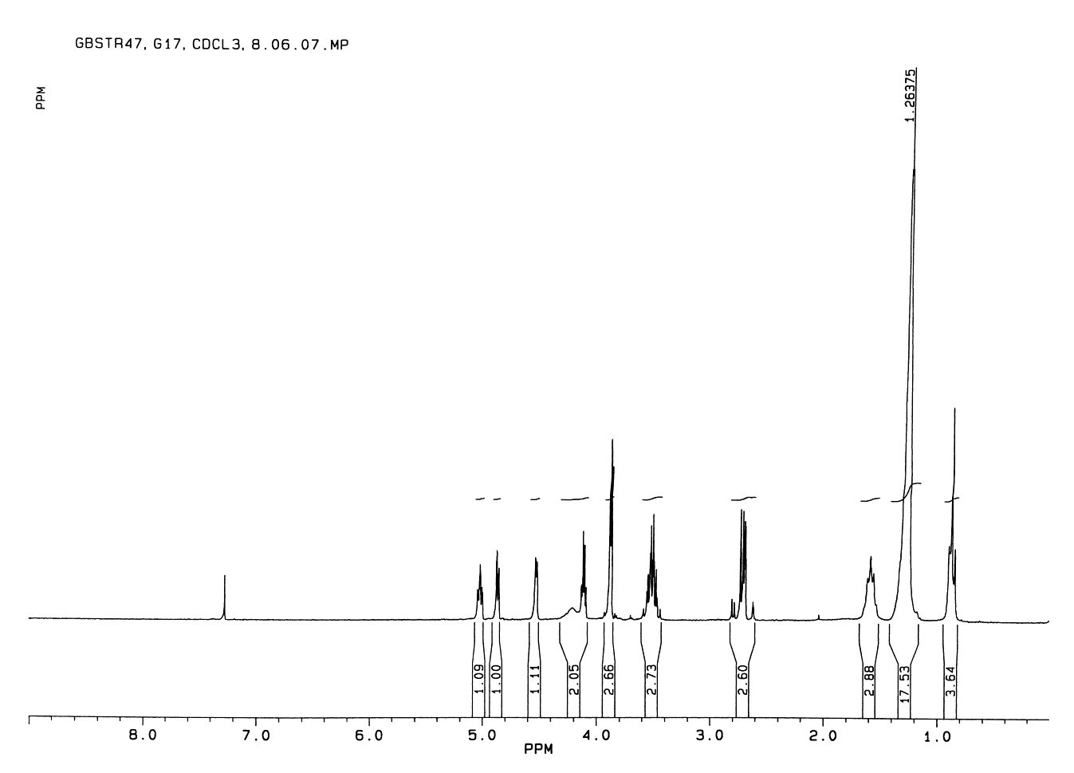



Fig. S-15. 1H-NMR spectrum of **6** (250 MHz, CDCl3).

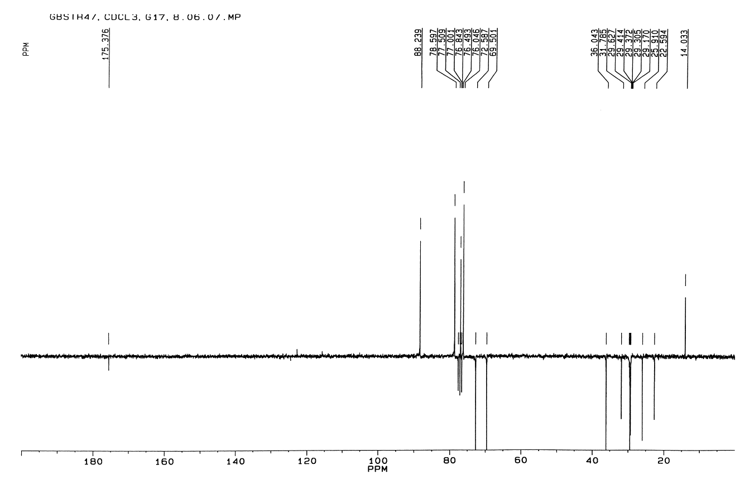

Fig. S-16. 13C-NMR spectrum of **6** (63.9 MHz, CDCl3).

Fig. S-17. 1H-NMR spectrum of **16** (250 MHz, CDCl3)**.**

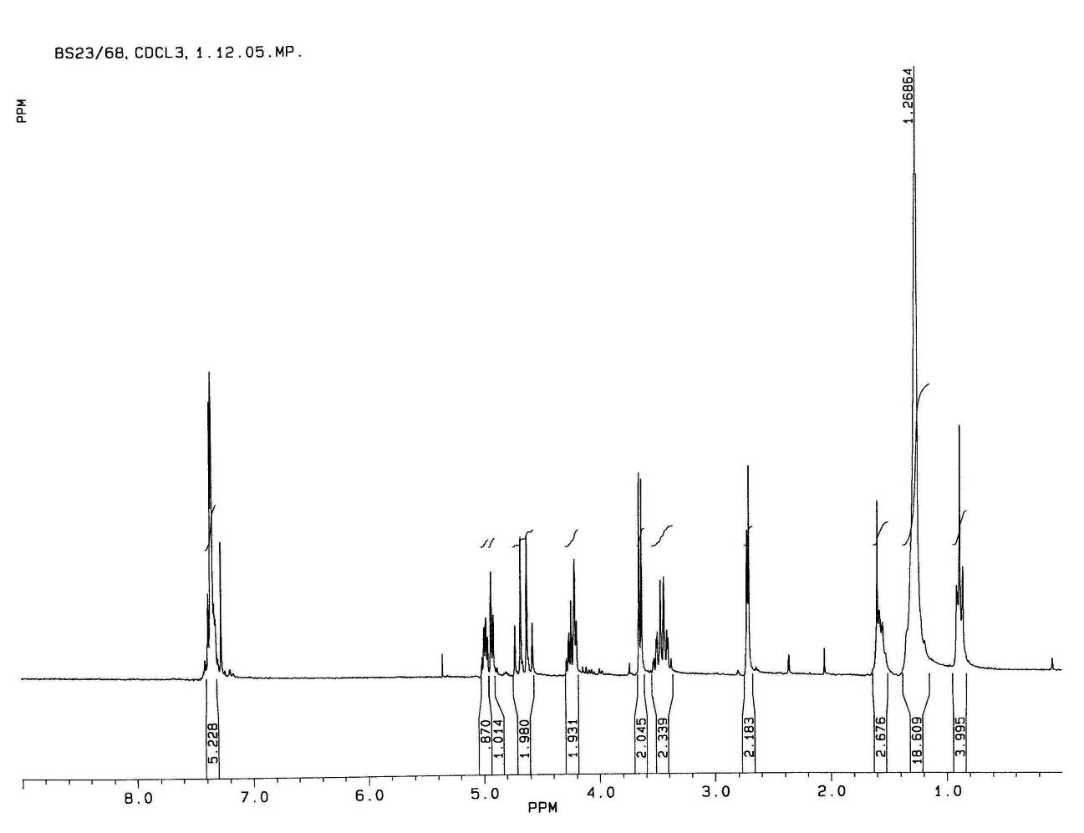

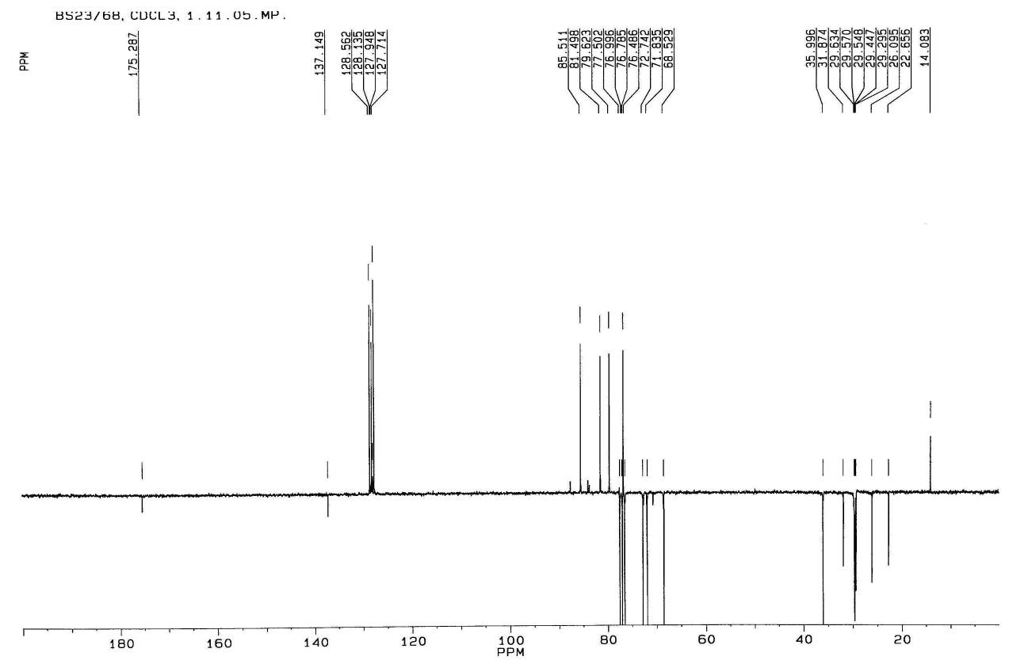

Fig. S-18. 13C-NMR spectrum of **16** (63.9 MHz, CDCl3).

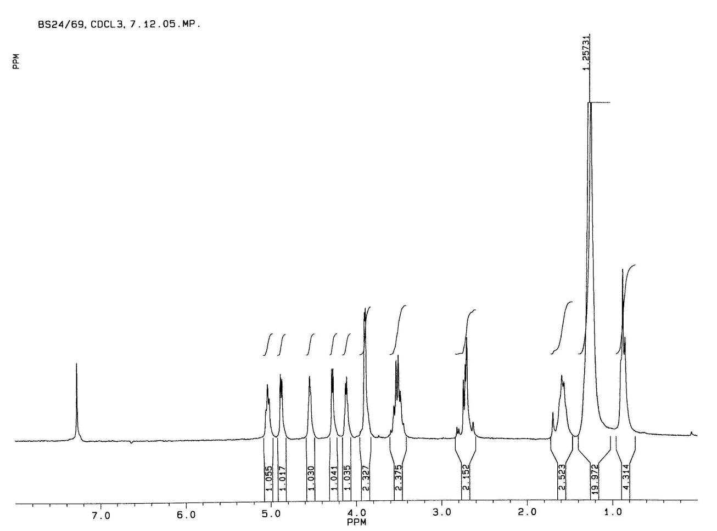

Fig. S-19. 1H-NMR spectrum of **7** (250 MHz, CDCl3).

Untitled.tif

Fig. S-20. 13C-NMR spectrum of **7** (63.9 MHz, CDCl3).



Fig. S-21. 1H-NMR spectrum of **17** (400 MHz, CDCl3).

Fig. S-22. 13C-NMR spectrum of **17** (100 MHz, CDCl3).

Fig. S-23. 1H-NMR spectrum of **8** (400 MHz, CDCl3).

Fig. S-24. 13C-NMR spectrum of **8** (100 MHz, CDCl3).



Fig. S-25. 1H-NMR spectrum of **18** (400 MHz, CDCl3).

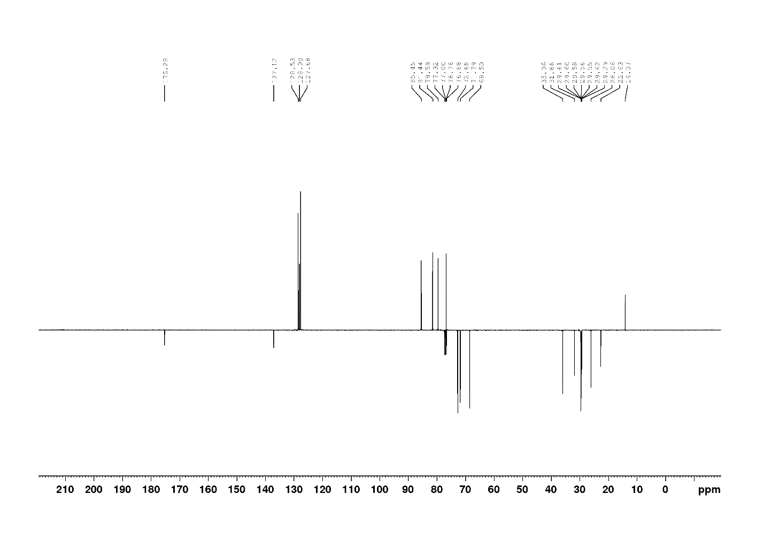

Fig. S-26. 13C-NMR spectrum of **18** (100 MHz, CDCl3).

Fig. S-27. 1H-NMR spectrum of **9** (400 MHz, CDCl3).

Fig. S-28. 13C-NMR spectrum of **9** (100 MHz, CDCl3).



Fig. S-29. 1H-NMR spectrum of **19** (400 MHz, CDCl3).

Fig. S-30. 13C-NMR spectrum of **19** (100 MHz, CDCl3).

Fig. S-31. 1H-NMR spectrum of **10** (400 MHz, CDCl3).

Fig. S-32. 13C-NMR spectrum of **10** (100 MHz, CDCl3).

Fig. S-33. 1H-NMR spectrum of **2** (400 MHz, acetone-*d*6).

Fig. S-34. 13C-NMR spectrum of **2** (100 MHz, acetone-*d*6).

# SAR ANALYSIS

TABLE S-1. Cytotoxicity data for SAR analysis.

|  |  |  |  |  |  |  |  |  |  |
| --- | --- | --- | --- | --- | --- | --- | --- | --- | --- |
| **Compounds** | **IC50 (µM)a, 72 h** | | | | | | | | |
| **K562** | **HL-60** | **Jurkat** | **Raji** | **MCF-7** | **MDA-MB 231** | **HeLa** | **A549** |
| **1** | 2.96 | 224.61 | 2.49 | 23.42 | 51.27 | 598.66 | 785.31 | 2.36 |
| **2** | 2.69 | 9.97 | 9.51 | 7.40 | 9.64 | 0.24 | 5.22 | 31.45 |
| **3** | 0.70 | 4.91 | 8.87 | 1.11 | 12.34 | 15.62 | 3.54 | 2.43 |
| **4** | 1.02 | 1.10 | 11.53 | 5.98 | 2.38 | 9.76 | 0.56 | 4.43 |
| **5** | 0.74 | 0.68 | 19.78 | 4.25 | 0.34 | 28.70 | 3.41 | 4.19 |
| **6** | 8.61b | 1.53b | 6.64b | 7.25 | 102.36 | 296.78 | 9.59b | 0.92 |
| **7** | 1.25b | 0.14b | 103.27b | 76.36 | 89.36 | 112.36 | 0.30b | 29.05 |
| **8** | 0.18 | 1.83 | 16.26 | 2.79 | 2.28 | 26.57 | 4.11 | 7.72 |
| **9** | 3.46 | 8.25 | 8.02 | 3.52 | 5.31 | 7.63 | 2.25 | 3.96 |
| **10** | 4.87 | 3.96 | 4.29 | 4.88 | 15.36 | 36.47 | 10.32 | 0.025 |

*a* IC50 is the concentration of compound required to inhibit the cell growth by 50% compared to an untreated control. Values are means of three independent experiments. Coefficients of variation were less than 10%.

b Taken from reference 22.

The structure-activity relationships were accessed as follows: the IC50 values of two compounds were compared, and the ∆ log IC50 was calculated (∆ log IC50 is a difference between the log IC50 values of an analogue and the corresponding control compound). Positive ∆ log IC50 values show a decrease of antiproliferative activity, whereas negative values indicate an increase in the activity upon the structural modification being considered. The results are presented in Figure S-35.



Fig. S-35. SAR Analysis. Influence of: (A) replacement of the hydroxybenzyl group in **1** with an alkoxymethyl chain; (B) introduction of an alkyl chain at the 7-OH position in molecule **2**; (C) increasing the number of carbon atoms in the side chain of analogues **3**–**10**.

1. K. Bock, I. Lundt, C. Pedersen, *Carbohydr. Res.* **179** (1988) 87.
2. V. Popsavin, B. Srećo, G. Benedeković, M. Popsavin, J. Francuz, V. Kojić, G. Bogdanović, *Bioorg. Med. Chem. Lett.* **18** (2008) 5182.