Author's Response to Reviewers Comments

Reference: #8658

Dear Editor and Reviewers,
We greatly appreciate your e-mail from 19. November, 2019. in relation to manuscript "The correlation of plasma protein binding and molecular properties of selected antifungal drugs" submitted for Journal of the Serbian Chemical Society (Reference: #8658); from authors Jadranka V. Odović, Milkica A. Crevar Sakać and Zorica B. Vujić.

We have carefully evaluated the recommendations for revision and made the necessary changes according to the suggestions. Please find the revised manuscript attached. All changes in the manuscript have been marked with yellow color.
We would be very grateful if our revised manuscript could be accepted for publication.
Thank you for your great help.

Reviewer:

1. PPB, PSA Mw Vol and S should be defined!
Response: Authors agree with the reviewer’s suggestion. In the revised manuscript, PPB, PSA Mw Vol and S should be defined.
Line 8:
Incorrect text: plasma protein binding
Proper text: plasma protein binding (PPB),
Line 10:
Incorrect text: Lipophilicity
Proper text: Lipophilicity (log P),
Line 11:
Incorrect text: molecular weight, volume, polar surface area, and solubility
Proper text: molecular weight (Mw), volume (Vol), polar surface area (PSA), and solubility play (log S)

2. please define A, AC, M, X, mi
Response: Authors agree with the reviewer’s suggestion and additionally defined abbreviations used for descriptors. For explanations authors added additional reference No 20 while previous reference 20 and 21 are renumbered as 21 and 22.
Lines 137-153:
The calculation of lipophilicity descriptors, different logP values (A logPs, AC log P, mi log P, A log P, M log P, X log P2, X log P3) were performed using software package Virtual Computational Chemistry Laboratory¹⁶. The first letters of molecular descriptor mark is related to the method of calculation of lipophilicity. The methods applied can be divided as: substructure-based (atom-based and fragmental methods) and property-based methods. The atom-based methods provide several lipophilicity descriptors (A log P, AC log P, X log P2, X log P3,) in which molecules are cut down to the single atoms and commonly do not apply corrections while fragmental methods cut molecules into fragments with corrections application and summing contributions of all fragment to provide final log P value (mi log P). The property-based methods use the description of the entire molecules and include: empirical methods based on molecule’s 3D-structure or methods based on topological descriptors (M log P, A log Ps)¹⁷⁻¹⁹. The abbreviations used for descriptors are: A logPs, neural networks is used to predict the logP; AC log P, atom-additive method; mi log P, calculation include charge interactions and organometallic compounds; A log P, classical atomic contribution approach; M log P, Moriguchi octanol-water partition coefficient; X log P2, additive atom/group model and X log P3, based on additive atom/group model which starts from the known logP value of a similarly reference compound²⁰.

3. Units?
Response: Authors revised TABLE IV and added missing unit according to reviewer’s suggestions.
Line 209
No | Antifungals | Mw / Da | Vol / Å³ | PSA / Å²
1 | Amphotericin B | 924 | 865 | 320
2 | Fluconasole | 306 | 249 | 82
3 | Itraconasole | 706 | 608 | 105
4 | Ketoconazole | 531 | 452 | 69
5 | Posaconasole | 701 | 623 | 116
6 | Terbinafine | 291 | 307 | 3
7 | Voriconasole | 349 | 285 | 77
8 | Caspofungin | 1093 | 1026 | 412

4. Missing unit on y-axis!
Response: Authors revised Figure 1 and added missing unit according to reviewer’s suggestions.
Line 264
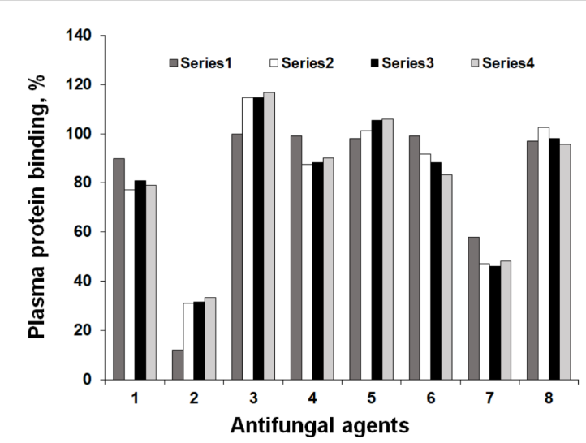

With great appreciations for recommendations that improve our manuscript, thank you in advance.

Sincerely yours,

Jadranka Odović;
University of Belgrade-Faculty of Pharmacy

