In-vitro and in-silico analysis of the effect of fluconazole, an antifungal drug, on DNA

Sumeyye Zarf ¹ and Ibrahim Arman ^{1*}
¹ Department of Molecular Biology and Genetics, Faculty of Arts and Sciences, Bulent Ecevit University, Zonguldak, Turkey
*Corresponding: Ibrahim Arman; Department of Molecular Biology and Genetics, Faculty of Arts and Sciences, Bulent Ecevit University, 67100 Zonguldak, Turkey. Tel.: + 90 5367304074, Fax: + 903722574181. Email: ibrahimarmann@gmail.com ORCID: https://orcid.org/0000-0003-4603-7602

Abstract: Fluconazole is an important antifungal drug used worldwide for the treatment of peritonitis and cryptococcal meningitis, urinary tract infections, esophageal tract infections and vaginal candidiasis. In this research, pUC19 plasmid DNA was treated with different concentrations of fluconazole in the presence of ascorbic acid, H₂O₂, iron, iron plus H₂O₂, copper and copper plus ascorbic acid, followed by agarose gel electrophoresis. Fluconazole-DNA interactions were investigated by UV-Vis spectrophotometeric titration and in-silico methods. Even in the presence of an oxidative agent and a reducing agent, the double stranded DNA was not broken with higher concentrations of fluconazole than those found in human plasma. Fluconazole concentrations ≥ 88 μM could protect 46 µM of DNA against radical hydroxyl produced by the reaction between 1.5 mM of FeSO₄ and 6 mM of H₂O₂ while the drug concentrations ≤ 44 μM could not provide the protection. In addition, the drug could not protect DNA against the ROS originated from the reaction between copper and ascorbic acid. The binding constant of fluconazole-DNA in UV-Vis spectrophotometry analysis and docking analysis was estimated as 1.087×10³ M⁻¹ and 6.22×10⁵ M⁻¹, respectively.
Keywords: DNA; fluconazole; antifungal; docking; interactions

RUNNING TITLE: Effect of fluconazole on DNA

INTRODUCTION
Fluconazole (FCZ), an antifungal agent, is used against a vast spectrum of pathogenic fungi such as dermatophytosis, histoplasmosis, cryptococcosis, coccidioidomycosis, blastomycosis, candidiasis, etc.¹ Fluconazole exerts its antifungal effect by inhibiting lanosterol 14α- demethylase enzyme (Erg11) which is responsible for the conversion of lanosterol to ergosterol, a very important part of the fungal plasma membrane. On the other hand, the lanosterol is potentially toxic sterol and accumulation of the sterol exert fungistatic activity.²
The study of drug-DNA interactions is very interesting because DNA (Deoxyribonucleic acid) is an important material in maintaining cell life and it is including all genetic information of cells. Interactions of drugs and chemicals with DNA and the resulting DNA damage are often associated with cancer.³ Binding of chemical substances to double-strand DNA can be by covalent, groove binding and intercalation way. Different binding modes of chemicals to DNA can expose different effects to cells, which depend on cell type and tissue.⁴ Some of the minor groove bindings (MGBs) let to damage to DNA while some of them inhibit DNA dependent functions by binding to the DNA. The minor groove of DNA is sensitive to the attacks of small drug molecules. Depending on the chemical structure of drugs, they show selectivity for some nucleophilic parts of DNA.⁵ Cooper and iron are essential elements of life. Both of them are important elements in the maintenance of chromosome structure.⁶ They are transition elements and show two oxidation states, oxidized states (Cu²⁺ and Fe⁺³) and reduced states (Cu⁺ and Fe²⁺). In a reduced state, they catalyze the generation of damaging reactive oxygen species (ROS) that has a toxic effect.⁷ There are many studies showing the presence of correlation between iron intake and the risk of multiple cancers such as colorectal cancer, Breast cancer, Esophagus cancer and Lung cancer.⁸ Also, there are several reports showing that some drugs can induce DNA breakage in the presence of iron and/or copper, for instance, chloramphenicol can cleave DNA in the presence of copper.⁹
In one research, fluconazole caused dose-dependent cytotoxicity in rat hepatocytes with high lactate dehydrogenase (LDH) as assessed by in-vitro test.¹⁰ Yuzbasioglu and his coworkers¹¹ using in-vitro test showed that the 12.5, 25, and 50 µg/mL of fluconazole increased chromosomal aberrations (CA), sister chromatid exchange (SCE) and micronuclei frequency in human lymphocytes by dose-dependent manner while the drug was not clastogenic in in-vivo test. Correa and her coworkers¹² reported that the 3, 81.6, 326.5 and 1306 µM of fluconazole increased micronuclei frequency and DNA damage index (as assessed by comet test) in African green monkey kidney (Vero) cell line. In the study conducted by Silva¹³, fluconazole concentrations ranging from 6 to 120 µg/mL caused the concentration-dependent increase in micronuclei frequency in cultured human peripheral blood mononuclear cells (PBMCs). Molecular docking is a very important method in molecular biology and medicine design, such that docking- related papers have precipitously increased in https://www.ncbi.nlm.nih.gov/pmc, while the number of the papers were 2272 in 2004, it was reached to 11299 in 2018 in the website. Therefore, this study aimed to investigate the effect of fluconazole on DNA by treating supercoiled double-strand DNA with the drug in the presence and absence of reducing agent, oxidative agent, iron and copper. In addition in this study, the drug-DNA interaction was investigated by docking analysis and UV absorption titration method.
MATERIAL AND METHODS
Reagents
In this research pUC19 plasmid DNA, previously purified from transformed Escherichia coli NEB5α strain in our lab, was used. 0.5% of ethanol (100% pure) was used to facilitate the dissolution of fluconazole. Fluconazole was purchased from Sigma-Aldrich (PHR1160-1G) and used as a test substance. The molecular weight of fluconazole (FCZ) was 306.27 g/mol and its chemical structure was as shown below:
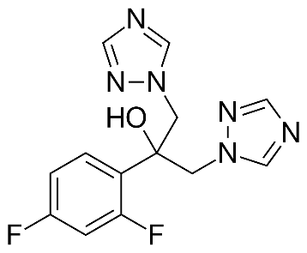
Chemical structure of fluconazole
Effect of fluconazole on DNA
To study the DNA-breaking effect of fluconazole, 46 µM bases of pUC19 plasmid DNA was treated with different concentrations of fluconazole (8800, 880, 88, 44 and 22 µM) at 37°C for 45 minutes. After incubation, the reaction mixtures were analyzed on 1% agarose gel electrophoresis at 90 V for 55 minutes. The test was repeated in the presence of an oxidative agent (H₂O₂, 6 mM and 6 µM) and in the presence of a reducing agent (ascorbic acid, 88 µM). Untreated pUC19 plasmid DNA was also used as a control sample. All tests were performed three times in phosphate saline buffer (PBS) (pH = 7.5) (Lee et al., 2017).
Effect of fluconazole on DNA in the presence of iron
The protective effect of fluconazole against hydroxyl radicals resulting from the reaction between FeSO₄ and H₂O₂ was studied according to the method used by Ul-Haq and his coworkers.¹⁴ Briefly, 46 µM bases of pUC19 plasmid DNA was incubated with a solution including different concentrations of fluconazole (8800, 880, 88, 44 and 22 µM), 1.5 mM of FeSO₄ and 6 mM of H₂O₂ at 37ºC for 60min. Sample incubated with FeSO₄ (1.5 mM) plus H₂O₂ (6 mM) was used as positive control and untreated DNA was used as a negative control.
In order to analyze the effect of the drug on DNA in the presence of iron, the DNA was treated with the H₂O₂-free solution containing fluconazole (8800, 880, 88, 44 and 22 µM) and FeSO₄ (1.5 mM). All tests were done in three repeats in PBS buffer (Phosphate Buffered Saline; pH, 7.4).
Effect of fluconazole on DNA in the presence of copper
To analyze the effect of fluconazole on copper-mediated DNA breaking, pUC19 plasmid DNA (46 mM bases) was treated with different concentrations of fluconazole (8800, 880, 88, 44 and 22 µM) and CuCl₂ (60 µM) for 45 minutes at 37ºC followed by analysis in agarose gel (1%) electrophoresis. In addition, another test was conducted by treating the DNA with the solution containing different concentrations of fluconazole (8800, 880, 88, 44 and 22 µM) and CuCl₂ (60 µM) plus ascorbic acid (60 µM). All tests were done in three repeats in PBS buffer (Phosphate Buffered Saline; pH, 7.4).
DNA binding analysis by UV absorption measurements
For this purpose Calf thymus DNA (ctDNA) and Fluconazole were dissolved at Tris-HCl buffer (50mM Tris, pH 7.2). 0.5% of ethanol (100% pure) was used to facilitate the dissolution of fluconazole. The DNA solution was titrated by the fluconazole solution followed by recording their spectra at wavelengths between 220 nm and 320 nm using UV-Vis Spectrophotometer (Optizen 2120) at every 1 nm of wavelengths. The mixtures were incubated 5 minutes at room temperature before recording their spectra. Binding constant (Kb) was calculated using the following equation:
In this equation; A₀ is the absorbance of DNA at 260 nm in the absence of ligand. A∞ is the final absorbance value of the saturated state of DNA and fluconazole. A is the absorbance value recorded at different fluconazole concentrations. C _{ligand} belongs to fluconazole concentration.¹⁵
Molecular docking analysis
The crystal structure of B-DNA (PDB ID: 1BNA) was downloaded from the Protein Database(RCSB)¹⁶ in PDB format. The 3D structure of the drug was downloaded from the PubChem database¹⁷ in SDF format and converted to PDB format by Discovery Studio 3.0 software.¹⁸ Macromolecule (DNA) and ligand (drug) files in PDB format were prepared using AutoDock tools version 1.5.4 and Molecular docking studies were calculated using Autodock Vina program.¹⁹ B-DNA was used as a rigid input receptor molecule for docking, whereas fluconazole was used as flexible ligands and the number of active torsions is set to 6. The receptor was enclosed in a script box which had a much number of grid points in x × y × z directions of 52 × 48 × 98 and a grid spacing of 0.375 Å. The amounts of independent docking runs performed for docking simulation was set to 10. The lowest-energy docked conformer is considered to be the best result and is used to further analyze the molecular interactions of fluconazole with DNA. LIGPLOT (version .4.5.3) was used to study the two dimensional (2D) structure of the fluconazole – DNA interaction. ²⁰

RESULT
Effect of fluconazole concentrations on DNA
The supercoiled plasmid DNA treated with different drug concentrations (8800, 880, 88, 44, 22 μM) showed no changes in agarose gel electrophoresis compared to untreated DNA, even in the presence of ascorbic acid and H₂O₂ while in the presence of H₂O₂ plus FeSO₄, the DNA was converted to linear form (Fig. 1).

Fig.1. Treatment of 46 µM bases of pUC19 plasmid DNA with fluconazole (FCZ), FCZ plus H₂O₂ and FCZ plus ascorbic acid (Asc). a, b, c, d and e represent 8800, 880, 88, 44 and 22 μM concentrations of FCZ, respectively. For H₂O₂, a and b show the concentration of 6 mM and 6 µM, respectively and b* represents H₂O₂ (6 µM) plus FeSO₄ (1.5 mM). The concentration of ascorbic acid was 88 µM. Plus and minus signs represent presence and absence, respectively. R, L, and S represent relaxed, linear and supercoiled form of the plasmid DNA, respectively.

Effect of fluconazole on DNA in the presence of iron
When the pUC19 plasmid DNA was incubated with 8800, 880, 88, 44 and 22 µM of fluconazole plus 1.5 mM of FeSO₄, no breakage of DNA occurred. Treatment of the supercoiled pUC19 plasmid DNA with FeSO₄ (1.5 mM) plus 6 mM of H₂O₂ converted the supercoiled form of the DNA to a relaxed form and linear form because of breakages. Fluconazole concentration ≥ 88 μM could protect 46 µM of DNA against radical hydroxyl while the drug concentration ≤ 44 μM could not provide the protection (Fig. 2).
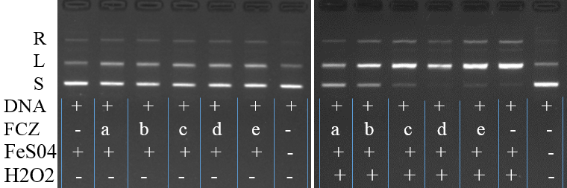
Fig. 2: Effect of fluconazole (FCZ) on DNA in the presence of iron. pUC19 plasmid DNA was used as 46 µM. The different concentrations of fluconazole were shown as a, b, c, d and e that presented 8800, 880, 88, 44 and 22 μM, respectively. The concentrations of FeSO₄ and H₂O₂ were 1.5 mM and 6 mM respectively. Plus and minus signs represent presence and absence, respectively.
Effect of fluconazole on DNA in the presence of copper
CuCl₂ without a reductive agent did not break the supercoiled pUC19 plasmid DNA while it converted the DNA to both relaxed form and linear form in the presence of ascorbic acid as a reductive agent. Fluconazole did not induce CuCl₂ to break the DNA and was unable to protect DNA from the breaking effect of CuCl₂ in the presence of ascorbic acid (Fig. 3).

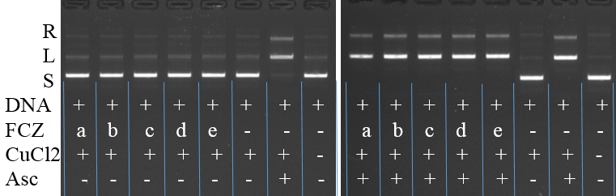
Fig. 3. Effect of fluconazole (FCZ) on DNA in the presence of copper. pUC19 plasmid DNA was used as 46 µM. The concentrations of fluconazole were shown as a, b, c, d and e that represented 8800, 880, 88, 44 and 22 μM, respectively and the concentration of CuCl₂ and Asc were as 60 µM. Plus and minus signs represent presence and absence, respectively.
DNA binding study of fluconazole by UV absorption titration
In the study conducted with the UV titration method, the absorption peak wavelength of DNA did not change while the absorbance value at 260 nm has been increased by a fluconazole concentration-dependent manner. Fluconazole itself has an absorption peak at 261 nm, therefore the absorbance value related to fluconazole was subtracted from the obtained absorption values and observed that the absorption value of DNA was decreased by fluconazole concentration ranging from 0.000393 molars to 0.00157 molars followed by stopped the decrease in absorbance. The decrease indicated the interaction of the drug with DNA. The free binding energy and binding constant (Kb) were calculated as -4.14 kcal/mol and 1.087× 10³ M⁻¹ respectively (Fig. 4).

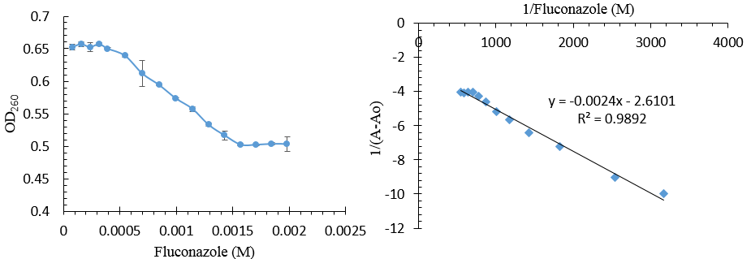
Fig. 4. Absorption of ctDNA at wavelengths of 260 nm in the presence of different concentrations of fluconazole. Initial solution (containing only 0.113 mM of ctDNA) showed 0.75 absorption value at 260 nm while the absorption value decreased to 0.502 by 0.00157, 0.00170, 0.00184 and 0.00198 molar of fluconazole. Binding constant was calculated using the equation . Fluconazole and ctDNA solutions were prepared in Tris-HCl buffer (50mM Tris, pH 7.2).
DNA binding study of fluconazole by molecular docking method
Docking study showed that fluconazole (ligand) was located in the minor groove of double-helix DNA. One of the ligand conformation having lowest binding energy (-7.9 kcal/mol) and highest Kb value (6.22 × 10⁵ M⁻¹) made 2 hydrogen bonds including A: DG4: N2 - Flu: N7 and B:DG22: N2 - Flu: N7 with the bond length of 3.14 and 3.19 Å respectively (Fig. 5). In addition, the drug had hydrophobic bonds with the nucleotides including A: DA6 and B: BDC21.
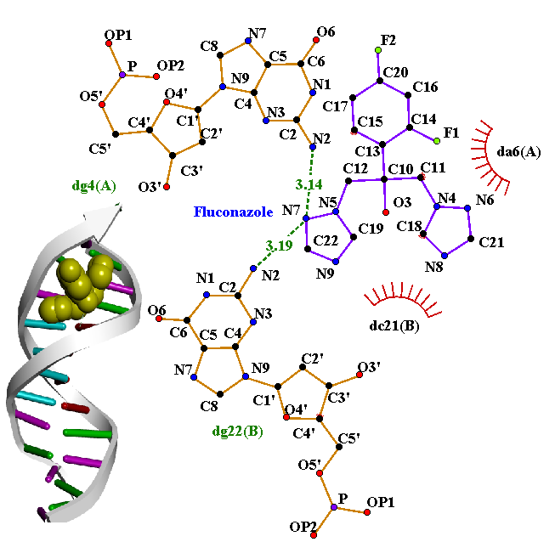
Fig. 5.Molecular modeling of the interaction between fluconazole and double-helix DNA. In the two-dimensional form of the interaction, the bonds shown by dashed lines represent hydrogen bonds and the bonds shown by radius lines represent hydrophobic bonds. Nucleotides were shown by one letter code followed by the numbers showing their position in DNA strands, A or B within parenthesis identify DNA strands (A: CGCGAATTCGCG / B: CGCGAATTCGCG). In the three-dimensional form of the interaction in that fluconazole is shown by space fill (CPK) style shows the drug in the minor groove of the double-strand DNA.

DISCUSSION
In this research pUC19 plasmid DNA was used as DNA sample because the native conformation of pUC19 plasmid DNA is a supercoiled form. Any breakage in one of the double strands converts the supercoiled form to open circular (relaxed) form while breakage in the same position on both strands makes linear plasmid DNA. The migration of the linear form through agarose gel is slower than the supercoiled form and faster than the open circle form.²¹ Concentrations of fluconazole in human plasma have been reported as 26.9 mg/ml (87.8 µM).²² Human cells are exposed to ascorbate concentrations in the range of 10 µM to 70 µM ²³. Although, regarding H₂O₂ concentrations in human plasma, there are various reports such as 100 mM²⁴ and 5 μM. ²⁵ In this study, fluconazole, Asc and H₂O₂ concentrations were selected considering this information. Asc was used at high concentration (88 and 60 µM) found in human plasma and H₂O₂ was applied at two concentrations (6 µM and 6 mM) which can be considered as high concentration. In this study, even in the presence of high concentrations of an oxidative agent (H₂O₂, 6 µM and mM) and a reducing agent (Asc, 88 µM), the DNA was not broken by fluconazole concentrations higher than those in human plasma and higher than those used by the aforementioned investigators. These tests were not repeated in the presence of low concentrations of oxidative agent and reducing agent since fluconazole did not break DNA in the presence of a high concentration of oxidative agent and reducing agent. Human physiological plasma iron had been reported as 82 μM. ²⁶ Iron concentration in the human brain had been reported as 34 mM.²⁷ Considering the mentioned information, in this study, the concentration of FeSO₄ and H₂O₂ was selected as 1.5 and 6 mM as used by Li and her coworkers.²⁸ fluconazole concentration ≥ 88 μM could protect 46 µM of DNA against radical hydroxyl produced by the reaction between 1.5 mM of FeSO₄ and 6 mM of H₂O₂ while the drug concentration ≤ 44 μM could not provide the protection. Therefore in our opinion, the protection was provided by binding and covering DNA by the drug. Most of the cellular copper was gathered in the nucleus and bound to DNA bases.²⁹ The concentration of Copper (60 μM) used in this research was within the range (0.2 - 80 μM) of that in human cells.³⁰ In the presence of ascorbate or other reducing agents, copper can lead to the production of ROS by catalyzing some reactions and damage DNA and chromatin.³¹ In this research, fluconazole did not induce copper to break DNA. In addition, fluconazole could not protect DNA against the ROS originated from the reaction between copper and ascorbic acid while it could protect DNA against radical hydroxyl originated from iron and H₂O₂. In our opinion, this result was because oxidation and DNA damaging effects of copper is 50 times faster than iron³¹. In addition, copper ions bind strongly to DNA and disrupt the double-stranded structure³², thus adversely affecting drug binding to DNA.
UV-visible spectroscopy is the most common and convenient way to study the interaction between chemicals and double stranded DNA.³³ The band at 260 nm of DNA arises due to the π-π* transitions of DNA bases. “Hyperchromic” effect and “hypochromic” effect are the spectra features of DNA due to its double helical structure. The spectral change process reflects the corresponding changes in DNA in its conformation and structures after the drug bound to DNA. Hypochromism results from the contraction of DNA in the helix axis, as well as from the change in conformation on DNA; in contrast, hyperchromism derives from damage to the DNA double helix structure.³⁴ In this research, by the addition of fluconazole, the absorbance value of the ct-DNA solution decreased at 260 nm and showed a hypochromic effect due to contraction of the double-stranded ct-DNA. The binding constant obtained using UV-Vis spectrophotometry analysis and docking analysis was 1.087×10³ M⁻¹ and 6.22×10⁵ M⁻¹ respectively. The inconsistencies of the spectrophotometry and docking analysis results may be due to the differences in the methods by that the two analyses are performed. One is based on algorithms and scoring function (theory) and analyzes the interaction between DNA and drug while the other one is an experimental method that can be affected by some other ingredients and factors such as buffer and temperature. The value of Kb for fluconazole is comparable to esculetin (an anti-cancer agent) (1.87×10⁴ M⁻¹) which binds to DNA.³⁵A chemical substance can increase or decrease gene expression by binding to DNA and inhibit binding of proteins involved in transcription regulation.³⁶ In line with our results, before it was reported that fluconazole concentrations caused to increase TNF-a, and decrease IL-6 and IL-10 expressions in PBMCs ¹³. Drug binding causes structural and conformational changes in the DNA such as DNA bending, winding double or single-strand breaks, resulting in DNA damage.³⁷Therefore the DNA-breaking effects (e.g. CA, SCE, and micronucleus) reported by researchers can be due to the binding of fluconazole to DNA.

CONCLUSION
In conclusion, although fluconazole did not break double helix DNA even in the presence of H₂O₂ and ascorbic acid, it strongly bounds to double-stranded DNA. Fluconazole could protect DNA against radical hydroxyl originated from iron and H₂O₂ when its concentration was above DNA concentration. Therefore, fluconazole may make DNA fragmentation by binding to DNA.

ACKNOWLEDGMENT
This research was a master thesis that was conducted under the supervision of assistant professor Ibrahim Arman in Zonguldak Bulent Ecevit University-TURKEY. We wish to thank the Zonguldak Bulent Ecevit University Scientific Research Commission for supporting our study through project grants no. 2017-50737594-01.

CONFLICT OF INTEREST
The authors don’t have any conflict of interest.

REFERENCES
1. L. Peyton, S. Gallagher and M. Hashemzadeh, Drugs Today (Barc) 51 (2015) 705 (https://doi.org/10.1358/dot.2015.51.12.2421058)
2. S. Revankar, J. Fu, M. Rinaldi, S. Kelly, D. Kelly, D. Lamb, S. Keller and B. L. Wickes, Biochem. Biophys. Res. Commun. 324(2004)719 (https://doi.org/10.1016/j.bbrc.2004.09.112)
3. J. D. Davis and S.-Y. Lin, World J Clin Oncol 2(2011)329 (https://dx.doi.org/10.5306%2Fwjco.v2.i9.329)
4. K. Gurova, Future Oncol 5(2009)1685 (https://doi.org/10.2217/fon.09.127 )
5. B. Ç. Toptanci, G. Kizil and M. Kızil, Middle East J Sci 2(2016)33 (https://doi.org/10.23884/mejs/2016.2.1.03)
6. C. Bertoncini, R. Meneghini, F. Galembeck, M. Calió and A. Carbonel, J. Cancer Sci. Ther. 8(2016)213 (https://doi.org/10.4172/1948-5956.1000415)
7. G. J. Brewer, Chem. Res. Toxicol. 23(2009)319 (https://doi.org/10.1021/tx900338d)
8. A. Fonseca-Nunes, P. Jakszyn and A. Agudo, J Cancer Epidemiol Prev 23(2014)12 (https://doi.org/10.1158/1055-9965.EPI-13-0733)
9. S. Ohnishi, M. Murata, N. Ida, S. Oikawa and S. Kawanishi, Free Radical Res. 49(2015)1165 (https://doi.org/10.3109/10715762.2015.1050963)
10. N. Somchit, S. Hassim and S. Samsudin, Hum. Exp. Toxicol. 21(2002)43(https://doi.org/10.1191%2F0960327102ht208oa)
11. D. Yüzbaşıoğlu, F. Ünal, S. Yılmaz, H. Aksoy and M. Celik, Mutat Res Genet Toxicol Environ Mutagen 649(2008)155 (https://doi.org/10.1016/j.mrgentox.2007.08.012)
12. R. M. d. S. Correa, T. C. Mota, A. C. Guimarães, L. T. Bonfim, R. R. Burbano and M. d. O. Bahia, Biomed Res Int 2018(2018) (https://doi.org/10.1155/2018/6271547)
13. G. Silva, L. Zuravski, M. Duarte, M. Machado and L. Oliveira, Immunopharmacol. Immunotoxicol. 41(2019)123 (https://doi.org/10.1080/08923973.2019.1566357)
14. I. Ul-Haq, N. Ullah, G. Bibi, S. Kanwal, M. S. Ahmad and B. Mirza, Iran J Pharm Res 11(2012)241(https://www.ncbi.nlm.nih.gov/pmc/articles/PMC3813110/)
15. B. Coban and U. Yildiz, Appl. Biochem. Biotechnol. 172(2014)248 (https://doi.org/10.1007/s12010-013-0513-7)
16. RCSB PDB, (https://www.rcsb.org/structure/1bna), (2020)
17. PubChem, (https://pubchem.ncbi.nlm.nih.gov), (2020)
18. I. Accelrys, San Diego, CA 92121(2011) http://accelrys.com/products/discovery-studio/visualization-download.php
19. O. Trott and A. J. Olson, J. Comput. Chem. 31(2010)455 https://doi.org/10.1002/jcc.21334
20. A. C. Wallace, R. A. Laskowski and J. M. Thornton, Protein. Eng. Des. Sel. 8(1995)127 https://doi.org/10.1093/protein/8.2.127
21. R. G. Moreno, M. V. Alipázaga, O. F. Gomes, E. Linares, M. H. Medeiros and N. Coichev, J. Inorg. Biochem. 101(2007)866 (https://doi.org/10.1016/j.jinorgbio.2007.02.003)
22. M. Kami, Y. Sawada, S. i. Mori, J. Hirate, N. Kojima, Y. Kanda, A. Moriya, K. Yuji, T. Saito and S. Chiba, Am. J. Hematol. 66(2001)85 (https://doi.org/10.1002/1096-8652(200102)66:2%3C85::AID-AJH1022%3E3.0.CO;2-M)
23. S. J. Padayatty and M. Levine, Oral Dis. 22(2016)463 (https://doi.org/10.1111/odi.12446)
24. N. Cavarocchi, M. England, H. V. Schaff, P. Russo, T. Orszulak, J. W. Schnell, J. O'Brien and J. Pluth, Circulation 74(1986)III130 (https://mayoclinic.pure.elsevier.com/en/publications/oxygen-free-radical-generation-during-cardiopulmonary-bypass-corr)
25. Y. Yamamoto, M. H. Brodsky, J. C. Baker and B. N. Ames, Anal. Biochem. 160(1987)7 (https://doi.org/10.1016/0003-2697(87)90606-3)
26. C. Salustri, R. Squitti, F. Zappasodi, M. Ventriglia, M. G. Bevacqua, M. Fontana and F. Tecchio, J. Affect. Disord. 127(2010)321(https://doi.org/10.1016/j.jad.2010.05.012)
27. G. McAuley, M. Schrag, S. Barnes, A. Obenaus, A. Dickson, B. Holshouser and W. Kirsch, Magn. Reson. Med. 65(2011)1592 (https://doi.org/10.1002/mrm.22745)
28. Y. Li, Y. Zheng, Y. Zhang, J. Xu and G. Gao, Molecules 23(2018)1(https://doi.org/10.3390/molecules23030707)
29. M. C. Linder, Mutat Res 733(2012)83 (https://doi.org/10.1016/j.mrfmmm.2012.03.010)
30. C. Garcia, Clemson University, 2011(https://tigerprints.clemson.edu/all_theses/1252/)
31. D. Bar-Or, G. W. Thomas, L. T. Rael, E. P. Lau and J. V. Winkler, Biochem. Biophys. Res. Commun. 282(2001)356 (https://doi.org/10.1006/bbrc.2001.4533)
32. K. Yokawa, T. Kagenishi and T. Kawano, Biosci., Biotechnol., Biochem., (2011)1106082534 (https://doi.org/10.1271/bbb.100900)
33. R. Valipour, M. B. Yilmaz and E. Valipour, Drug Res., 69 (2019) 545 (https://doi.org/10.1055/a-0809-5044)
34. C.-Y. Zhou, X.-L. Xi and P. Yang, Biokhimiia 72(2007)37 (https://doi.org/10.1134/S000629790701004X)
35. T. Sarwar, M. A. Husain, S. U. Rehman, H. M. Ishqi and M. Tabish, Mol. Biosyst. 11(2015)522 (https://doi.org/10.1039/c4mb00636d)
36. J. M. Gottesfeld, J. M. Turner and P. B. Dervan, Gene Expr 9(2001)77 (https://doi.org/10.3727/000000001783992696)
37. S. A. Shaikh, S. R. Ahmed and B. Jayaram, Arch. Biochem. Biophys. 429(2004)81(https://doi.org/10.1016/j.abb.2004.05.019)

