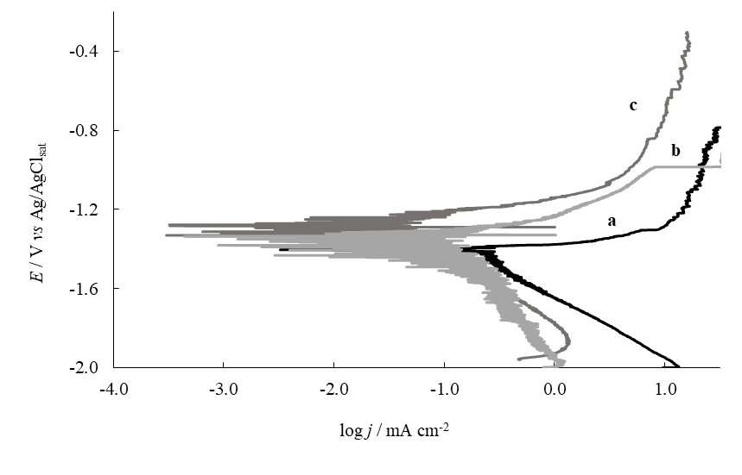

Fig. 2. Potentiodynamic polarization curves in Ringer solution for: (a) uncoated AZ91D alloy and the alloy covered with: (b) PPy_{0.25;} (c) PPy_{0.50}. The scan rate was 0.001 Vs⁻¹.

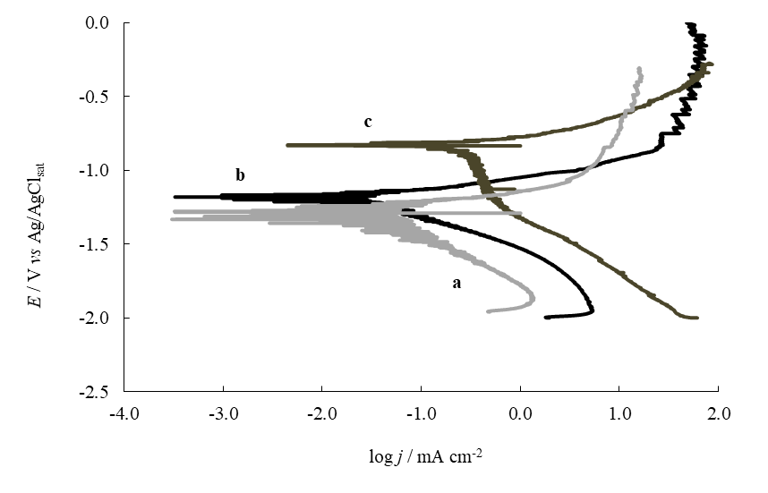

Fig. 4. Potentiodynamic polarization curves in Ringer solution for the AZ91D alloy covered with: (a) PPy_{0.25;} (b) RMo-PPy_{0.25} and (c) RMo-PPy_{0.25}-Ag. The scan rate was 0.001 Vs⁻¹.

